Delta Live Tables (DLT) End-to-End Data Engineering Project

Project Overview
This project demonstrates an end-to-end Medallion Architecture implementation using Databricks Delta Live Tables (DLT).
The pipeline ingests streaming customer, product, and sales data into Bronze tables, performs cleansing and CDC handling in Silver tables, and finally builds Gold-level dimensional and business aggregation tables for analytics.
Key Features:
• Streaming ingestion
• Data quality expectations
• CDC (Change Data Capture)
• SCD Type 1 & Type 2
• Materialized tables
• DLT Views
• Incremental processing
• Business aggregation layer

Architecture
Source Tables
↓
Bronze Layer (Raw Streaming Ingestion + Expectations)
↓
Silver Layer (Transformations + CDC + Cleansing)
↓
Gold Layer (Fact/Dimension Modeling + Business Aggregations)

Project Structure
DLT_Pipeline_Root/
│
├── explorations/
│
├── transformations_DLT/
│ ├── bronze/
│ │ ├── customers_ingestion.py
│ │ ├── product_ingestion.py
│ │ └── sale_ingestion.py
│ │
│ ├── silver/
│ │ ├── Transform_customer.py
│ │ ├── Transform_product.py
│ │ └── Transform_sales.py
│ │
│ └── gold/
│ ├── dim_customer.py
│ ├── dim_product.py
│ ├── fact_sales.py
│ └── business_sales.py
│
└── README.md

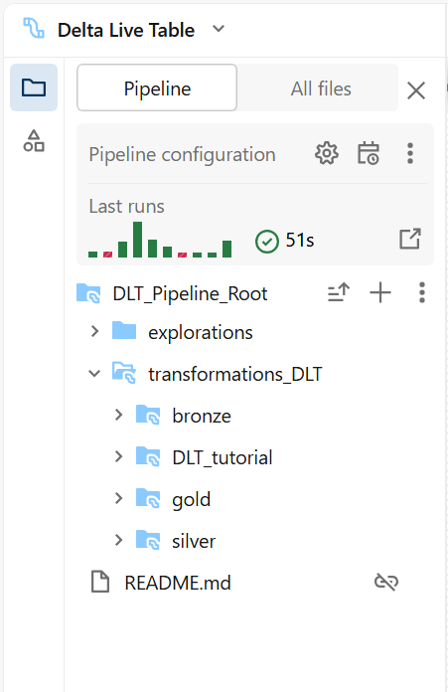
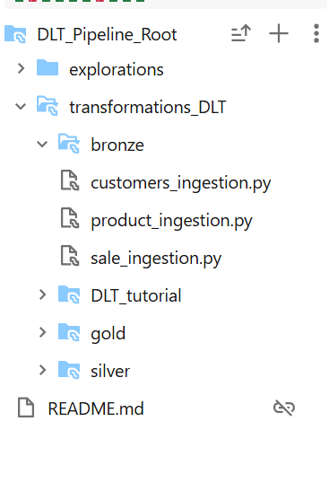
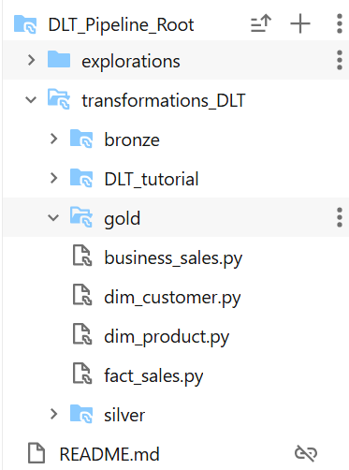
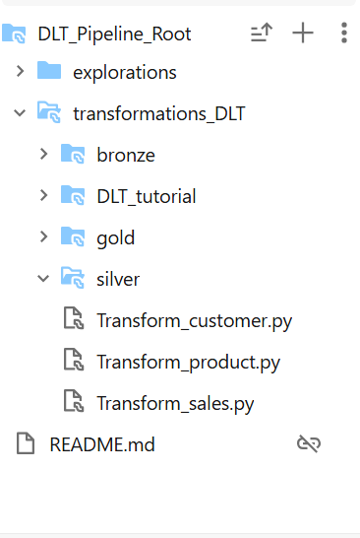

Bronze Layer
The Bronze layer is responsible for:
• Raw streaming ingestion
• Schema validation
• Data quality checks
• Initial filtering
Customer expectations:
- customer_id IS NOT NULL
- customer_name IS NOT NULL
Product expectations:
- product_id IS NOT NULL
- price >= 0
Sales ingestion:
- sales_east stream
- sales_west stream
Merged using append flows into a single streaming table.

Why Views Were Used
Views were introduced between Bronze and Silver layers to isolate transformation logic.
Benefits:
• Separation of concerns
• Reusability
• Cleaner architecture
• Better maintainability
• Easier debugging
• Improved readability
Instead of directly applying transformations inside CDC flows, views act as reusable transformation layers.

Silver Layer
The Silver layer performs:
• Data cleansing
• Data enrichment
• Type casting
• CDC handling
• SCD implementation
Transformations:
• Customer names converted to uppercase
• Product price cast to integer
• Sales total_amount derived using quantity * amount

CDC and SCD Implementation
CDC Implementation:
Used dlt.create_auto_cdc_flow() for incremental merge processing.
SCD Type 1:
• customer_enriched
• products_enriched
• sale_enriched
• fact_sales
Behavior:
- Maintains latest version only
SCD Type 2:
• dim_customer
• dim_product
Behavior:
- Maintains historical versions of records

Gold Layer
The Gold layer provides business-ready datasets.
Tables:
• fact_sales
• dim_customer
• dim_product
• business_sales
business_sales aggregates:
• Region
• Category
• Total Sales

Materialized Tables
Materialized tables physically store precomputed results.
Benefits:
• Faster query performance
• Reduced recomputation
• Optimized BI reporting
• Faster dashboard response times

Pipeline Flow
customers → customer_stage → customer_enriched_view → customer_enriched → dim_customer
products → products_stage → products_enriched_view → products_enriched → dim_product
sales_east + sales_west → sales_stage → sales_enriched_view → sale_enriched → fact_sales
fact_sales + dimensions → business_sales

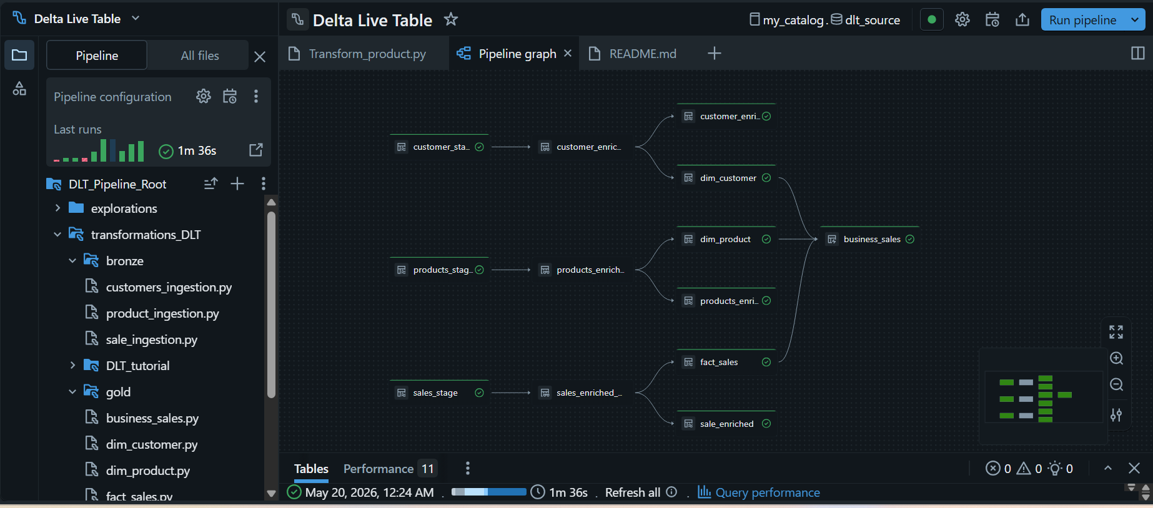
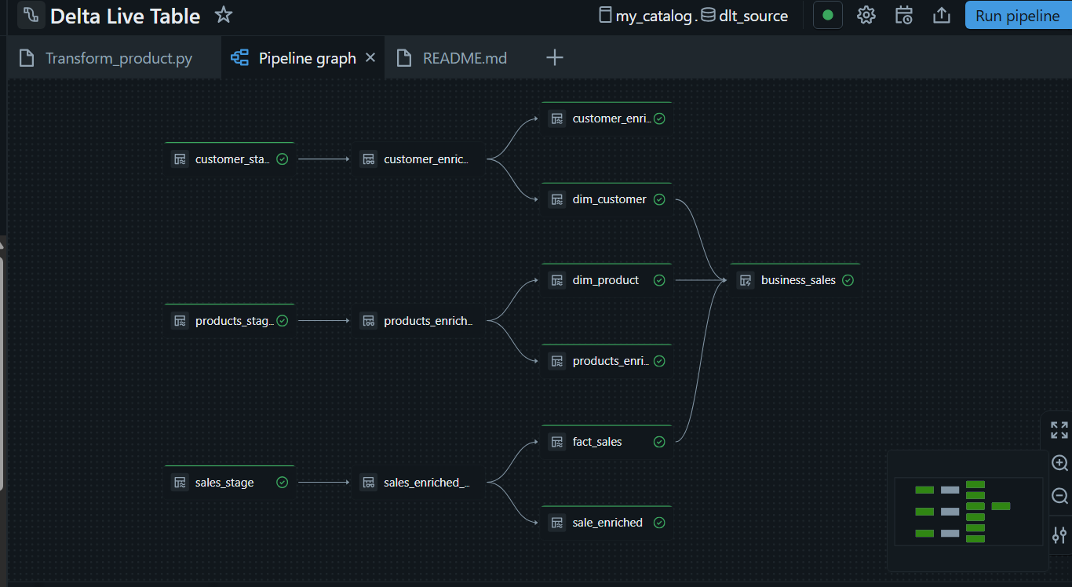
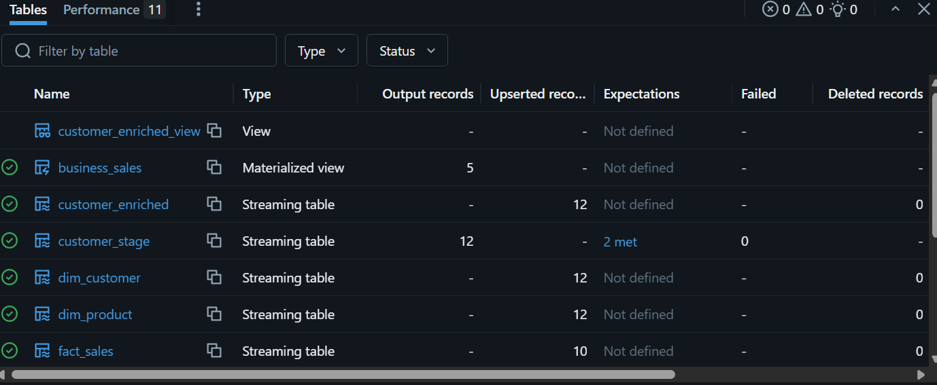
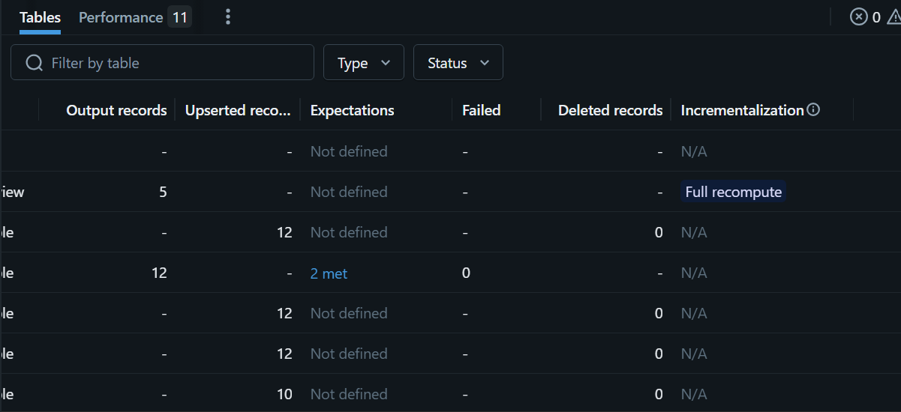
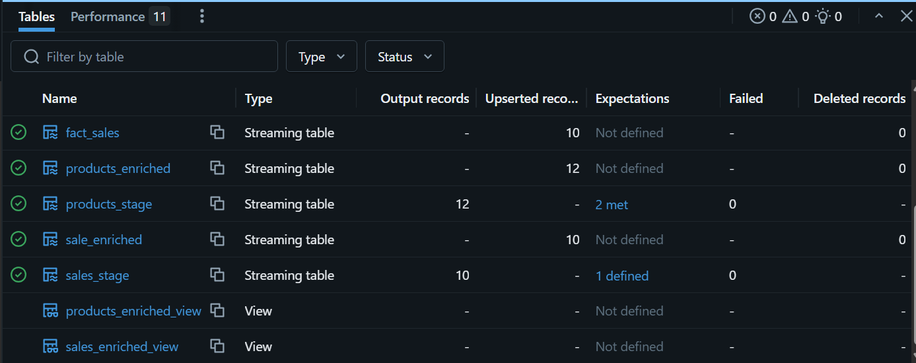
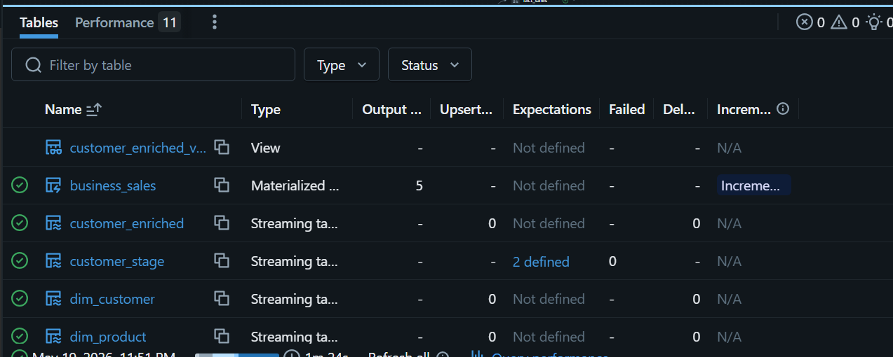

Technologies Used
• Databricks
• Delta Live Tables (DLT)
• PySpark
• Delta Lake
• Structured Streaming
• CDC
• SCD Type 1 & Type 2

Conclusion
This project demonstrates a scalable enterprise-grade DLT implementation capable of handling streaming ingestion, CDC processing, historical tracking, and analytical reporting using modern data engineering principles.

Author
Sai Shiva

