[swayam-logo](https://swayam.gov.in/) [](https://swayam.gov.in/nc_details/NPTEL)

[sriramoji20245a0334@grietcollege.com](https://onlinecourses.nptel.ac.in/noc22_cs47/)

[**NPTEL**](https://swayam.gov.in/explorer?ncCode=NPTEL) **»** [**Programming In Java**](https://onlinecourses.nptel.ac.in/noc22_cs47/course)

Week 7 : Assignment 7

**Due date: 2022-03-16, 23:59 IST.**

**Your last recorded submission was on 2022-03-13, 17:43 IST**

***1 point***

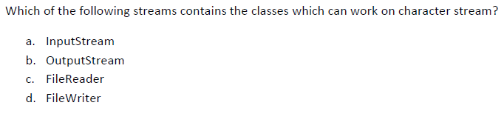

 a

 b

 c

 d

***1 point***

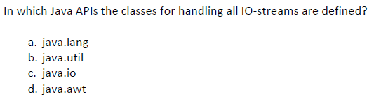

 a

 b

 c

 d

***1 point***

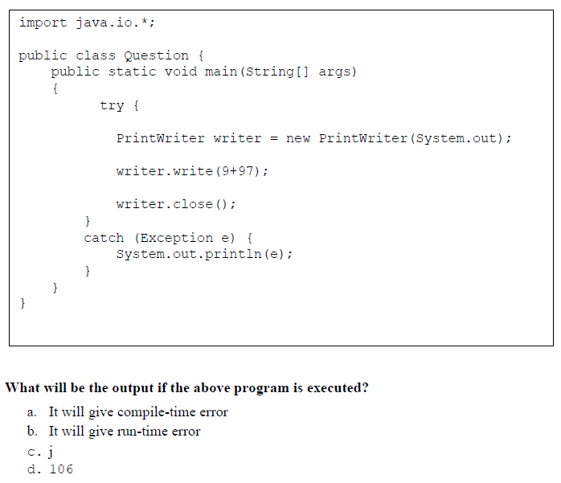

 a

 b

 c

 d

***1 point***

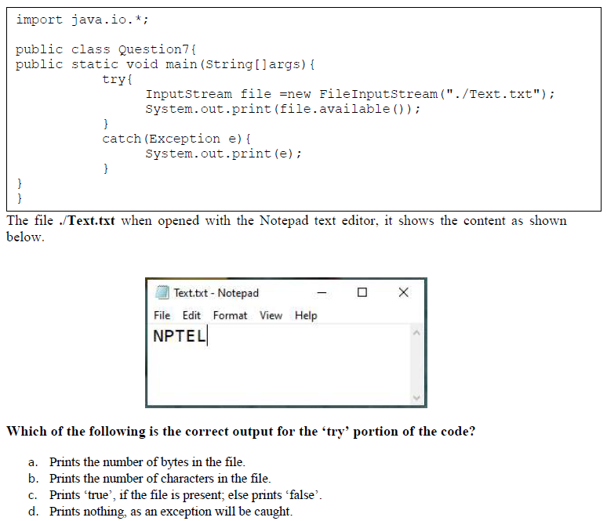

 a

 b

 c

 d

***1 point***

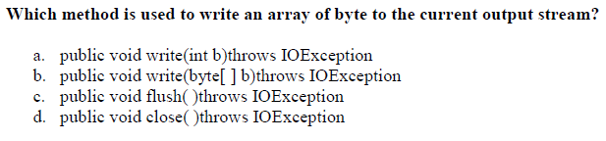

 a

 b

 c

 d

***1 point***

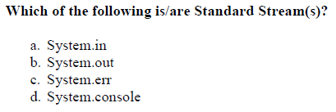

 a

 b

 c

 d

***1 point***

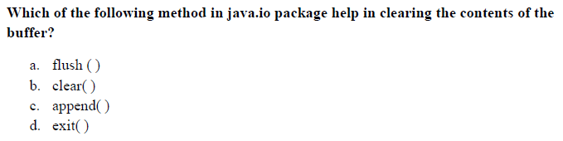

 a

 b

 c

 d

***1 point***

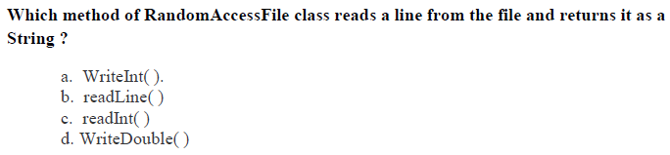

 a

 b

 c

 d

***1 point***

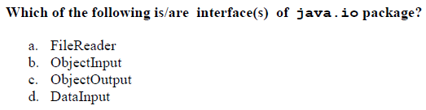

 a

 b

 c

 d

***1 point***

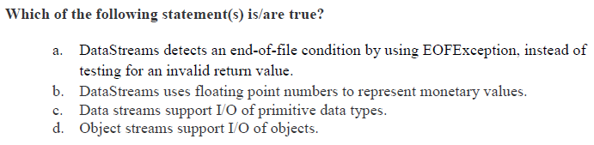

 a

 b

 c

 d

You may submit any number of times before the due date. The final submission will be considered for grading.

Submit Answers