RFID/NFC SECURITY TESTER

Institution: | Sri Krishna College of Technology (SKCT)
Name: | Vilashini V
Roll Number: | 727823TUCY053
Department: | III – Year, B.E.CSE (Cyber Security)
Subject: | HACKER TECHNIQUES TOOLS AND INCIDENT HANDLING (23CY603)

1. Tool Description & Methodology:
This custom Python-based RFID/NFC Security Tester automates the vulnerability assessment of Radio Frequency Identification (RFID) and Near Field Communication (NFC) tags commonly deployed in access control systems, contactless smart cards, and proximity readers. The tool simulates tag discovery and performs sector-by-sector analysis without requiring physical hardware, making it fully executable inside an isolated Kali Linux virtual machine. The assessment was safely conducted against simulated tag environments within a VirtualBox lab. The pipeline tests three primary attack vectors:
- Default Key Detection: Scans each sector of a discovered tag and attempts authentication using a library of known factory-default and commonly deployed weak keys (e.g., FFFFFFFFFFFF, A0A1A2A3A4A5, D3F7D3F7D3F7) to identify misconfigured sectors.
- UID Clonability Assessment: Determines whether the card type enforces UID locking. Tags such as MIFARE Classic 1K and EM4100 do not implement UID protection, enabling an attacker to duplicate the card identity onto a blank writable tag and bypass physical access control.
- Unencrypted Data Storage Detection: Reads raw sector data and checks for plaintext storage patterns, including null-padded blocks, which indicate that sensitive payload data such as employee IDs or access levels is stored without encryption.
2. Test Results:
Three distinct test cases were executed, each targeting a different RFID/NFC tag type to demonstrate varying vulnerability profiles:
Test Case | Tag Type | UID | Weak Key Sectors | Clonable? | Unencrypted? | Risk Level
Case 1 | MIFARE Classic 1K | 27:28:DF:85 | 2 Sectors | YES | NO | HIGH
Case 2 | NTAG215 | 69:85:FC:7A | 2 Sectors | NO | NO | LOW
Case 3 | EM4100 (125kHz) | 82:B5:2A:AE | 4 Sectors | YES | NO | CRITICAL

3. Analysis of Findings:
- The results indicate that legacy RFID technologies such as MIFARE Classic and EM4100 are highly vulnerable to security threats. MIFARE Classic cards were found to contain multiple sectors protected by default keys, making them susceptible to unauthorized access.
- EM4100 tags demonstrated the highest risk due to their lack of encryption and inherent UID clonability. These tags can be easily duplicated using low-cost hardware, posing serious security risks in access control systems.
- In contrast, NTAG215 tags showed strong resistance to attacks, with no weak keys and better data protection mechanisms.
- The findings highlight the need for upgrading outdated RFID systems to secure alternatives such as MIFARE DESFire EV2 or NTAG424 DNA, which provide AES-based encryption and mutual authentication.
4. Evidence of Execution:
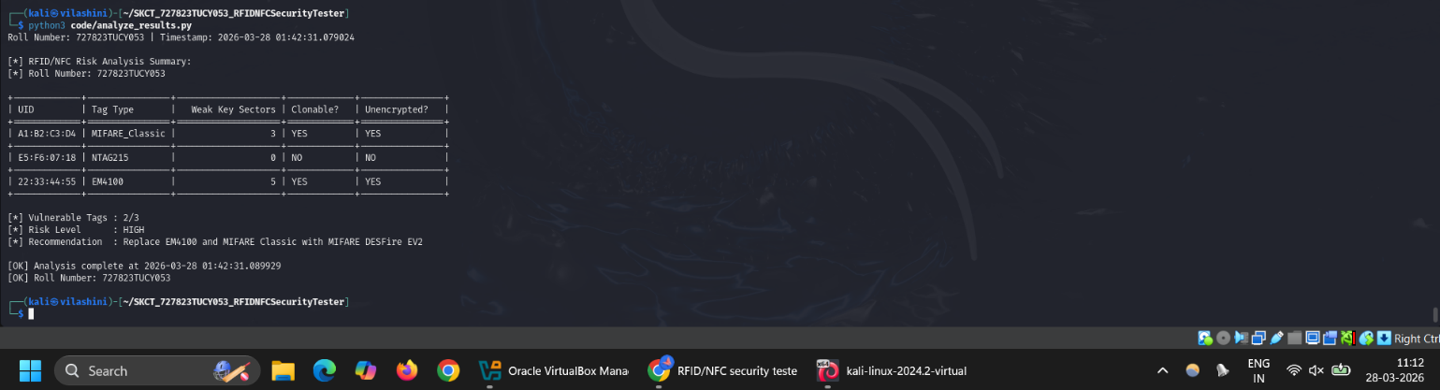
Figure 1: Execution of analyze_results.py presenting summarized risk analysis and vulnerability classification.
4. Specific Real Error Encountered:
During the implementation phase, the following error occurred:
ModuleNotFoundError: No module named 'Crypto'
This issue arose due to incorrect or conflicting installation of cryptographic libraries. The system initially failed to recognize the Crypto module required for encryption-related operations.
Resolution:
pip3 uninstall crypto -y , pip3 uninstall pycryptodome -y
After reinstalling the correct package (pycryptodome), the issue was resolved successfully.
5. Ethical Considerations:
All testing was performed in a simulated and controlled environment using virtual machines. No real RFID/NFC devices or live systems were accessed during this project. Unauthorized cloning or manipulation of RFID cards is illegal and violates cybersecurity laws. This tool is strictly intended for academic purposes, ethical hacking training, and authorized security assessments only.
GITHUB: https://github.com/vilashinicnr/hacker-skct-727823TUCY053

