1) pan card validation

%{
#include <iostream>
#include <string>
#include <vector>
using namespace std;
bool validate = false;

%}

%%
[A-Z]{5}[0-9]{4}[A-Z]{1} {validate = true; printf("PAN NUMBER IS VALID: %s\t", yytext); }
. {}
"\n" {}
%%

int yywrap(){
return 1;
}

int main(void){
yylex();
if(!validate) printf("PAN NUMBER IS NOT VALID\n");
return 0;
}

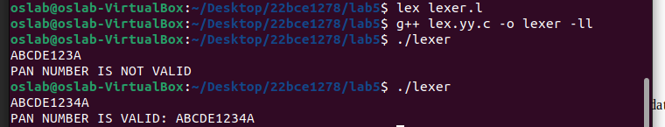
2) Read a CSV file and tokenize

%{
#include <stdio.h>
#include <string.h>

%}

%%
, {}
\n {printf("End of line\n");}
[^,\n]+ { printf("Token: %s\n", yytext);}
%%

int main() {
yylex();
return 0;
}

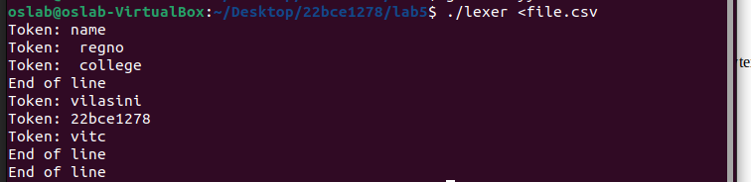
3) MATHEMATICAL STATEMENT TOKENIZE
%{
#include <stdio.h>
#include <string.h>

%}

%%
[0-9]+ { printf("Number: %s\n", yytext);}
"+"|"-"|"/"|"*" {printf("Operator: %s\n", yytext);}
"("|")"|"{"|"}"|"["|"]" {printf("Parenthesis: %s\n", yytext);}
"sin"|"cos"|"tan" {printf("Function: %s\n",yytext);}
. {}
%%

int main() {
yylex();
return 0;
}

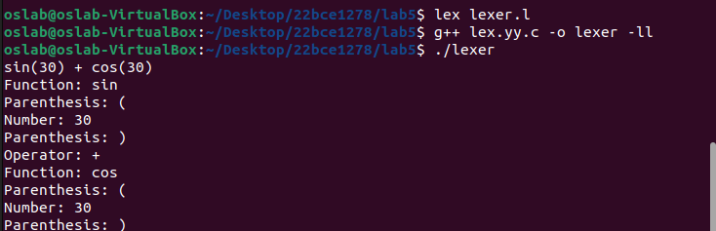
%{
#include <stdio.h>
%}

%%
[-+]?[0-9]+(\.[0-9]+)?([eE][-+]?[0-9]+)? { printf("Number: %s\n", yytext); }
. { /* ignore other characters */ }
%%

int main() {
yylex();
return 0;
}

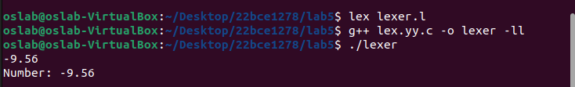

%{
#include <stdio.h>
#include <stdlib.h>
%}

%%
[0-9]{2}[/][0-9]{2}[/][0-9]{4} {printf("Valid date (DD/MM/YYYY): %s\n", yytext);}
[0-9]{4}[-][0-9]{2}[-][0-9]{2} {printf("Valid date (YYYY-MM-DD): %s\n", yytext);}
. {}
%%

int main() {
yylex();
return 0;
}

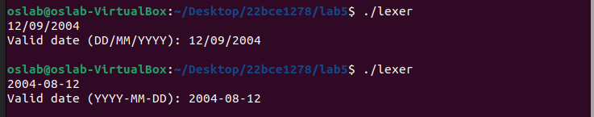

%{
#include <stdio.h>
%}

%%
[A-Za-z0-9._%+-]+@[A-Za-z0-9.-]+\.(com|org|net|edu|gov) {
printf("Valid email: %s\n", yytext);
}
. { /* ignore */ }
%%

int main() {
yylex();
return 0;
}

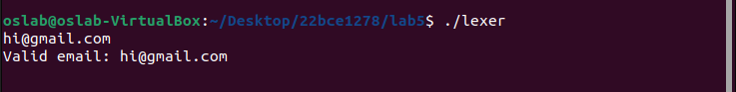

%{
#include <stdio.h>
%}

%%
[A-Z]{2}[0-9]{2}[A-Z]{1,2}[0-9]{4} {
printf("Vehicle Registration Number: %s\n", yytext);
}
. { /* ignore */ }
%%

int main() {
yylex();
return 0;
}

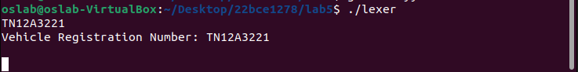

%{
#include <stdio.h>
#include <string.h>

int emailCount=0, phoneCount=0, urlCount=0;

void printSummary() {
printf("Emails: %d\nPhones: %d\nURLs: %d\n", emailCount, phoneCount, urlCount);
}
%}

%%
[A-Za-z0-9._%+-]+@[A-Za-z0-9.-]+\.(com|org|net|edu|gov) {
emailCount++;
}

(\+?[0-9]{1,3}[-.\s]?|)[0-9]{10} {
phoneCount++;
}

https?://[A-Za-z0-9./?=_-]+ {
urlCount++;
}

. { /* ignore */ }
%%

int main() {
yylex();
printSummary();
return 0;
}

%{
#include <stdio.h>
%}

%%
[-+]?[0-9]+(\.[0-9]+)?([eE][-+]?[0-9]+)? { printf("Number: %s\n", yytext); }
. { /* ignore other characters */ }
%%

int main() {
yylex();
return 0;
}

%{
#include <stdio.h>
#include <stdlib.h>

int validDate(int d, int m, int y) {
if(m < 1 || m > 12) return 0;
if(d < 1 || d > 31) return 0;
// Add more detailed day checks per month if needed
return 1;
}
%}

%%
([0-9]{2})/([0-9]{2})/([0-9]{4}) {
int d = atoi(yytext);
sscanf(yytext, "%2d/%2d/%4d", &d, &m, &y);
if(validDate(d,m,y)) printf("Valid date (DD/MM/YYYY): %s\n", yytext);
else printf("Invalid date: %s\n", yytext);
}

([0-9]{4})-([0-9]{2})-([0-9]{2}) {
int y,m,d;
sscanf(yytext, "%4d-%2d-%2d", &y, &m, &d);
if(validDate(d,m,y)) printf("Valid date (YYYY-MM-DD): %s\n", yytext);
else printf("Invalid date: %s\n", yytext);
}

. { /* ignore */ }
%%

int main() {
yylex();
return 0;
}

%{
#include <stdio.h>
%}

%%
[A-Za-z0-9._%+-]+@[A-Za-z0-9.-]+\.(com|org|net|edu|gov) {
printf("Valid email: %s\n", yytext);
}
. { /* ignore */ }
%%

int main() {
yylex();
return 0;
}

%{
#include <stdio.h>
%}

%%
[A-Z]{2}[0-9]{2}[A-Z]{1,2}[0-9]{4} {
printf("Vehicle Registration Number: %s\n", yytext);
}
. { /* ignore */ }
%%

int main() {
yylex();
return 0;
}

%{
#include <stdio.h>
#include <string.h>

int emailCount=0, phoneCount=0, urlCount=0;

void printSummary() {
printf("Emails: %d\nPhones: %d\nURLs: %d\n", emailCount, phoneCount, urlCount);
}
%}

%%
[A-Za-z0-9._%+-]+@[A-Za-z0-9.-]+\.(com|org|net|edu|gov) {
emailCount++;
}

(\+?[0-9]{1,3}[-.\s]?|)[0-9]{10} {
phoneCount++;
}

https?://[A-Za-z0-9./?=_-]+ {
urlCount++;
}

. { /* ignore */ }
%%

int main() {
yylex();
printSummary();
return 0;
}

