**Assignment Backend Details :**

**Used Services :**

1. API Gateway

2. SQS

3. S3

4. Lambda

5. SES

6. MongDB Atlas

7. CloudWatch

**Explaintion :**

Using API we send request for Export Data and shedule report email depends on operation parameter API calls **QueueRequest** lambda function . **QueueRequest** save reuest in 2 queuse

(**ExportReportQueue.fifo,ScheduleReportQueue.fifo**) depent on operation.

I have created 2 Schedulers using CloudWatch wich runs every minitue named **ExportReport**

and **ScheduleReport.**

Scheduler **ExportReport** invokes **ExportReport** lambda function

Scheduler **ScheduleReport** invokes **ScheduleReport** lambda function

**ExportReport** lambda read Request from **ExportReportQueue.fifo** Queue and according that

get result from MongDB Atlas write result in file and upload file to S3 buckect named

**aws-s3-reporting-bucket.**

**ScheduleReport** lambda read Request from **ScheduleReportQueue.fifo** Queue and according that

get file from S3 buckect named **aws-s3-reporting-bucket** send to email**.**

**API Gateway :**

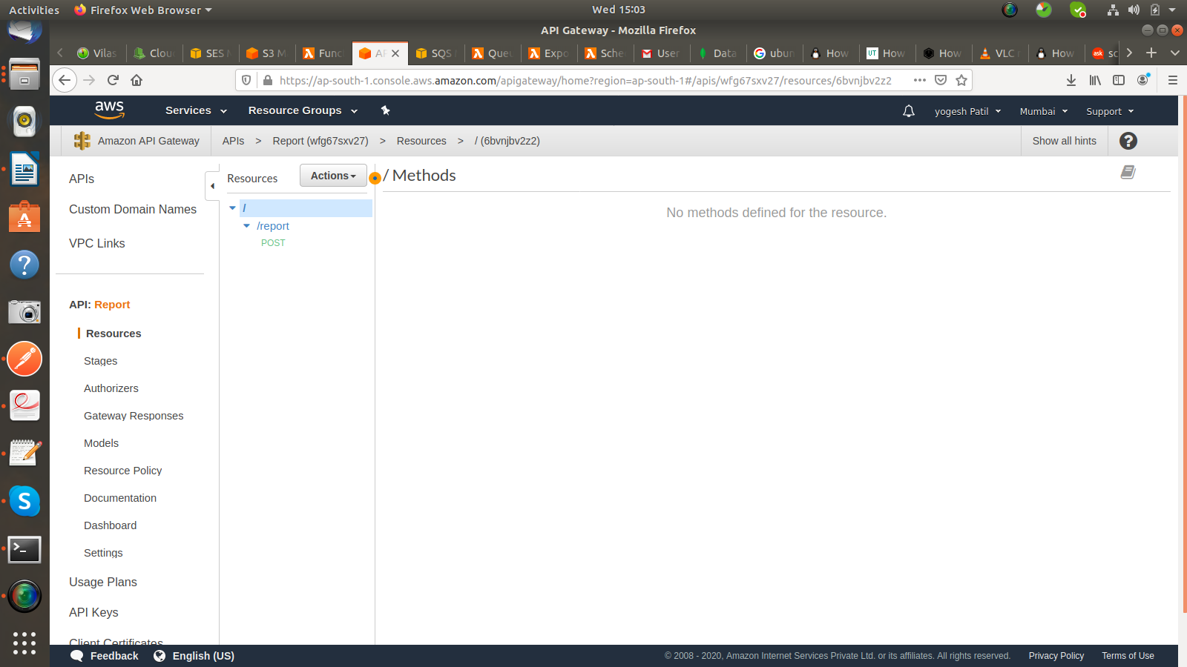

**Lambda :**

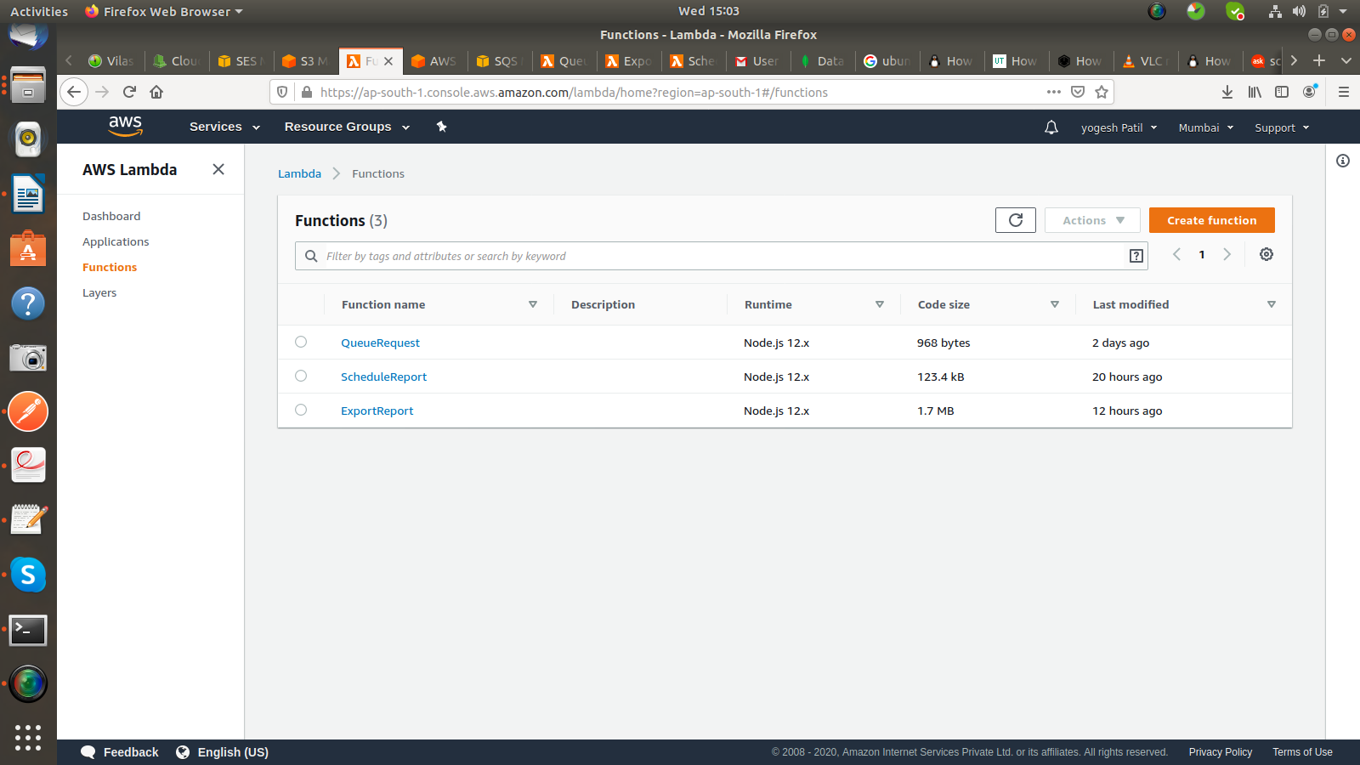

**SQS :**

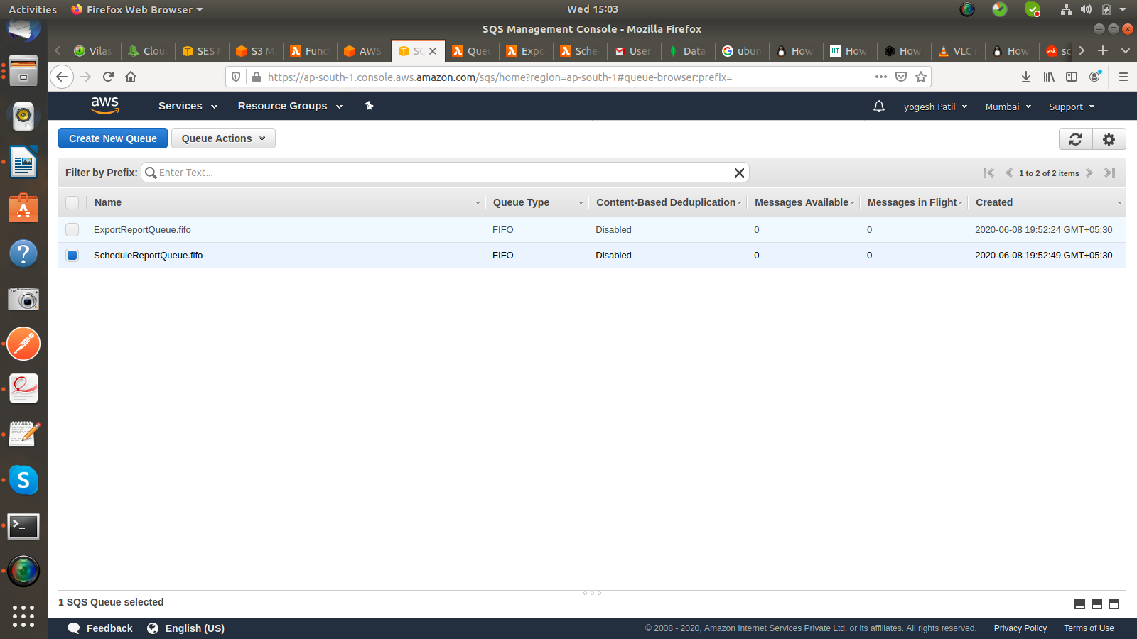

**Schedulars:**

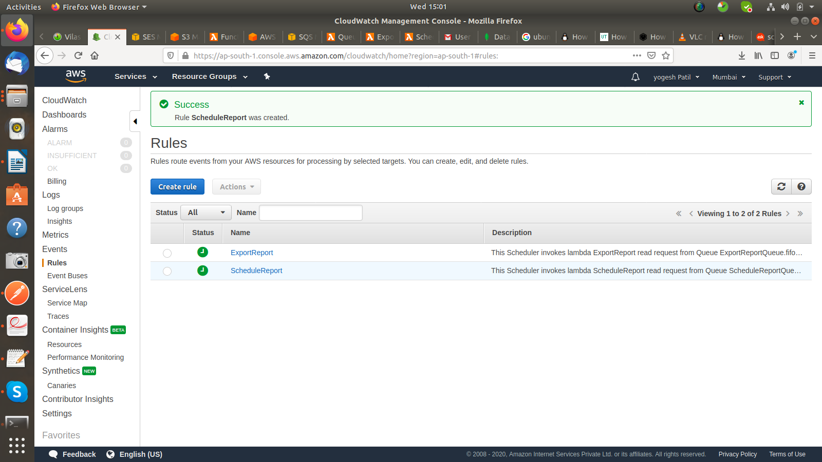

**S3 Bucket :**

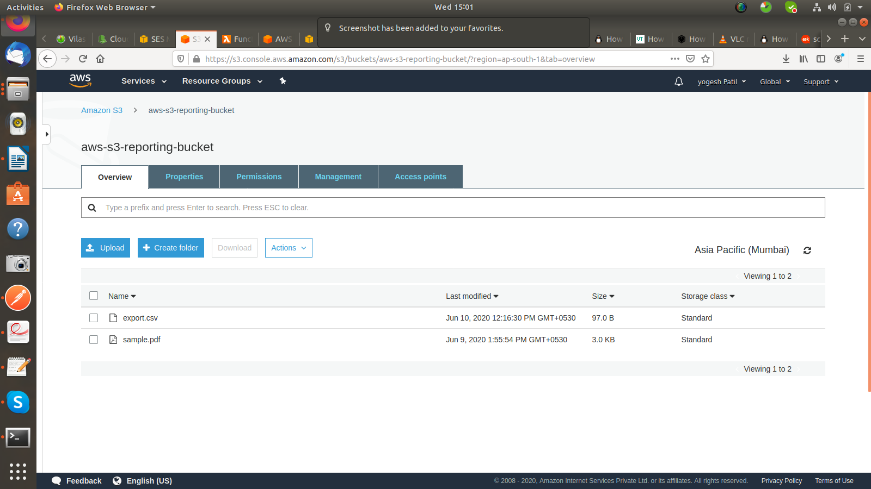

**Database Records :**

