**ASSIGNMENT 8**

Here the application I created is about Cultural Night in UMKC. It is about registering yourself to the cultural night. Below it is explained with all details:

**Homepage:**

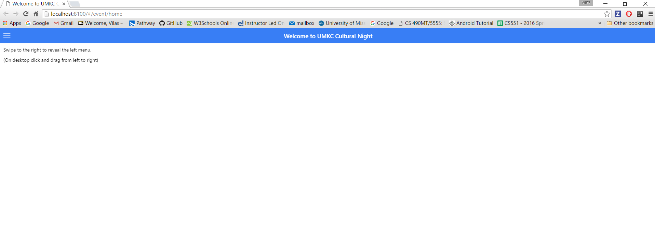

Once you run your application it will display the above screen. Here you can see that there is a left menu also. You can swipe or drag it as below mentioned.

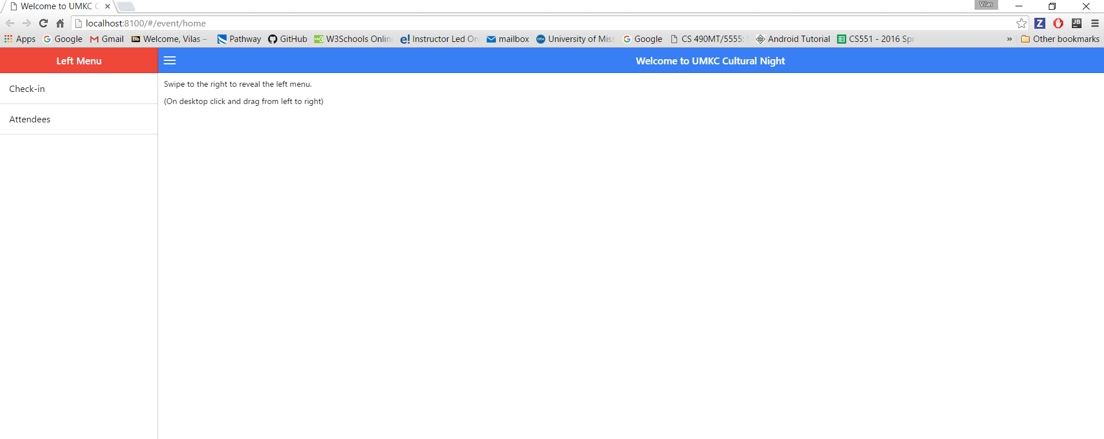

You can now click on **CHECK IN** from the left menu. Then the below screen will be displayed.

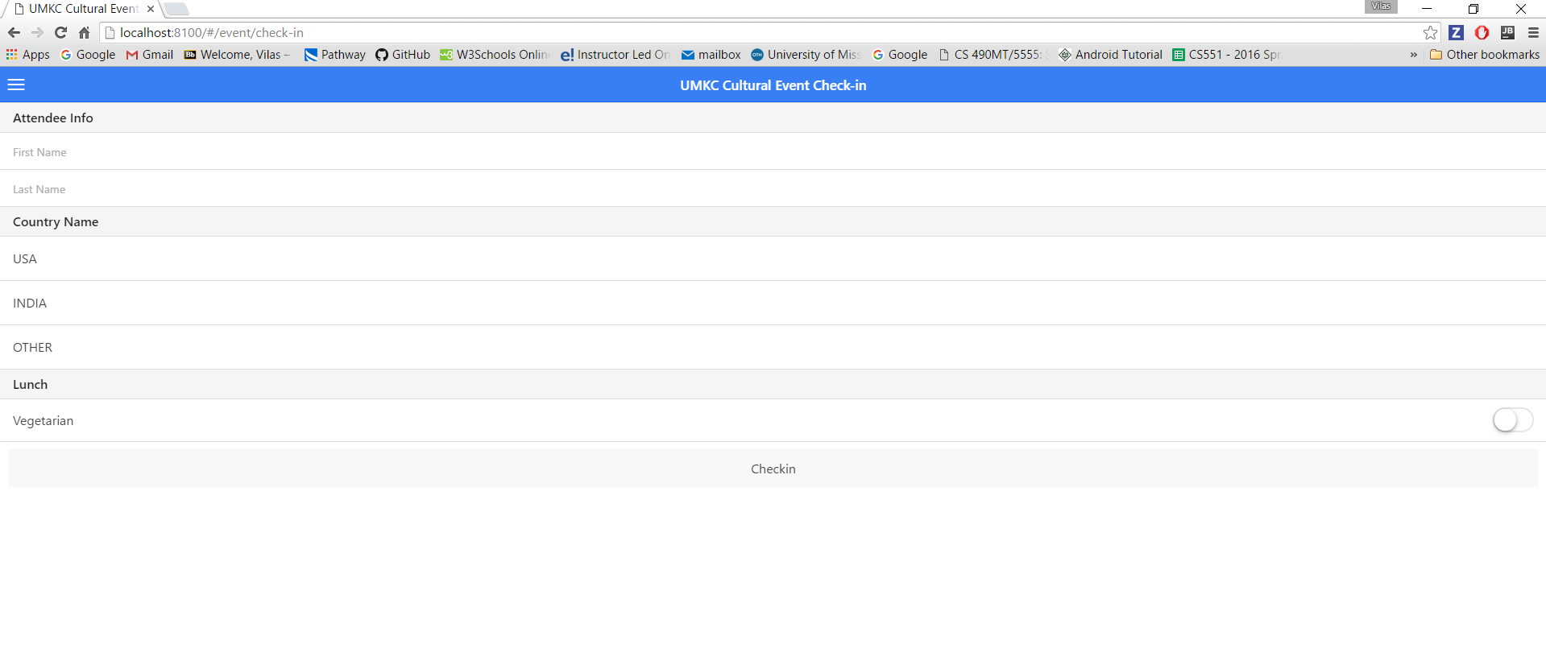

If you click on **Attendee** you will see the already enrolled registered members as below:

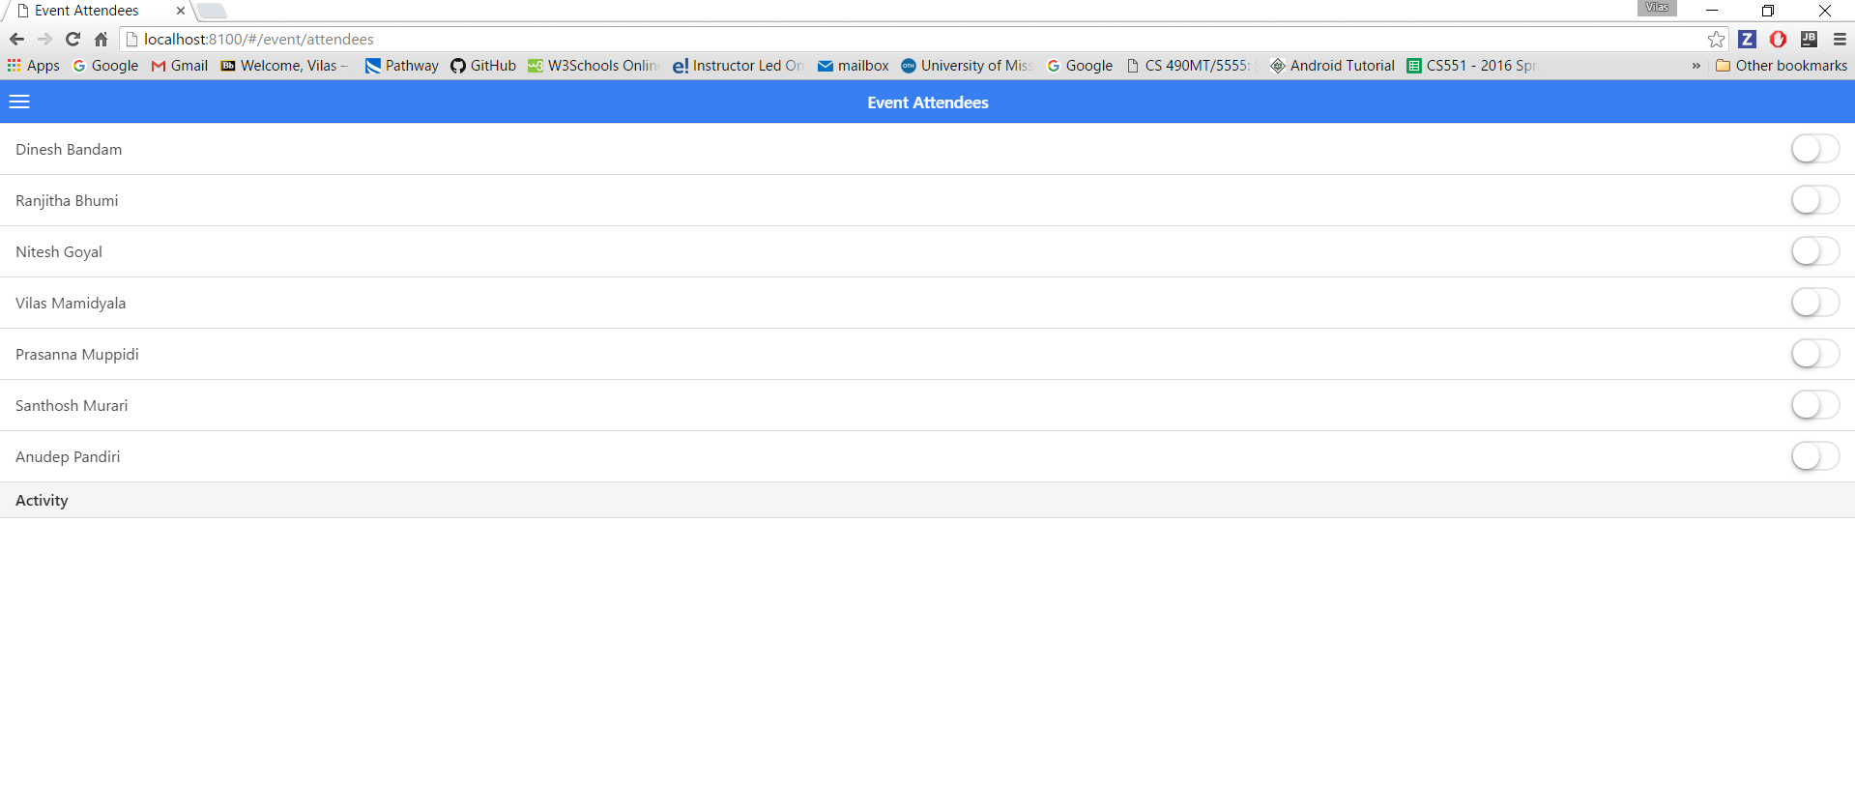

You need to click on check in after entering the above required information Else the below screen will be displayed.

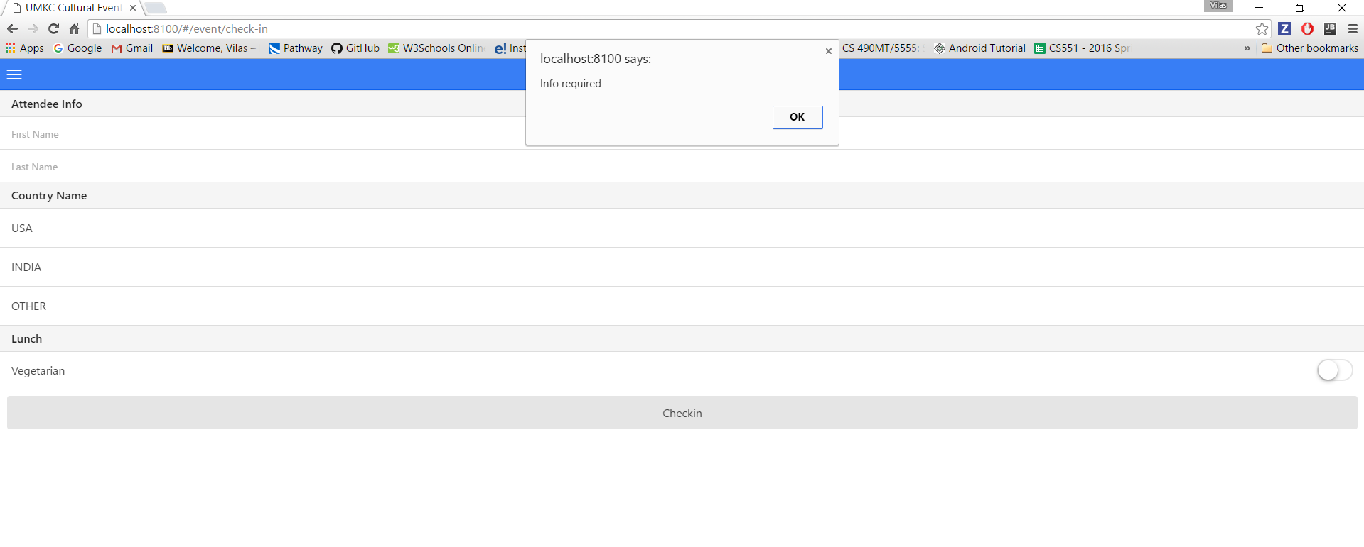

If you have not registered for this event, you need to fill the information as below:

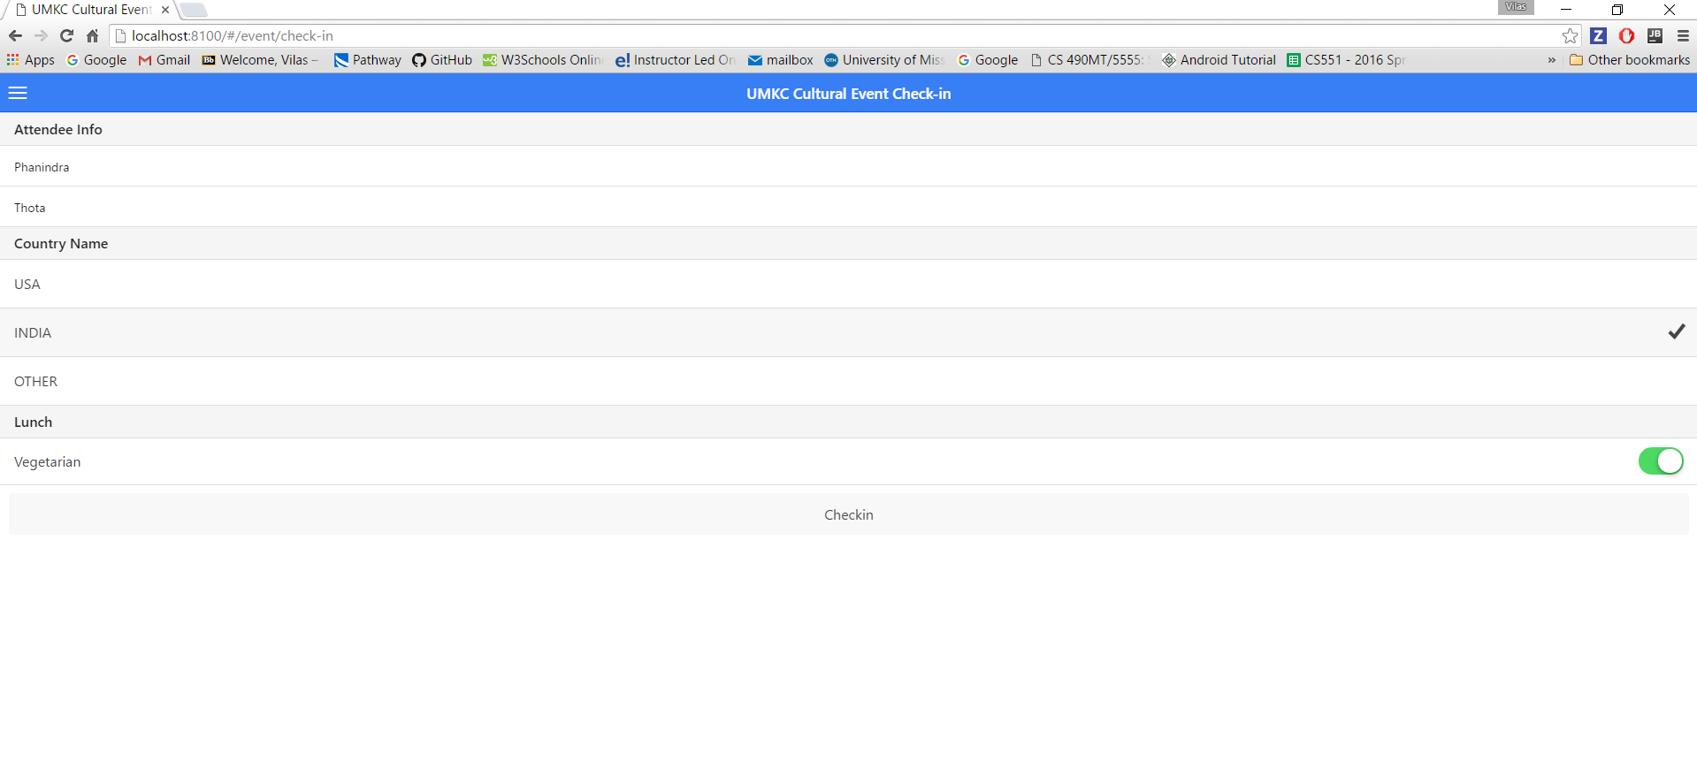

Once you filled the above information, you need to click on check in. Once you click you will see the below screen.

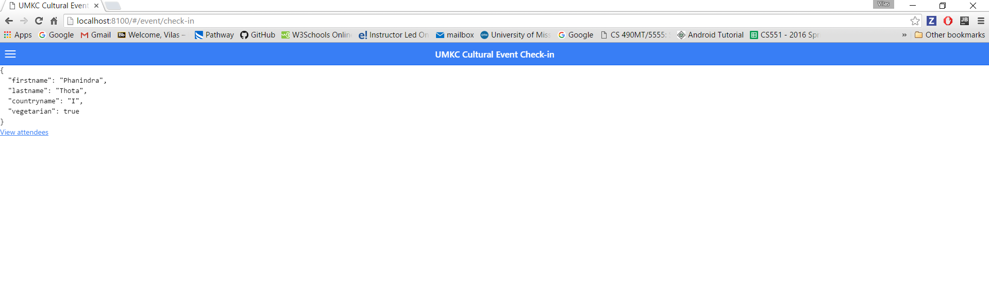

You can now view your name in the attendee list as below:

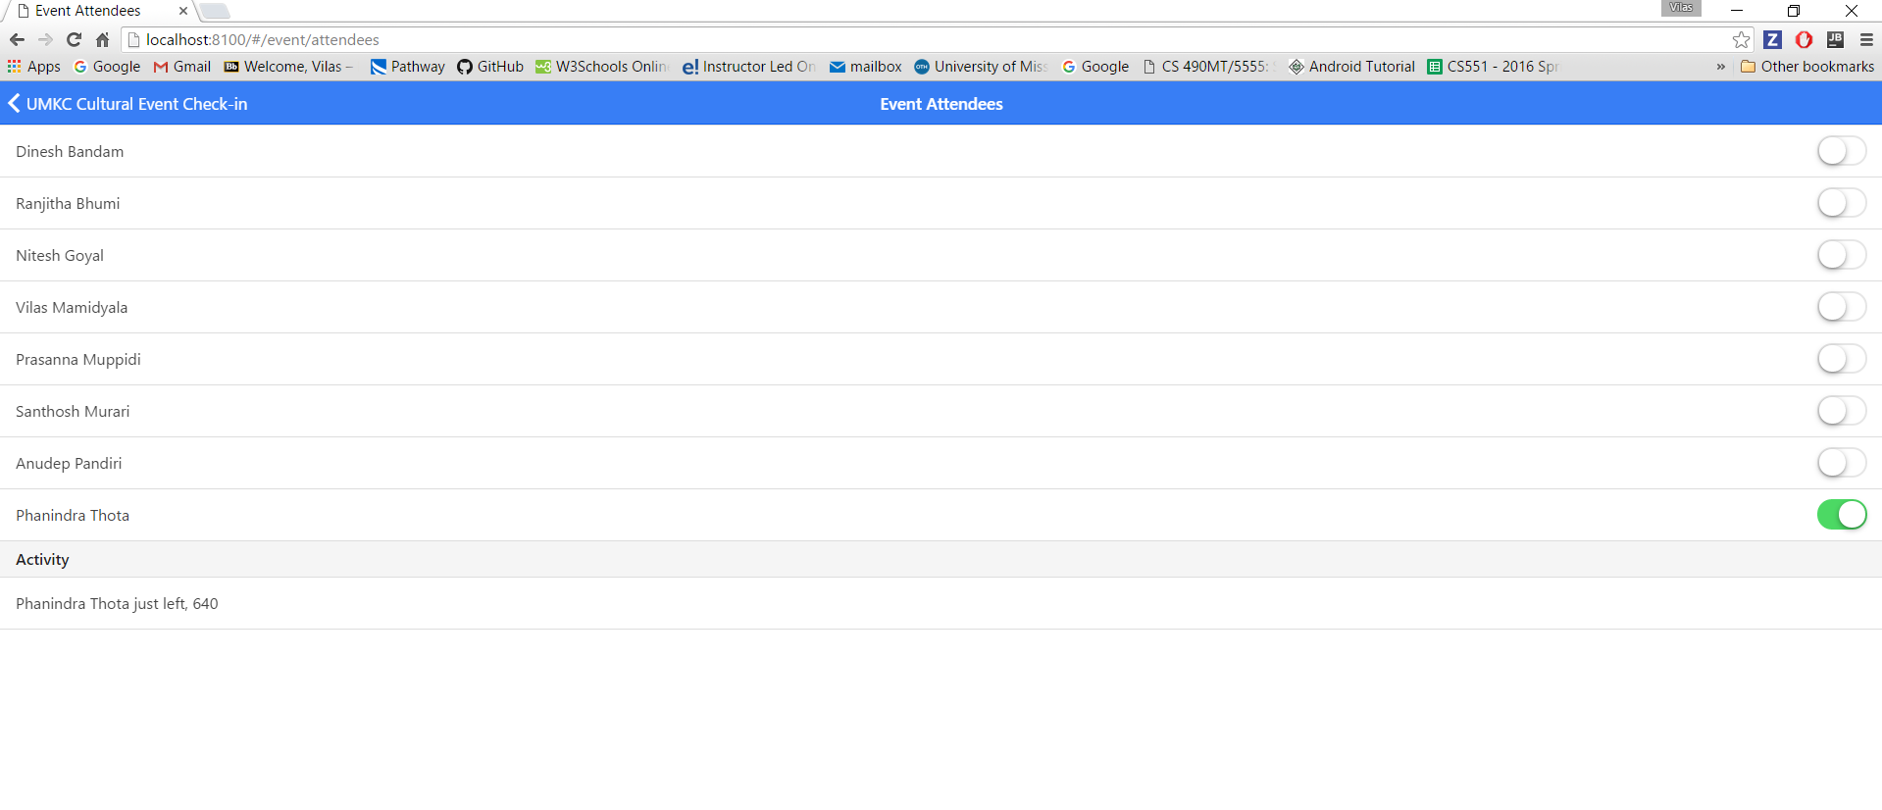

Now if you select the toggle switch in the right hand it will display whether you arrived at the event and left as below (the time is displayed in milli seconds):

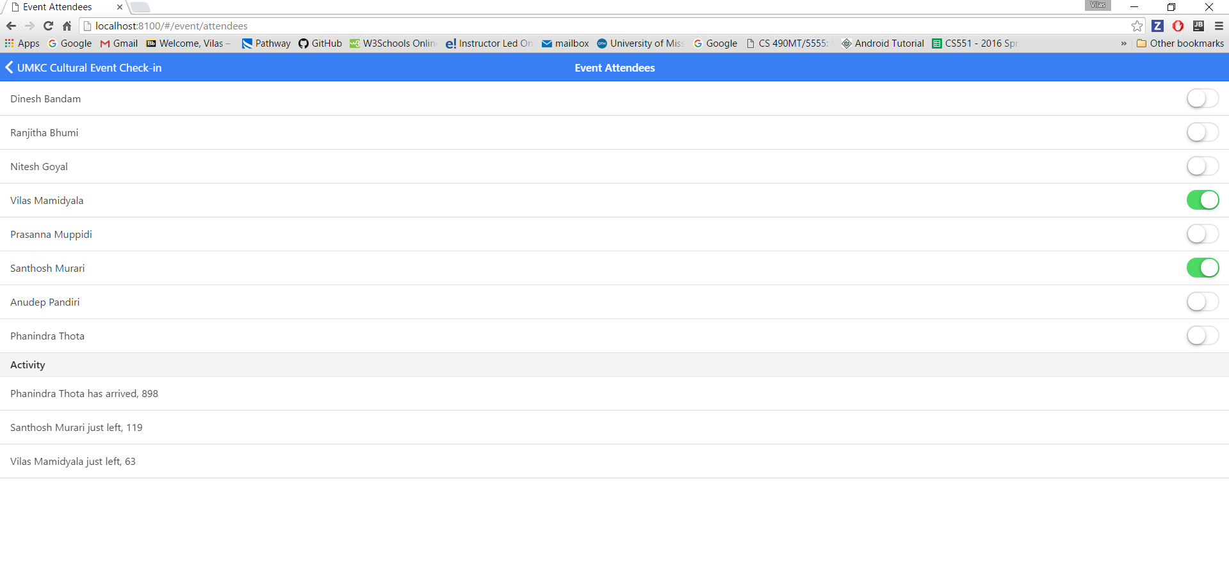

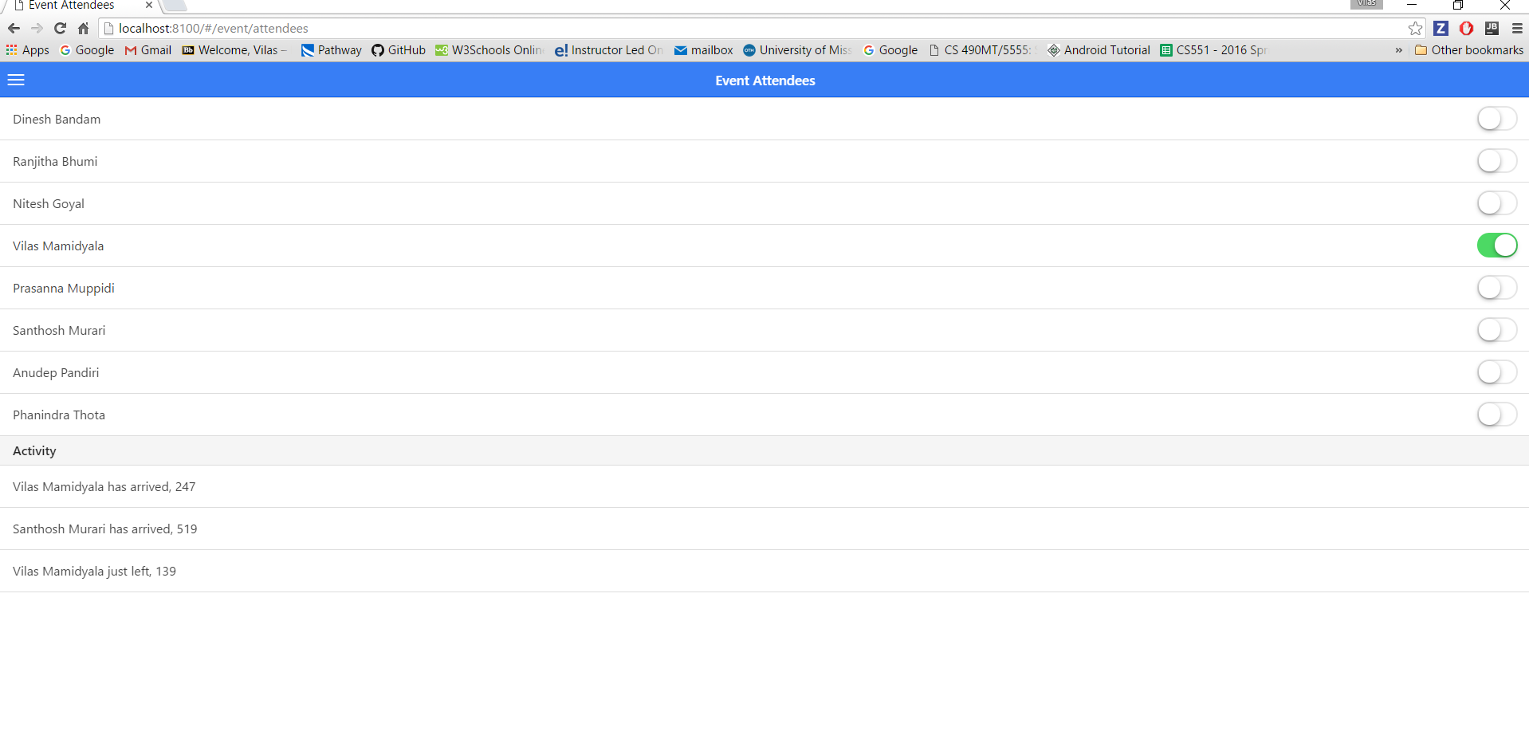

**Test cases:**

Below is the screen shot for starting the testing:

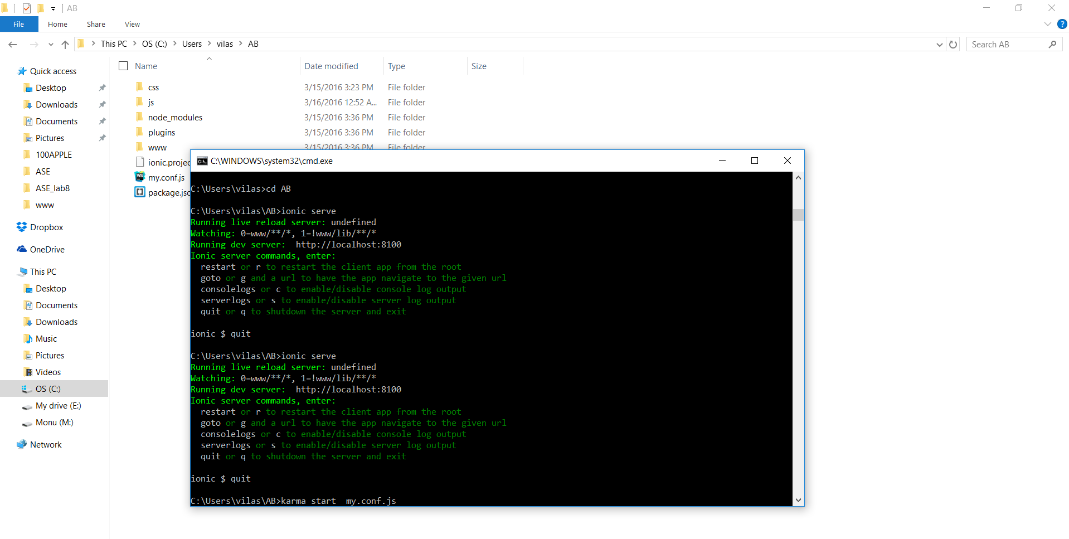

We have three test cases written for this assignment. After above run you will get as below

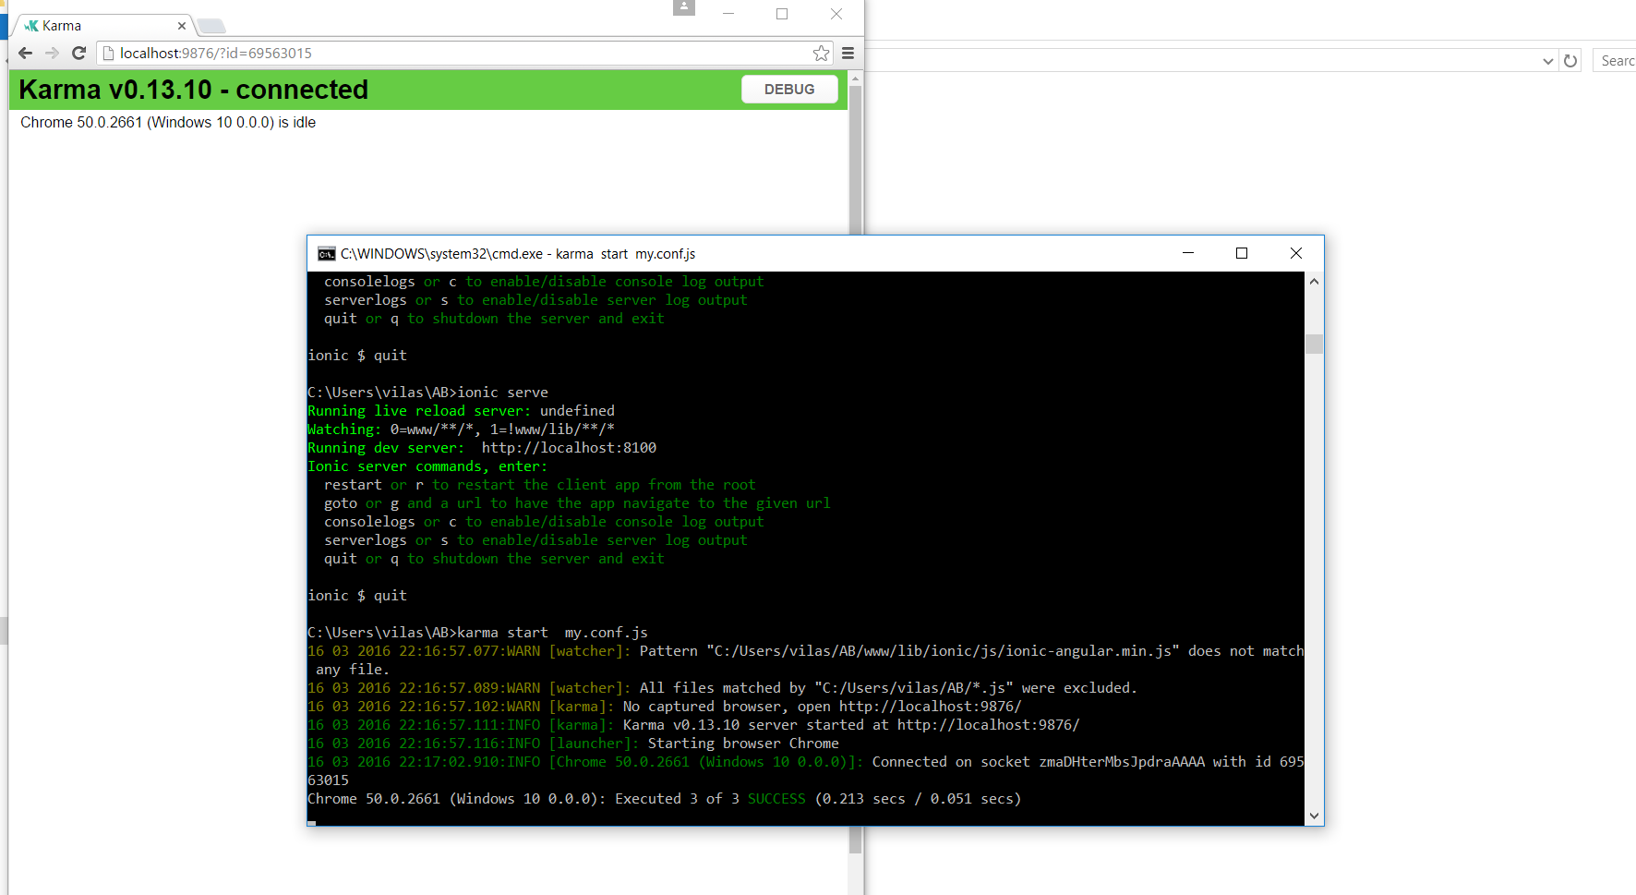

Here the three test examples I had written successful cases and the failure cases. Below shows validation for country name.

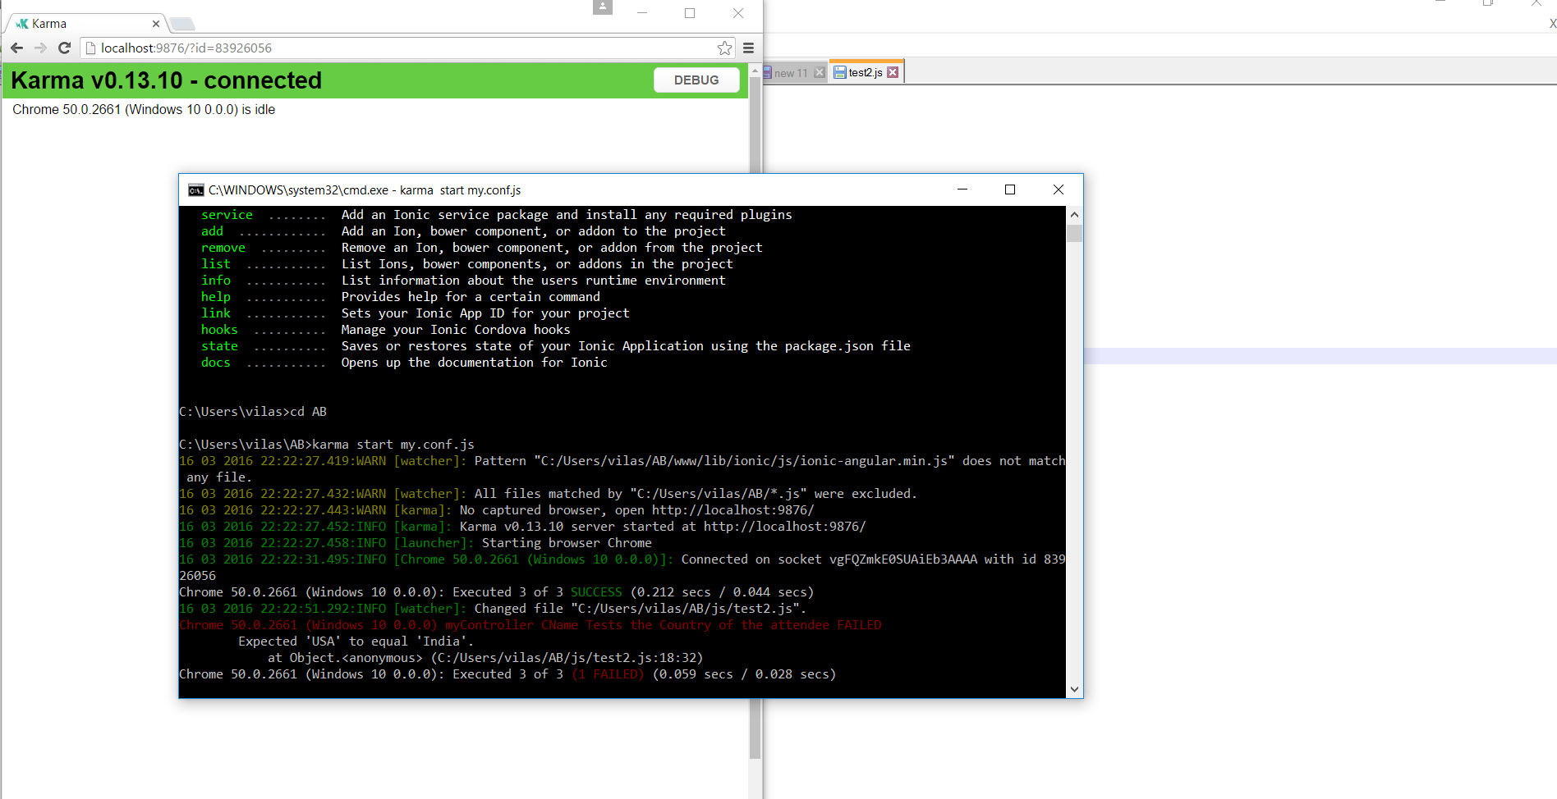

If you change in values in the one of the test cases, you will get the second failure as below:

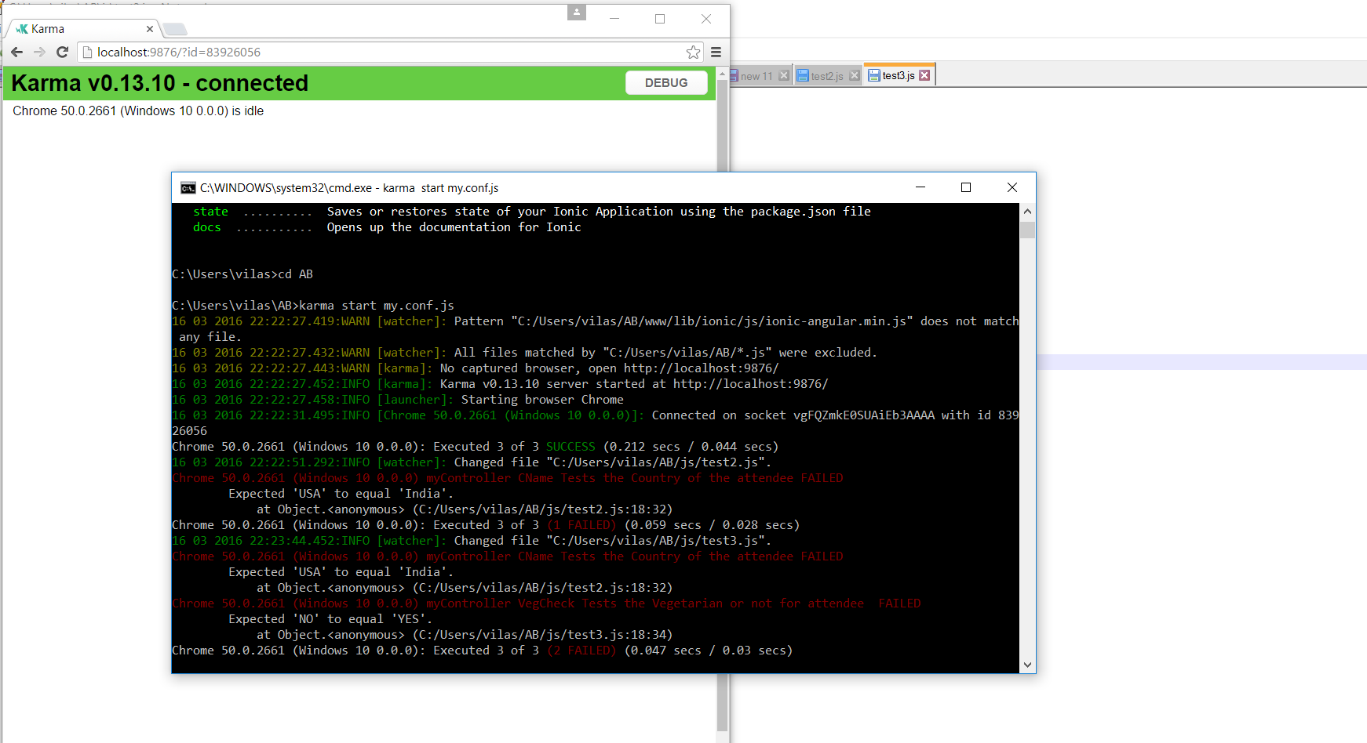

When we fail the third test case. You will get the failure as below:

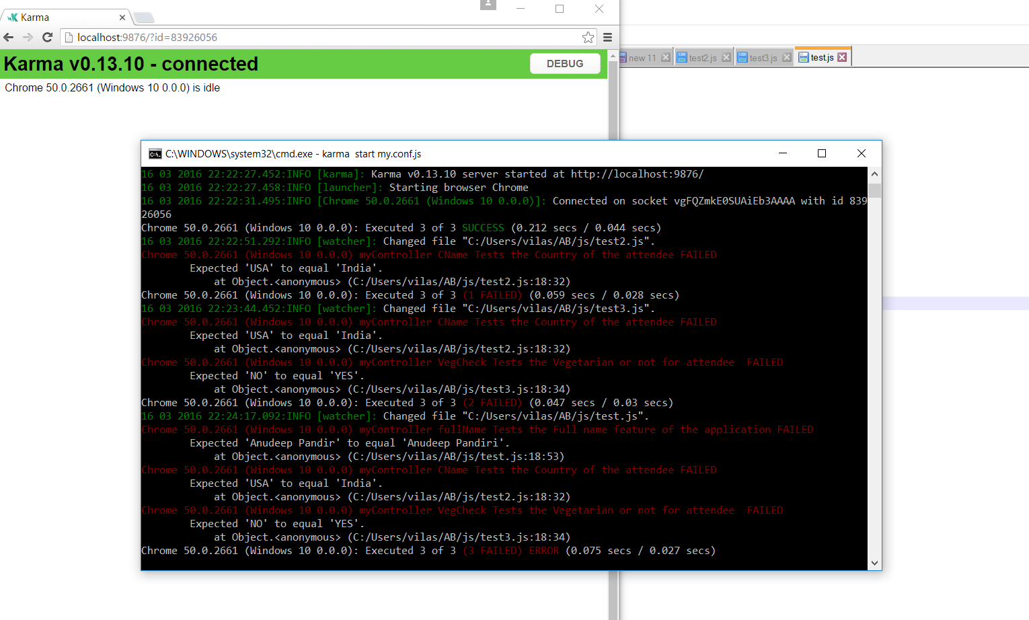

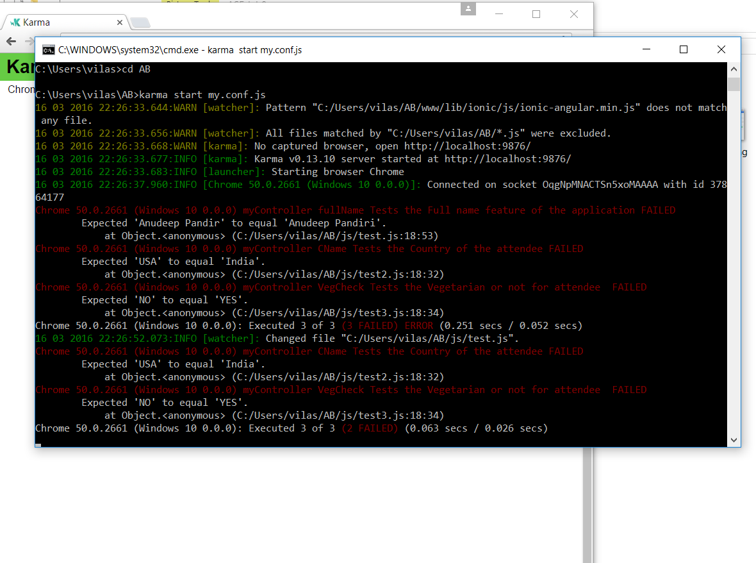

**Part B:**

I had continued on the assignment 6 to add the sign in page and you need to sign in and calculate your height in CM.

This is the Homepage:

.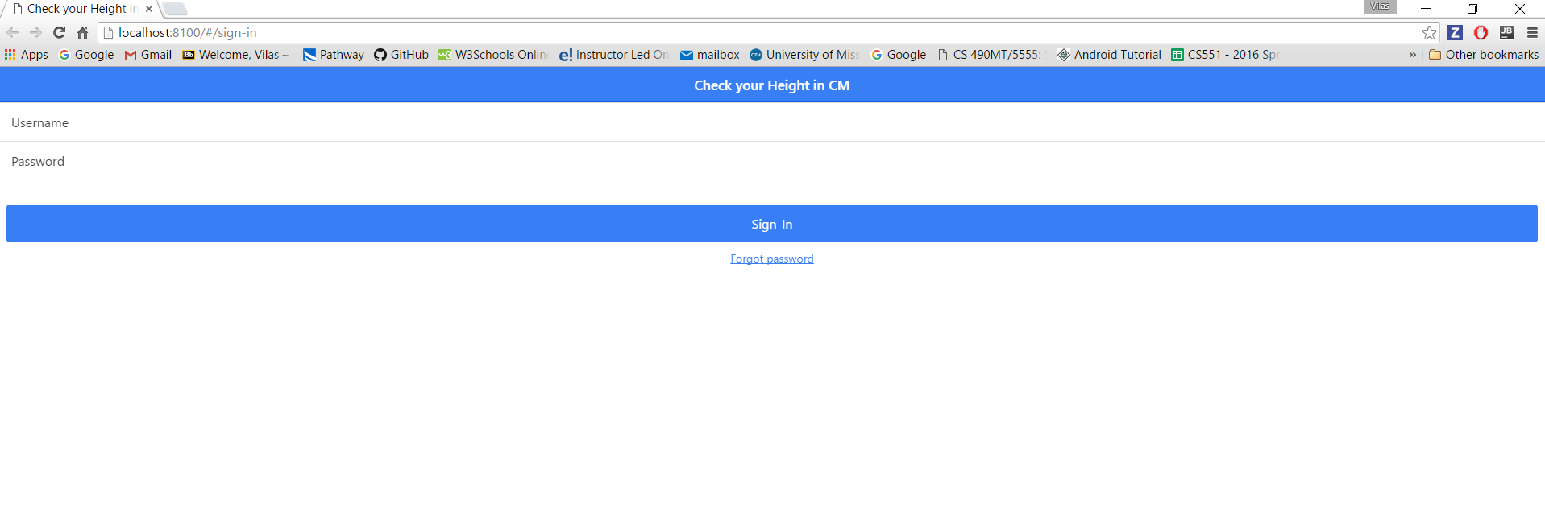

You give the username and password as below and click on sign in button

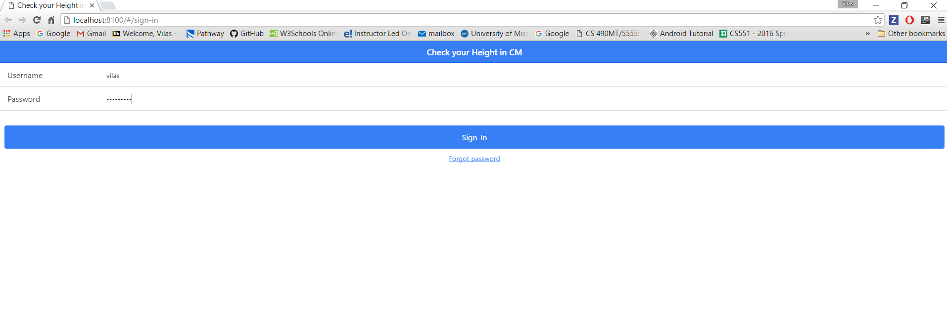

Once you click on **sign in** you will see as below page:

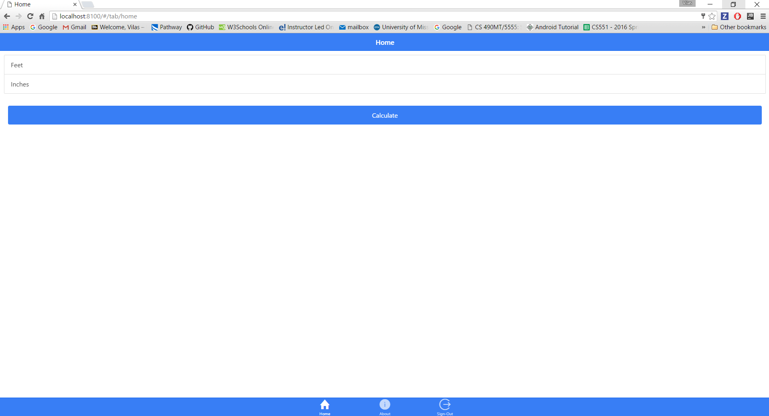

You need to enter the height in feet and inches as below.

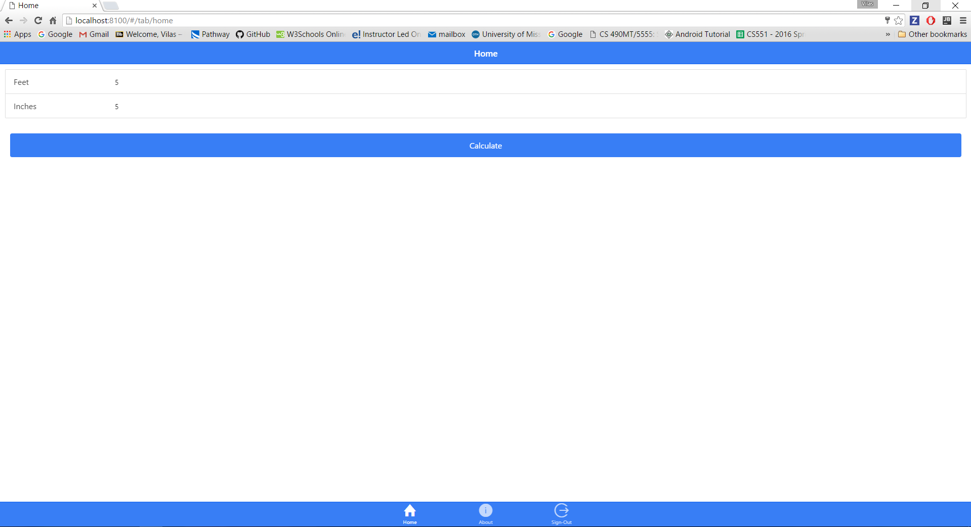

Now you click on the calculate and you will see the output as below.

