ASSIGNMENT 10

This assignment is about deploying application into the Amazon web services.

Here I had taken assignment6 rest example and then deployed into amazon Elastic Beanstalk.

This is after deploying it.

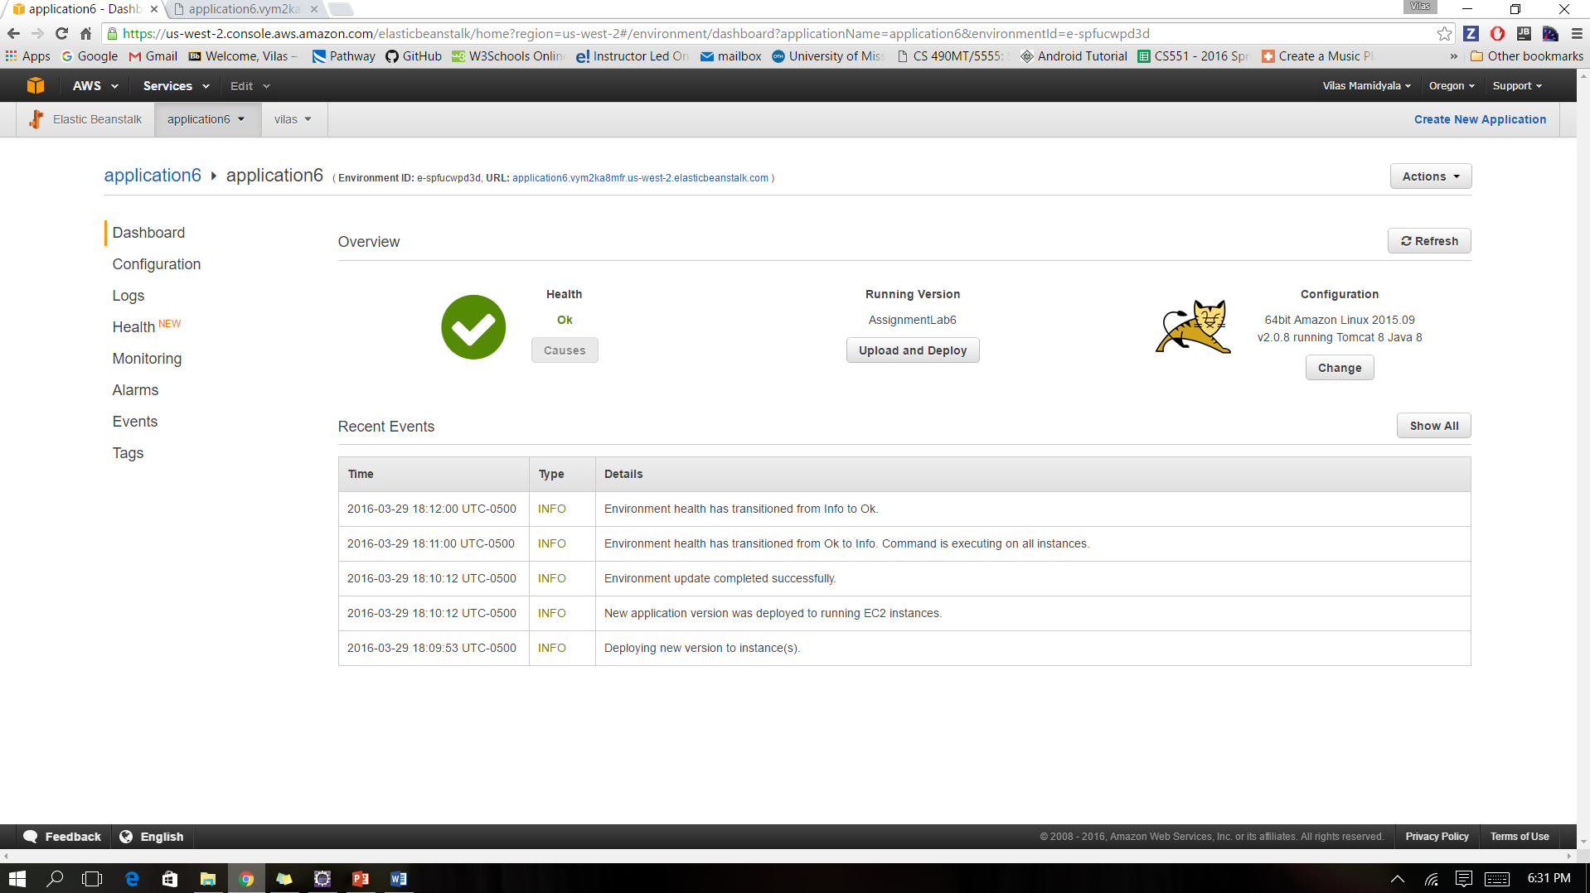

We can now run it by selecting the URL

<http://application6.vym2ka8mfr.us-west-2.elasticbeanstalk.com/>

<http://application6.vym2ka8mfr.us-west-2.elasticbeanstalk.com/conversion/hconvert>

<http://application6.vym2ka8mfr.us-west-2.elasticbeanstalk.com/conversion/wconvert>

