**LAB6 ASSIGNMENT:**

Here we have taken the two conversions services. First one is height service. Here takes input as feet and inches and calculates and displays your height in cm as follows:

By default, it will take the input values and displays as below:

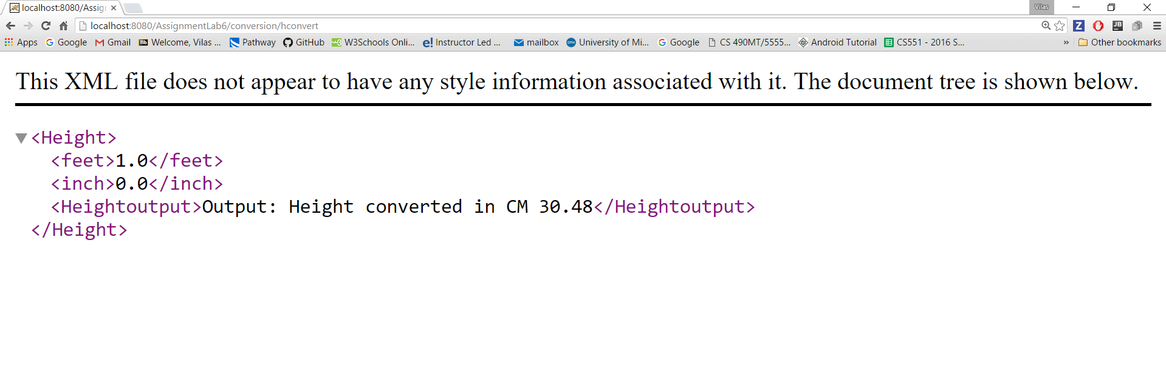

You can give your height also as below (here 5 feet 5 inch is given as input)

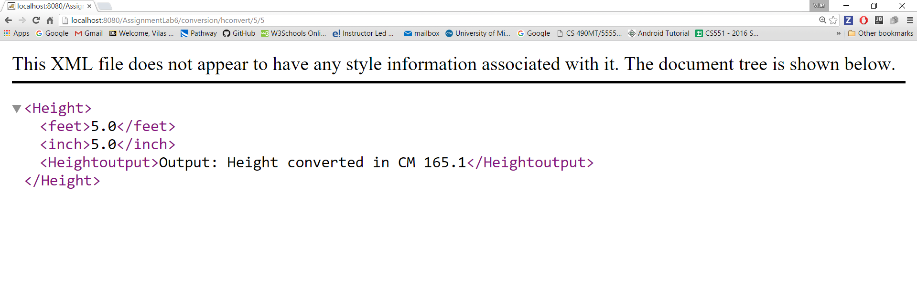

Another service is weight service:

Here it will convert your weight from kg to pounds as well as ounces. By default, it will read default inputs and gives result as below:

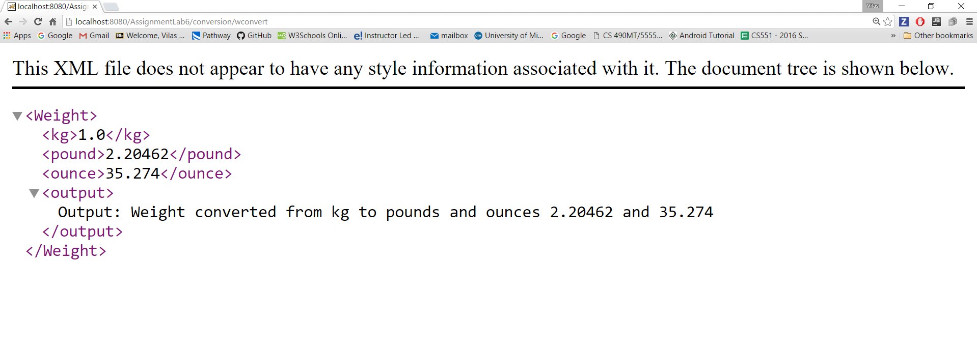

Here you can also give your input weight and see its converted values in pounds and ounces.

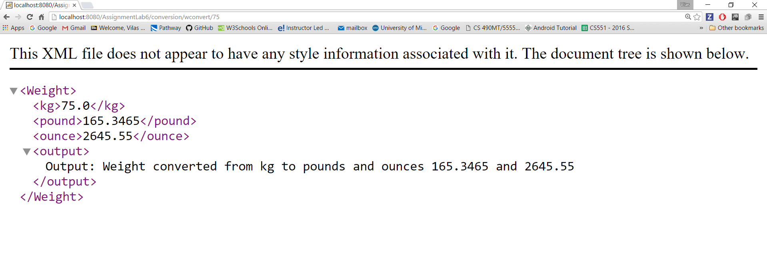

**Testcases:**

Here we are having the two test cases related to height and weight. Consider the height here we get the two cases one is success case and failure test case.

The successful test case evaluates the input from the user and calculated value as below and if success will display as below:

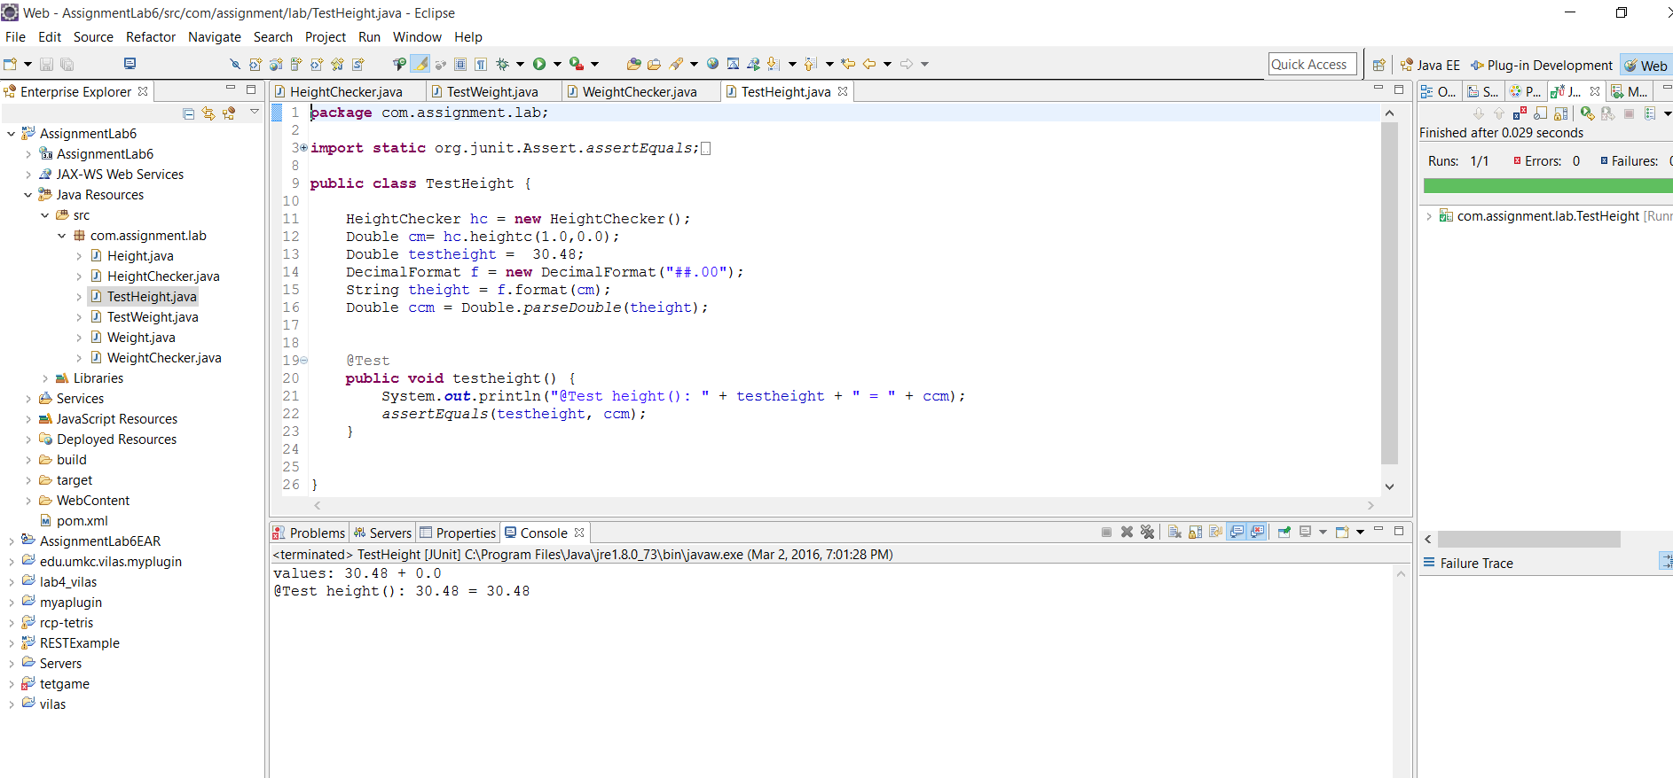

Whereas for the failure case you will get the output as below:

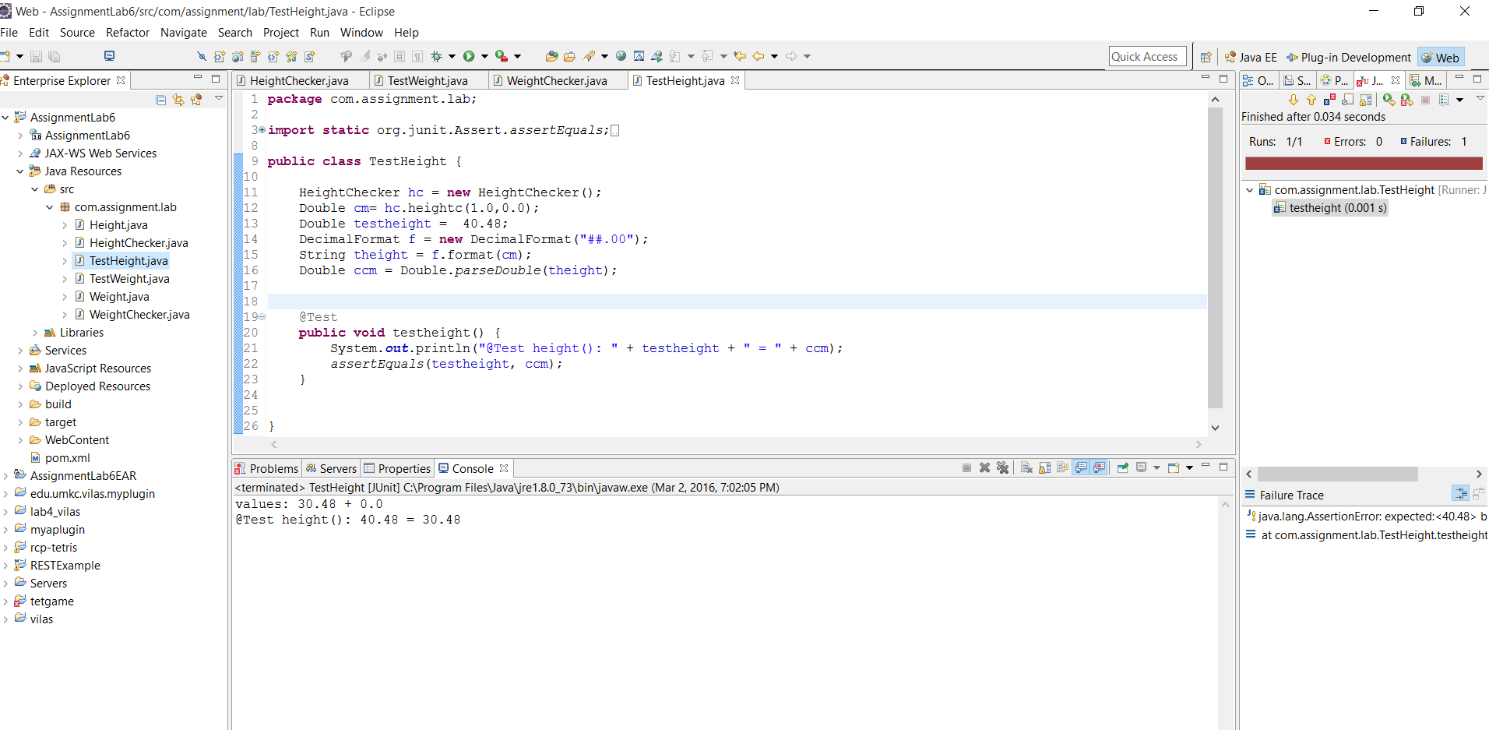

For weight calculation test cases also we have success case and the failure cases

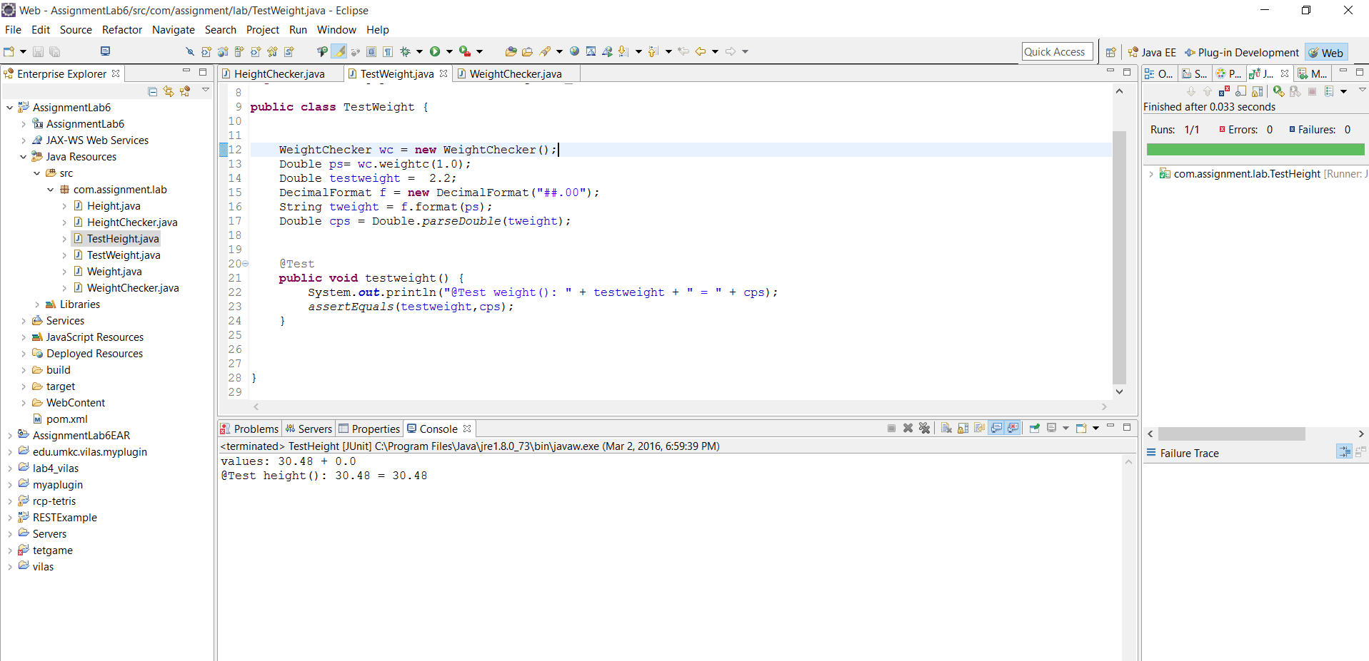

Failure case:

