**Part-I: GDP Analysis of the Indian States**

• Calculate the average growth of states for the duration 2013-14, 2014-15 and 2015-16 by taking the mean of the row '(% Growth over previous year)'. Compare the calculated values and plot them for the states. Make appropriate transformations, if necessary, to plot the data. Report the average growth rates of the various states:

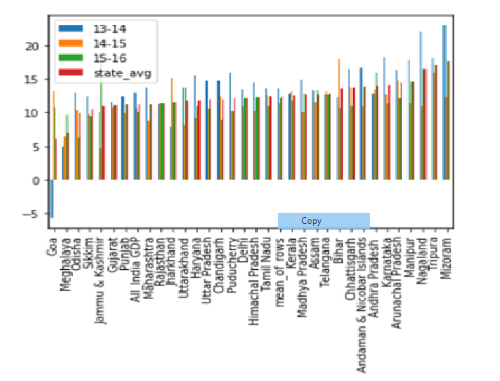

Average Growth Rates:

* Which states have been growing consistently fast, and which ones have been struggling?
* Rajasthan, Andhra Pradesh, Telangana have been consistently growing fast.
* Goa, Meghalaya and Odisha are the ones which are struggling.
* Curiosity exercise: What has been the average growth rate of your home state, and how does it compare to the national average over this duration?
* The average growth rate of my home state: Telangana is 12.76-GDP and the national average is: 11.20-GDP

**Plot the total GDP of the states for the year 2015-16:**

The Total GDP of the states for the year 2015-16 is as follows:

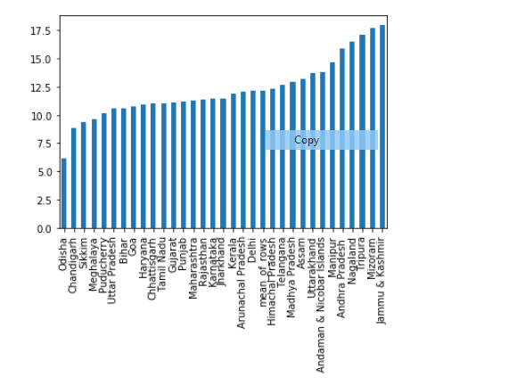

* Identify the top 5 and the bottom 5 states based on total GDP.
  + Top 5:

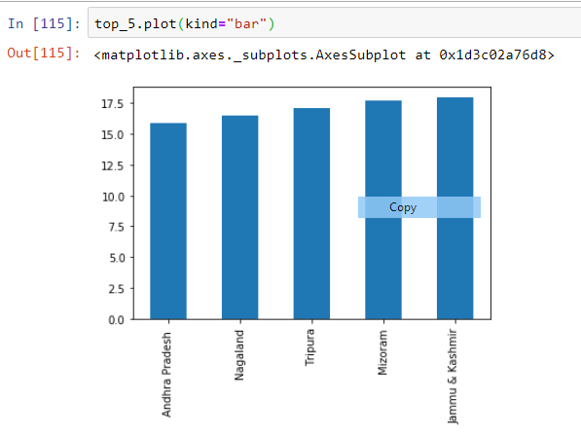

* + Bottom 5:

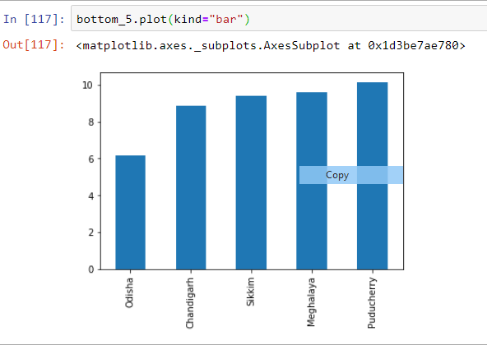

# **Part I-B:**

Plot the GDP per capita for all the states.

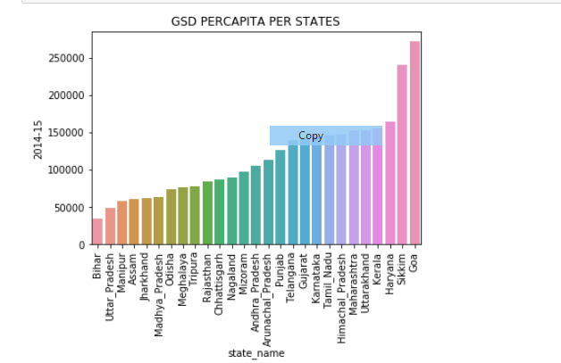

* Identify the top 5 and the bottom 5 states based on the GDP per capita.

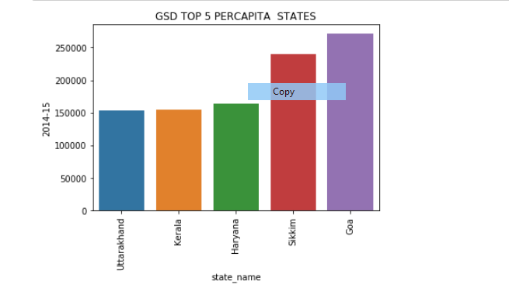

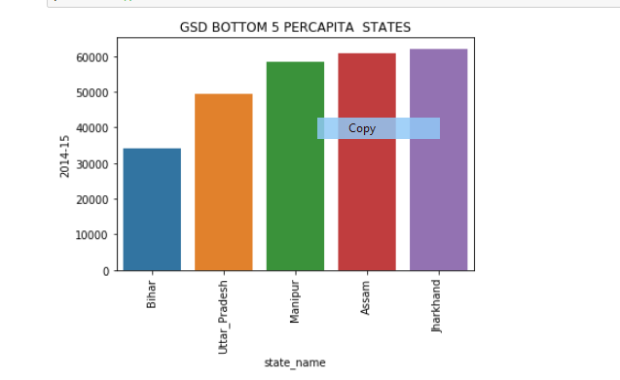

* Find the ratio of the highest per capita GDP to the lowest per capita GDP.

The ratio between the Highest Per-Capita GDP and the lowest per-capita GDP is 8

* Plot the percentage contribution of the primary, secondary and tertiary sectors as a percentage of the total GDP for all the states.

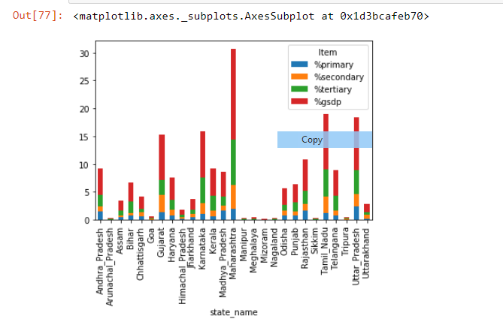

* Categorize the states into four groups based on the GDP per capita (C1, C2, C3, C4, where C1 would have the highest per capita GDP and C4, the lowest). The quantile values are (0.20,0.5, 0.85, 1), i.e., the states lying between the 85th and the 100th percentile are in C1; those between the 50th and the 85th percentiles are in C2, and so on.
* **Note:**Categorization into four groups will simplify the subsequent analysis, as otherwise, comparing the data of all the states would become quite exhaustive.

Have calculated the quantiles first as per the below formula.

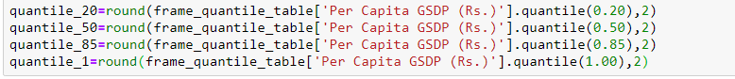

For C1 Category: We do the following

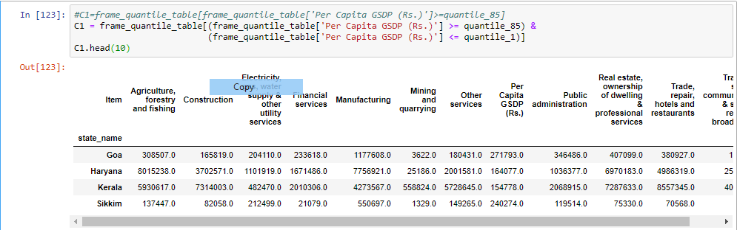

C2 Category we do the following:

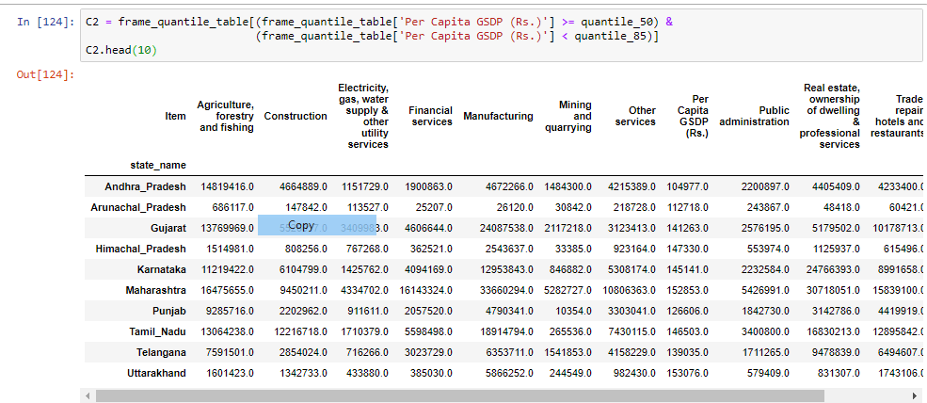

For C3 Category we do the following:

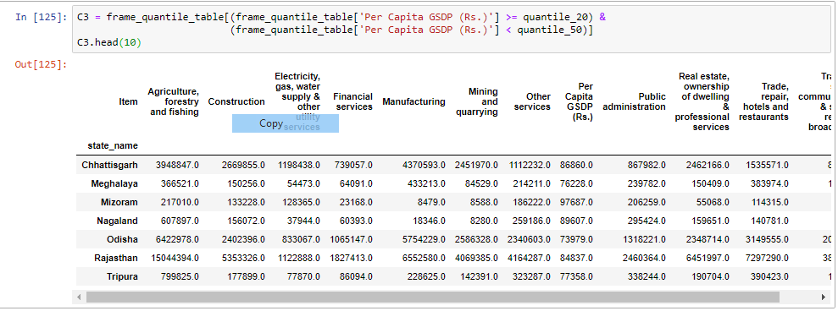

For the C4 we categorize as follows:

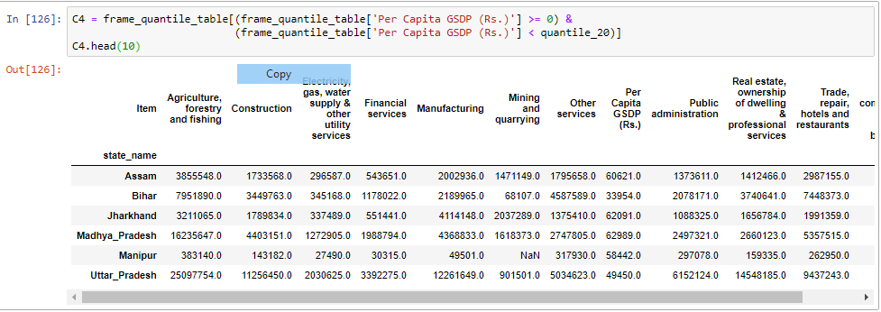

For each category (C1, C2, C3, C4):

* Find the top 3/4/5 **sub-sectors (**such as agriculture, forestry and fishing, crops, manufacturing etc., not primary, secondary and tertiary) that contribute to approximately 80% of the GSDP of each category.
* Plot the contribution of the sub-sectors as a percentage of the GSDP of each category.

For C4:

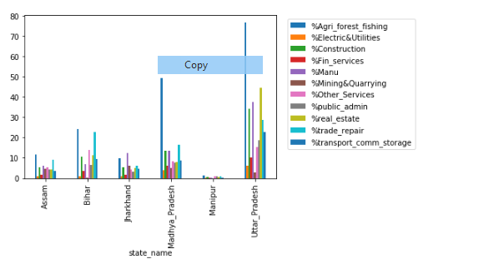

For C3:

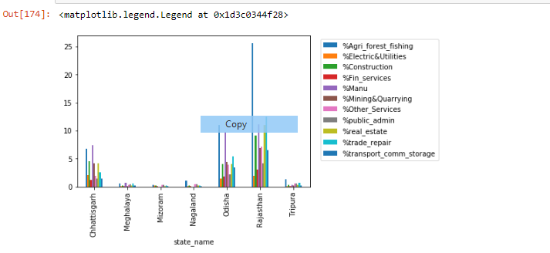

For C2:

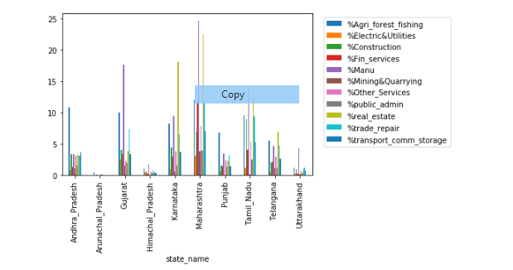

For C1:

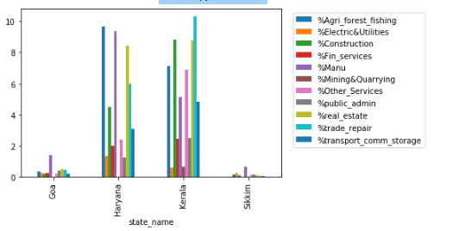

Recommendations to Improve the per capita GDP.

1. Lower interest rates – reduce cost of borrowing and increase consumer spending and investment.
2. Increased real wages – if nominal wages grow above inflation.

Part-II: GDP and Education

* Analyse if there is any correlation of GDP per capita with dropout rates in education (primary, upper primary and secondary) for the year 2014-2015 for each state. Choose an appropriate plot to conduct this analysis.

Following are the scatter plots for the year 2014-15 for each state in the Primary, Upper Primary and Secondary

Primary

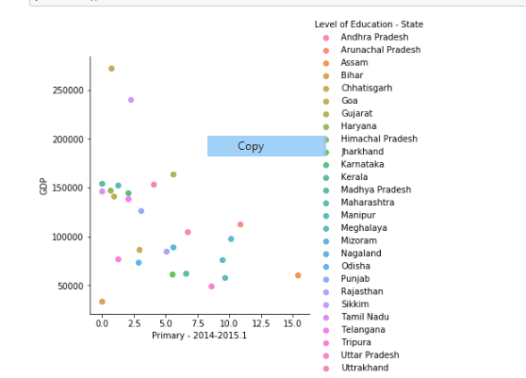

Upper Primary

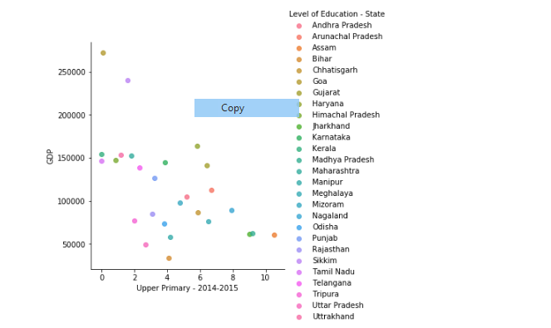

Secondary:

