# Integrating Jquery ( Ajax & Post ) / Sping MVC and Spring Boot

The following are the steps that needs to be executed

* Create **Spring Boot project**
* Create simple model
* Create simple **Response** message
* Create **Web Controller** to provide web views
* Create **RestController** for **POST & GET** requests
* Create an **index.html** view
* Create **Ajax POST & GET** requests
* Run & Check results

# Creating Spring Boot Project.

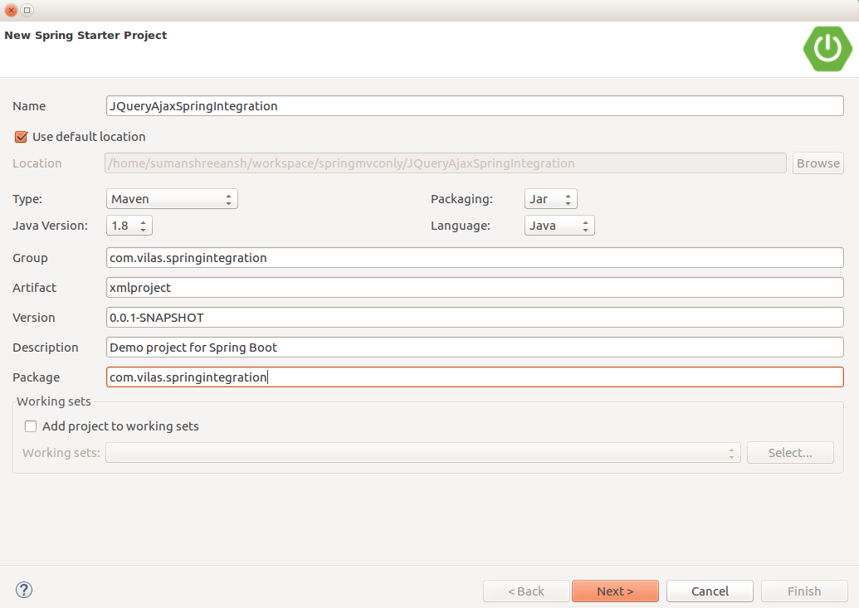

# **Creating the Simple Model:**

**Customer**

--> First Name,( String)

--> Last Name,( String)

--> DepartMent ( String)

**package** com.vilas.springintegration.model;

**public** **class** Customer {

**private** String firstName;

**private** String lastName;

**private** String custDept;

**public** Customer(){}

**public** Customer(String firstName, String lastName, String custDept) {

**super**();

**this**.firstName = firstName;

**this**.lastName = lastName;

**this**.custDept = custDept;

}

**public** String getFirstName() {

**return** firstName;

}

**public** **void** setFirstName(String firstName) {

**this**.firstName = firstName;

}

**public** String getLastName() {

**return** lastName;

}

**public** **void** setLastName(String lastName) {

**this**.lastName = lastName;

}

**public** String getCustDept() {

**return** custDept;

}

**public** **void** setCustDept(String custDept) {

**this**.custDept = custDept;

}

@Override

**public** String toString() {

**return** "Customer [firstName=" + firstName + ", lastName=" + lastName + ", custDept=" + custDept + "]";

}

}

# **Create an Response**

**Response**

--> String status;

--> Object data

Create an POJO for the response object as below.

**package** com.vilas.springintegration.message;

**public** **class** Response {

**private** String status;

**private** Object data;

**public** Response(){}

**public** Response(String status, Object data) {

**super**();

**this**.status = status;

**this**.data = data;

}

**public** String getStatus() {

**return** status;

}

**public** **void** setStatus(String status) {

**this**.status = status;

}

**public** Object getData() {

**return** data;

}

**public** **void** setData(Object data) {

**this**.data = data;

}

@Override

**public** String toString() {

**return** "Response [status=" + status + ", data=" + data + "]";

}

}

# **Create Webcontroller to provide the View in ( MVC)**

package com.vilas.springintegration.controller;

import org.springframework.stereotype.Controller;

import org.springframework.web.bind.annotation.RequestMapping;

import org.springframework.web.bind.annotation.RequestMethod;

@Controller

public class WebController {

@RequestMapping(value="/", method=RequestMethod.GET)

public String homepage(){

return "index";

}

}

**Create RestController for POST & GET requests**

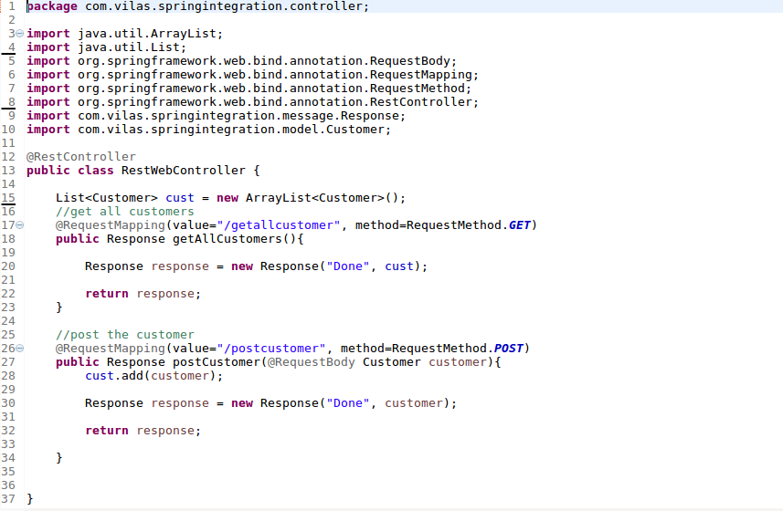

# **Run AJAX POST – GET Embedded in the index.html**

<!DOCTYPE html>

<html>

<head>

<meta charset=*"UTF-8"*/>

<title>Spring Ajax Integration</title>

<script src=*"http://ajax.googleapis.com/ajax/libs/jquery/3.1.1/jquery.min.js"*></script>

<script>

$(document).ready(**function**(){

**var** url =window.location;

$("#postBtn").click(**function**(event){

event.preventDefault();

ajaxPost(url);

})

$("#getbtn").click(**function**(event){

event.preventDefault();

ajaxGet(url);

})

});

**function** ajaxPost(url){

**var** formData = {

firstName : $("#firstName").val(),

lastName : $("#lastName").val(),

custDept: $("#custDept").val()

}

$.ajax({

type:"POST",

contentType:"application/json",

url : url + "/postcustomer",

data: JSON.stringify(formData),

dataType:'json',

success:**function**(result){

**if**(result.status=="Done")

{

$("#postResultDiv").html

("<strong>"

+ "Posted Successfully"

+ "FirstName = "

+result.data.firstName

+" , LastName = "

+result.data.lastName

+" , Department = " +result.data.custDept

+ "</strong>");

}

**else**

{

$("#postResultDiv").html("<strong> Error </strong>");

}

console.log(result);

},

error:**function**(e)

{

alert("Error!");

console.log(e);

}

});

}

**function** ajaxGet(url)

{

$.ajax({

type:"GET",

url : url + "/getallcustomer",

success:**function**(result){

**if**(result.status=="Done")

{

$('#getResultDiv .list-group li').remove();

$.each(result.data, **function**(i, customer)

{

**var** customer = "Customer"+" "+i+" "+":FirstName ="+" "+customer.firstName+" "+":LastName ="+" "+customer.lastName+" "+":Department ="+" "+customer.custDept+"<br/>";

$('#getResultDiv .list-group').append('<li><h4 class="list-group-item">'+customer+'</h4></li>');

});

}

**else**

{

}

console.log(result);

},

error:**function**(e){

alert("Error!");

console.log(e);

}

});

}

</script>

<link rel=*"stylesheet"* href=*"http://netdna.bootstrapcdn.com/bootstrap/3.0.3/css/bootstrap.min.css"* />

</head>

<body>

<div class=*"container"*>

<h1>Shreeansh WebSite Login</h1>

<div id=*"postdiv"*>

<form id=*"customerForm"*>

<label>FirstName</label>

<input type=*"text"* id=*"firstName"* class=*"form-control"*/>

<label>LastName</label>

<input type=*"text"* id=*"lastName"* class=*"form-control"*/>

<br/>

<label>Department</label>

<input type=*"text"* id=*"custDept"* class=*"form-control"* />

<br/>

<button type=*"submit"* id=*"postBtn"* class=*"btn btn-primary"*>Submit</button>

</form>

</div>

<br/>

<div id=*"postResultDiv"*>

</div>

<br/>

<div id =*"postJsonDiv"*>

</div>

<br/>

<div id = *"getdiv"*>

<button id=*"getbtn"*>Get All Customers</button>

</div>

<br />

<div id = *"getResultDiv"*>

<ul class=*"list-group"*>

</ul>

</div>

</div>

</body>

</html>