Integrated Development Environment (IDE) for Teamcenter Engineering Rich Client Customization

Author: sabari_k

Date written (MM/DD/yyyy): 30/04/2008

Project details:
- Projects involved: ALSTVPDM
- S/W Environment: Windows
- Appln. type: Java development tool
- Project type: Development

Target readers:
This manual is intended for developers who customize the Teamcenter Engineering rich client interface. A basic understanding of object-oriented programming (OOP) and Teamcenter Engineering concepts are required. Basically for Developers and software engineers.

Keywords:
Teamcenter, Teamcenter Engineering, Eclipse, Rich client, Rich client configuration, configuration, customization, Rich client customization, Teamcenter Engineering Rich client customization, Teamcenter Rich client customization

Document Information

Related Documents

Document Number | Document Description
 | RichClientCustomizationProgrammerGuide.pdf

Document Review and Approval

Action | Responsible Person | Date | Signature
Created by | Sabari_k | 2008-05-13
Reviewed by | S_gangadhar | 2008-05-13
Approved by

Terminology, Definitions and Abbreviations

Doc Document

Notation Used

Notation and abbreviations used for objects:

Notation | Object
JAR | Java Archive
IMAN_ROOT | Location where Teamcenter Engineering has been installed.
IMAN_DATA | Location where all the database information of Teamcenter Engineering has been stored.
IMAN_LOCAL | Location where all the customization are deployed which has same folder structure like IMAN_ROOT

Table contents

1 Introduction 3
2 Teamcenter Architecture 3
2.1 2-tier architecture: 3
2.2 4-tier ARCHITECTURE: 4
3 Rich Client 5
4 Setting Up the Integrated Development Environment (IDE) 5
5 References: 11

Introduction

Teamcenter Engineering 2 tier rich client uses Java as the front end. One of the main
reasons for using Java is that it is platform independent. Previously, development
and customization was complex in a heterogeneous environment, because you had
to maintain libraries for multiple platforms. Using Java eliminates the need to
build libraries on multiple platforms.

Teamcenter Architecture

2-tier architecture:

The Teamcenter Engineering 2-tier architecture comprises of client layer, enterprise layer, resource layer as shown in the below picture,
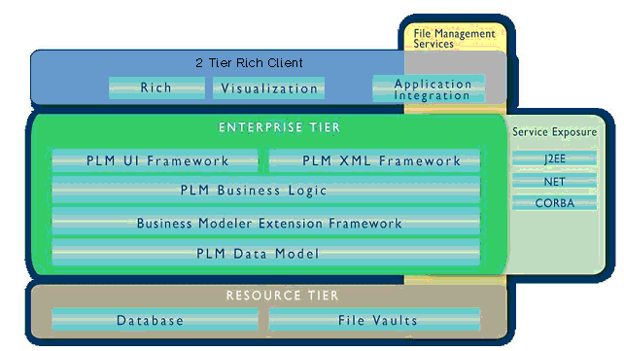

Resource Tier:

The resource tier comprises a database server, database, volumes, and file servers with two file management systems Teamcenter File Management System (FMS) and Teamcenter File Services (TCFS).

Enterprise Tier:

The enterprise tier comprises a configurable pool of Teamcenter Engineering C++ server processes and a server manager. The enterprise tier retrieves data from and stores data in the database. This is the tier where the ITK programming is used to customize Teamcenter Engineering on the server side.

4-tier ARCHITECTURE:

The Teamcenter Engineering 4-tier architecture comprises of client layer, web layer, enterprise layer, resource layer as shown in the below picture,

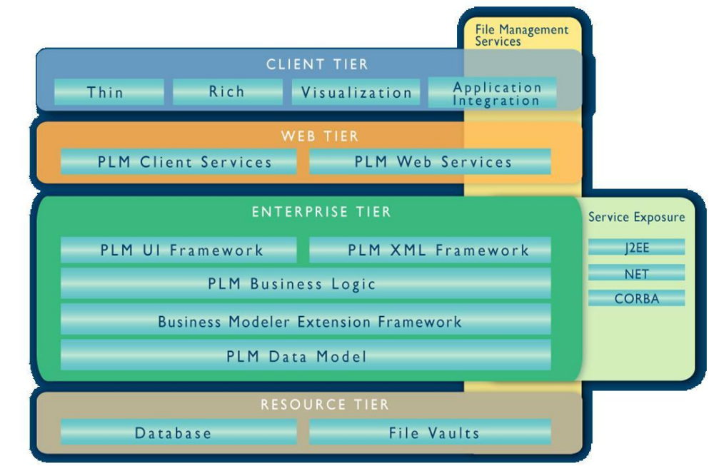

Web Tier:

The Web tier is a Java application that runs in a Java 2 Enterprise Edition (J2EE) application server, such as BEAWebLogic, and is responsible for communication between the client tier and enterprise tier. The Web tier application also includes the Application Interface Web Service (AIWS) and Teamcenter Engineering Data Integration Services Adapter.

Rich Client

The Persistent Object Manager (POM) is the core module in Teamcenter Engineering.
The POM interfaces the applications modules to the system modules. The primary
System module in Teamcenter Engineering is Oracle RDBMS. The POM allows
applications to interface to Oracle RDBMS at a higher level of data abstraction than
RDBMS relational tables. For example, an application may request the POM to
create a folder in Teamcenter Engineering. The POM interprets this command and
generates the necessary SQL statement to create the relational data.

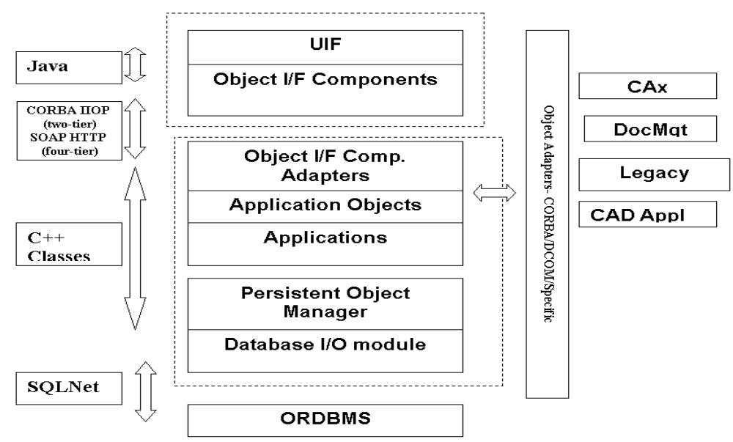

Client Layer

The client layer consists of software tools used to interact with the user. This layer is
written in Java, making use of the JFC (Java Foundation Classes) and Swing classes. The UIF layers, along with the object interface components, form the Teamcenter Engineering client.

Setting Up the Integrated Development Environment (IDE)

It is assumed that Teamcenter Engineering rich client is installed in the
machine.

It is assumed that Java 2 Software Development Kit (SDK) version 1.4.2_05 (or above) is installed in the machine.SDK is available for free in the following web site,

http://java.sun.com/products/archive/j2se/1.4.2_05/index.html

The following steps are required to customize the rich client with Eclipse for the
first time:

- Install Eclipse.

- Set up the customization directory structure and project preferences.

- Create the Java project.

- Bundle your customization into a JAR file.

- Deploying the custom generated JAR file in Teamcenter.
For subsequent projects, you can start with step 3.

Step 1: Install Eclipse

- Download the Eclipse 3.2 or latest version kit from the following location given below,
http://download.eclipse.org/eclipse/downloads/index.php

- After you download the kit, extract the ZIP file to a directory on your machine
(for example, D:\apps\eclipse3.2). The eclipse directory is automatically
created below the installation directory.

- Specify the Java SDK path for Eclipse by adding the following statement to the target command line textbox in the properties for the eclipse.exe shortcut
-vm D:\apps\jdk1.4.2_05\bin\javaw

- Double-click the eclipse.exe shortcut then you see the Workspace Launcher dialog window as shown in figure given below.

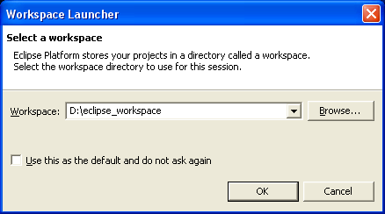

- Specify a location for the workspace. This location is used by Eclipse to store the
project related information. Then click OK. You then see the welcome page.

Step 2: Set Up the Customization Directory Structure and Project Preferences

- Create a directory on your local drive to store your customization files
(for example, D:\my_richclient)

- In Eclipse, choose Window->Preferences to open the Preferences dialog window. Verify that the correct Java Runtime Environment (JRE) version is listed and checked.
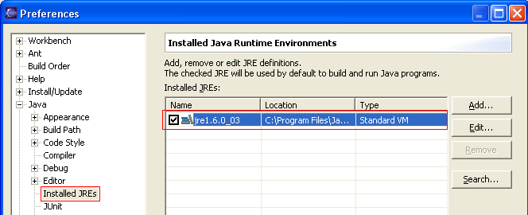

If not follow the steps given below,

- In the Preferences dialog window, click the Add button.
- In the Add JRE dialog window, enter the name of the JRE in the JRE name field.
- Enter the path to the JRE directory in the JRE home directory field. It is the jre directory under the Java SDK installation directory, for example, D:\apps\jdk1.4.2_05\jre.
- In the Add JRE dialog window, click OK to save and close the window.
- In the Preferences dialog window, check the new JRE.

- When you are finished with the Preferences dialog window, click OK.

Step 3: Create the Java Project

To create a new Java project, follow these steps:

- In Eclipse, choose File->New->Project.

- In the New Project dialog window, expand the Java folder and choose the Java Project node. Then click Next.

- Enter the project name and choose Create project from existing source. In the Directory field, enter the location of the directory that contains theTeamcenter rich client customization. This directory contains the com hierarchy for all packages created as part of the customization. For example, enter D:\my_richclient if that is the directory you created earlier. Then click Next.

- Under Java Settings, choose the Libraries tab and then the Add External JARs button.

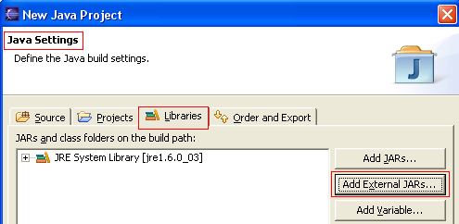

- In a text editor, open either the portal.bat or otwportal.bat file. In the JAR selection dialog window, navigate to the IMAN_ROOT\portal directory and choose all the JAR files listed in the portal.bat or otwportal.bat file. The fscjavaclientproxy.jar and fmsutil.jar files are in the IMAN_ROOT\fms\jar directory.

- After adding all the JAR file as mentioned in the above step, the project window looks like as shown below,

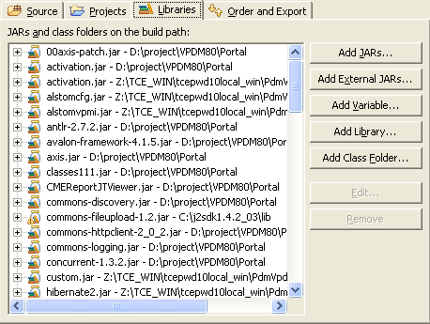

- Under Java Settings, click the Order and Export tab. Reorder the JAR files to match the order in the portal.bat or otwportal.bat file.

- In the New Java Project dialog window, click Finish. You are prompted for a perspective switch. Choose Yes. The Package Explorer is displayed and if the directory you created earlier (D:\my_richclient) has any source files, they are compiled.

- Now select Window->Preferences, to open the preferences dialog window. In that preferences dialog window expand Java link and select Compiler from that. Then select the Compliance and Classfiles tab as shown in the below picture,

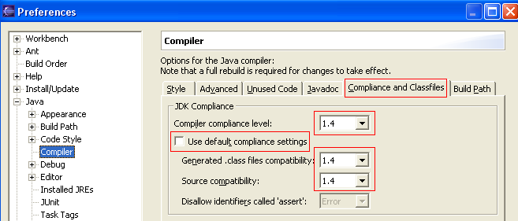

As shown in the above picture modify the value under the Compliance and Classfiles tab. Unselect the “Use default compliance settings” option and modify all compiler level to latest Java SDK version in your machine.

Step 4: Bundle Your Customization Into a JAR File

To bundle your changes into a JAR file, follow these steps:

- In Eclipse, choose File->Export.

- In the Export dialog window, expand the Java folder and choose the JAR file. Then click Next.

- Choose the resources that need to be exported to the JAR file. Do not include the configuration files (.properties) in the IMAN_ROOT\portal directory, the .classpath, or the .project files. Enter a path and name in the JAR file field. For example D:\temp\custom.jar then click Finish.

- The JAR file will be exported in the designated location.

Step 5: Deploying the Rich client customization in to Teamcenter.

To deploy the custom function in Teamcenter, create a JAR file through Eclipse as mentioned in STEP 4 and follow the steps given below:

Simplest way of deploying the custom generated JAR file is,

- Copy the newly generated JAR file from the designated location.

- Deploy the JAR file directly in the IMAN_ROOT/portal folder and include this JAR file name in portal.bat JAR file list before calling the actual portal.jar for 2-tier rich client and for 4-tier rich client otwportal.bat should be modified as mentioned,

Example: set CLASSPATH=%CLASSPATH%;.\cuatom.jar

But the actual way of deploying the custom JAR file has series of steps as described below,

- Create a folder in your local disk which is going to act like a repository for all your Temacenter Engineering customization.
For example (D:\CustomLocal)

- Under the D:\CustomLocal create another folder called “portal”. Now paste the custom.jar file inside the D:\CustomLocal\potal folder.

- Now modify the iman_profilevars.bat file under the IMAN_DATA location. Add the following lines in iman_profilevars.bat file,
Set IMAN_LOCAL = D:\CustomLocal

- Then modify the portal.bat file under the IMAN_ROOT/portal folder for 2-tier rich client and for 4-tier rich client otwportal.bat file should be modified, add the following line given below,

Set CUSTOMLOCATION=%IMAN_LOCAL%
Set CLASSPATH=%CLASSPATH%;%CUSTOMLOCATION%

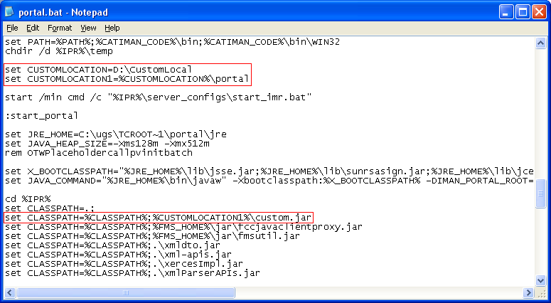

- Now directly click the Teamcenter Engineering icon in the desktop to see the customization you have done for rich client interface.

Now all customization done for the Teamcenter will be placed in the IMAN_LOCAL location which has the similar folder structure as like the IMAN_ROOT.

References:

This document refers some data from the help docs and training material in Teamcenter Engineering from UGS.

Title of book: RichClientCustomizationProgrammerGuide.pdf
Author : UGS

