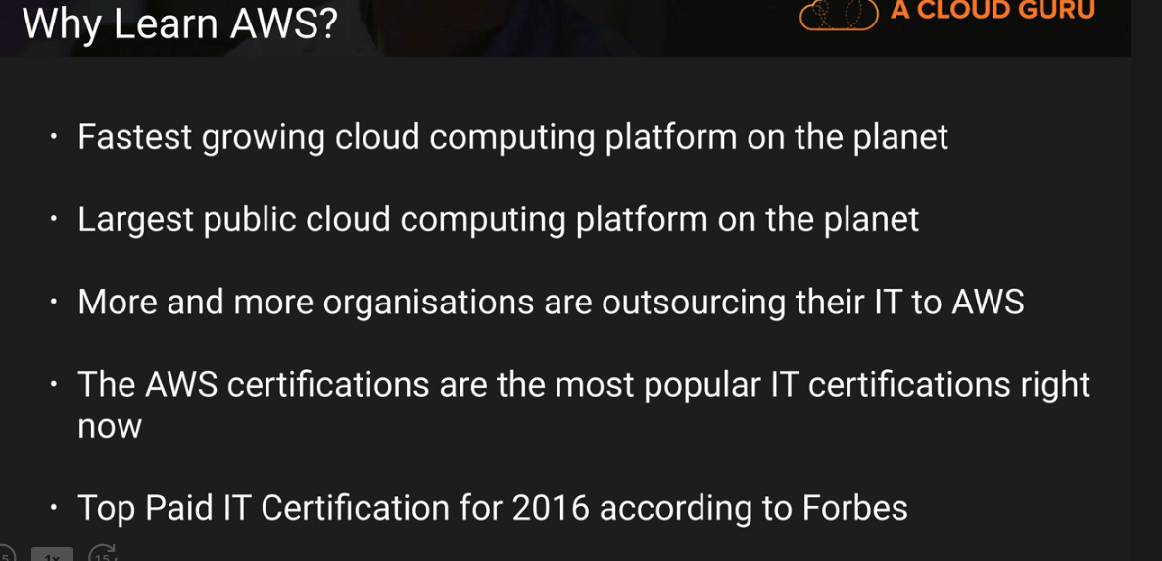

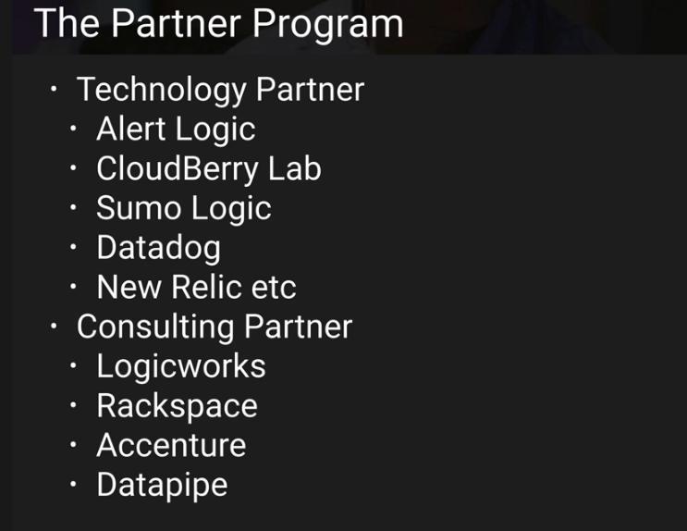

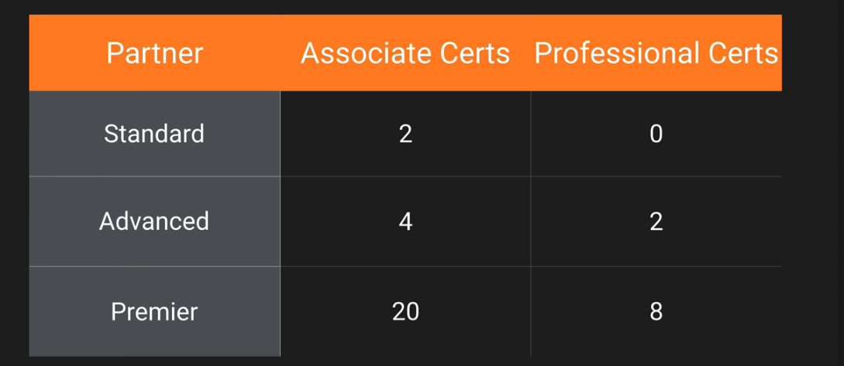

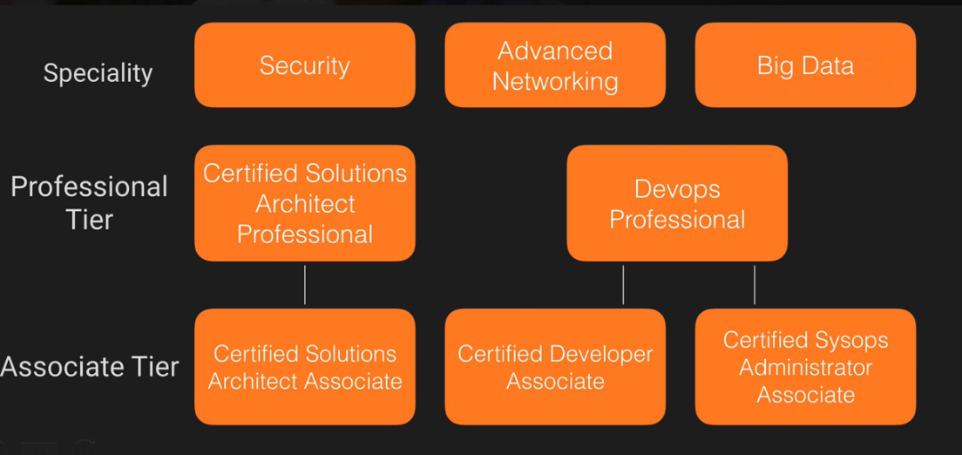

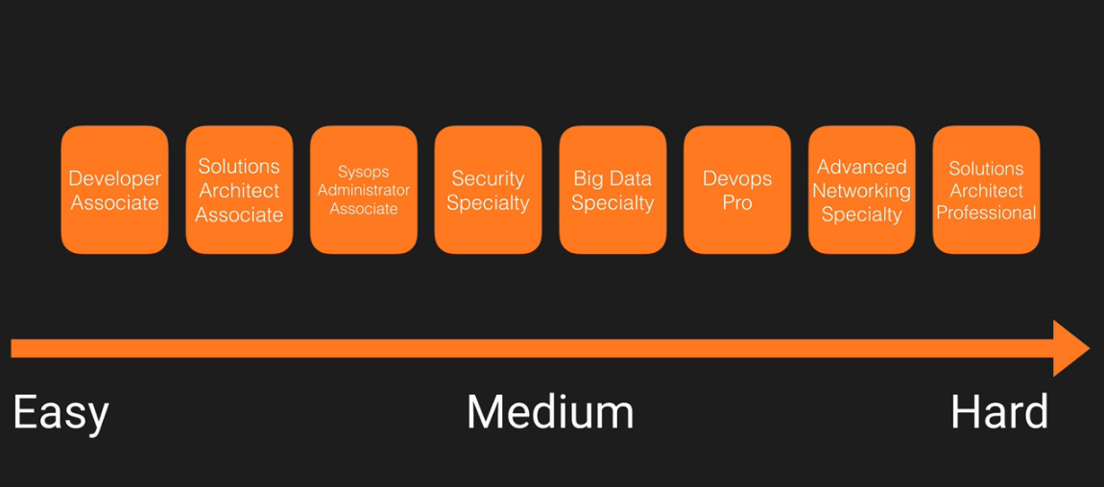

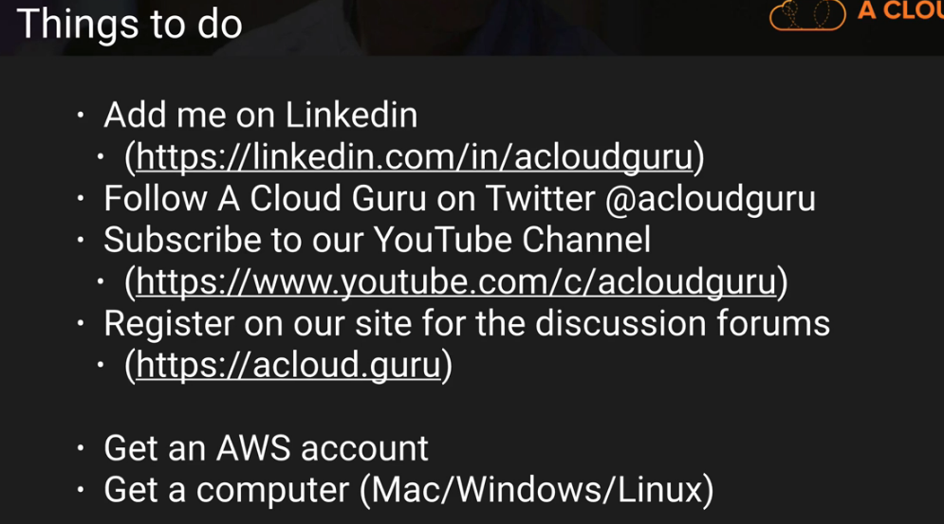

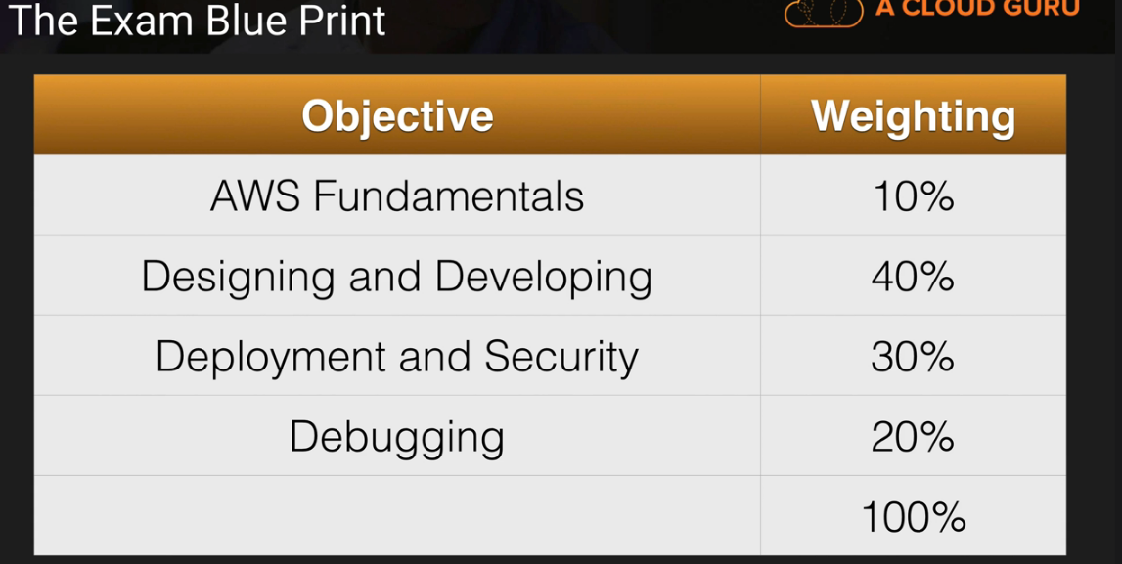

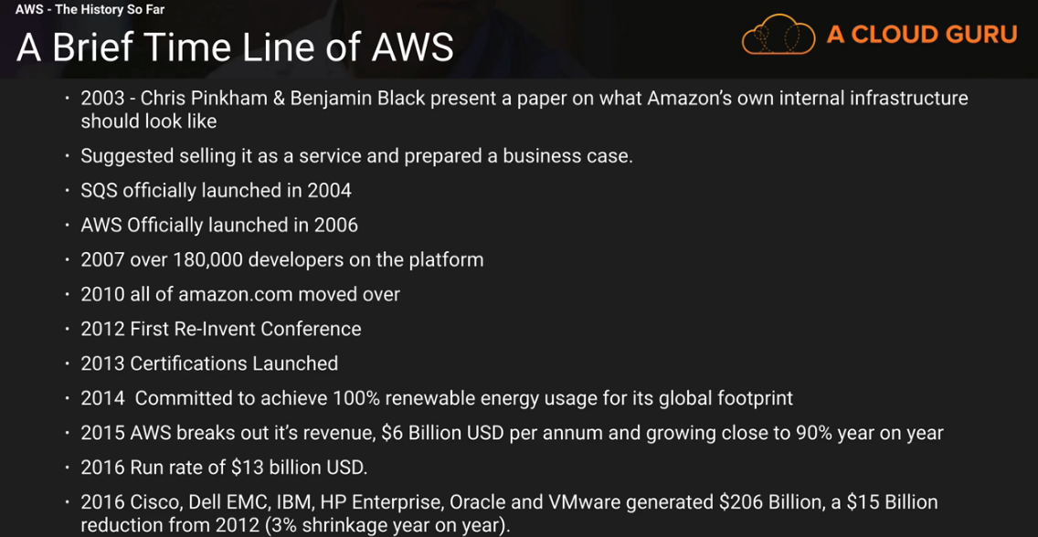

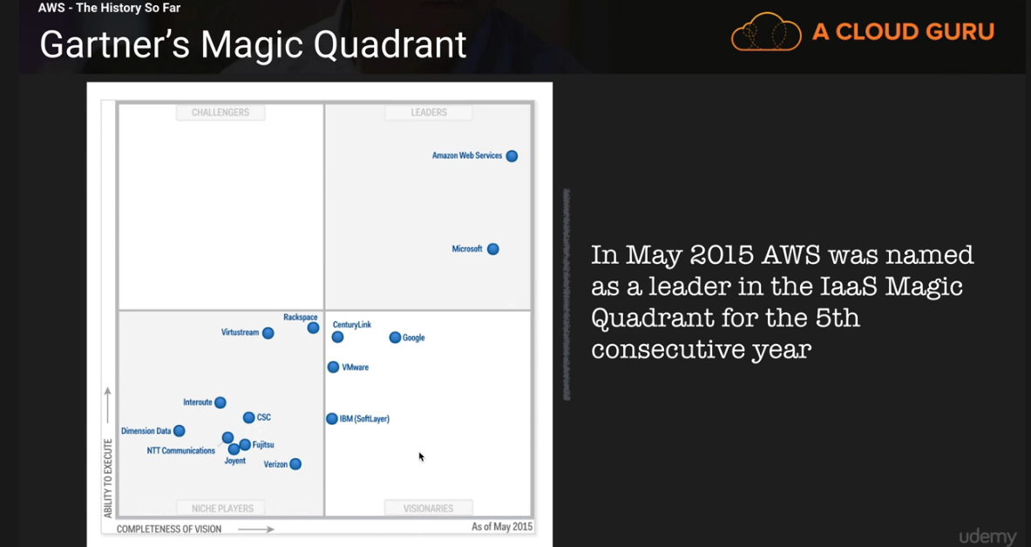

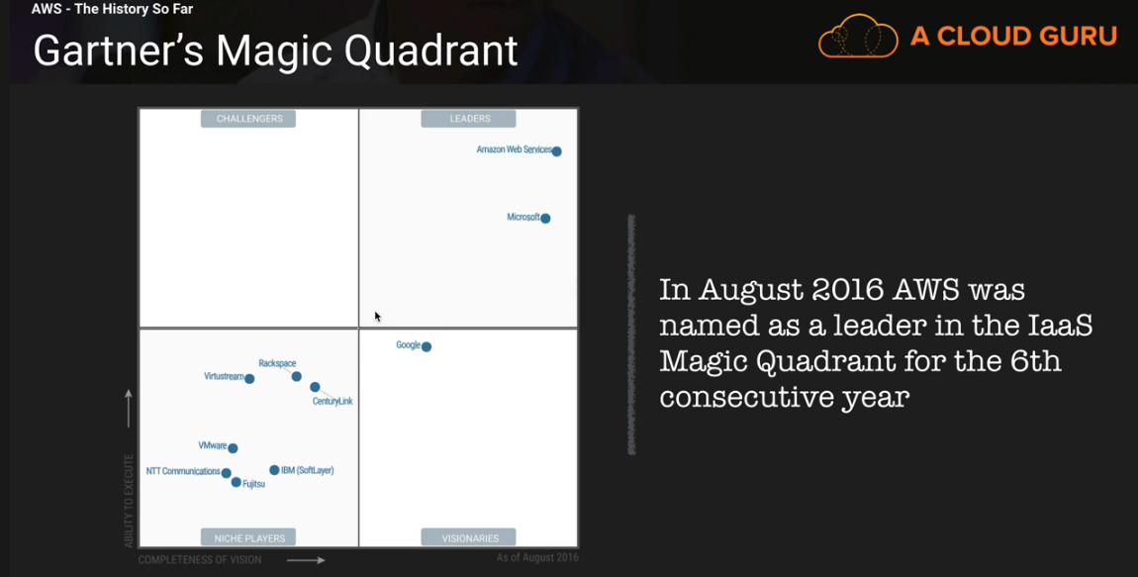

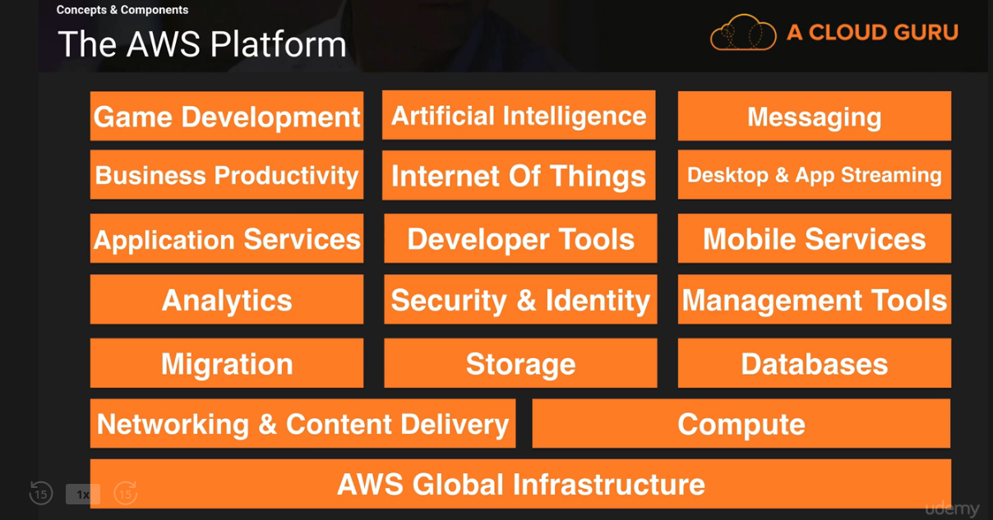

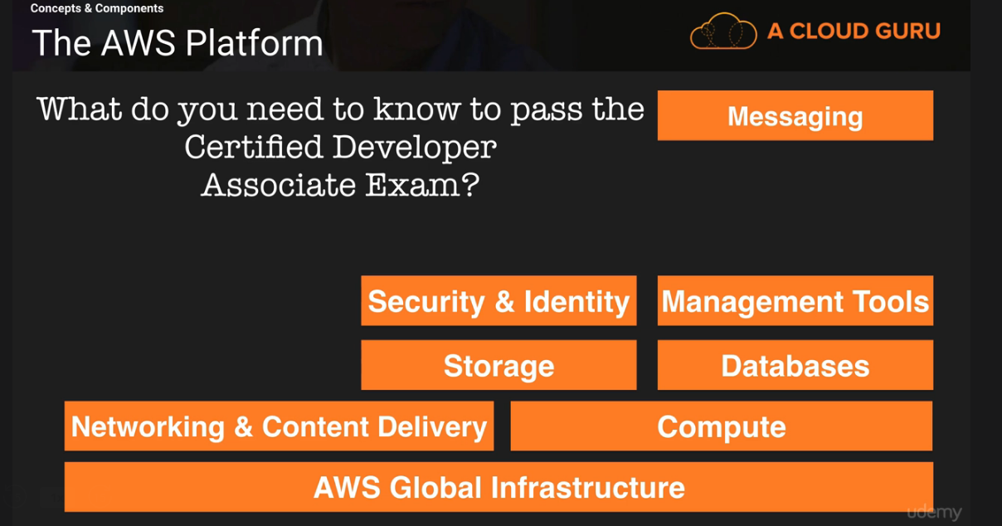

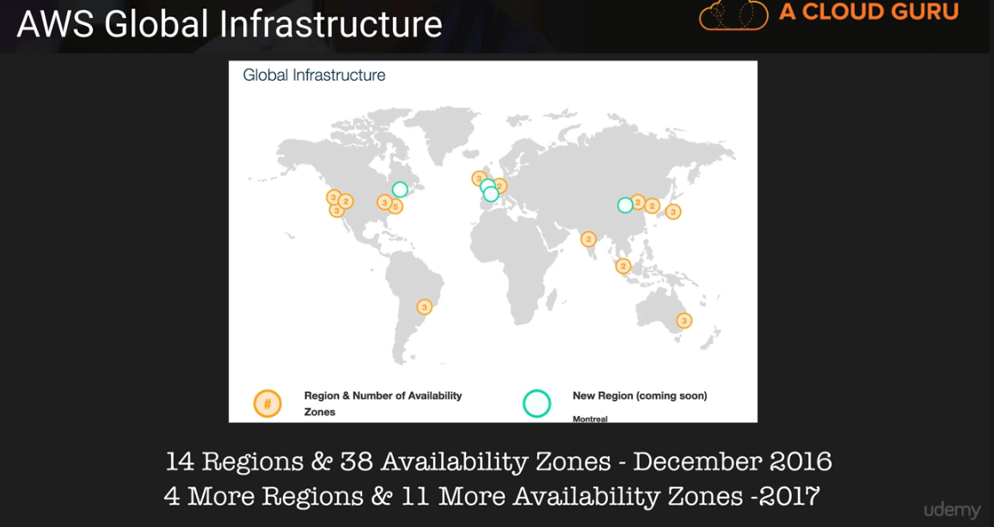

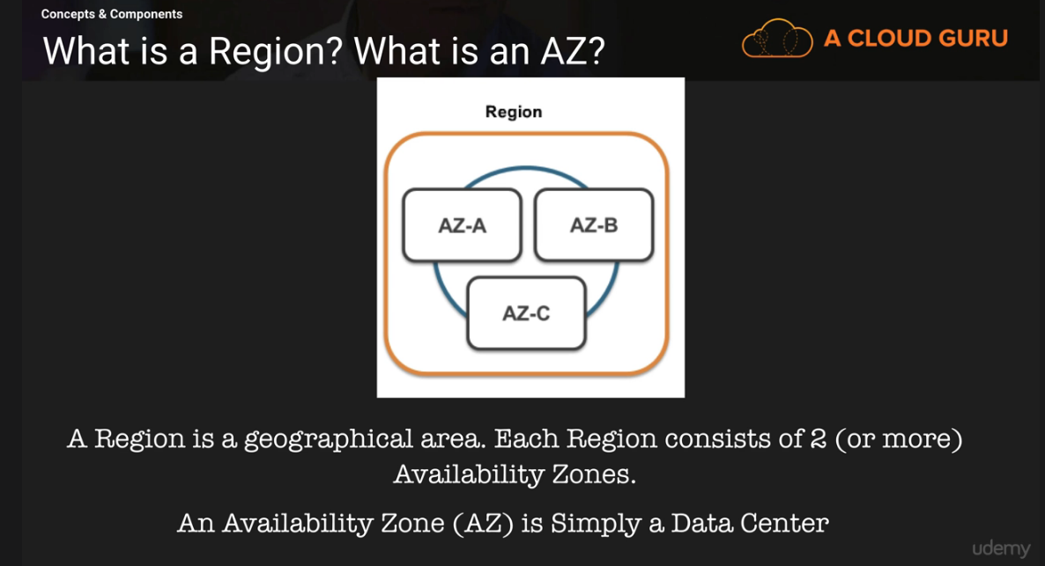

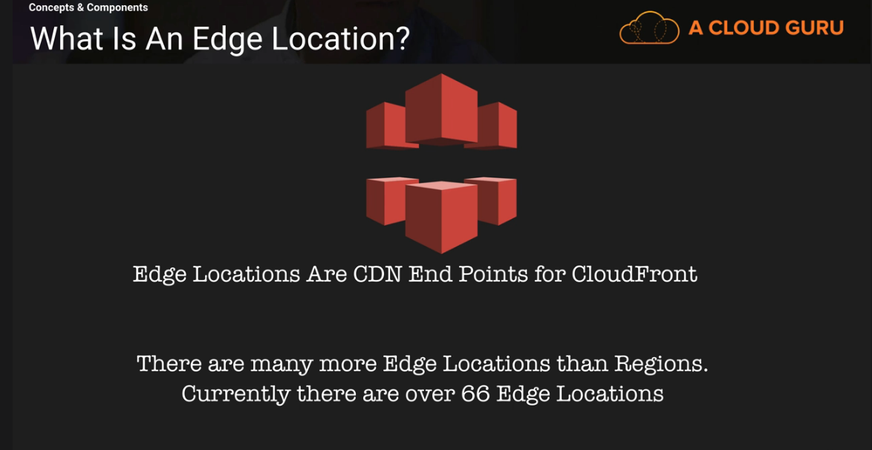

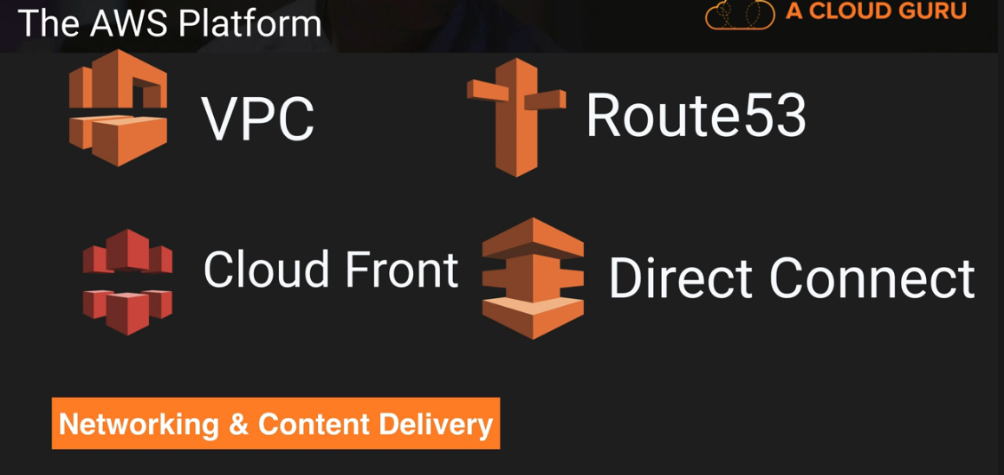

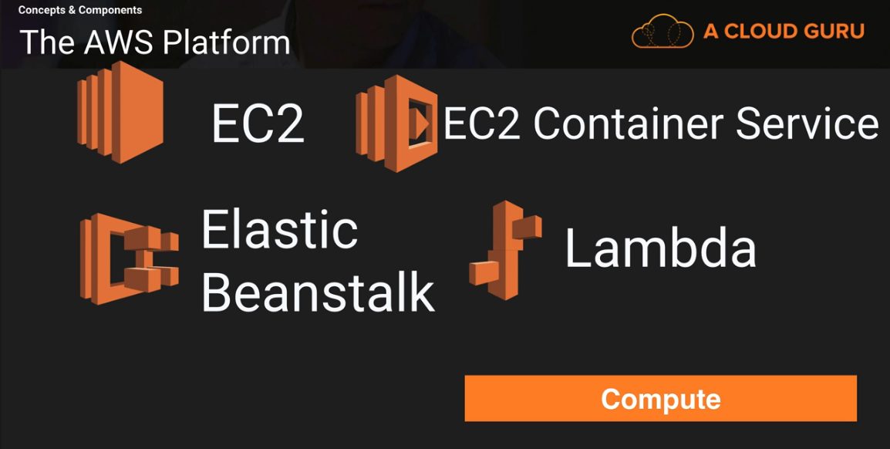

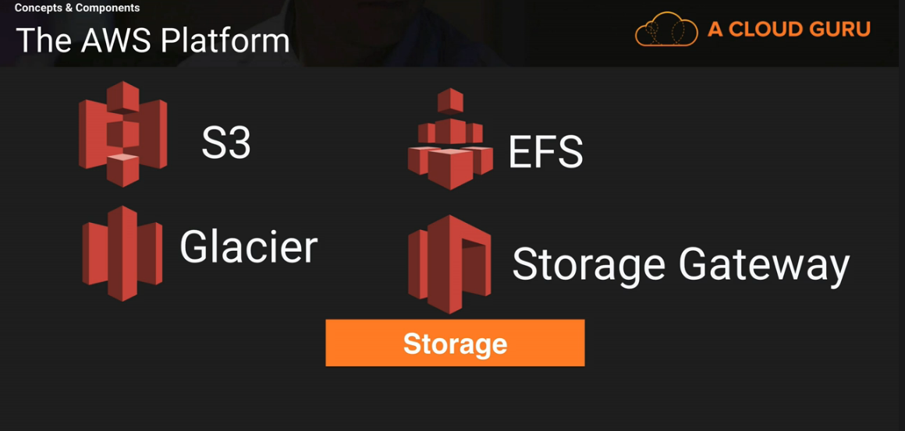

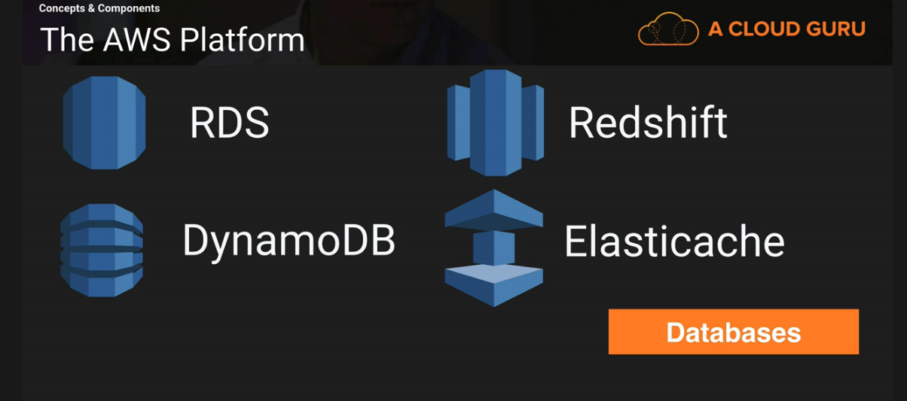

Migration Services:

DMS – Migrate on premises DB to AWS and vice versa.
Lets say We have Oracle and Migrate it Aurora and AWS via DMS
No Downtime and is done via replication.

SMS( Server Migration Services) – Targets VM’s on premises to replicate them to AWS.
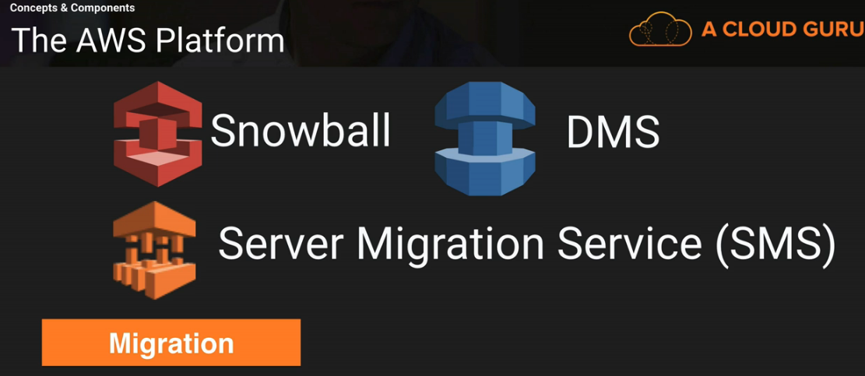

Analytics: ( Angolia for search)

Athena : Allows u to run sql queries on JSON , CSV etc on E3.
EMR: Elastaic Map Reduce – analyze lots amount of data ( big data ).
Cloud Search -
Elastic Search : Fully Managed service allows you to search within your wbsites .

Kinesis: Way of streaming and analyzing real time data . Sentiment Analysis.

Datra Pipeline : TO move data from one place to another ( s3 to dynamo db) or ( dynamodb to s3)
Quick Sight: Business Analytics and is used to analyze data that is stored in dynamo db etc...

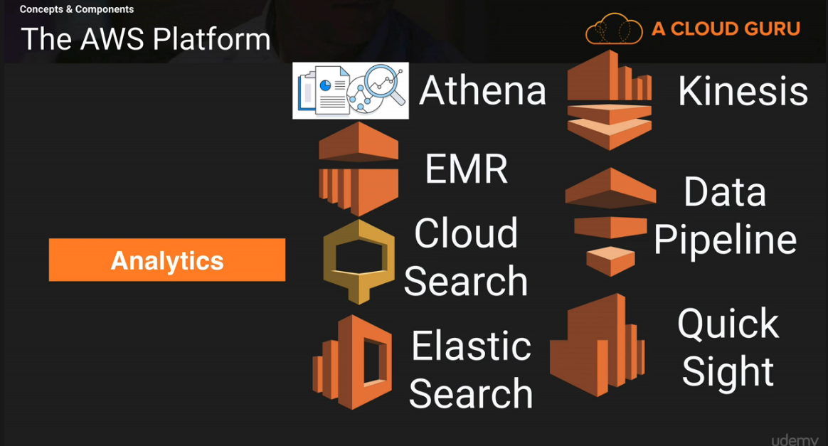

Security & Identity:

IAM: I dentity and access management)
Inspector :

Certificate Manager : free SSL certificates for the domain names
Directory Service :

WAF : Web application firewall.( Strop Cross site scrpting and SQL injections)

Artifacts: Documentation in AWS console

Management Tools: ( Environment)
Cloud Watch : Monitor performance of AWS tools of Disk utilization, Ram utilization
Cloud Formation: Turning infrastructure into code. You can provision the environment via command line, auto scaling , failover *****

Cloud Trail : Way of auditing and changes to AWS environment

OpsWorks: Automating deployments using Chef
Config Manager: Monitors environments and alerts when there is a breach.

Service Catalog: It is for larger enterprise spcific AWS like EC2 RDS for authorization to build it is for authorize or not.

Trusted Visor: Performance optimization, automated way to

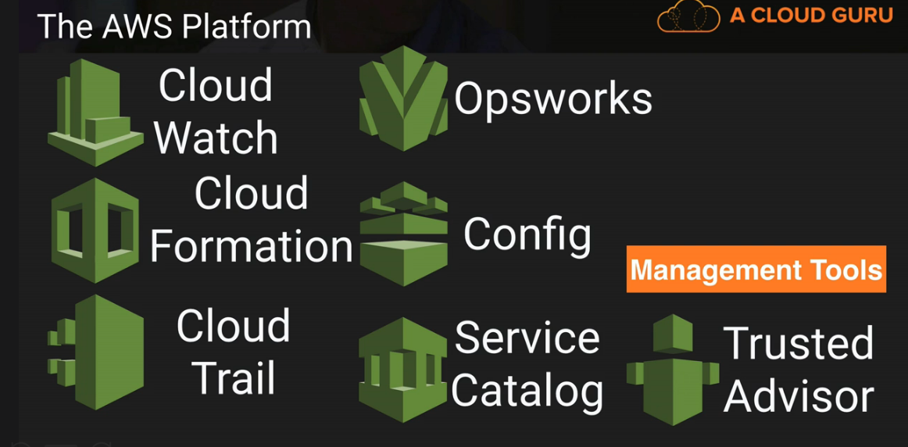

Application Services:
Step Functions: What is going on inside the application ( micro service)
SWF: Way of coordinateing automated tasks and human led tasks.( Simple Work Flow)
API Gateway: Door to access backend data and access business logic.( Angular JS from client which calls API Gateway and then call is made to Lambda function)

App Steam : Streaming desktop applciaions to users

Elastic Transcoder : Change the video format on different devices as per the screen formats.

Developer Tools:

Code Commit : Is the git hub and is used to store is the code in the cloud:

Code Build : - Code compile;

Code Deploy :

Code Pipeline: Different version on the environments.

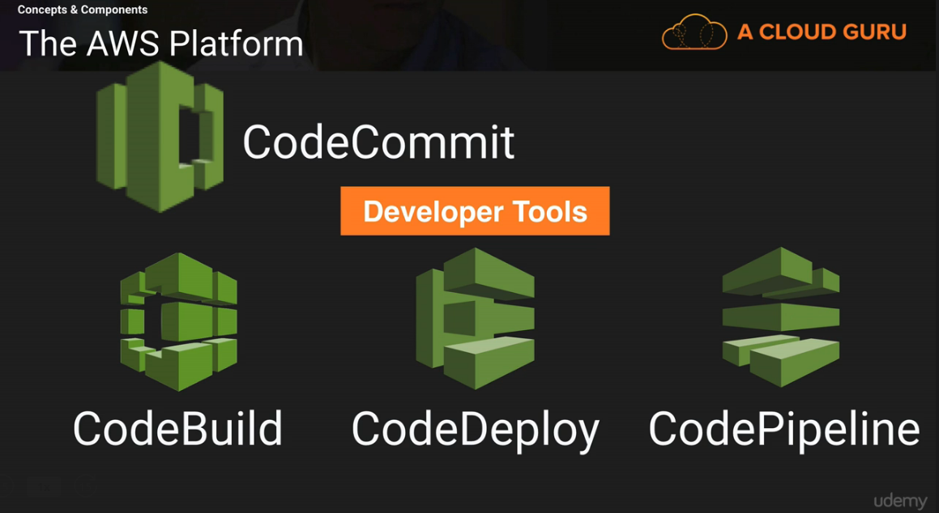

Mobile Servic es:

Mobile Hub: has its own console for its mobile development.
Cognito: PPL to signin and sign out
Device Farm: Test the devices phsically on AWS farm.
Mobile Analytics:
Pinpoint:

Business Productivity

IOT : Keeping track of the devices and
Workspaces: This is VD I desktop in the client.

Artificial Intelligence: ( Elon Musk – Character of Iron Man)

Super Intelligence – Nick Bostrom.

Alexa: AWS Voice Service and Cloud we are talking to Lambda and in Alexa we are talking to Lex.
Embed Alexa in different devices.

Polly: Super advance stuff serverless applciation and converts the notes to MP3.

Machine Learning: Give the dataset and the possible outcomes AWS will use ML and then analyse this data

Reckognition: Give the picture and it will tell you what it is . Picture recognition ( Brand new service)

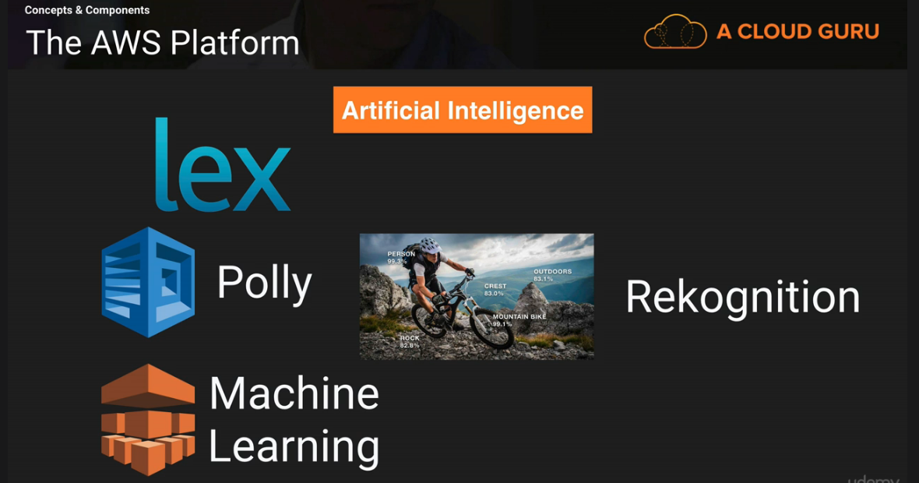

Messaging:

*SNS: Simple Notification Service.
*SQS: Decopluing applciation .. websites that generates names SQS
*SES: Simple Email Service.
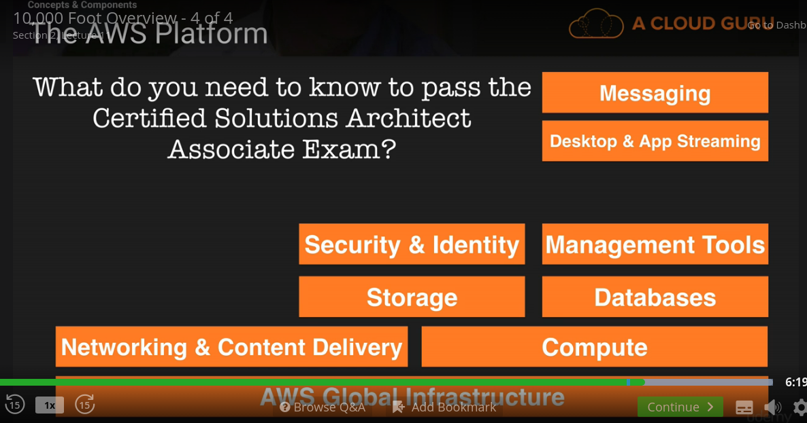

IAM

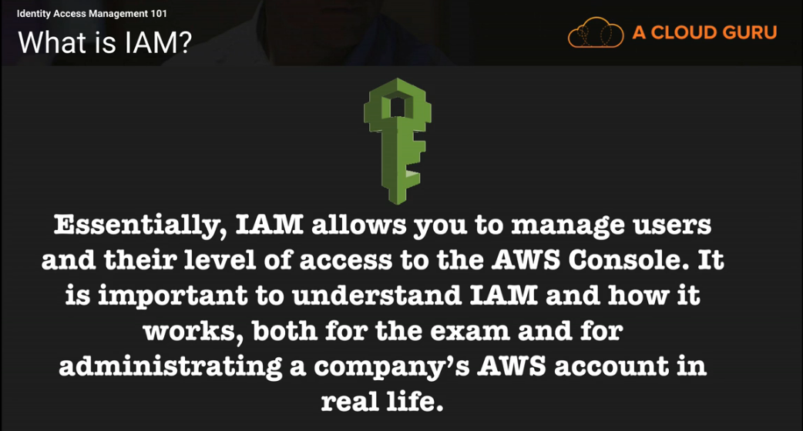

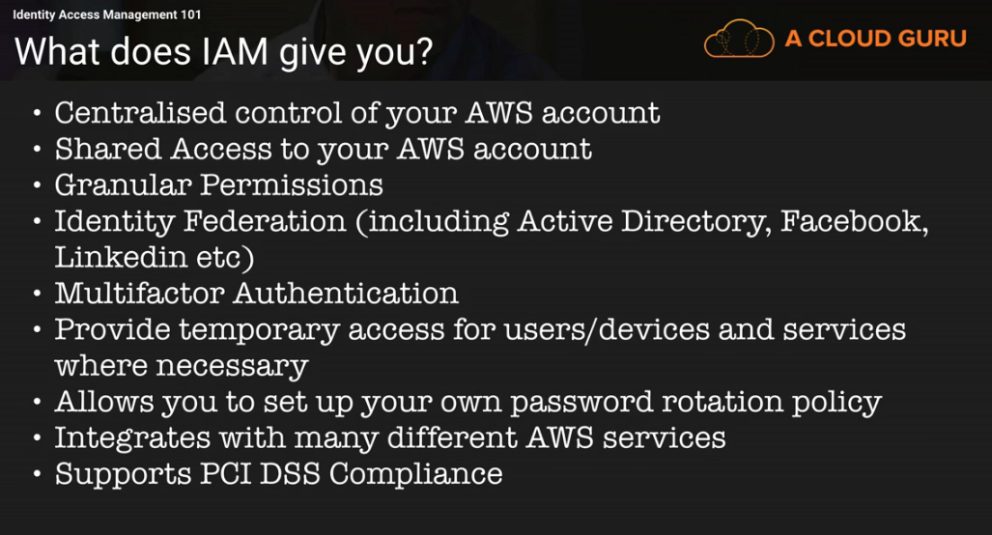

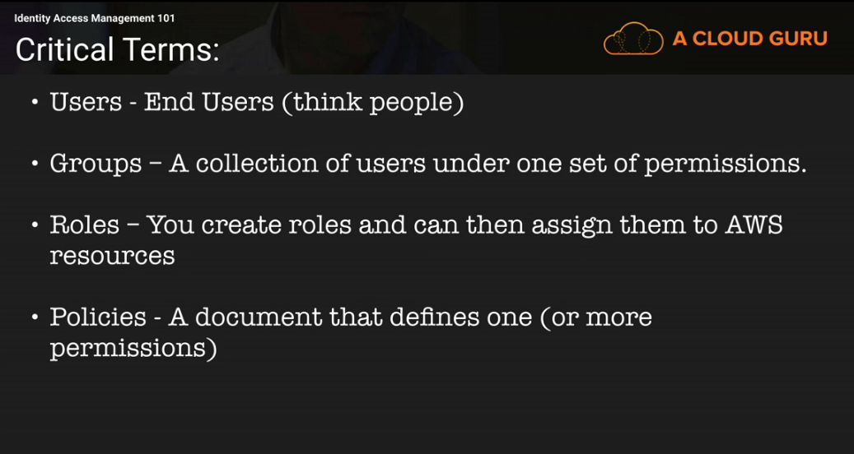

Root Account is the email that you have used to sign up.

STS(Sequrity Token Service)



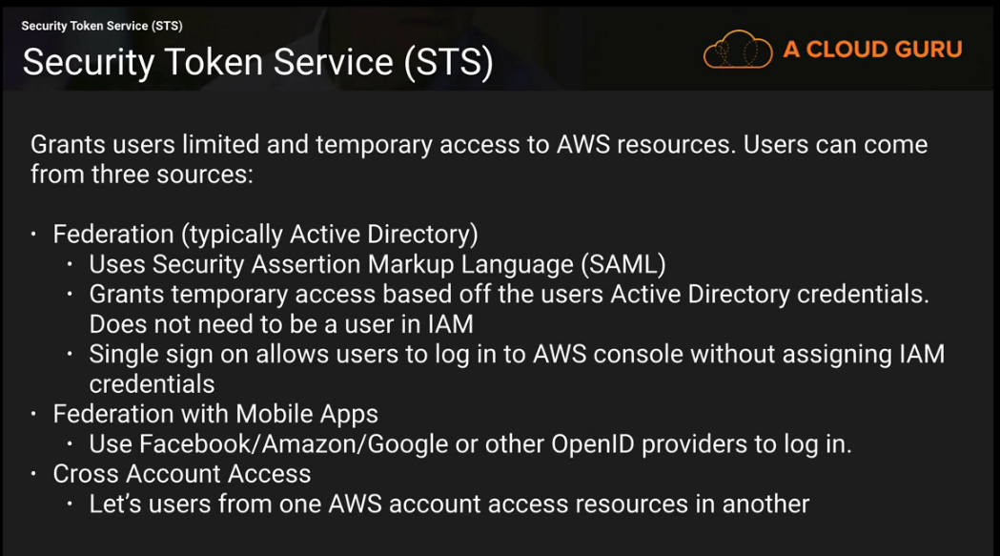

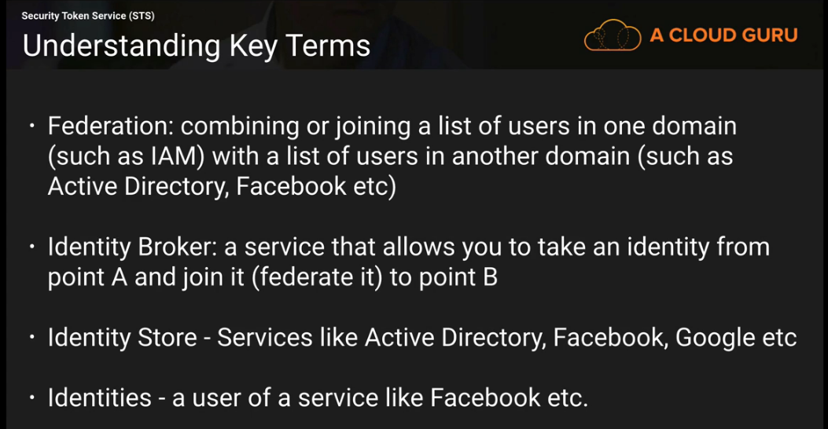

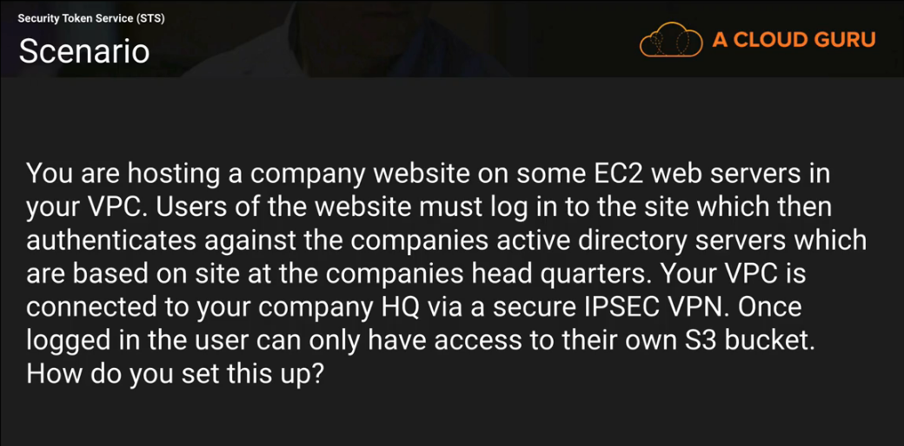

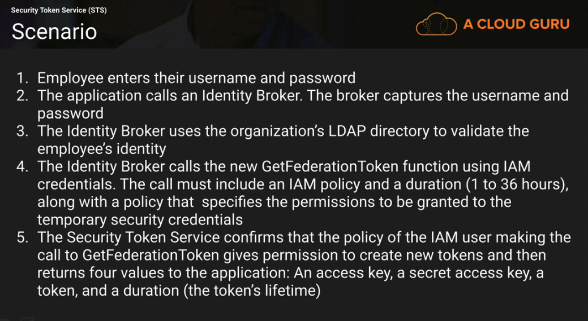

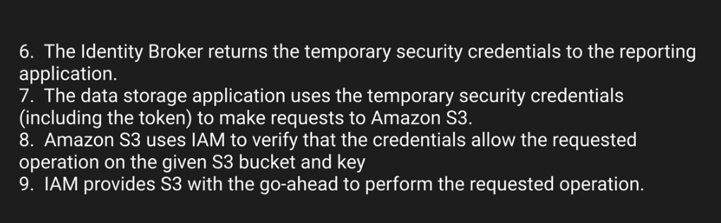

Distilled Version:

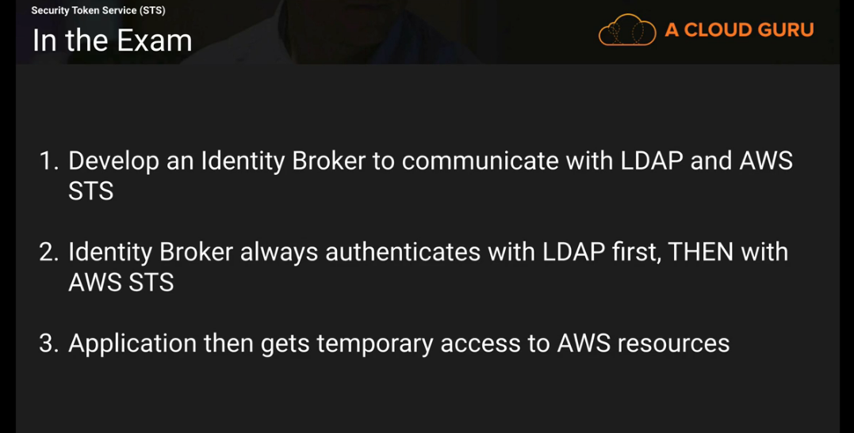

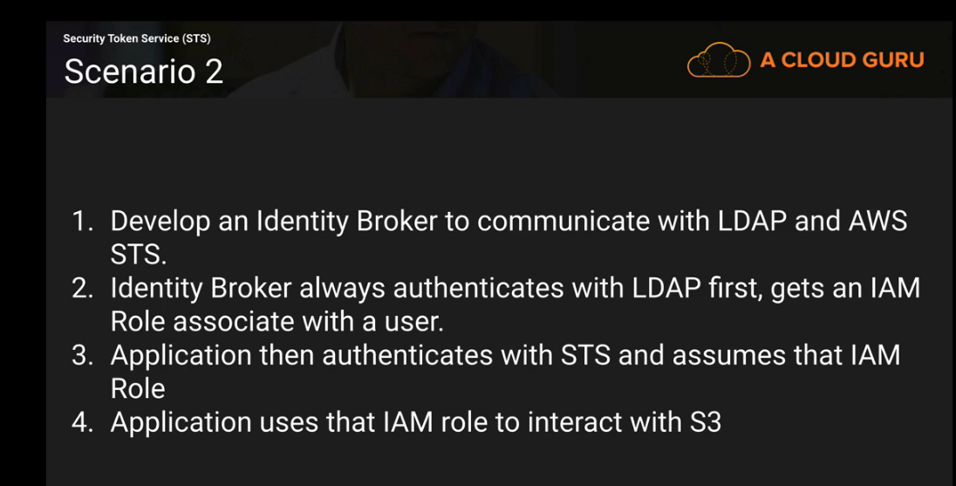

Active Directory Federation

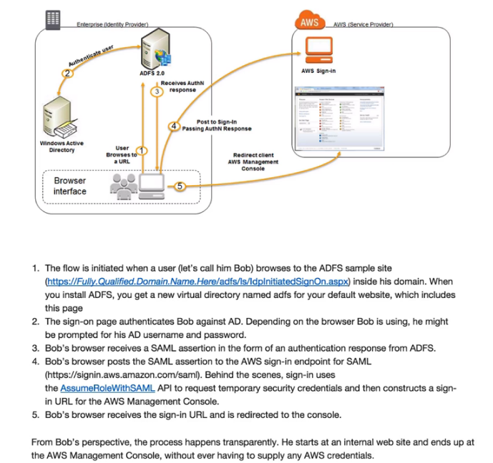

Web Identity Federation With Mobile Applications:

To programatically execute the Web Identity Federation with Mobile Applications:

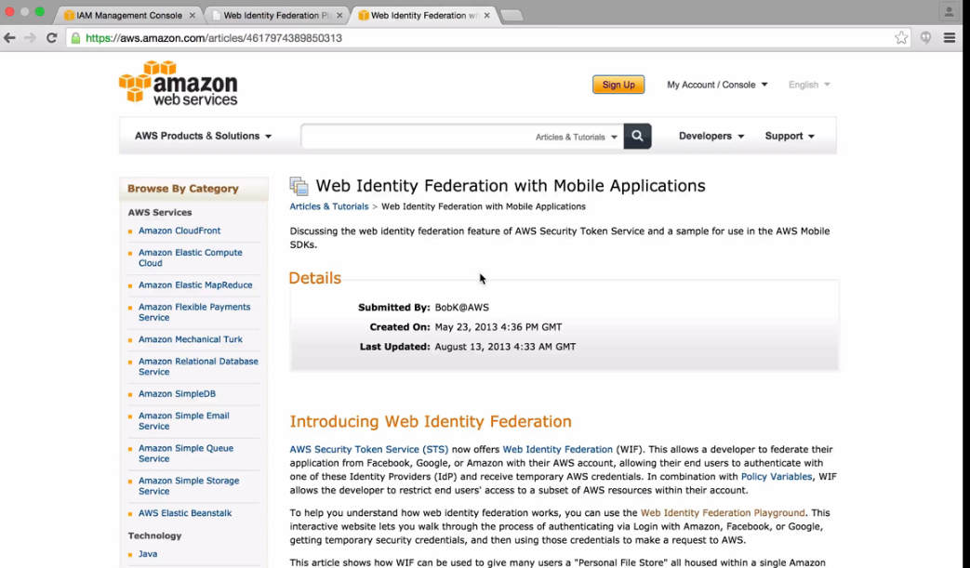

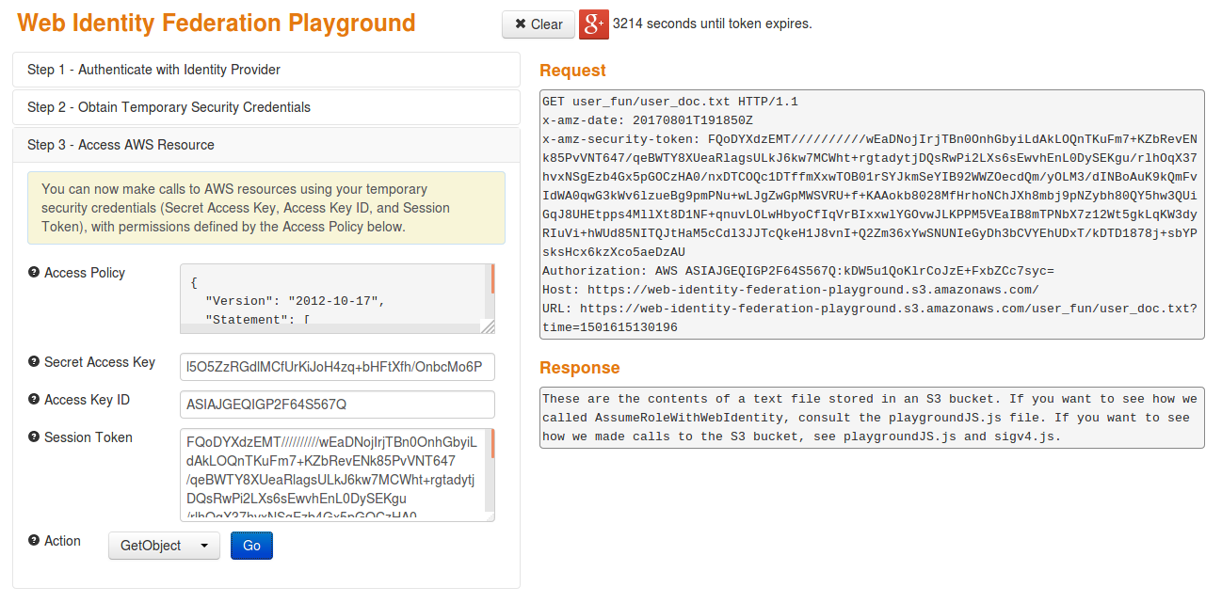

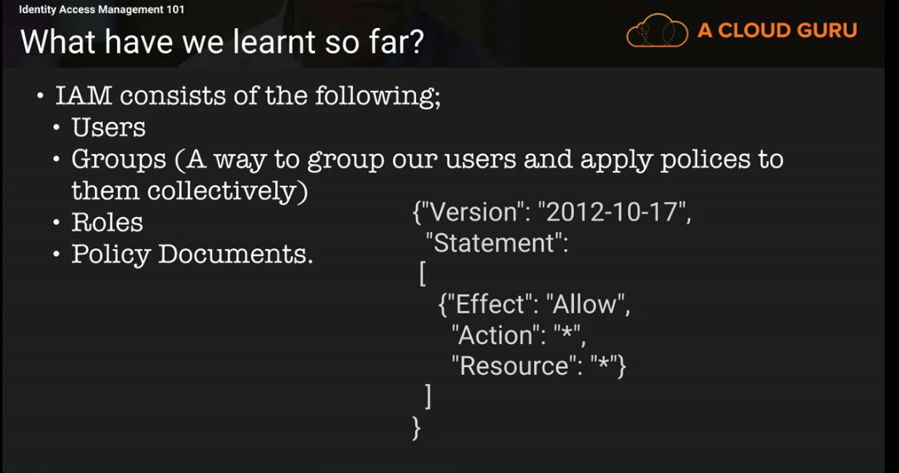

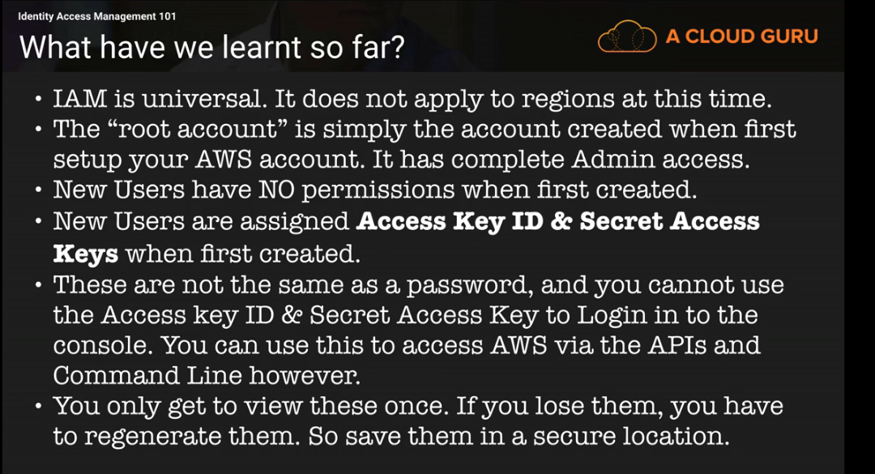

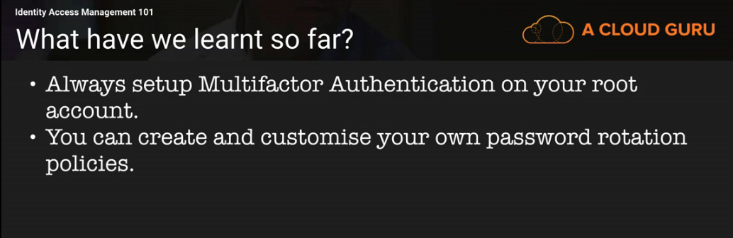

Elastic Compute Cloud ( EC2)
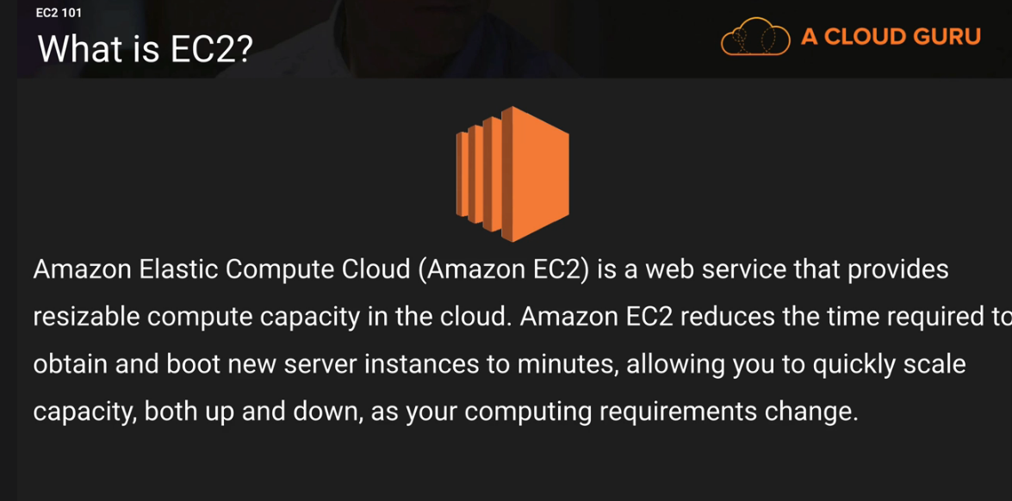

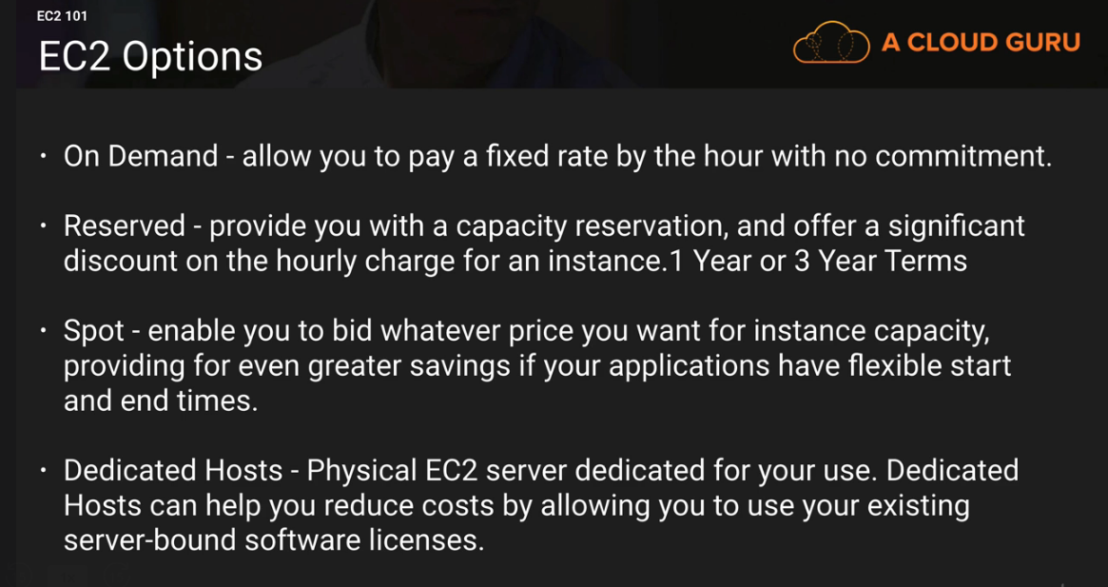

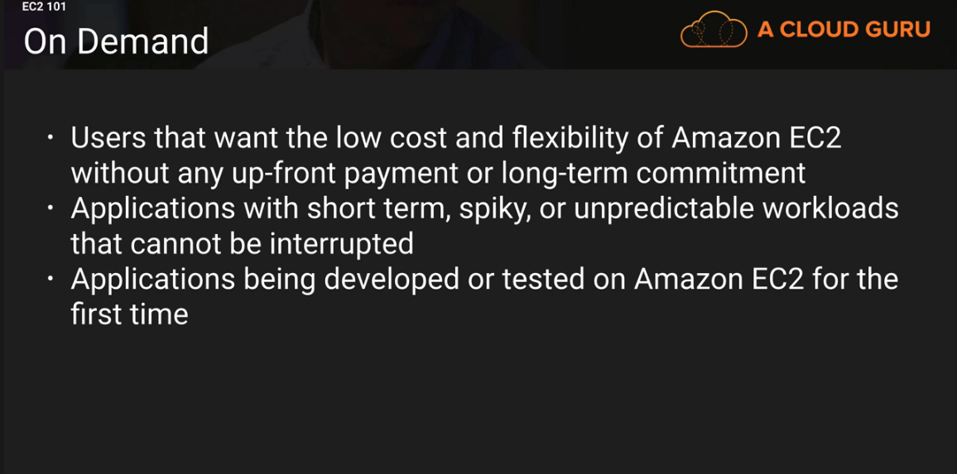

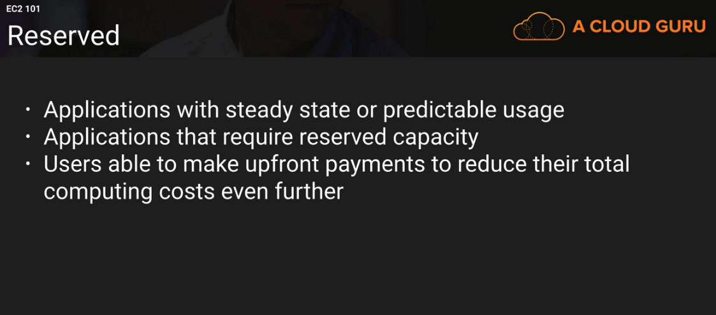

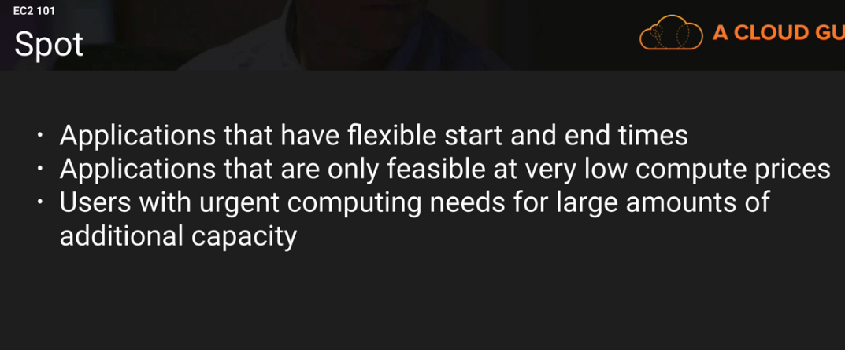

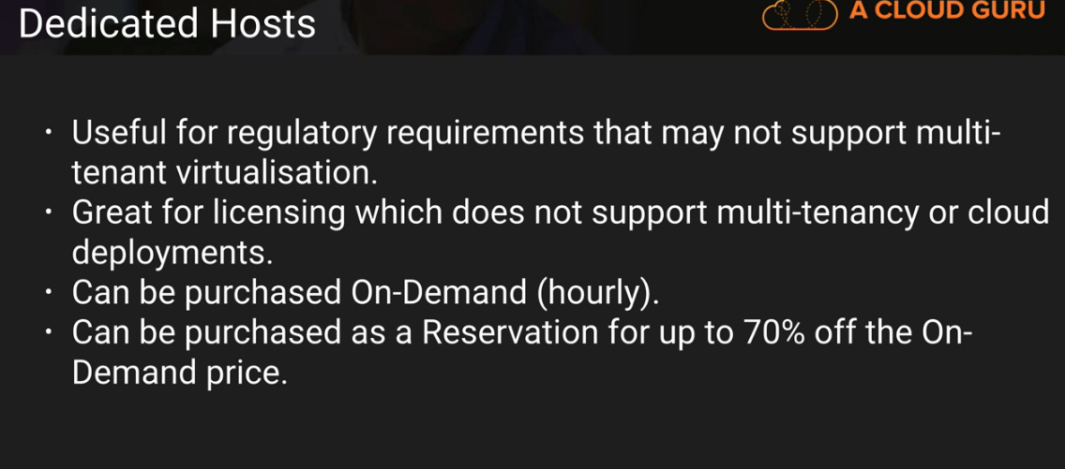

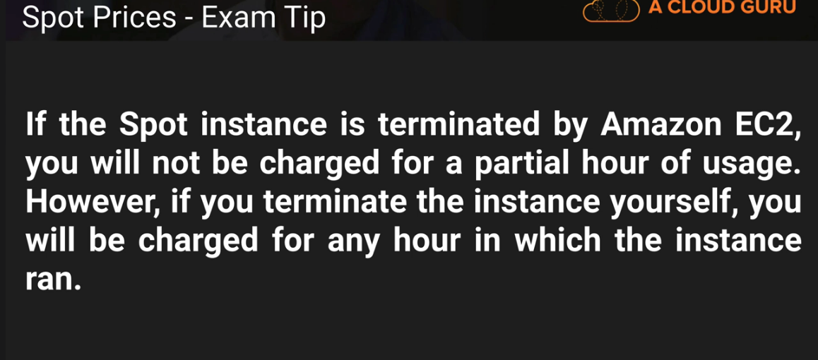

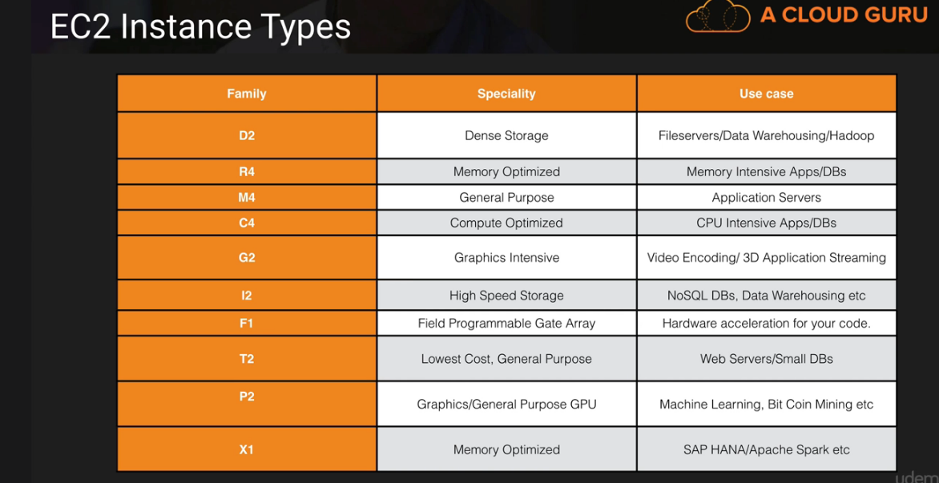

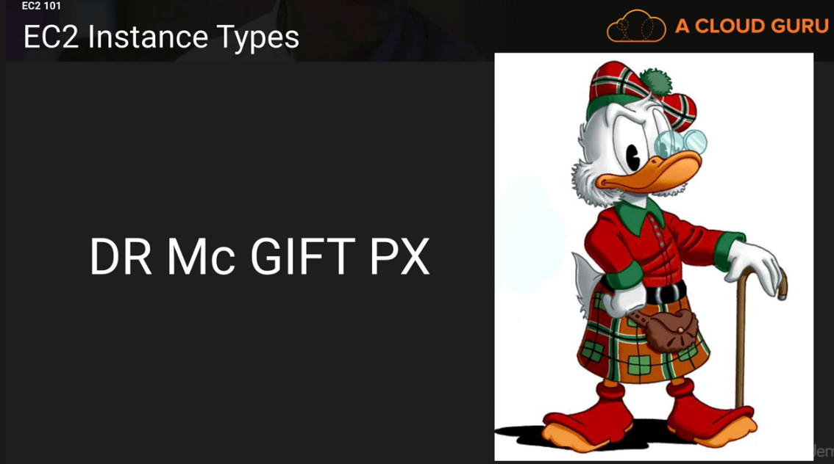

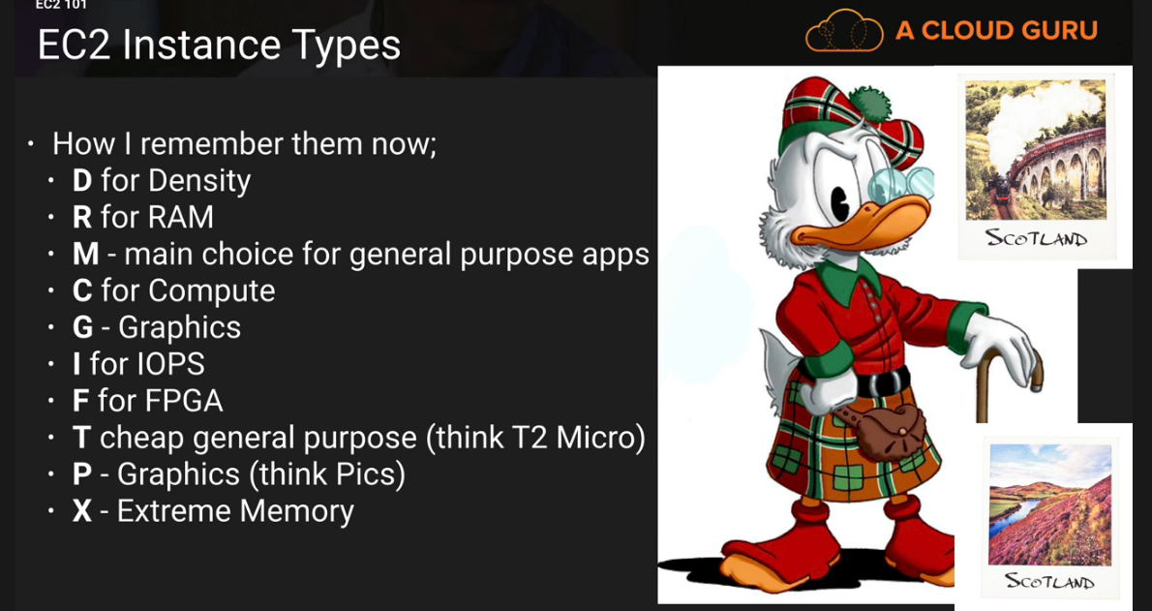

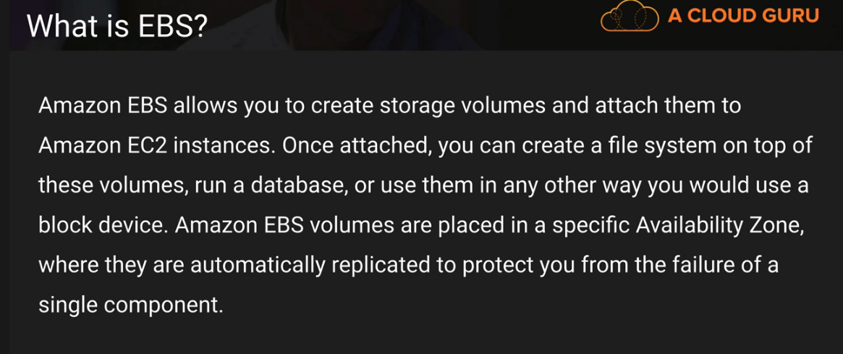
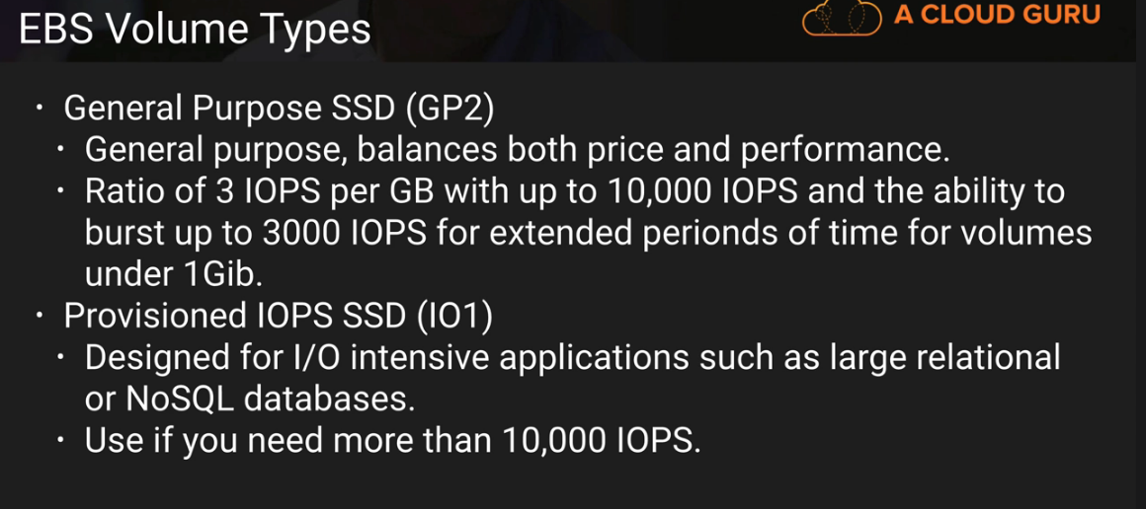
Can provision about 20,000 IOPS

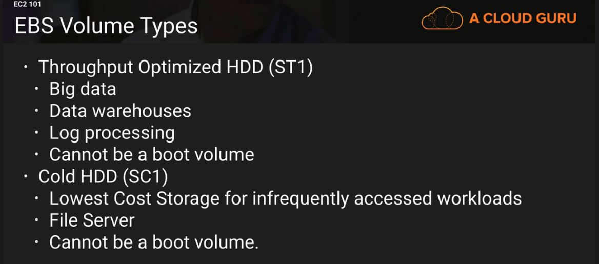

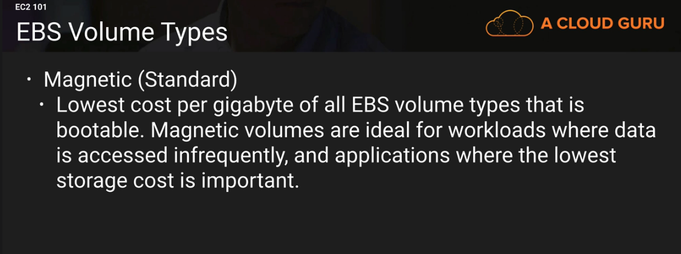

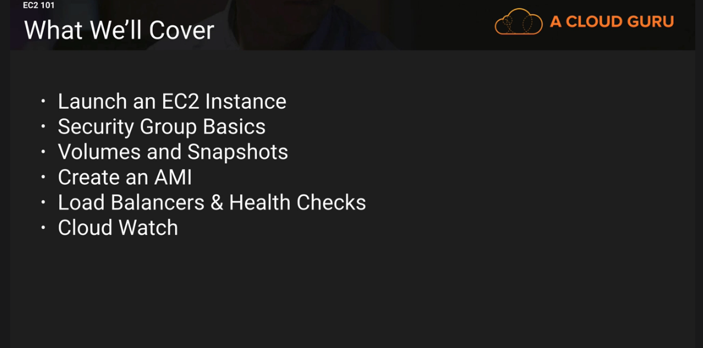
* EFS ( Elastic File System)
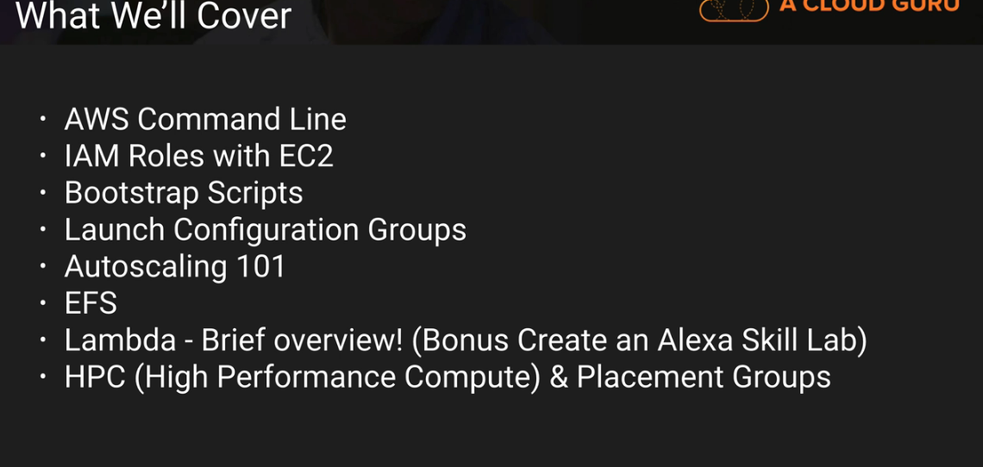
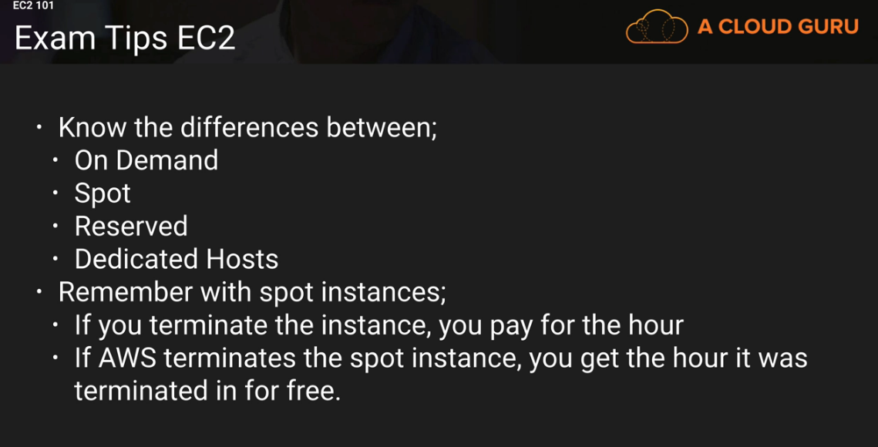

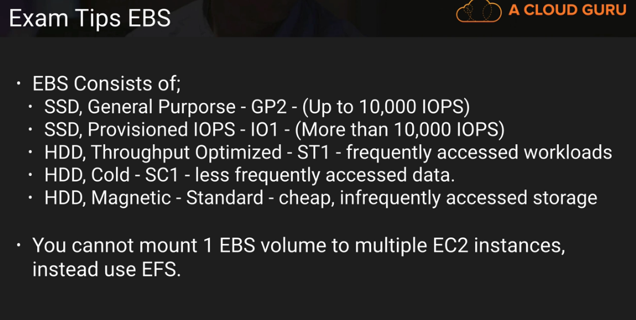

Lauch First EC2 Instance

Launch the EC2 instance by clicking on Services and choose Ec2
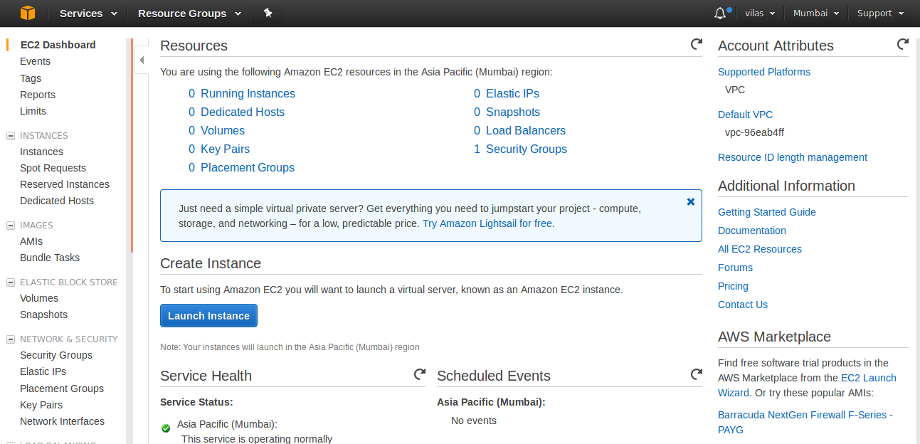

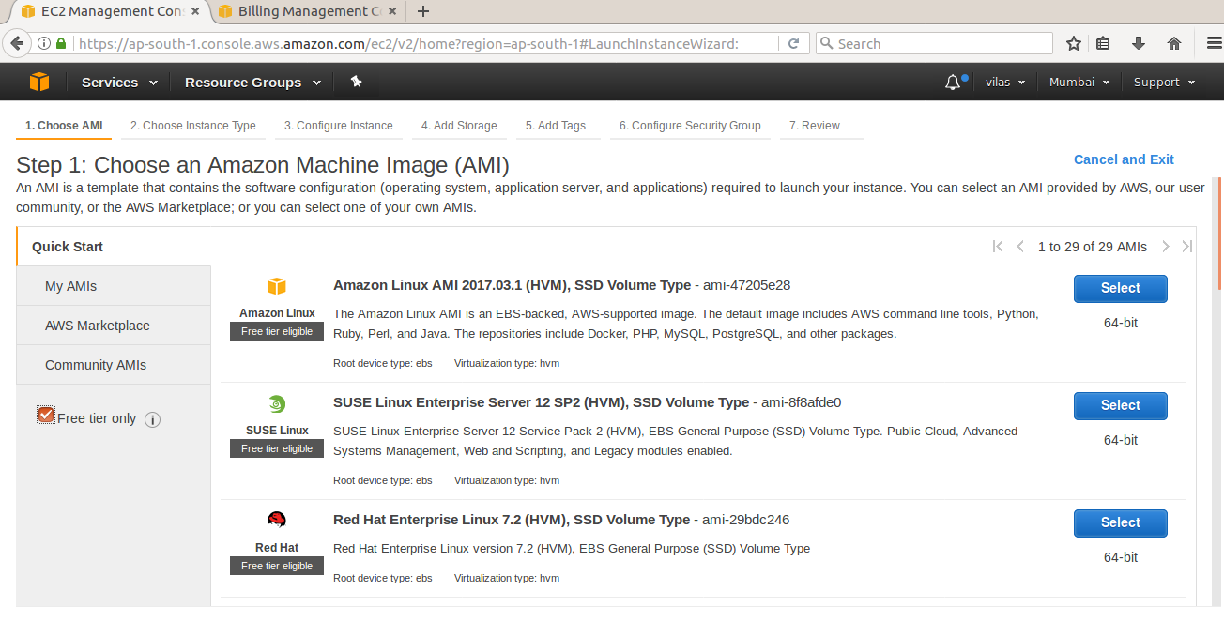

Choose Amazon Linux and Click on the Select button: this will get you the following page.
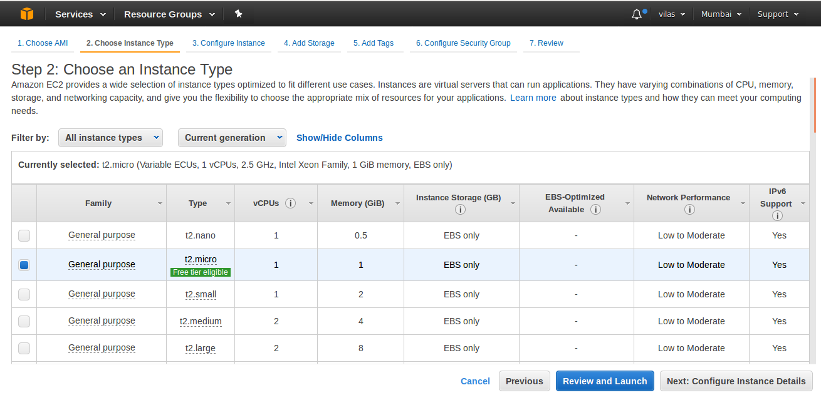

Click on Configure Instance Details

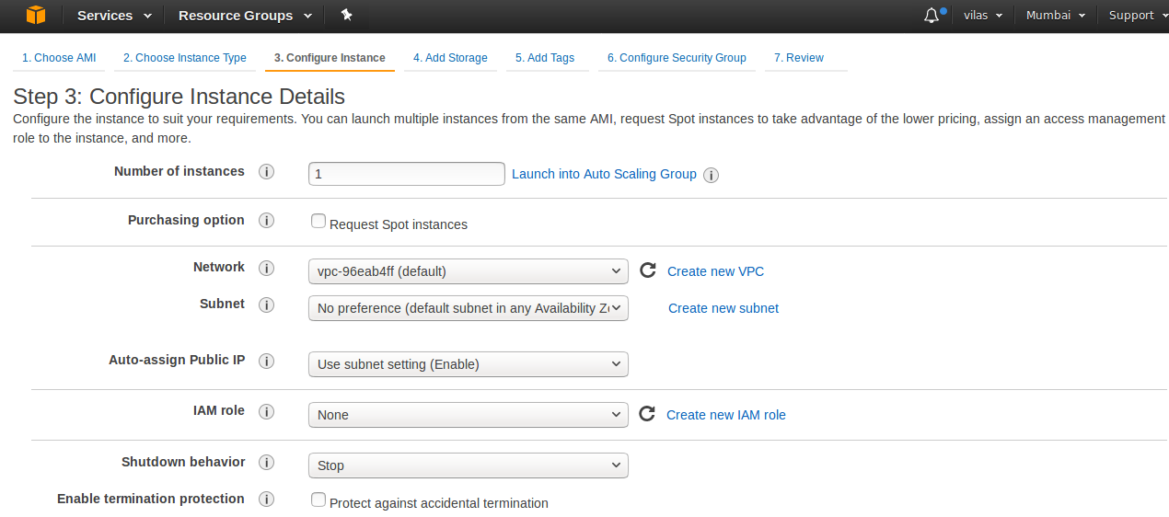

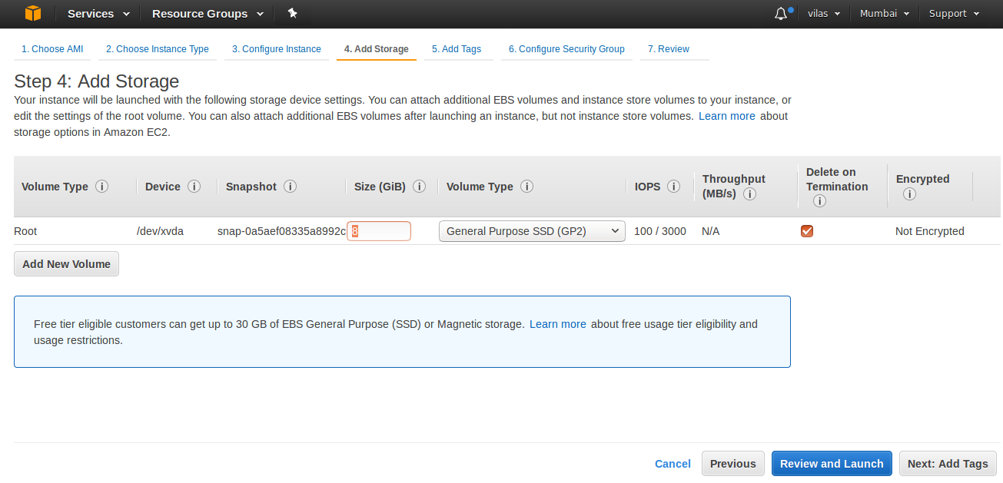

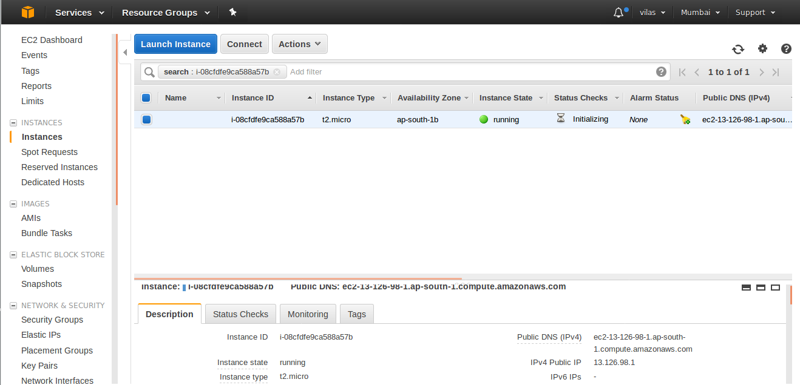

Once the the above is done we need to download the Key Pair.pem file in the folder.
From the command line go to the folder and create an SSH folder
Mv the *.pem file into SSH folder.
Create an CHMOD 400 on the *.pem file.

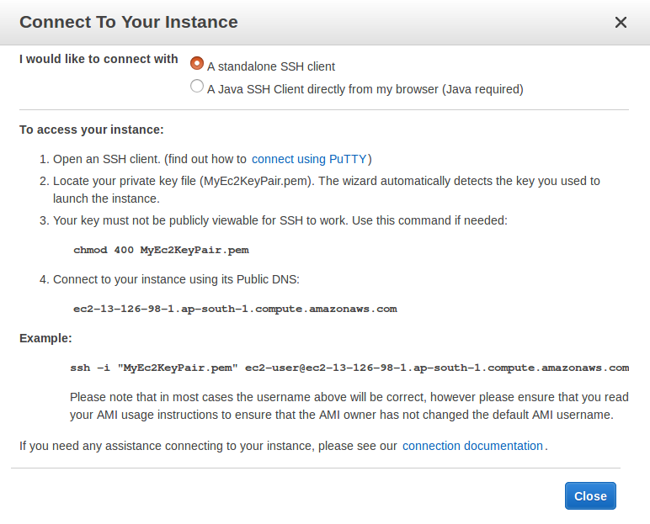
Update the user:
[root@ip-172-31-0-16 ec2-user]# yum update -y
Install the security update and install apache web server ( yum install httpd -y)
start the webserver --> service httpd start
Go to the cd /var/www/html and add the index.html file with some content and then run it.
It should give the web page as shown in the picture below:
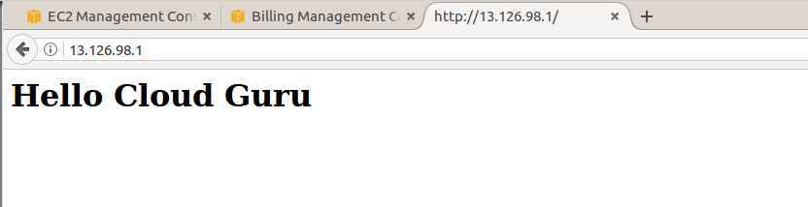

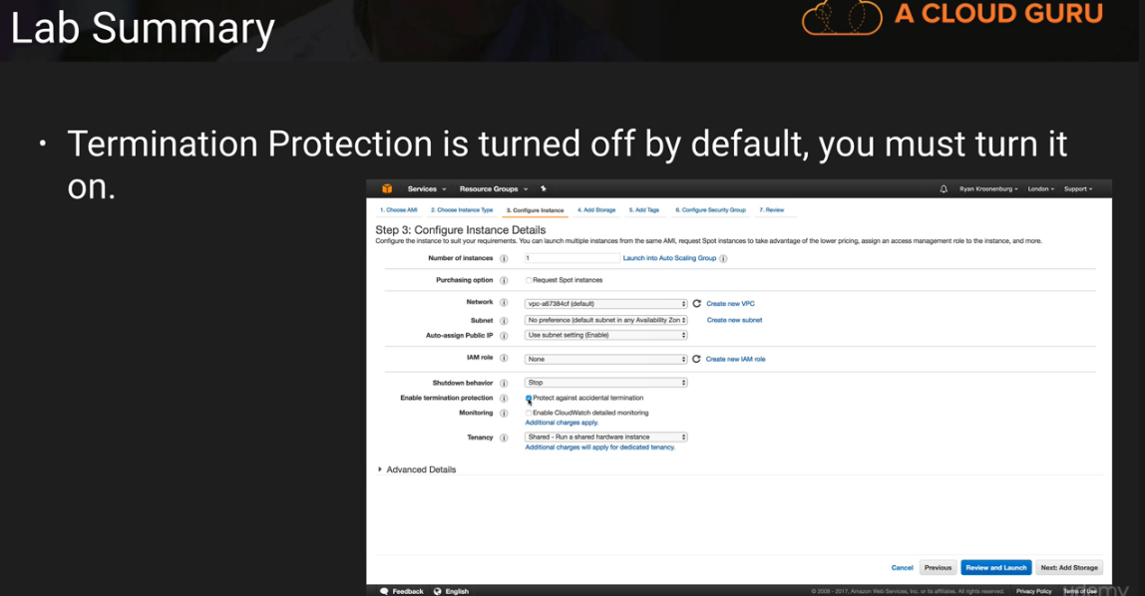

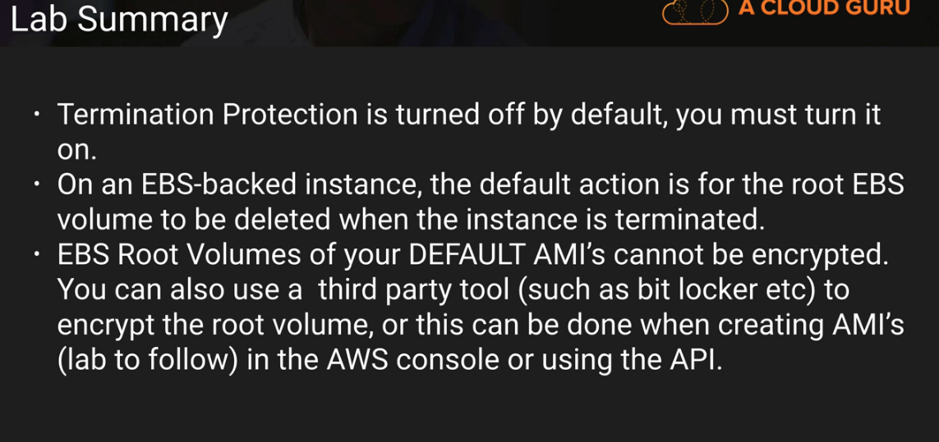
Additional Volumes Can be encrypted.

For Using PUTTY AND PUTTY KEY GEN

1) Down load putty and putty gen
2) Create and instance in AMI
3) While launching the instance it would ask for the certificate file *.pem to be downloaded
4) Download the file to an location by creating the folder as SSH.
5) use putty gen to convert *.pem file to *.ppk file
6) Use putty to map to the *.ppk file
7) launch putty with the *.ppk file and connect using user instance defined in the AMI

Security Groups:

To install apache service we run the following command
- yum install httpd
- to run the service
- service httpd start
to have the httpd service start always when the instance is running we use the following command

- chkconfig httpd on

Security groups are stateful and by adding an inboud rule the out bound rule is created.

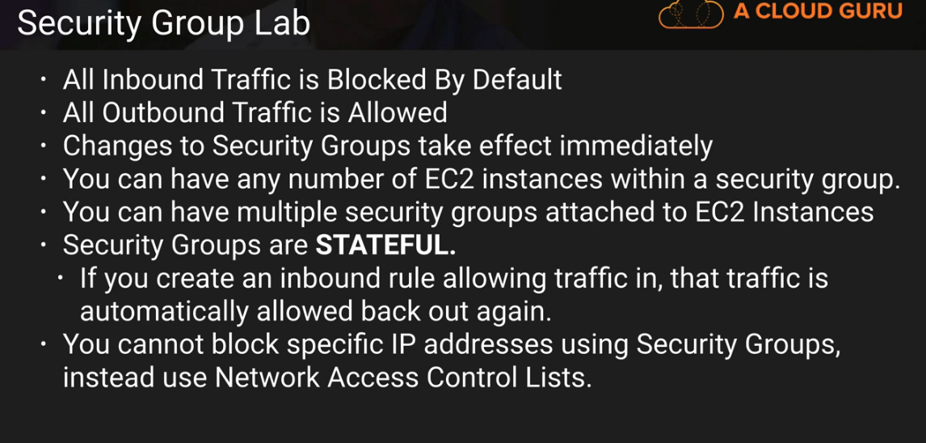
In addition to the above you can specify the allow rules but not the deny rules.

Upgrade EBS Volumes from One Storage Group To Another.

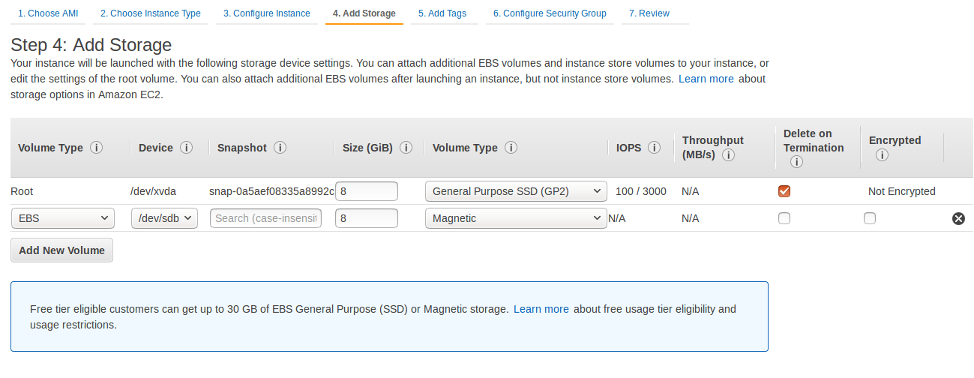

The current volumes associated:

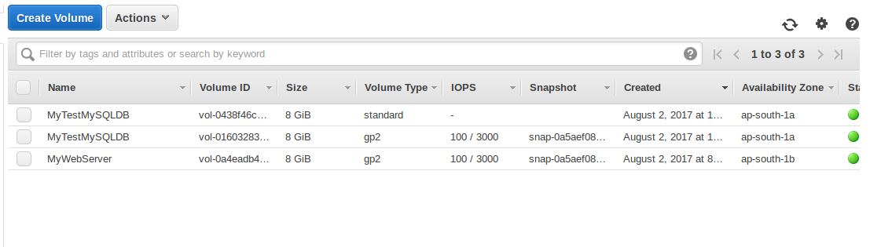
The lsblk command will let you know that the newly created volume is mounted.

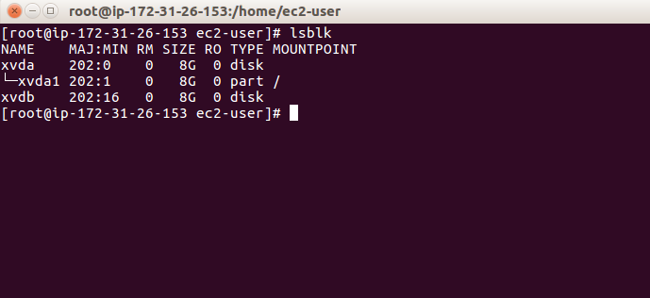
We have to create a filesystem for the same:
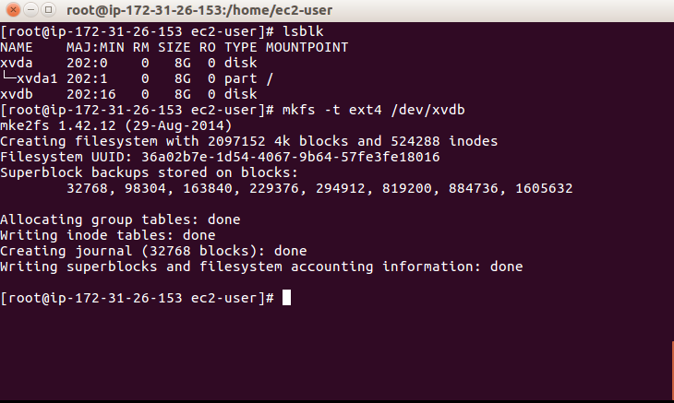

Create a directory and mount the filesystem to that directory.
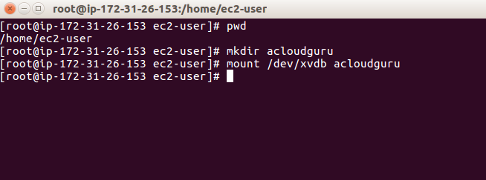

To check the mounted file system on to the directory:

[root@ip-172-31-26-153 ec2-user]# pwd
/home/ec2-user
[root@ip-172-31-26-153 ec2-user]# mkdir acloudguru

[root@ip-172-31-26-153 ec2-user]# mount /dev/xvdb acloudguru

[root@ip-172-31-26-153 ec2-user]# lsblk

NAME MAJ:MIN RM SIZE RO TYPE MOUNTPOINT
xvda 202:0 0 8G 0 disk
└─xvda1 202:1 0 8G 0 part /
xvdb 202:16 0 8G 0 disk /home/ec2-user/acloudguru
can be mounted and unmount the file system to a particular directory in the following way

[root@ip-172-31-26-153 acloudguru]# lsblk
NAME MAJ:MIN RM SIZE RO TYPE MOUNTPOINT
xvda 202:0 0 8G 0 disk
└─xvda1 202:1 0 8G 0 part /
xvdb 202:16 0 8G 0 disk
[root@ip-172-31-26-153 acloudguru]# mount -t ext4 /dev/xvdb /acloudguru
[root@ip-172-31-26-153 acloudguru]# lsblk
NAME MAJ:MIN RM SIZE RO TYPE MOUNTPOINT
xvda 202:0 0 8G 0 disk
└─xvda1 202:1 0 8G 0 part /
xvdb 202:16 0 8G 0 disk /acloudguru
[root@ip-172-31-26-153 acloudguru]# cd acloudguru
bash: cd: acloudguru: No such file or directory
[root@ip-172-31-26-153 acloudguru]# cd /acloudguru
[root@ip-172-31-26-153 acloudguru]# nano test.html
[root@ip-172-31-26-153 acloudguru]# cd /acloudguru
[root@ip-172-31-26-153 acloudguru]# ls
lost+found test.html

We can go to the AWS screen and choose the volume ( standard) and click on Actions and choose ( Detach Volume)
It will take a while to Detach.
$ ssh -i "MyEc2KeyPair.pem" ec2-user@ec2-13-126-129-222.ap-south-1.compute.amazonaws.com

Once the Volume is detached we need to create a snapshot.
Select the detached volume and then go to Actions --> create snapshot --> give a default volume.
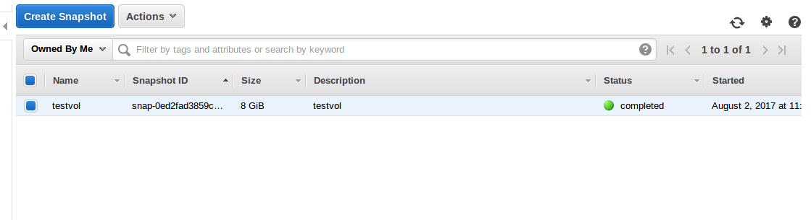
After the snapshot is created we need to create a volumne on the snapshot.
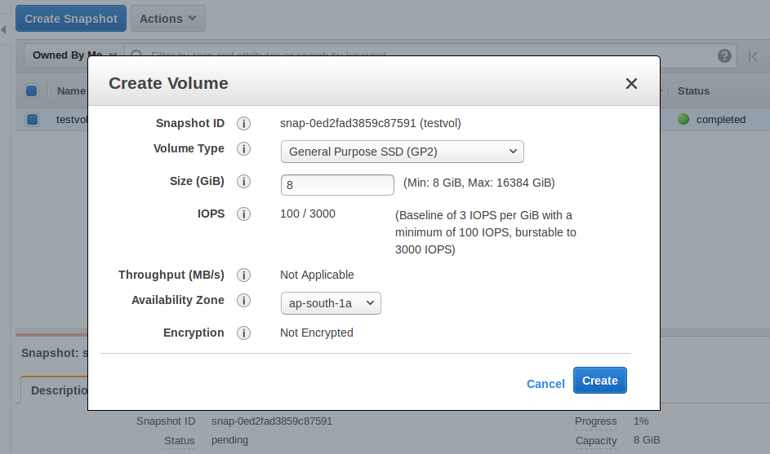

We create the volume based on the snapshot
We attach the created volume to the running instance.
We check the filesystem to see if there are any files in the file system.
[root@ip-172-31-26-153 /]# file -s /dev/xvdf
/dev/xvdf: Linux rev 1.0 ext4 filesystem data, UUID=36a02b7e-1d54-4067-9b64-57fe3fe18016 (extents) (large files) (huge files)
[root@ip-172-31-26-153 /]# mount /dev/xvdf /acloudguru
[root@ip-172-31-26-153 /]# cd /acloudguru
[root@ip-172-31-26-153 acloudguru]# ls
lost+found test.html

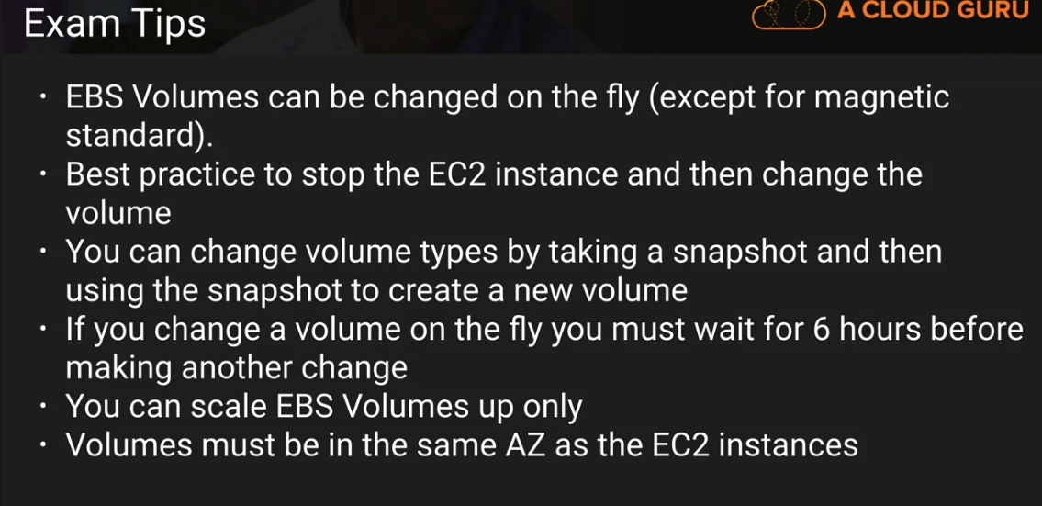

EFS LAB:

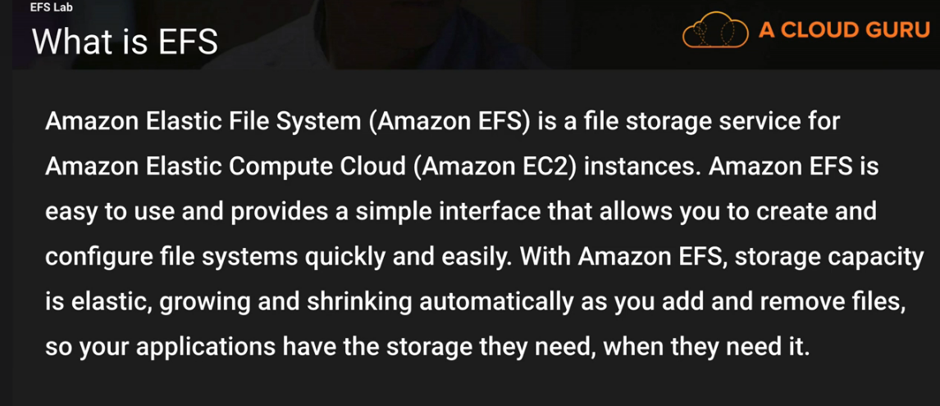

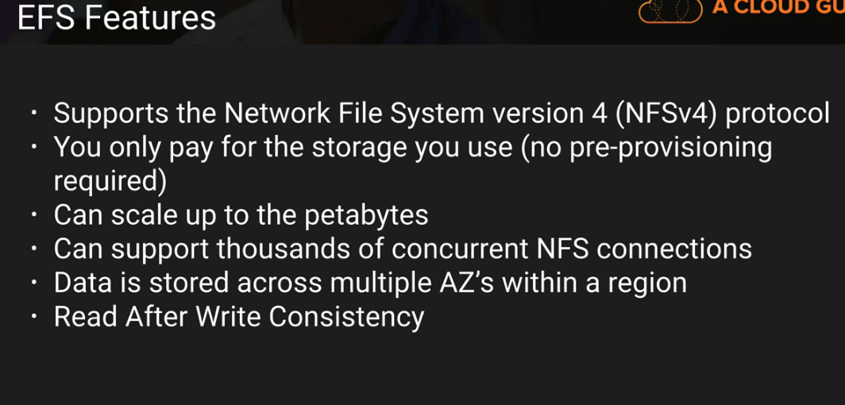

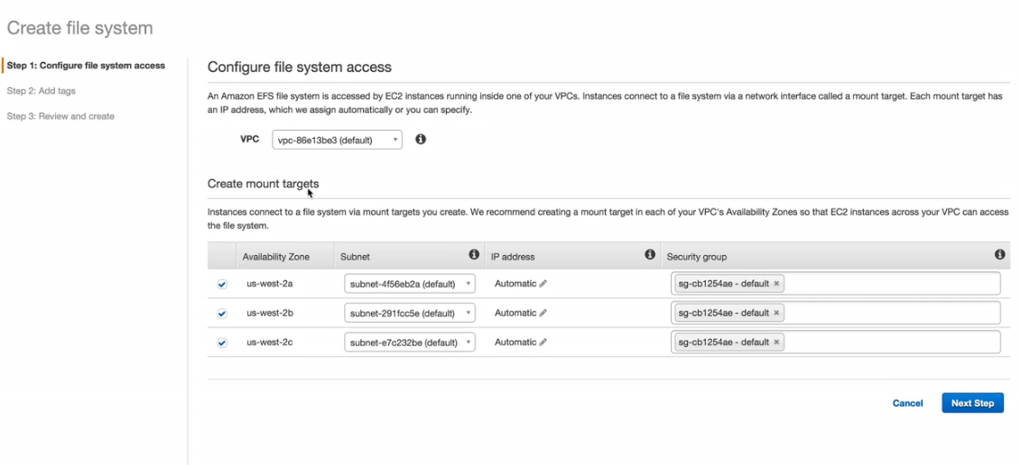

AWS CLI

Terminate the existing instances and then create a new one.
Once the terminal is created we need to connect to the terminal

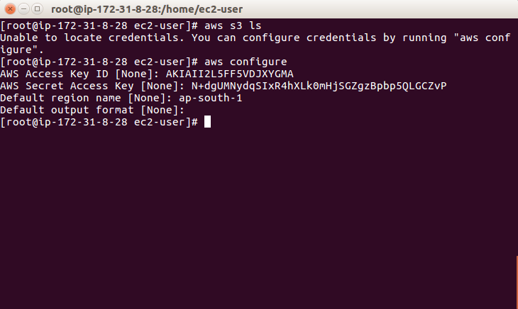
To check the instances running we need to execute the following command

aws ec2 describe-instances
to terminate the instance from the command line it is
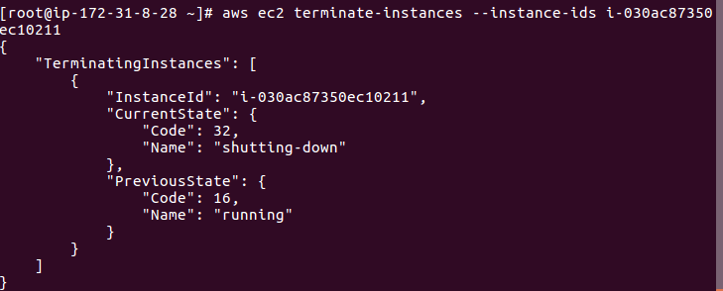
aws ec2 describe-images

AWS CLI USING ROLES:

Login into the IAM service
Delte the existing Role in IAM
Create a new Role and attach the policy to that role
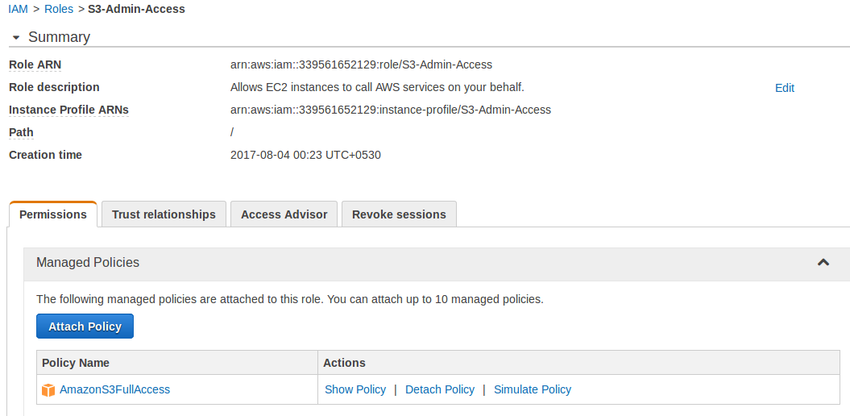

At the time of creating the policy attach the role to the policy.

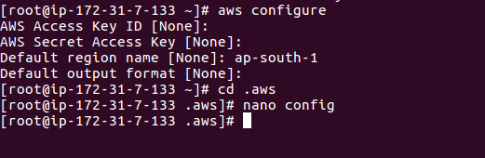

When we do that nano config on the .aws folder we do not have the secret key and the access id which is a big security risk when we upload the config to git anyone can get hold of the access key secret id and password they can ssh into your ec2 a/c.

CLI Commands for the Developer Exam.

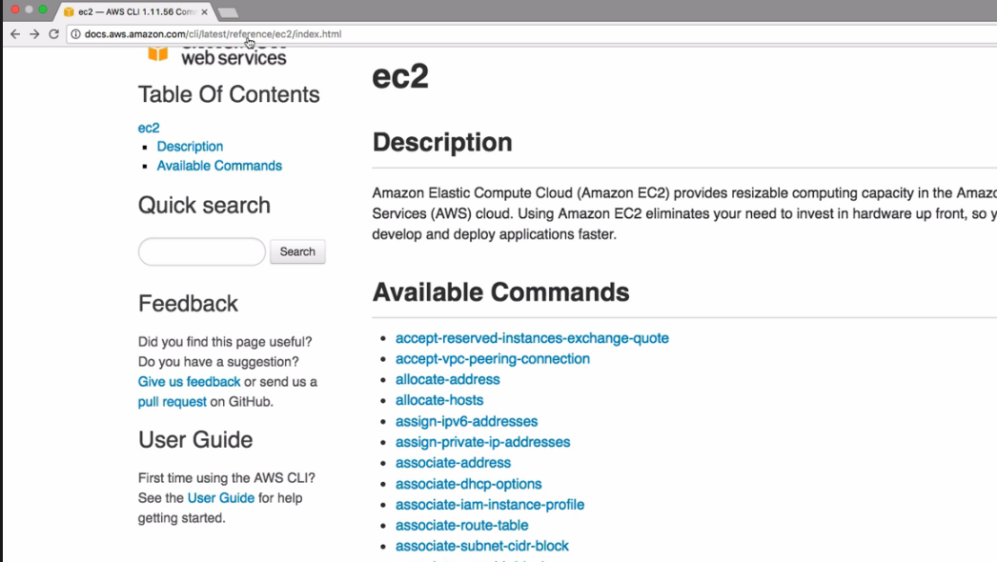

1) aws ec2 describe-instances
2) aws ec2 describe-images
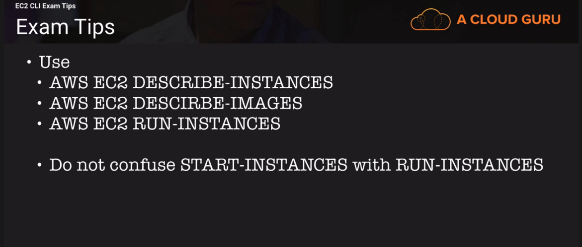

S3 CLI Regions

Create an EC2 instance.
Launch the instance once the instance is created.

1) aws s3 ls
2) To copy the contents from a particular bucket to the home drive.

3) We need to copy the files from a particular location to the home drive with the region feild.
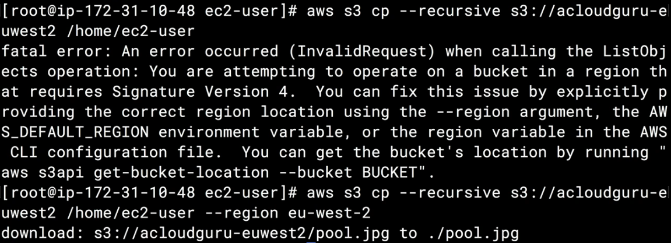
We ahve to use the region flag as a practice.

Bash Scripting LAB

We need to create an instance in EC2.
Create an index.html file
Create an S3 bucket and upload the file to the bucket.

During the creation of an EC2 instance we go to the “Advance Details” and then put the details in the text field given as below.
Write the following bash script as below:
#!/bin/bash
yum update -y
yum install httpd -y
service httpd start
chkconfig httpd on
aws s3 cp s3://mywebsitev.index.html /var/www/html

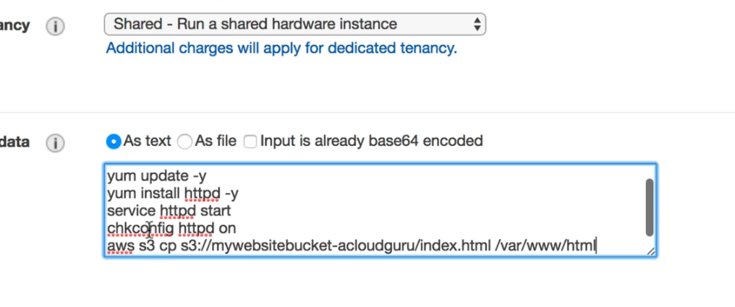
Create the appropriate security groups before the creation of the above instance.
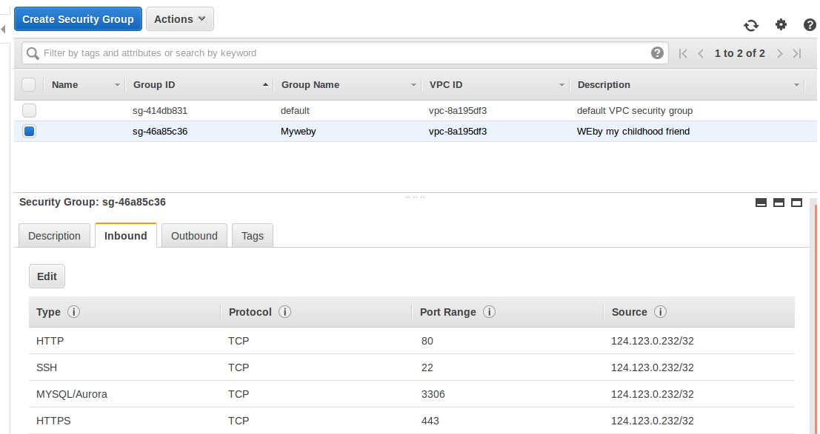

Launch the instance and check the creation of the same by launching the website.
The index.html file contents should be shown in the browser.

Installing PHP and Composer

Create the EC2 instance.
Login into the EC2 instance through SSH.

We add the following lines of code in the Advance Details to ensure that the EC2 instance starts at the launch

#!/bin/bash
yum update -y
yum install httpd24 php56 git -y
service httpd start
chkconfig httpd on
cd /var/www/html
echo "<?php phpinfo();?>" > test.php
git clone https://github.com/acloudguru/s3
When we start the instance we can check the installation of apache with the following commands
service httpd status

we also see that the GIT is cloned in /var/www/html

Should be in the /var/www/html directory.
1. Install the composer:
curl -sS https://getcomposer.org/installer | php
2. Run the Composer command to install the latest stable version of the SDK:
php composer.phar require aws/aws-sdk-php

Using PHP SDK to access S3

Connect To AWS

<?php
// Include the SDK using the Composer autoloader
require '/var/www/html/vendor/autoload.php';
$client = new Aws\S3\S3Client([
'version' => 'latest',
'region' => 'us-east-1'
]);
?>

Create Bucket using PHP
<?php
//copyright 2015 - A Cloud Guru.
//connection string
include 'connecttoaws.php';

// Create a unique bucket name
$bucket = uniqid("acloudguru", true);
// Create our bucket using our unique bucket name
$result = $client->createBucket(array(
'Bucket' => $bucket
));
//HTML to Create our webpage
echo "<h1 align=\"center\">Hello Cloud Guru!</h1>";
echo "<div align = \"center\"><img src=\"https://acloud.guru/images/logo-small-optimised.png\"></img></div>";
echo "<h2 align=\"center\">You have successfully created a bucket called {$bucket}</h2>";
echo "<div align=\"center\"><a href=\"createfile.php?bucket=$bucket\">Click Here to Continue</a></div>";
?>

Create File
<?php
//Copyright 2015 A Cloud Guru

//Connection string
include 'connecttoaws.php';

/*
Files in Amazon S3 are called "objects" and are stored in buckets. A specific
object is referred to by its key (or name) and holds data. In this file
we create an object called acloudguru.txt that contains the data
'Hello Cloud Gurus!'
and we upload/put it into our newly created bucket.
*/

//get the bucket name
$bucket = $_GET["bucket"];

//create the file name
$key = 'cloudguru.txt';

//put the file and data in our bucket
$result = $client->putObject(array(
'Bucket' => $bucket,
'Key' => $key,
'Body' => "Hello Cloud Gurus!"
));

//HTML to create our webpage
echo "<h2 align=\"center\">File - $key has been successfully uploaded to $bucket</h2>";
echo "<div align = \"center\"><img src=\"https://acloud.guru/images/logo-small-optimised.png\"></img></div>";
echo "<div align = \"center\"><a href=\"readfile.php?bucket=$bucket&key=$key\">Click Here To Read Your File</a></div>";
?>

Delete File

<?php

//Connection String

include'connecttoaws.php';

//Code to get our bucketname and file name

$bucket = $_GET["bucket"];

$key = $_GET["key"];

//buckets cannot be deleted unless they are empty

//Code to delete our object

$result = $client->deleteObject(array(

'Bucket' => $bucket,

'Key' => $key

));

//code to tell user the file has been deleted.

echo "<h2 align=\"center\">Object $key successfully deleted.</h2>";

//Code to delete our bucket

$result = $client->deleteBucket(array(

'Bucket' => $bucket

));

//code to create our webpage.

echo "<h2 align=\"center\">Bucket $bucket successfully deleted.</h2>";

echo "<div align = \"center\"><img src=\"https://acloud.guru/images/logo-small-optimised.png\"></img></div>";

echo "<h2 align=\"center\">Good Bye Cloud Gurus!</h2>";

?>

EC2 Instance Meta Data

For the EC2 Instance Metadata we do the following

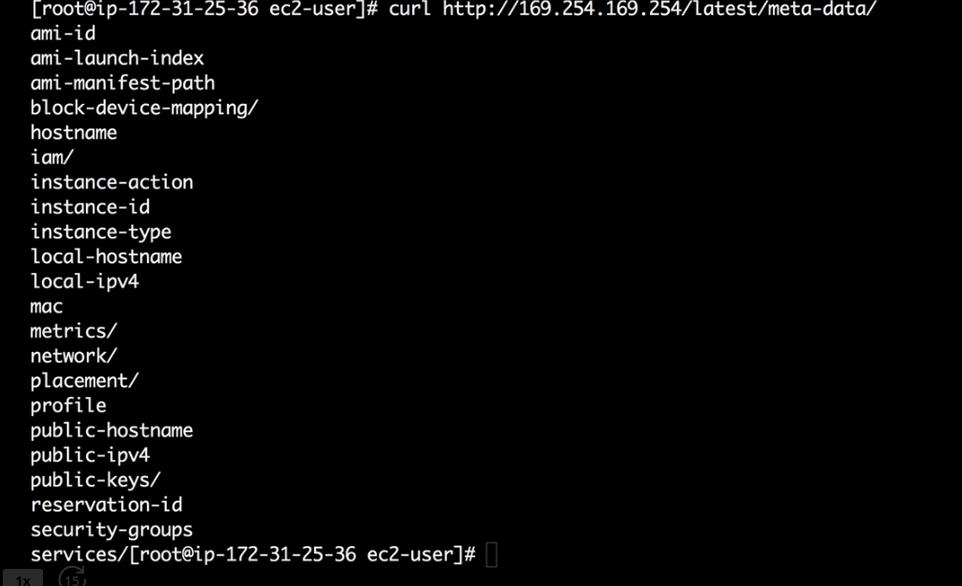

Elastic Load Balancers

Create an EC2 Instance
Install http server
start the http server
in /var/www/html folder create the html files index.html and healthcheck.html

We need to go back to the EC2 instance and do the following

1) Create an laod balancer by clicking on the load balancer
2) in the response page that comes up we click on the button on the top “Create Load Balancer”
3) There are two types of load balancers a) Application Load Balancer b) Classic Load Balancer
4) Choose the Classic Load Balancer
5) Configure the load balancer
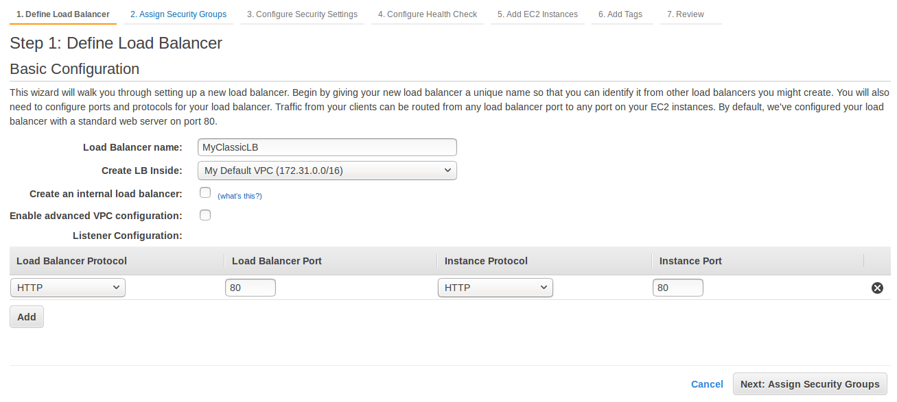
6) Assign Security Groups
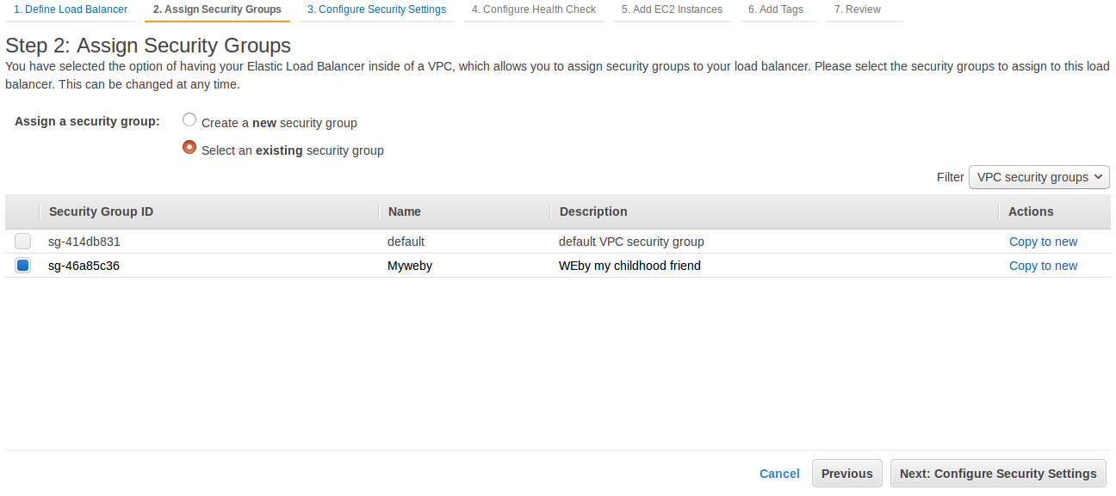
7) Ignore the error that is on “Configure Security Settings”

8) Click on “Configure Health Check”
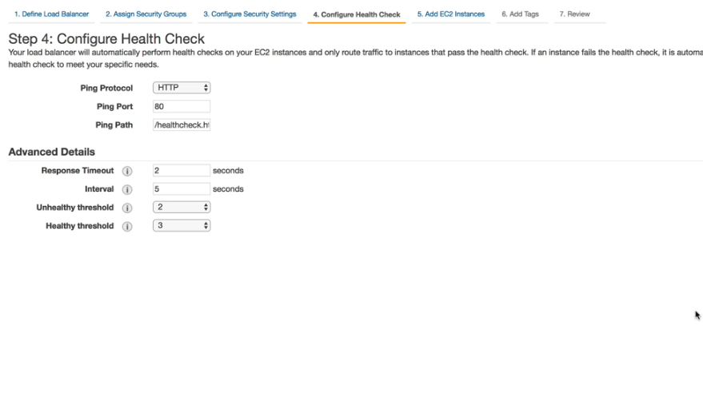
9) Add the EC2 instances that are displayed.
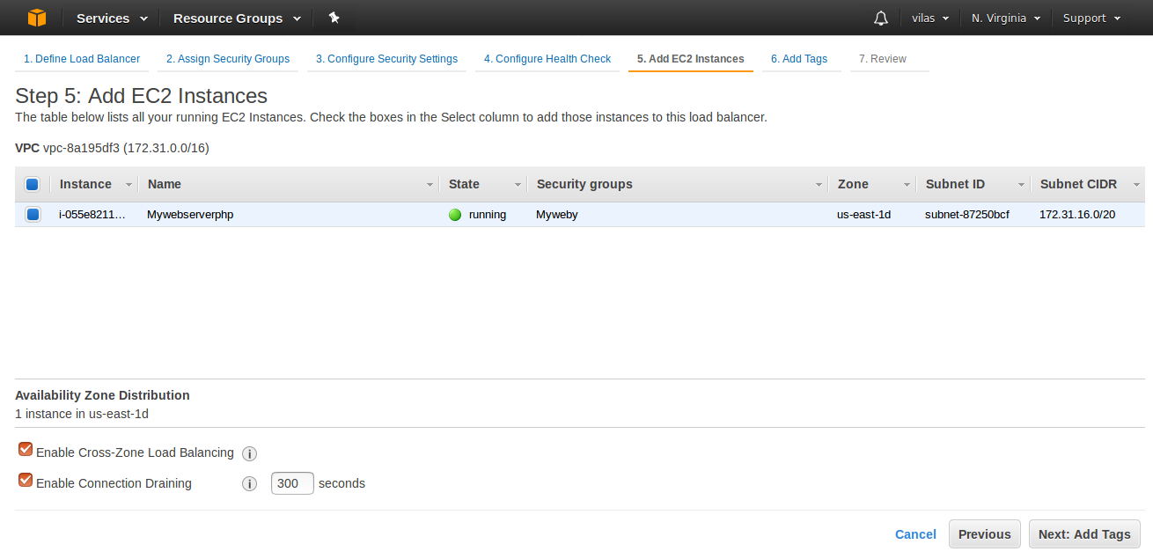

10) Add Tags

11) Once the EC2 instance is added it turns from “Out Of Service “ to “In Service”
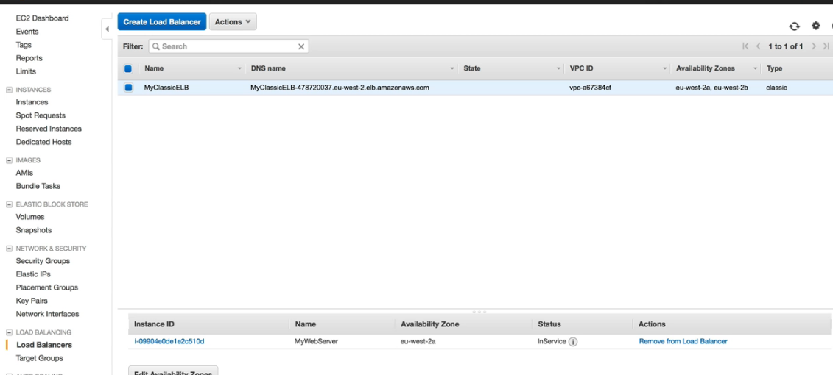

For the Load balancer will get only the DNS names.
WE do not get the public ipd address.

Application Load Balancers

Synopsys:
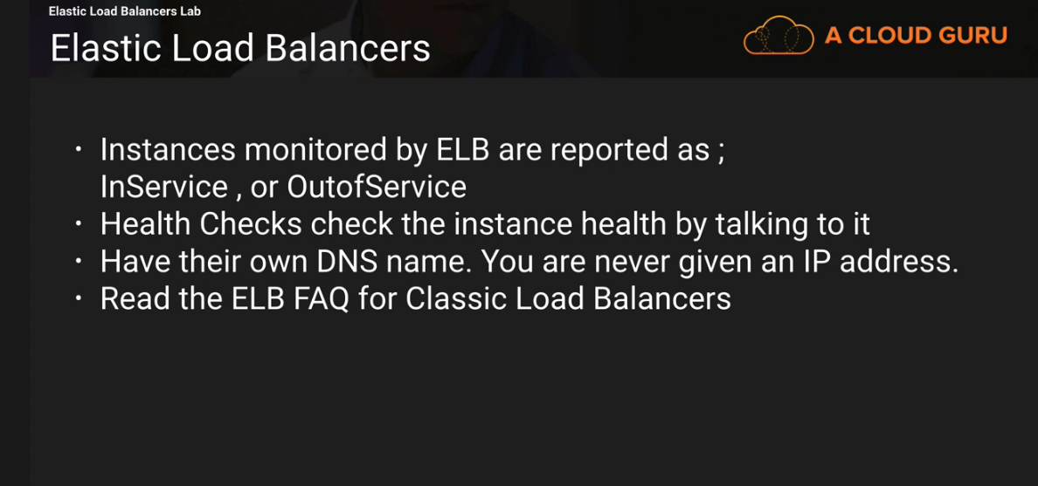

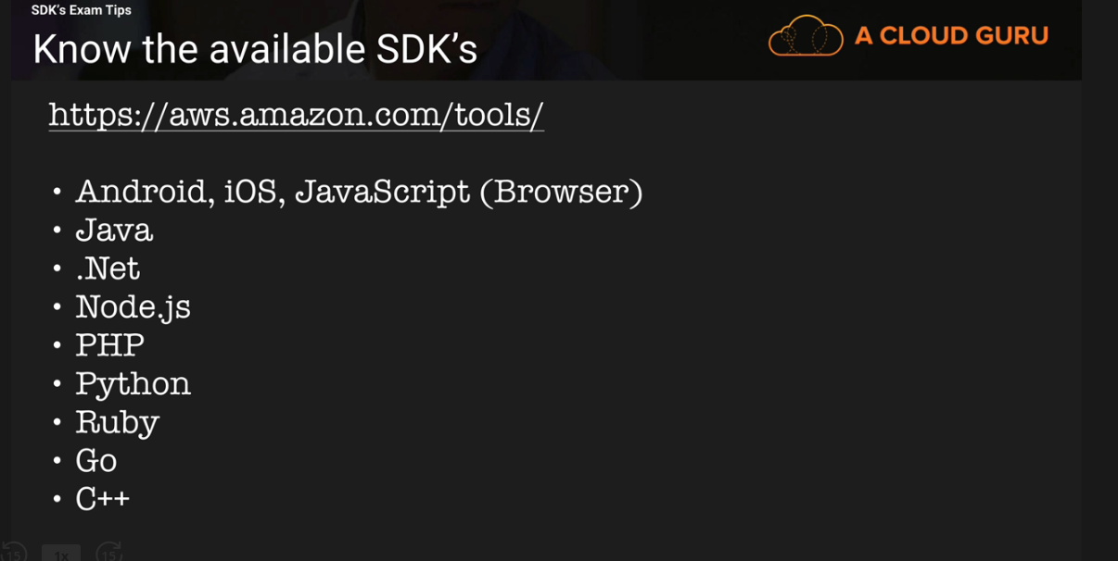

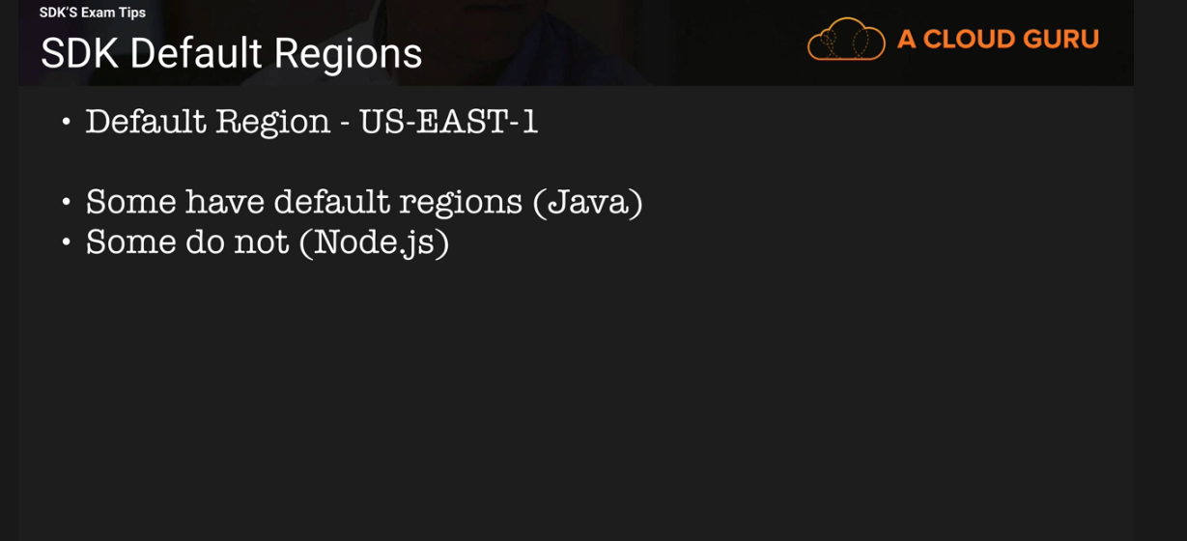

LAMBDA

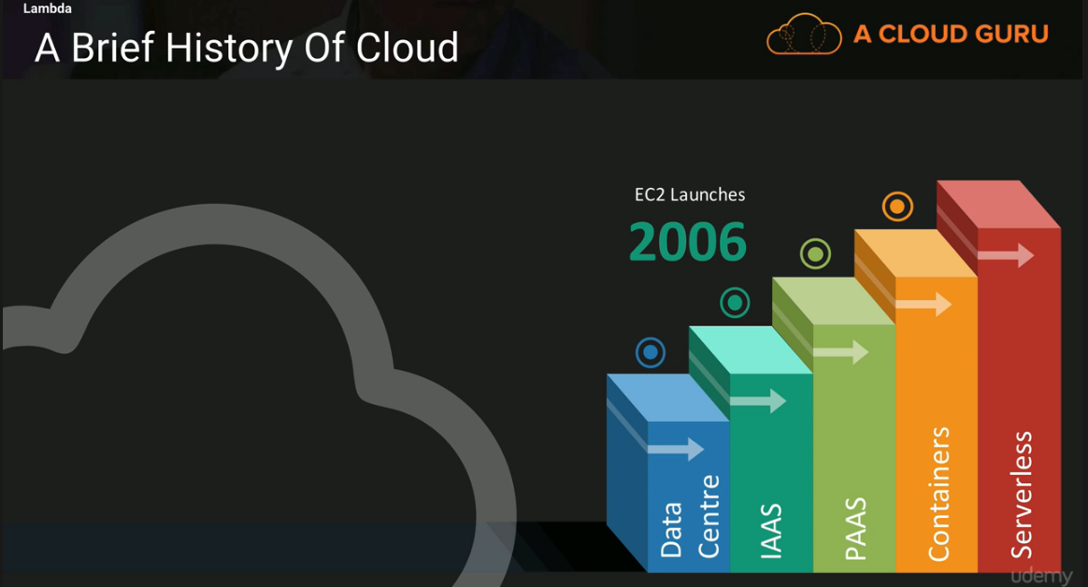

Worry about code and uplaod to Lambda

Encapulating Datacenter / IAAS/PAAS /Containers
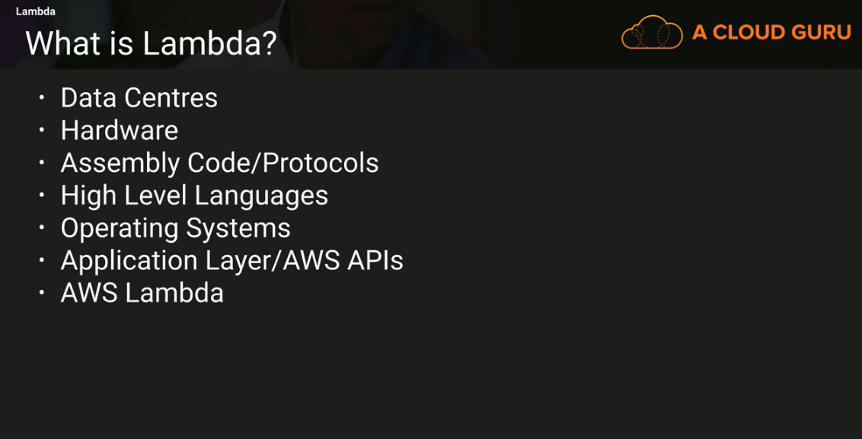
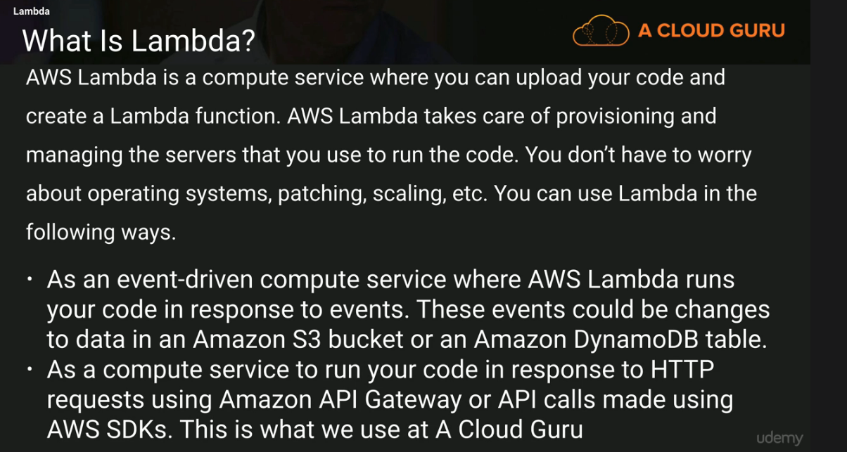

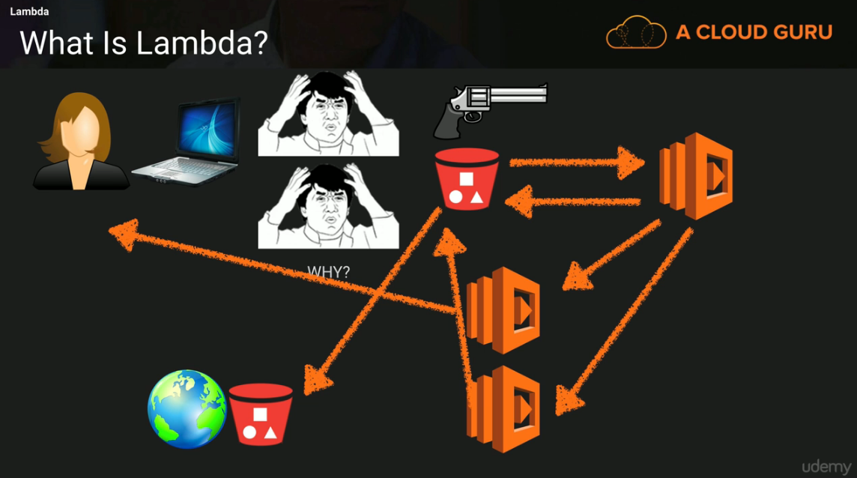

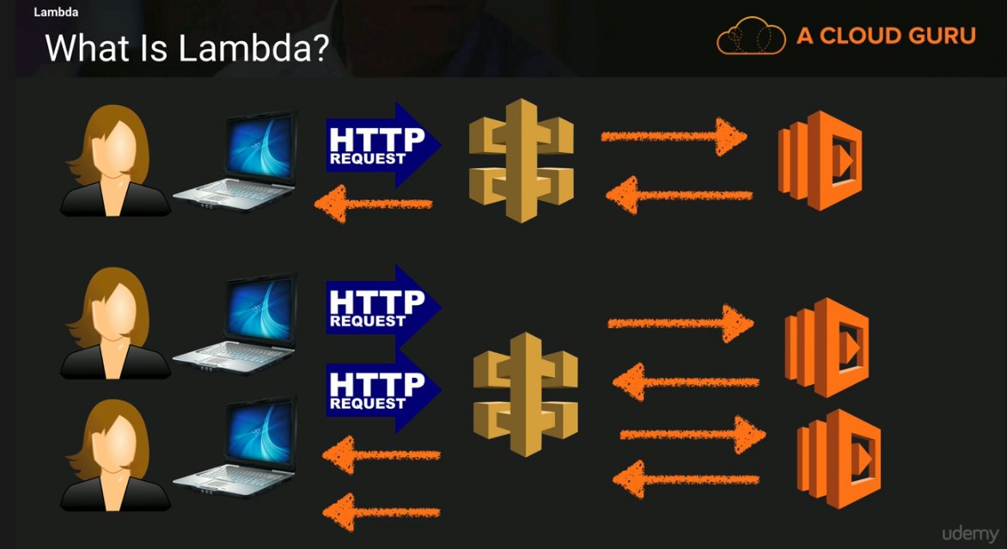

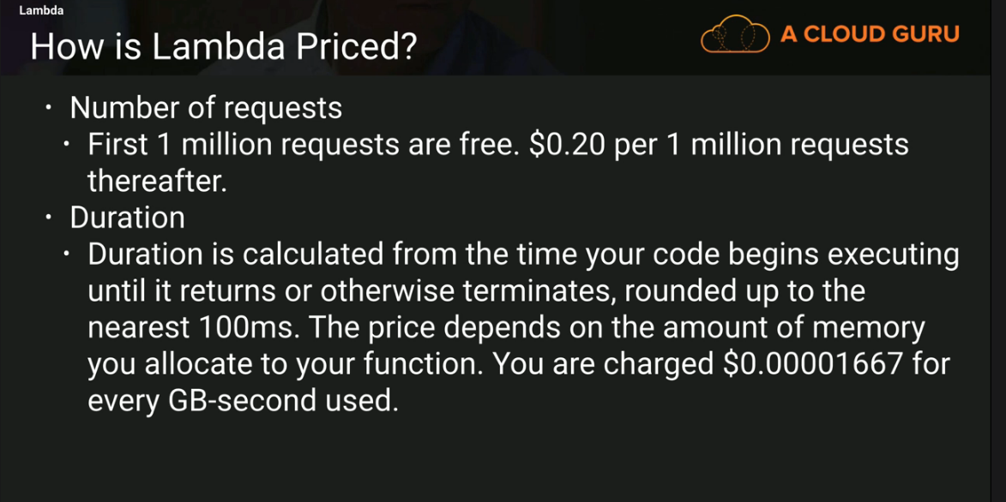

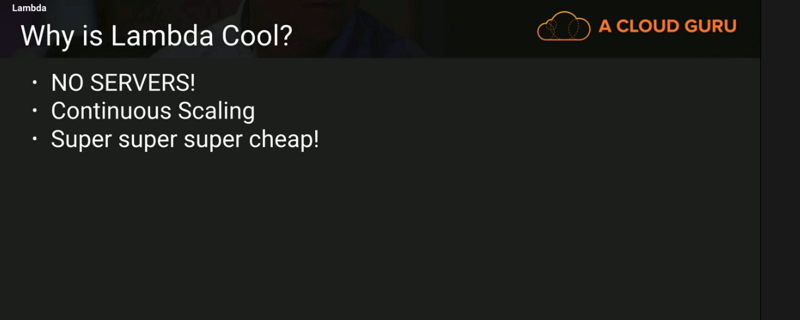

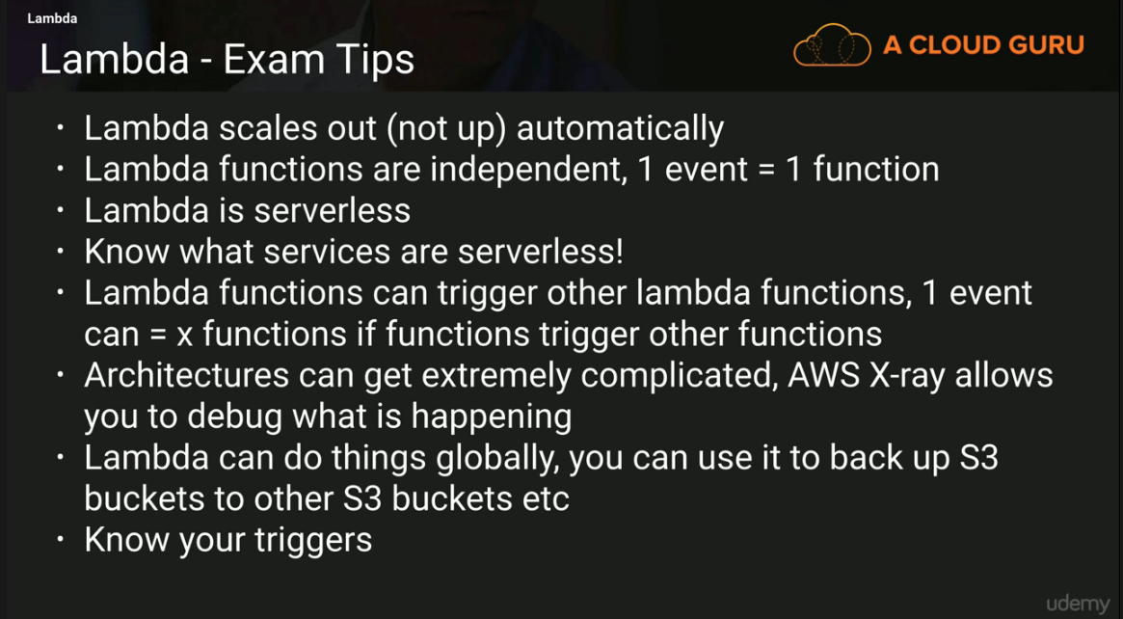

Summary EC2

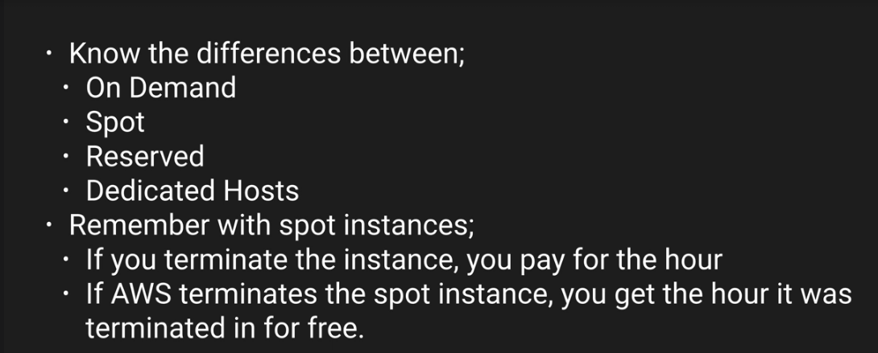

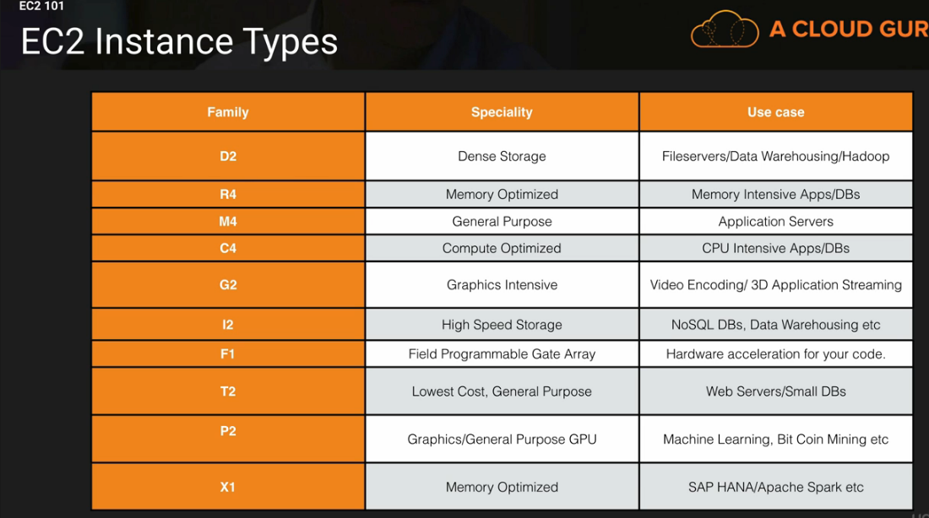

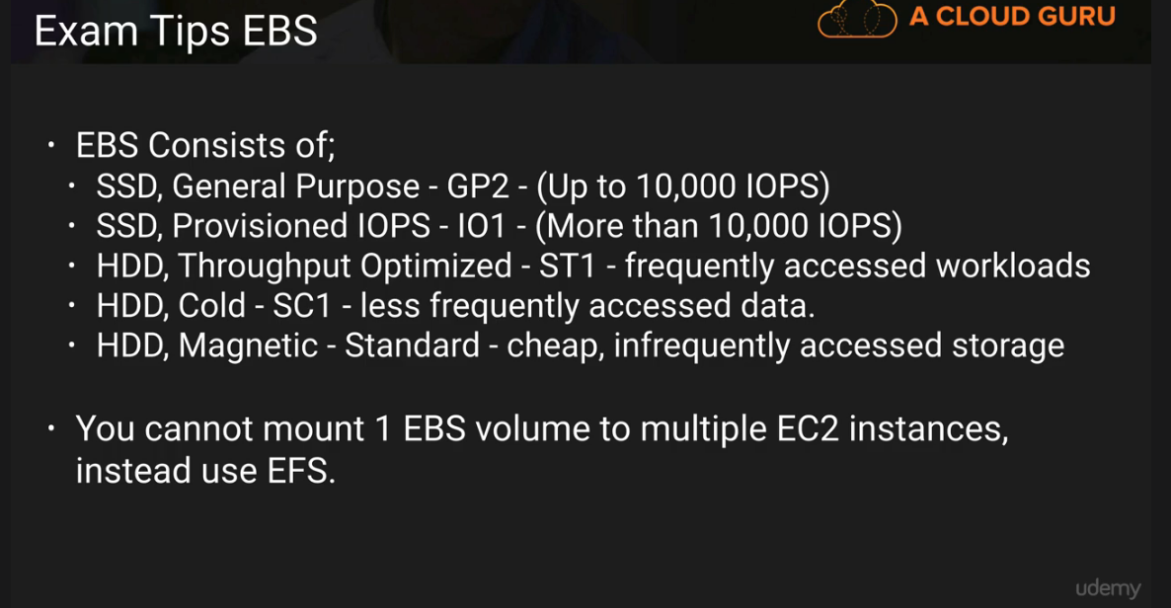

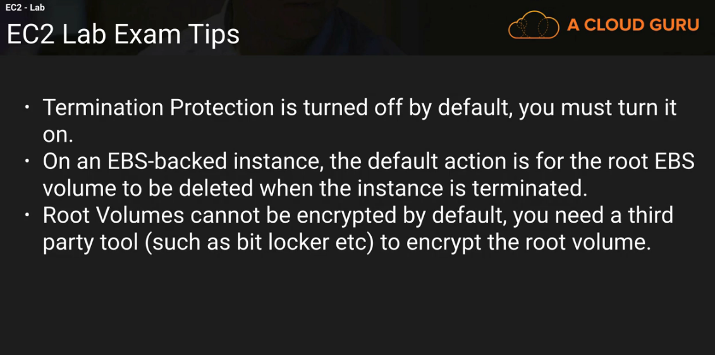

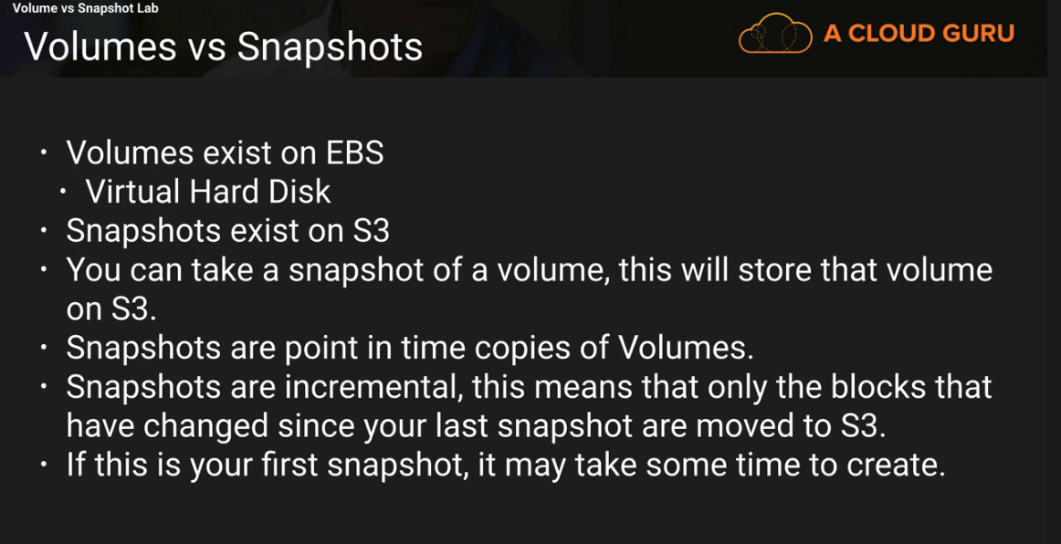

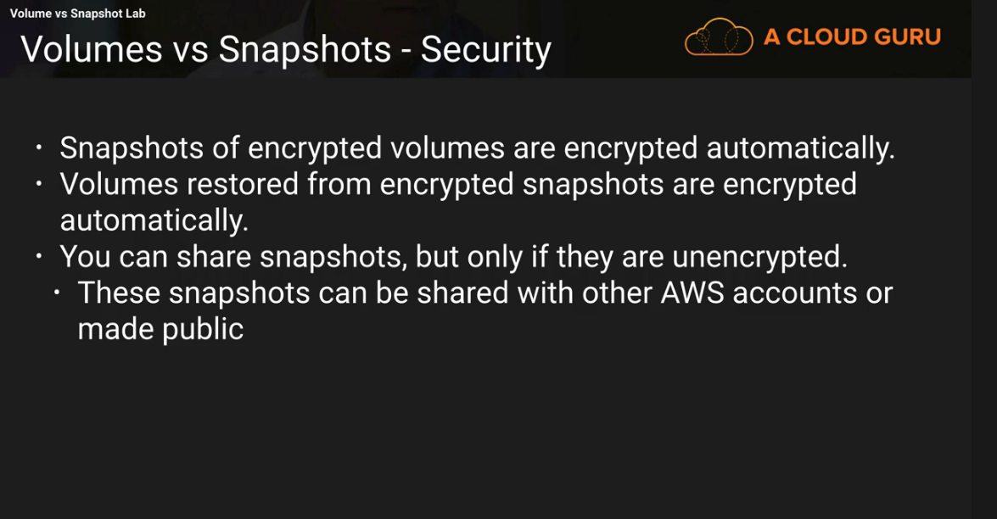

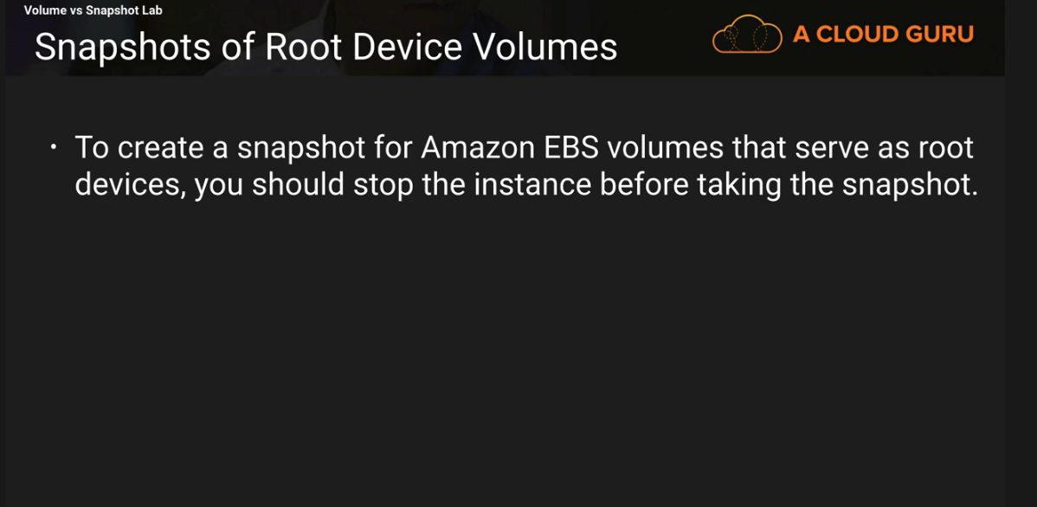

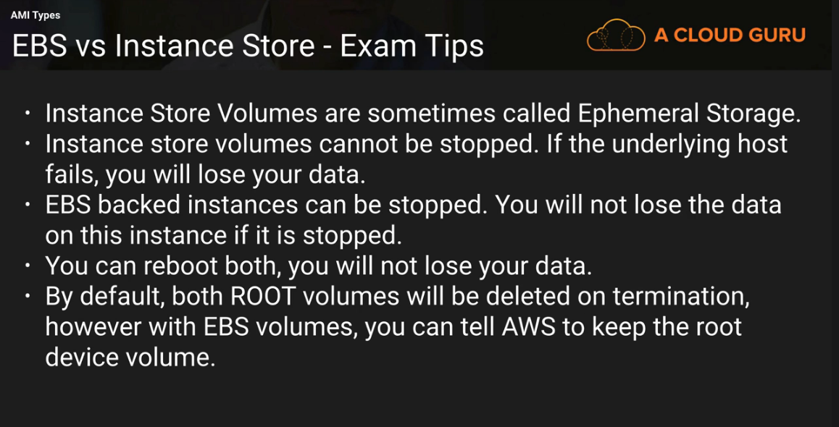

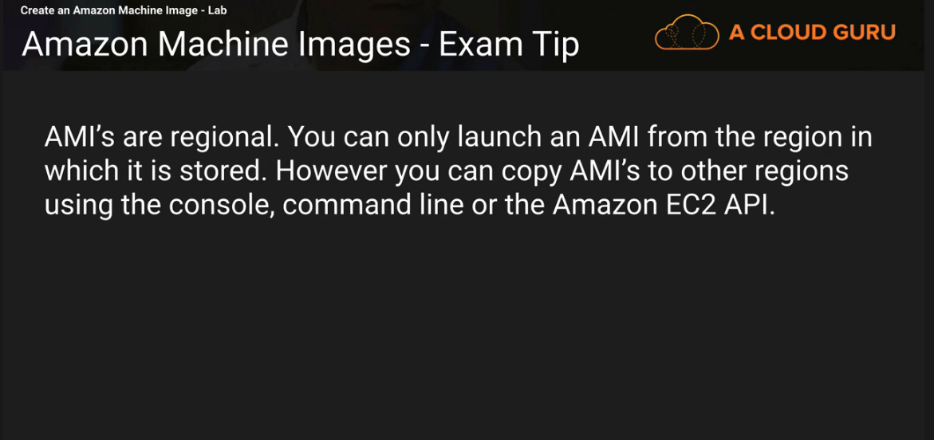

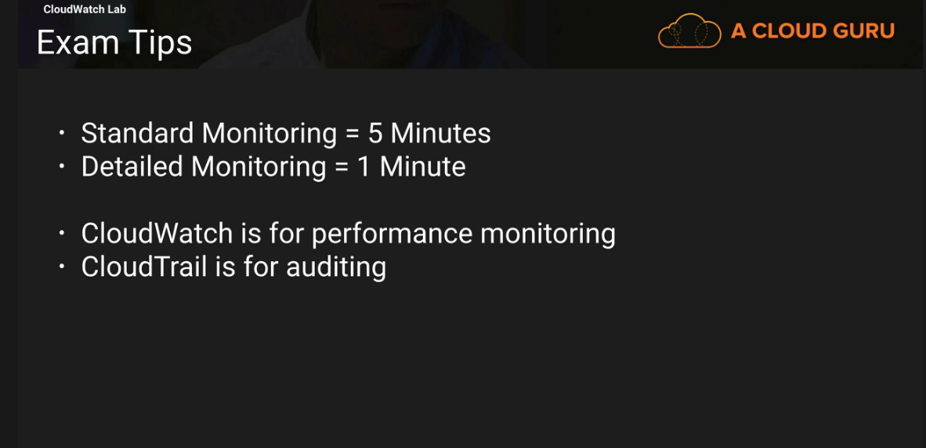

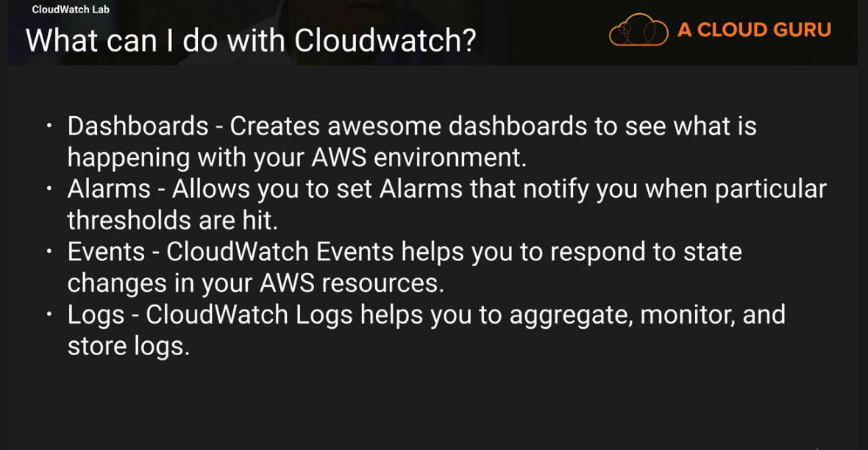

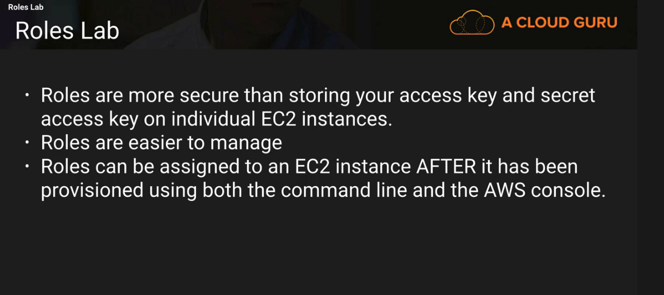

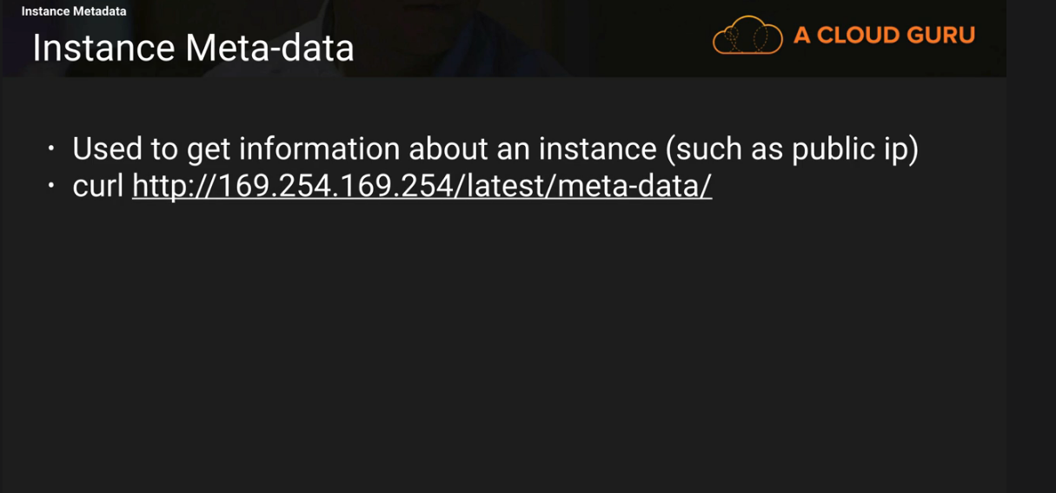

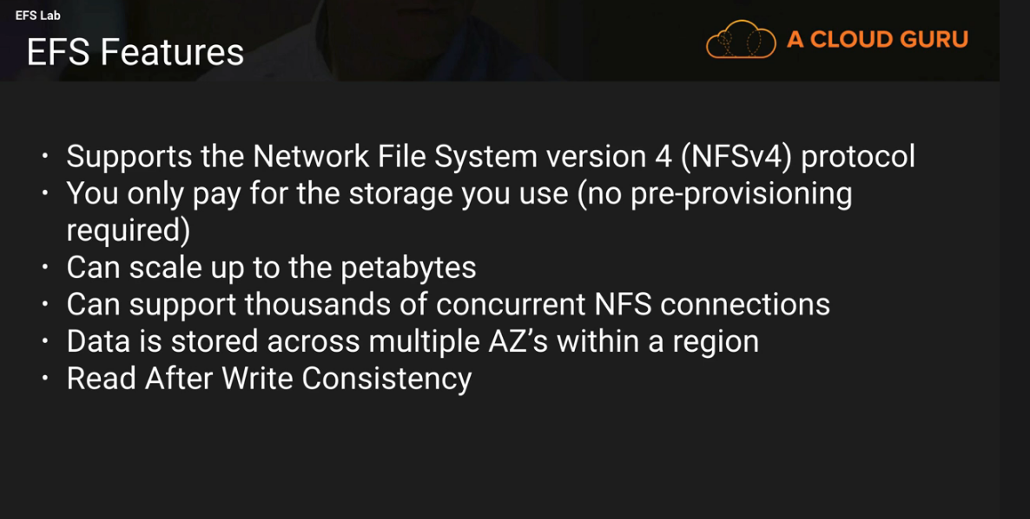

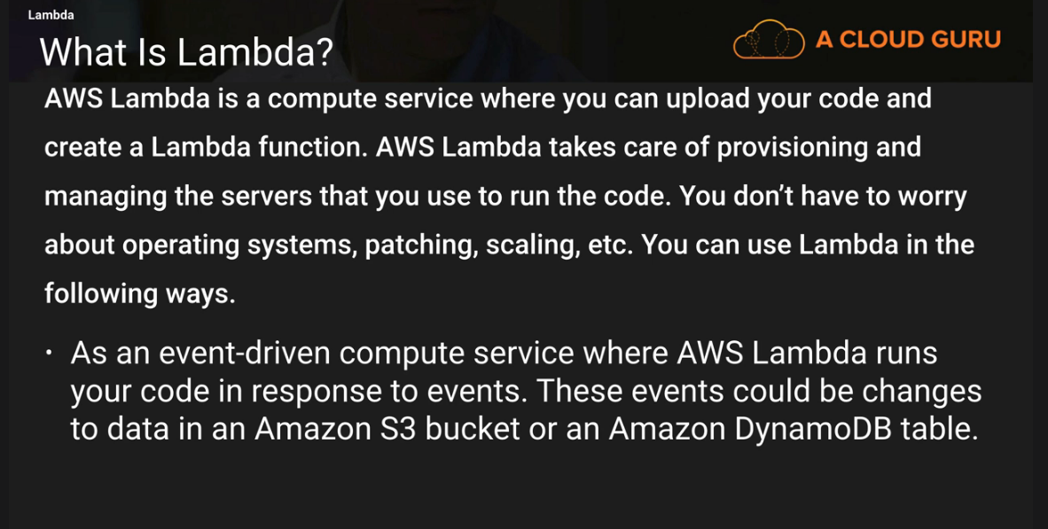

S3- 101
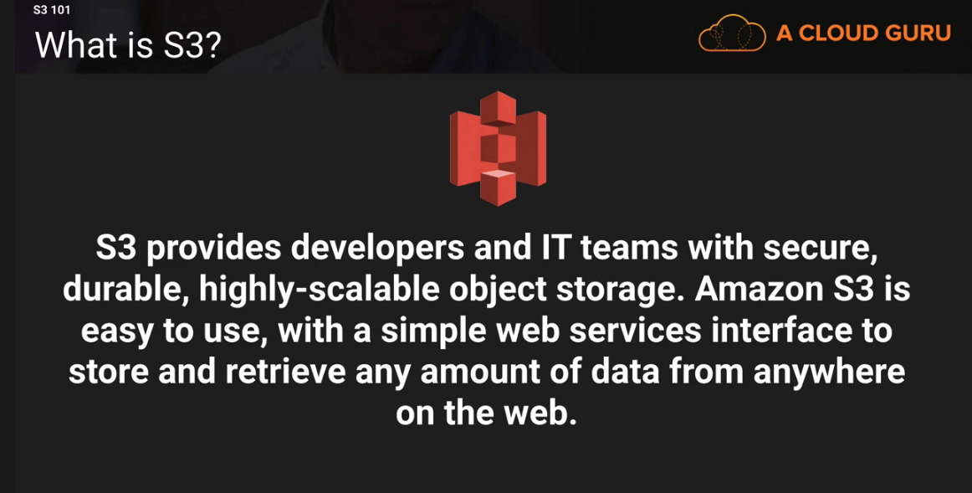

S3 – Simple Storage Space.
This is used to store files in the cloud computing space.
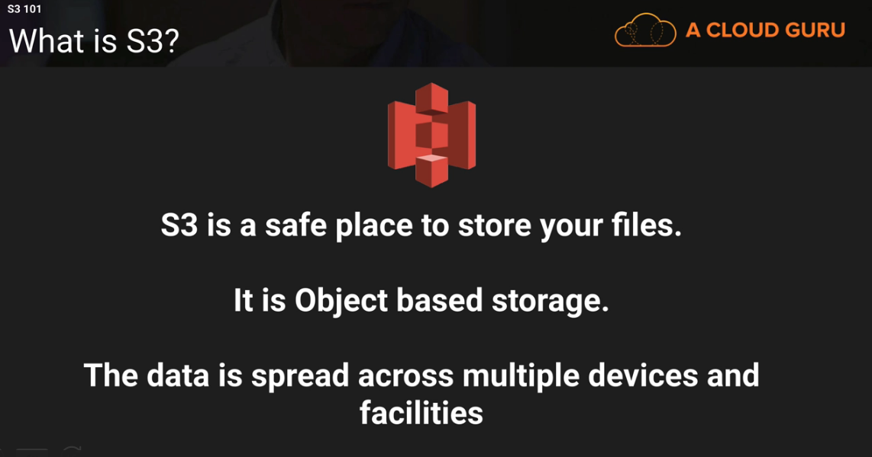

Object – is an file, picture.
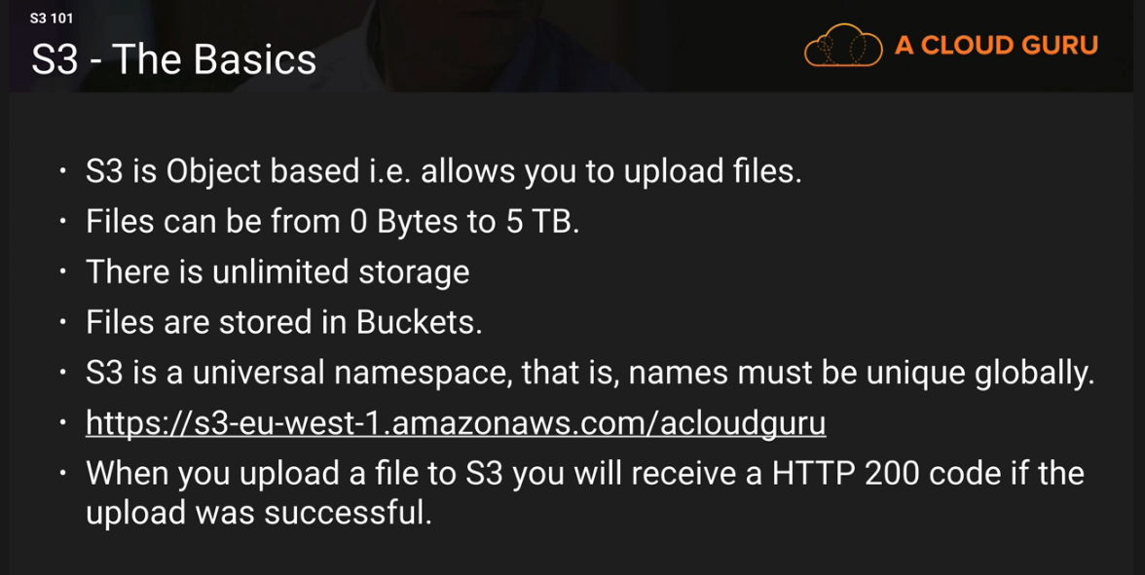
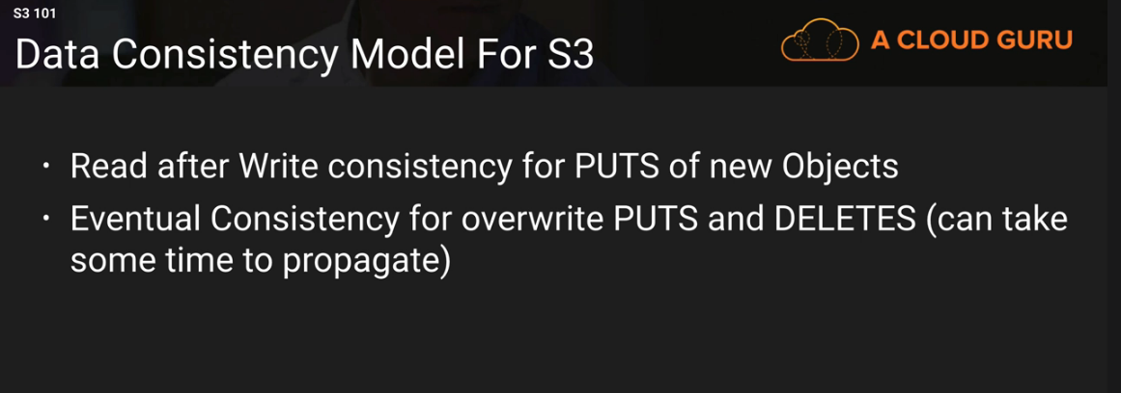

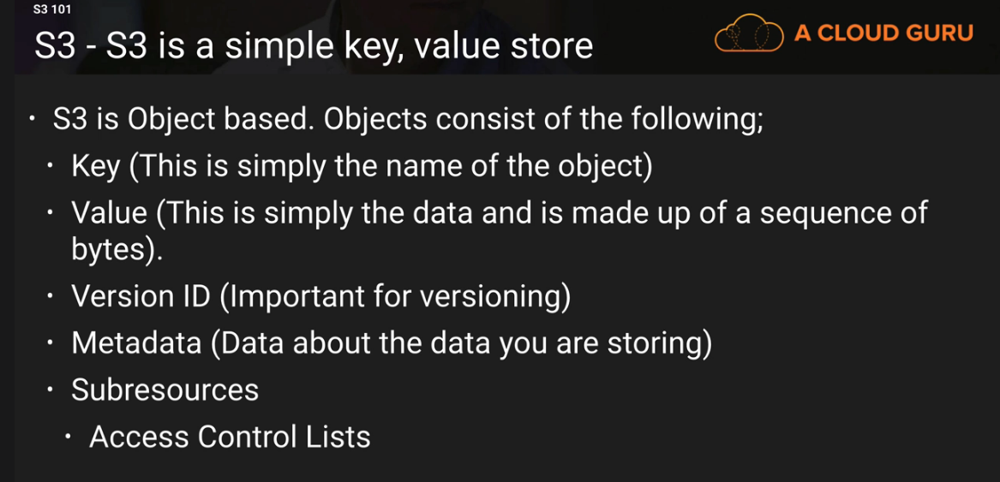
Also support Torrent.

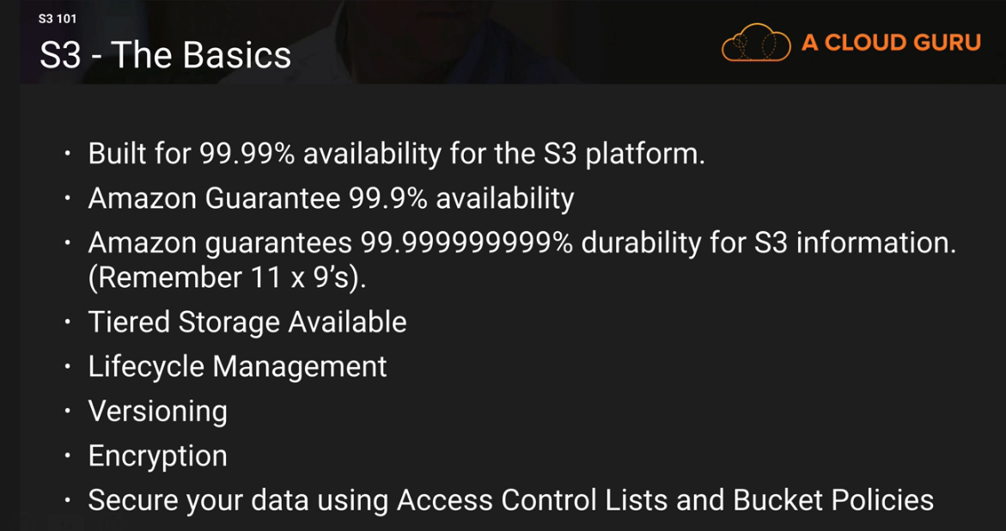

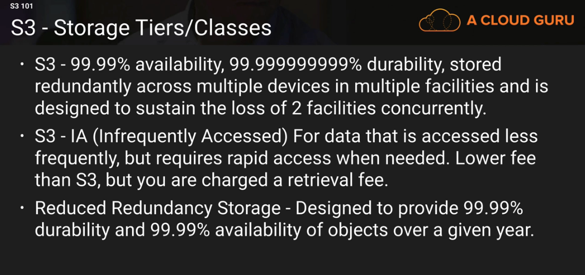
Glacier – IS very cheap , but it is used for archival only. It takes 3 – 5 hours to restore from Glaciar.

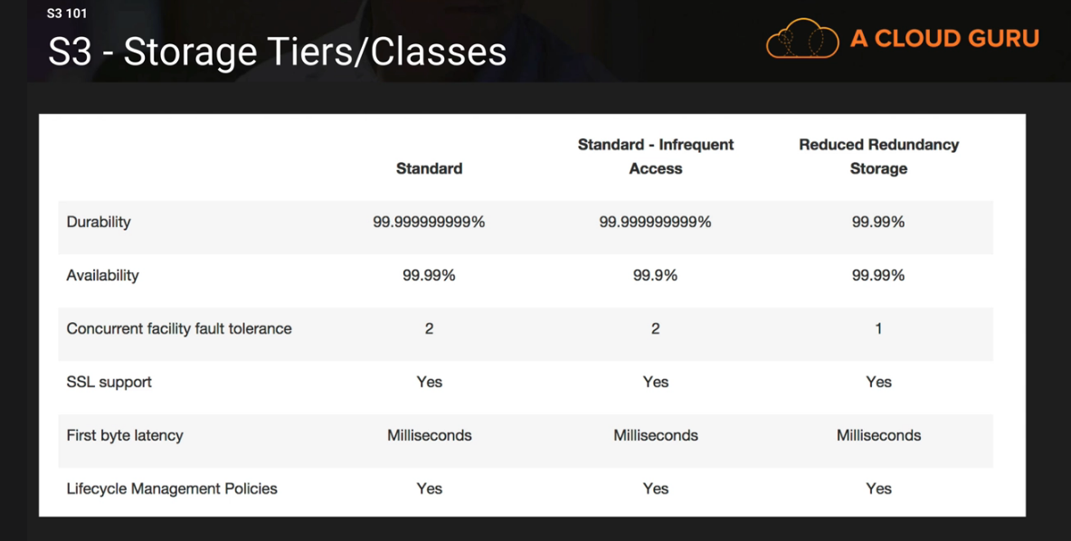

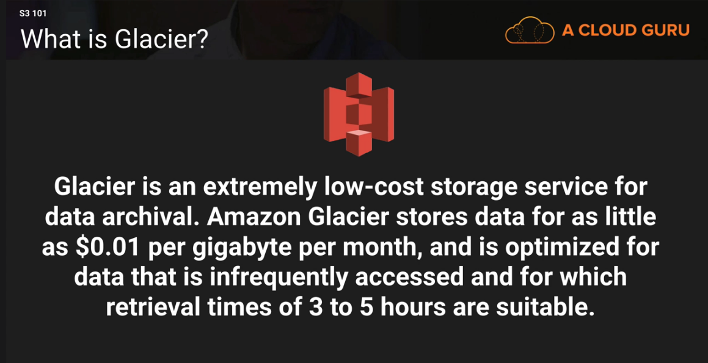

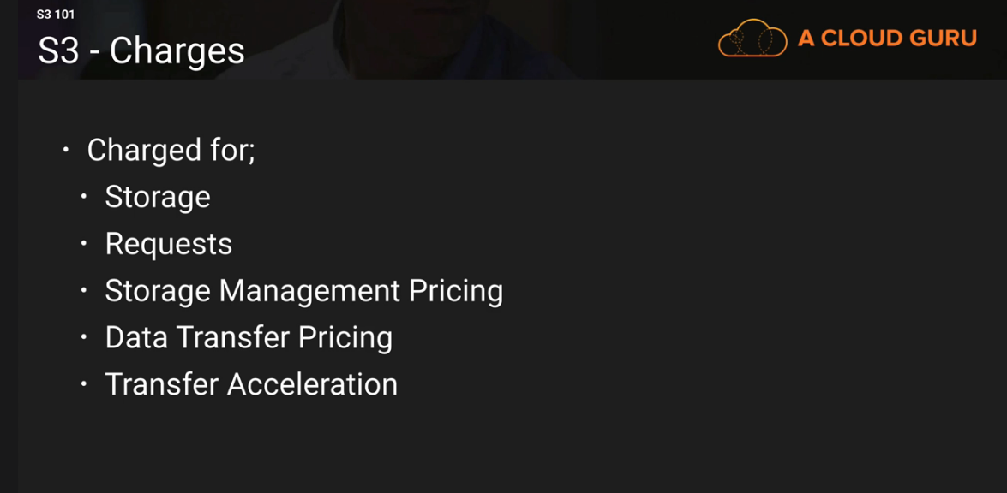

What is Transfer Acceleration:

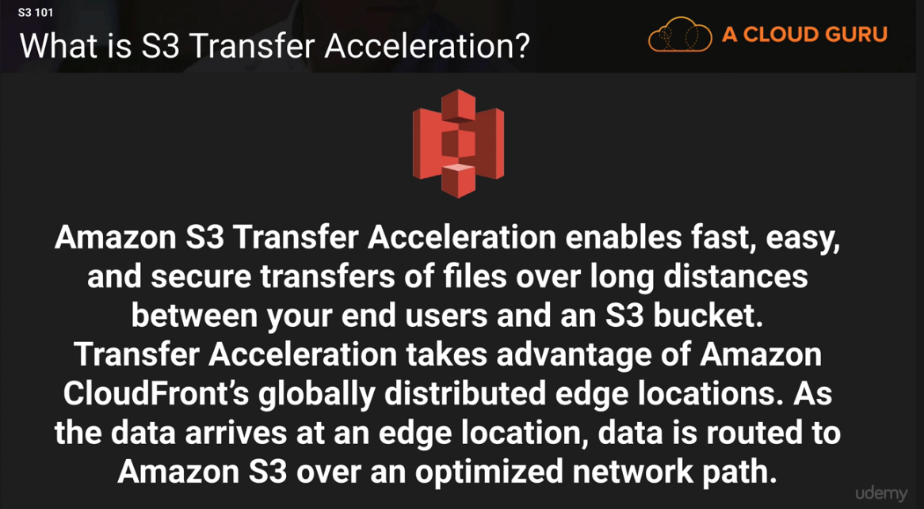

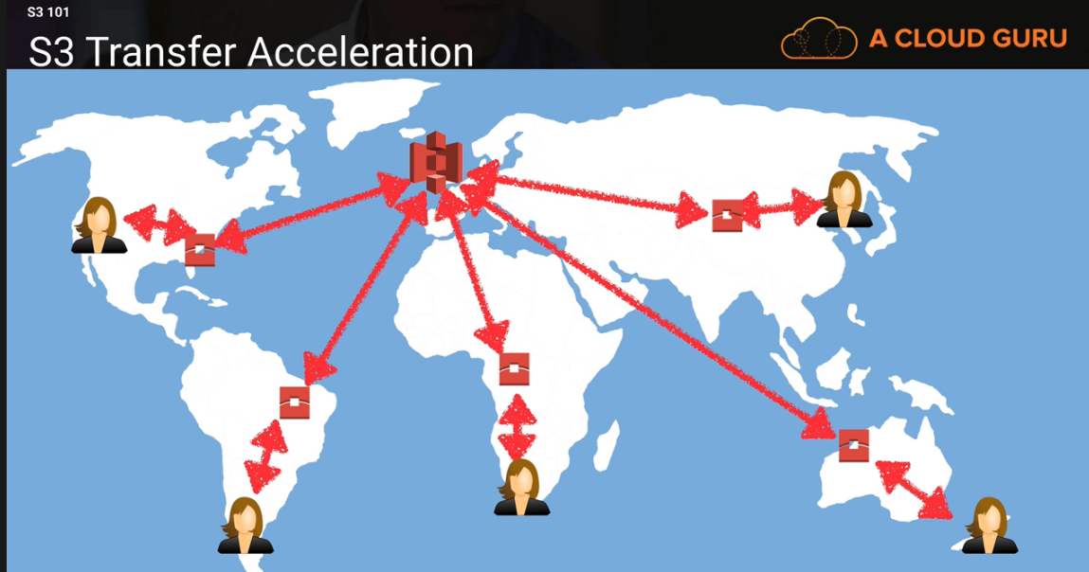

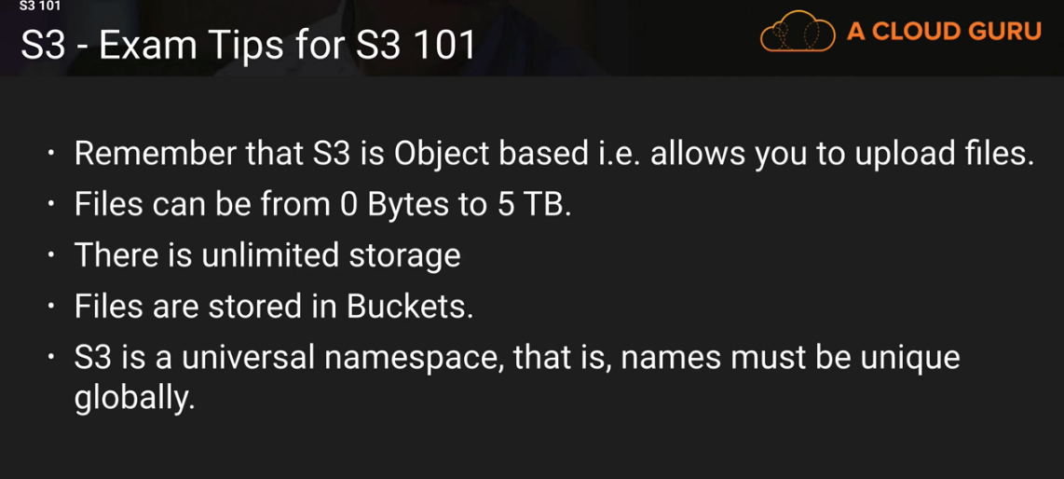
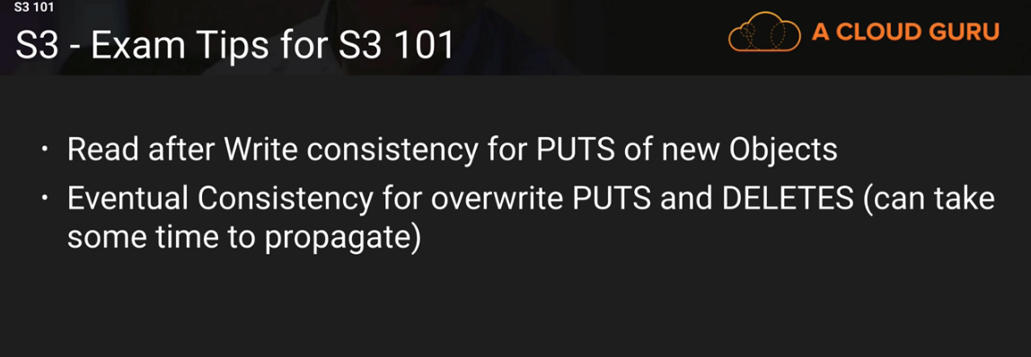
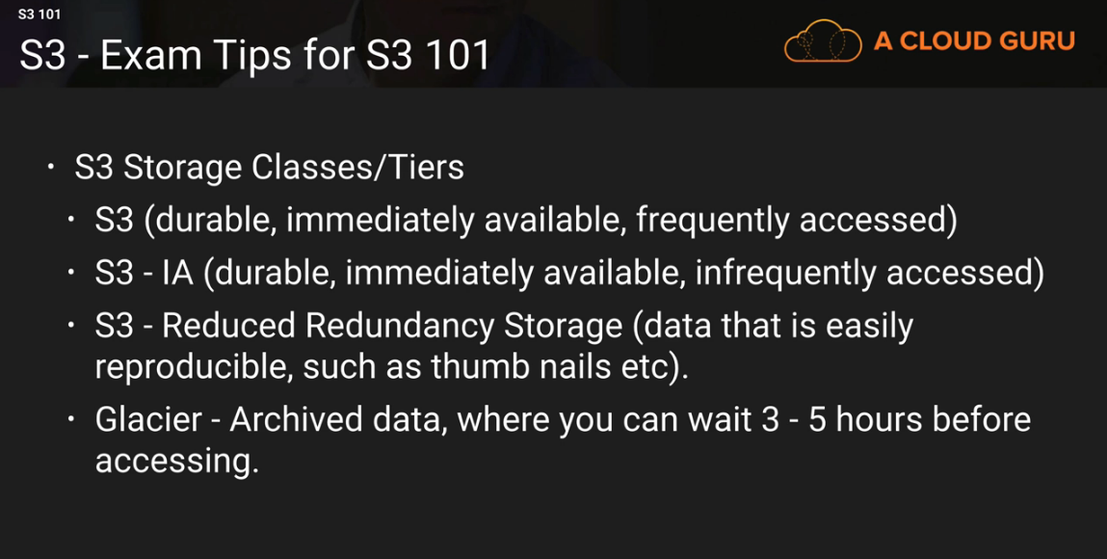

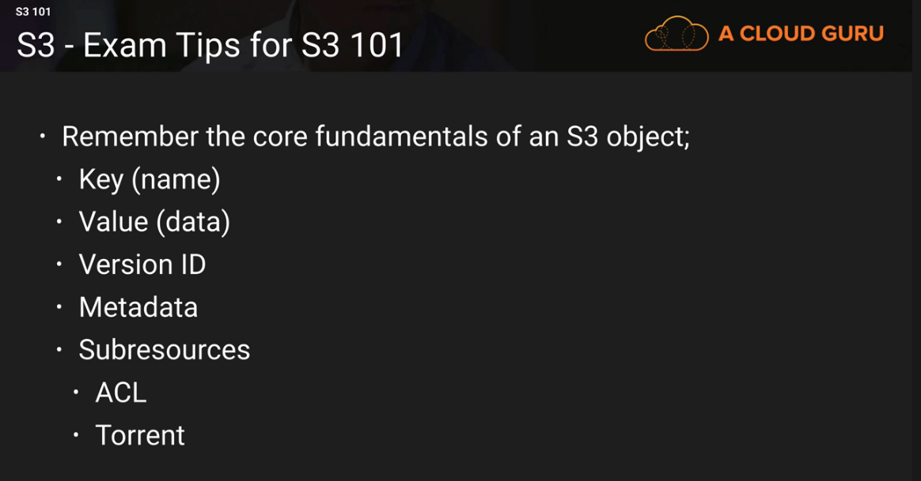

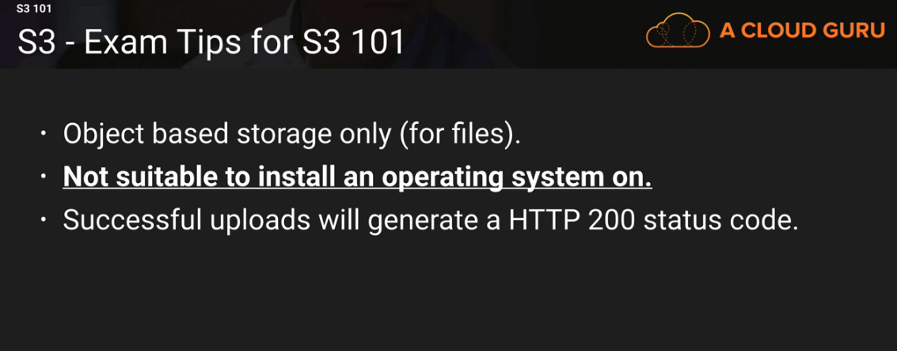

Create a Static Website
1) Create an

