Spring Form Validation:

Creating the Model:

package com.vilas.userlogin.Model;

public class Employee {

private int id;
private String name;
private float salary;
private String designation;

public Employee(){}

public Employee( int id, String name, float salary, String designation){
this.id = id;
this.name = name;
this.salary = salary;
this.designation = designation;
}

public int getId() {
return id;
}

public void setId(int id) {
this.id = id;
}

public String getName() {
return name;
}

public void setName(String name) {
this.name = name;
}

public float getSalary() {
return salary;
}

public void setSalary(float salary) {
this.salary = salary;
}

public String getDesignation() {
return designation;
}

public void setDesignation(String designation) {
this.designation = designation;
}

}

Creating the Controller:

package com.vilas.userlogin;

import org.springframework.stereotype.Controller;

import org.springframework.ui.ModelMap;
import org.springframework.web.bind.annotation.ModelAttribute;
import org.springframework.web.bind.annotation.RequestMapping;
import org.springframework.web.bind.annotation.RequestMethod;
import org.springframework.web.servlet.ModelAndView;

import com.vilas.userlogin.Model.Employee;

@Controller
public class EmployeeController {

@RequestMapping(value ="/showempform" ,method=RequestMethod.GET)
public ModelAndView showEmpForm(ModelMap model){

String message = " Please enter the details related to the Employee";
model.addAttribute("message", message);
return new ModelAndView("empform","empcommand",new Employee());

}

@RequestMapping(value="/save", method=RequestMethod.POST)
public ModelAndView showEmpDetails(@ModelAttribute("emp")Employee emp){
String message = "The Entered Details As Below";
ModelAndView model = new ModelAndView("showemp");
model.addObject("message", message);

return model;
}
}

Creating the View:

When we invoke the following URL : http://localhost:8080/userlogin/showempform

The for showempform is as follows and invokes the “empform.jsp” form as shown below:
<%@ page language="java" contentType="text/html; charset=UTF-8"
pageEncoding="UTF-8"%>
<%@ taglib uri="http://www.springframework.org/tags/form" prefix="form"%>

<!DOCTYPE html PUBLIC "-//W3C//DTD HTML 4.01 Transitional//EN" "http://www.w3.org/TR/html4/loose.dtd">
<html>
<head>
<meta http-equiv="Content-Type" content="text/html; charset=UTF-8">
<title>Employee Form</title>
</head>
<body>

<h2>${message}</h2>
<br>

<form:form action="save" method="POST" modelAttribute="empcommand">

<table>

<tr>
<td> Employee Id : </td>
<td><form:input path ="id" /> </td>

</tr>

<tr>
<td> Employee Name : </td>
<td><form:input path= "name" /> </td>
</tr>

<tr>
<td> Employee Salary : </td>
<td><form:input path= "salary" /> </td>
</tr>

<tr>
<td> Employee Designation : </td>
<td><form:input path="designation" /> </td>

</tr>

<tr>
<td><input type="submit" value ="Save Employee" /> </td>
</tr>

</table>

</form:form>

</body>
</html>

View for the Display of the Entered Form:

<%@ page language="java" contentType="text/html; charset=UTF-8"
pageEncoding="UTF-8"%>
<!DOCTYPE html PUBLIC "-//W3C//DTD HTML 4.01 Transitional//EN" "http://www.w3.org/TR/html4/loose.dtd">
<html>
<head>
<meta http-equiv="Content-Type" content="text/html; charset=UTF-8">
<title>Insert title here</title>
</head>
<body>

<h2> ${message }</h2>
<table border="2" width="20%" cellpadding="2">

<tr>
<td> Employee ID</td>
<td> ${emp.id} </td>
</tr>

<tr>

<td> Employee Name</td>
<td> ${emp.name} </td>

</tr>

<tr>
<td> Employee Salary</td>
<td> ${emp.salary } </td>
</tr>
<tr>
<td> Employee Designation</td>
<td> ${emp.designation} </td>
</tr>
</table>
</body>
</html>

Binding Result Example:

package com.vilas.userlogin;

import org.springframework.stereotype.Controller;
import org.springframework.ui.ModelMap;
import org.springframework.validation.BindingResult;
import org.springframework.web.bind.annotation.ModelAttribute;
import org.springframework.web.bind.annotation.RequestMapping;
import org.springframework.web.bind.annotation.RequestMethod;
import org.springframework.web.servlet.ModelAndView;
import com.vilas.userlogin.Model.Employee;

@Controller
public class EmployeeController {

@RequestMapping(value ="/showempform" ,method=RequestMethod.GET)
public ModelAndView showEmpForm(ModelMap model){
//public ModelAndView showEmpForm(@ModelAttribute("emp") Employee emp){ String message = " Please enter the details related to the Employee";
model.addAttribute("message", message);
return new ModelAndView("empform","emp",new Employee());
//ModelAndView model = new ModelAndView("empform");
//model.addObject("message", message);
//return model;

}

@RequestMapping(value="/save", method=RequestMethod.POST)
public ModelAndView showEmpDetails(@ModelAttribute("emp")Employee emp, BindingResult result){
if(result.hasErrors()){
System.out.println("Has Errors");
ModelAndView model = new ModelAndView("empform");
return model;
}
String message = "The Entered Details As Below";
ModelAndView model = new ModelAndView("showemp");
model.addObject("message", message);

return model;
}

}

The model attribute “emp” should be same for the GET and POST method defined above.

JSP File Snippet:
<%@ page language="java" contentType="text/html; charset=UTF-8"
pageEncoding="UTF-8"%>
<%@ taglib uri="http://www.springframework.org/tags/form" prefix="form"%>

<!DOCTYPE html PUBLIC "-//W3C//DTD HTML 4.01 Transitional//EN" "http://www.w3.org/TR/html4/loose.dtd">
<html>
<head>
<meta http-equiv="Content-Type" content="text/html; charset=UTF-8">
<title>Employee Form</title>
</head>
<body>

<h2>${message}</h2>
<br>
<form:errors path="emp.*"/>

<form:form action="save" method="POST" modelAttribute="emp">

<table>

<tr>
<td> Employee ID</td>
<td><form:input path ="id" /> </td>

</tr>

<tr>
<td> Employee Name</td>
<td><form:input path= "name" /> </td>
</tr>

<tr>
<td> Employee Salary</td>
<td><form:input path= "salary" /> </td>
</tr>

<tr>
<td> Employee Designation</td>
<td><form:input path="designation" /> </td>
</tr>
</table>
<table>
<tr><td>Address</td> </tr>
<tr>
<td>City</td>
<td><form:input path="empaddress.city"/></td>
</tr>
<tr>
<td>State</td>
<td><form:input path="empaddress.state"/></td>
</tr>
<tr>
<td>Country</td>
<td><form:input path="empaddress.country"/></td>
</tr>
<tr>
<td>ZipCode</td>
<td><form:input path="empaddress.zipcode"/></td>
</tr>
<tr>
<td><input type="submit" value ="Save Employee" /> </td>
</tr>

</table>

</form:form>

</body>
</html>

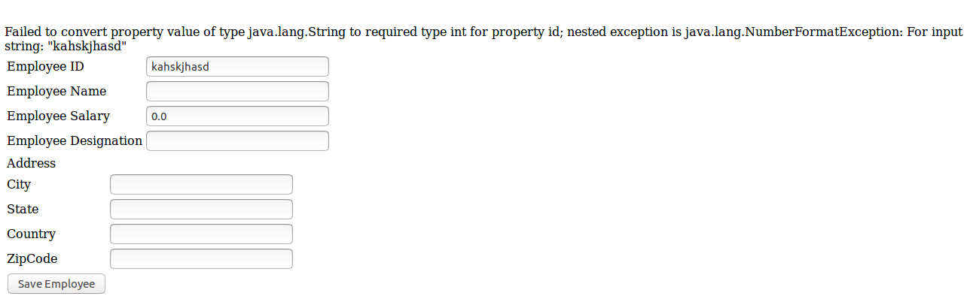
@InitBinder/WebDataBinder & CustomDateEditor(Property Editor Class) Annotations:

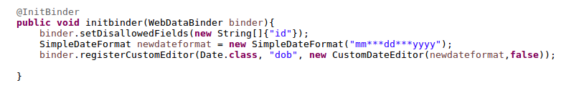

Built in Editor Classes:
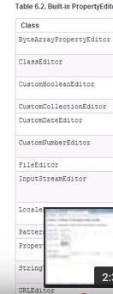

Writing custom property editor classes

In order to write the custom property editor we need to write the seperate class for that property by extending “PropertyEditorSupport”
When we extend the “PropertyEditorSupport” we need to over ride the following function in the class: setAsText(String propertyName)
Following is the snippet

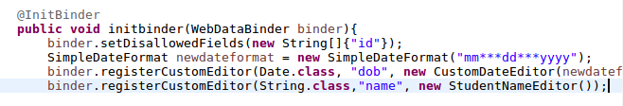
The StudentNameEditor class is as follows:

package com.vilas.userlogin;
import java.beans.PropertyEditorSupport;
public class StudentNameEditor extends PropertyEditorSupport{
public void setAsText(String name){
if(name.contains("Mr.")|| name.contains("Ms.")){
setValue(name);
}
else{
name="Ms."+name;
setValue(name);
}
}
}

Form validation :

1) Implment Hibernate Validator

The hibernate validator can be used for the form validator.

<dependency>
<groupId>org.hibernate</groupId>
<artifactId>hibernate-validator</artifactId>
<version>4.3.1.Final</version>
</dependency>

The following validation needs to be added to check if the size is less than 2 and more than 10 characters using
@Size(min=2, max=10)
The form validation is done through the @valid annotation using the following syntax in the controller as per the below example
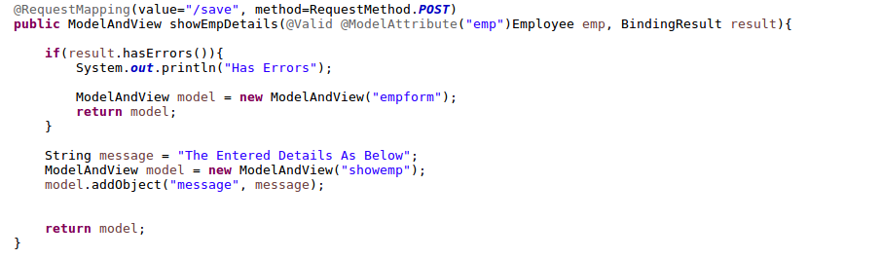

Customizing error messages

Customizing error messages can be done using the following syntax
@Size(min=2, max=10, message=”Enter the value between 2 and 10”)

The most generalized and commercial way to do is using the properties file.
We can write the properties files as follows:
for example:
I ahve written an properties file by the name
studentmessages.properties file and put the file in the classpath of the project.
“Size.emp.hobby=please enter a value between 2 and 10 characters”

We need to then add the following messages in the front controller servlet-context.xml in this case as below and restart the tomcat server for the changes to get reflected.

<beans:bean id="messageSource" class="org.springframework.context.support.ReloadableResourceBundleMessageSource">
<beans:property name="basename" value="classpath:studentmessages" />
</beans:bean>

2) Constraint Validator
3) Custom Validator.

Implement Hibernate Validator:
The following maven dependency needs to be updated in the pom.xml for the JSR 303
This maven dependency is used to implement the following annotations for example
@NotEmpty
@Email
@Size(Min=3, Max=6)

The Maven dependency is tag is as below:

<!-- https://mvnrepository.com/artifact/org.hibernate/hibernate-validator -->
<dependency>
<groupId>org.hibernate</groupId>
<artifactId>hibernate-validator</artifactId>
<version>4.3.1.Final</version>
</dependency>

Constraint Validator

Custom Validator
We need to create an Custom validator by creating a class that implements Validator

We need to annotate the custome validator with the @Component annotation.
For Example:
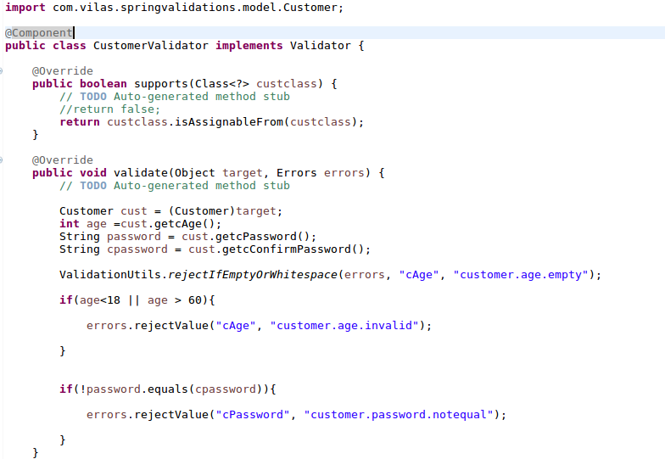
We have to Autowire the above class as below

@Autowired
CusomterValidator validator; << Create the getters and setters >>
In the actual method we do the following

validator.validate(“objectName”, result)
if result.HasErrors(){
<<Write the logic here to return the customer page
}
else{
return the page with the detials

}

eg:
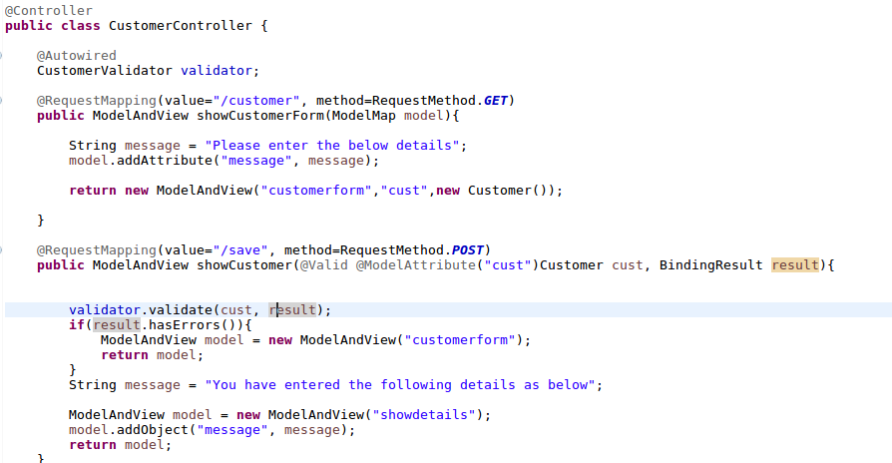

Constraint Validator:

For the constraint validator you should create the following

1) Annotation
2) Create an validator class that implements the ConstraintValidator

Creating an Annotation:

package com.vilas.springvalidations;

import java.lang.annotation.Documented;
import java.lang.annotation.ElementType;
import java.lang.annotation.Retention;
import java.lang.annotation.RetentionPolicy;
import java.lang.annotation.Target;

import javax.validation.Constraint;
import javax.validation.Payload;
@Documented
@Constraint(validatedBy=HobbyValidator.class)
@Target({ElementType.METHOD, ElementType.FIELD})
@Retention(RetentionPolicy.RUNTIME)

public @interface Hobby {

String message() default "{Hobby}";
Class<?>[] groups() default {};

Class<? extends Payload>[] payload() default {};

}

The only thing important in the above code is @Constraint(validatedBy=HobbyValidator.class) the rest is boiler plate code.

Creating Validator class by implementing the validator class by implementing ConstraintValidator<Hobby,String>

For Example:

package com.vilas.springvalidations;

import java.lang.annotation.Annotation;

import javax.validation.ConstraintValidator;
import javax.validation.ConstraintValidatorContext;

public class HobbyValidator implements ConstraintValidator<Hobby, String>{

@Override
public void initialize(Hobby arg0) {
// TODO Auto-generated method stub

}

@Override
public boolean isValid(String cHobby, ConstraintValidatorContext ctx) {
// TODO Auto-generated method stub
if(!cHobby.isEmpty() && (cHobby.equals("music")||cHobby.equals("sports"))){
return true;
}
return false;

}

}

We should only write the logic in the isValid(String cHobby,ConstraintValidatorContext ctx) the rest is the boiler plate code.

Once the annotation and the custom ConstraintValidator is implemented we should add the annotation to the field in the Customer class as below

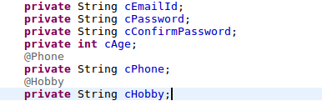

Finally we map the @Hobby and @ Phone in the messages.properties as below:

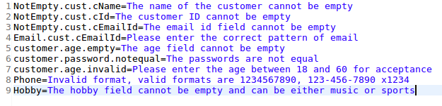

The spring MVC will spill out the messages like the below

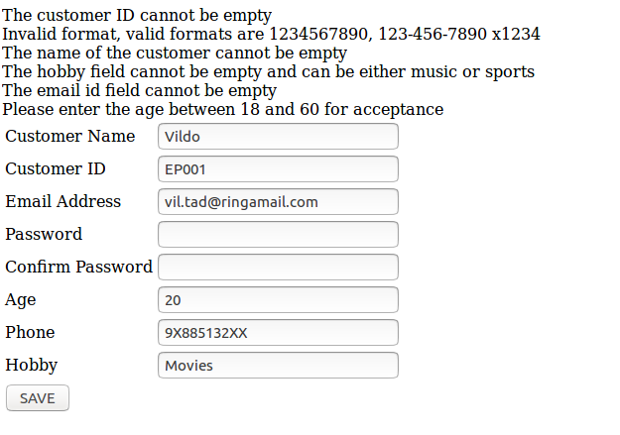

Interceptors

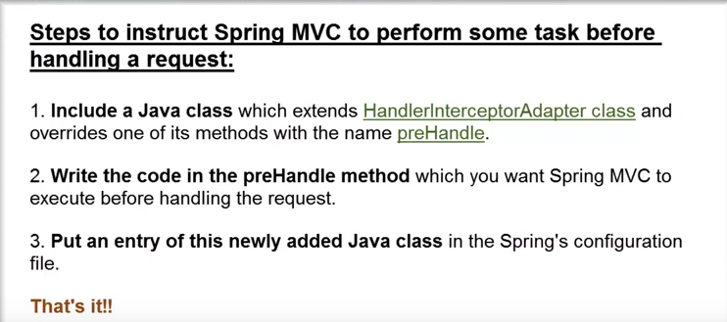

The following is the illustration of the prehandle. We have extended the HandlerInterceptorAdaptor class.
package com.vilas.springvalidations.interceptors;

import java.util.Calendar;

import javax.servlet.http.HttpServletRequest;
import javax.servlet.http.HttpServletResponse;

import org.springframework.web.servlet.handler.HandlerInterceptorAdapter;

public class DayofWeekBasedAccessInterceptor extends HandlerInterceptorAdapter{

public boolean preHandle(HttpServletRequest request, HttpServletResponse response, Object handler)
throws Exception {

Calendar cal = Calendar.getInstance();
int dayofweek=cal.get(cal.DAY_OF_WEEK);
if(dayofweek==3){
response.getWriter().write("Today is Thrusday and the site is closed due to maintenance");
return false;
}

return true;
}

}

The application should know about the interceptor as it should be mentioned in the front controller as below

<interceptors>

<beans:bean class="com.vilas.springvalidations.interceptors.DayofWeekBasedAccessInterceptor"/>

</interceptors>

if the above interceptor needs to work only for the following link

http://localhost:8080/springvalidations/customer

then we need to add the following in the <interceptors> </interceptors> tags
<interceptors>

<interceptor>

<mapping path=”/customer” />
<beans:bean class=”com.vilas.springvalidations.interceptors.DayofWeekBasedAccessInterceptor”/>
<interceptor>

</interceptors>

Post Handler & AfterCompletion methods

public void postHandle(
HttpServletRequest request, HttpServletResponse response, Object handler, ModelAndView modelAndView)
throws Exception {
}

/**
* This implementation is empty.
*/
public void afterCompletion(
HttpServletRequest request, HttpServletResponse response, Object handler, Exception ex)
throws Exception {
}

Internationalization & Localization using Interceptors

For the internationalization we set the following messages_fr.properties as below

label.cName=Nom de l'étudiant
label.cId=ID de l'étudiant
label.cEmailId=Courriel de l'étudiant
label.cPassword=Mot de passe
label.cConfirmPassword=Confirm Mot de passe
label.cAge=âge
label.cPhone=téléphone
label.cHobby=Étudiants hobby

Set the browser properties to french and push the french option to the top

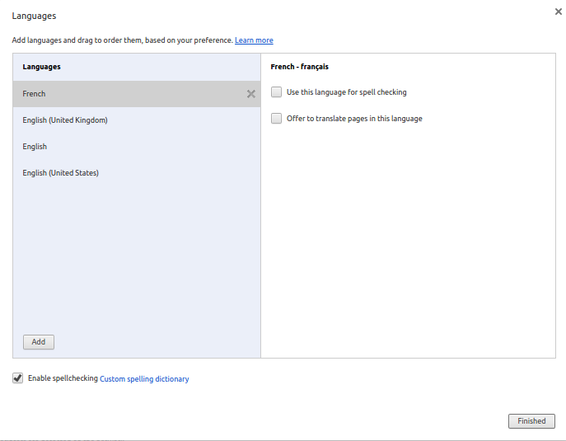

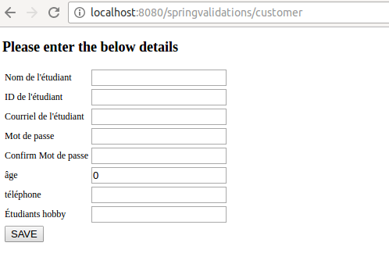

Internationalization and localization –2

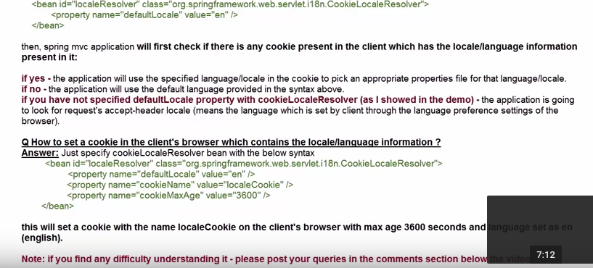

Exceptions:

Spring & SOAP/WSDL’s

Spring MVC & RESTFUL API’s

