Spring Boot

Easy to start and create an production ready within min.

End to End Rest ful API from controller which connects to DB.

Why is Spring Boot is?
Building an End to End flow using Restful API
Spring Boot features
Configuration and Customization.

What is Spring Boot.
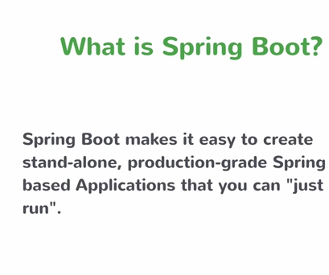

Create Spring Based applications and is stand-alone and produciton grade and just run.

What is Spring.

It is an Applciation Framework
Programming and Configuration Model
Infrastructure Support

Problems With Spring

Huge Framework.
Multiple Setup Steps
Multiple Configuration Steps
Multiple Build and Deploy Steps.

Enter Spring Boot
Opinionated
Convention over Configuration
Stand Alone : When we build a spring applicaiton we get a stand alone application you just run it and do not need an servlet container and runs as an stand alone applcaiton
It is produciton Ready.

With Spring Boot we need to do STS ( Spring tool Suite)

Creating a Project?

Create a Maven Java Project...

Once the Maven project is created inorder to make this maven project an Spring boot project we need to do the following in the pom.xml

<project xmlns="http://maven.apache.org/POM/4.0.0"
xmlns:xsi="http://www.w3.org/2001/XMLSchema-instance"
xsi:schemaLocation="http://maven.apache.org/POM/4.0.0
http://maven.apache.org/xsd/maven-4.0.0.xsd">
<modelVersion>4.0.0</modelVersion>
<groupId>io.vilas.springbootquickstart</groupId>
<artifactId>course-api</artifactId>
<version>0.0.1-SNAPSHOT</version>
<name>Vilas Course API</name>

<parent>

<groupId>org.springframework.boot</groupId>
<artifactId>spring-boot-starter-parent</artifactId>
<version>1.4.2.RELEASE</version>
</parent>

<dependencies>

<dependency>
<groupId>org.springframework.boot</groupId>
<artifactId>spring-boot-starter-web</artifactId>
</dependency>
</dependencies>

<properties>

<java.version>1.8</java.version>

</properties>

</project>

Starting Spring Boot:

- Setsup Default Configuration
- Starts Spring application context
- Performs Path Class Scan
- Starts Tomcat server.

Course API

Resources: Topic/Course and Lesson.

Topic can have multiple Lessons and a course can have multiple Lessons

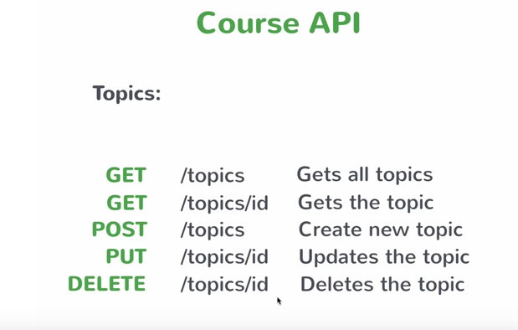

Creating an Business Service
we create the business service the common way.
Create a class

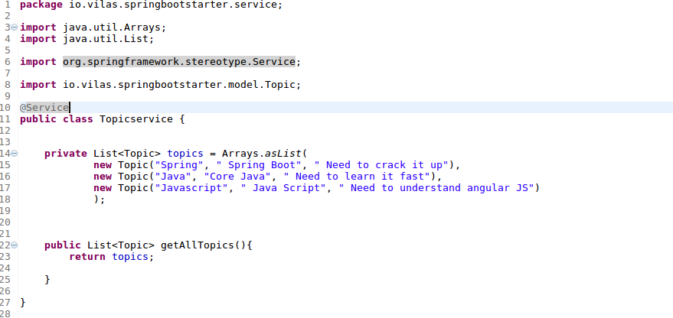

Using the instance as the autowired.

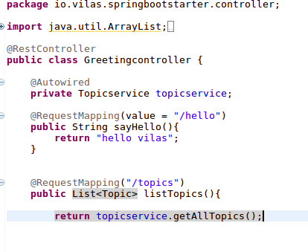

Getting a Single Resource:

We need to write an service and use the service in the controller

The service is as follows

public Topic getTopic(String id)
{

//we have the arraylist

return topics.Stream.filter(t-> t.getId().equals(id)).findFirst.get());

}

in the controller

@RequestMapping(“/topics/{id}”)
public Topic getTopic(@PathVariable String id){

return topicservice.getTopic(id);
}

Creating an new Resource using Post.

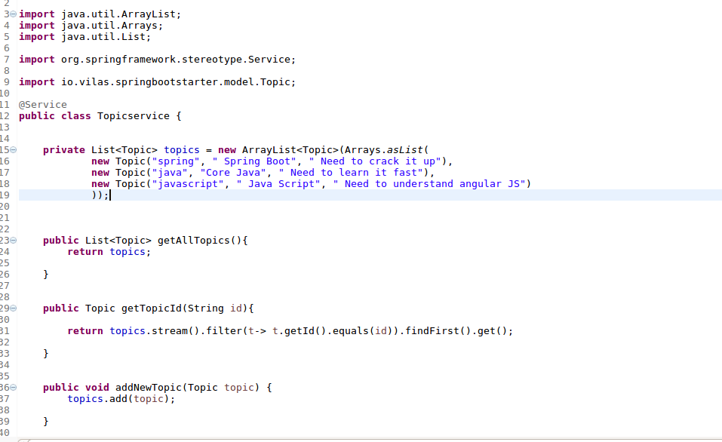

For the Controller

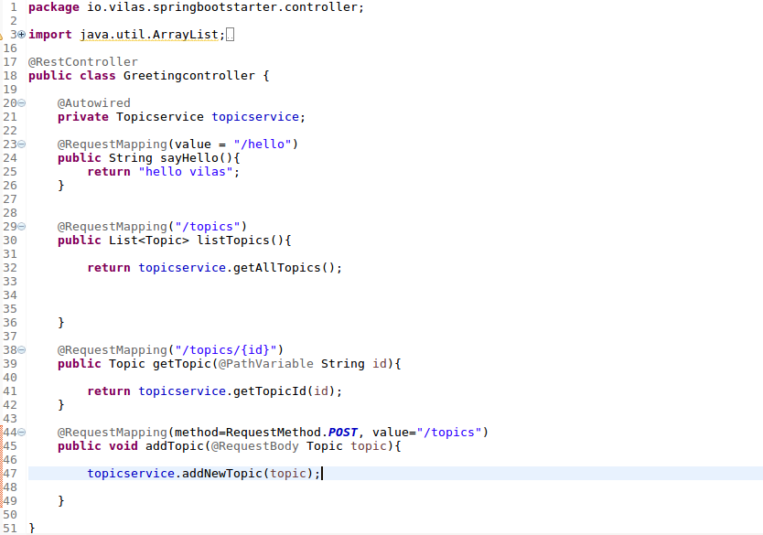

Update and Delete the resources.

The topic service for the update and delete

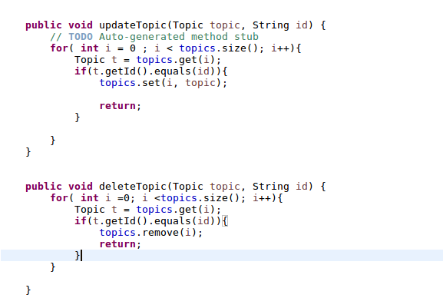

for update we do the following, here topics is the list that we created.
We send the Topic and the id that needs to be updated.

for( int i =0 ; i <topics.size(); i++){

Topic t = topics.get(i);

if( t.getId().equals(id)){
//update the list
topics.set(i, topic)
return ;

}

}

Creating a Spring Data JPARepository:

We need to create the Spring Starter Project.

We need to create the project using the “Web” opition and the inbuilt Apache Derby option the following is the pom.xml file

<?xml version="1.0" encoding="UTF-8"?>
<project xmlns="http://maven.apache.org/POM/4.0.0" xmlns:xsi="http://www.w3.org/2001/XMLSchema-instance"
xsi:schemaLocation="http://maven.apache.org/POM/4.0.0 http://maven.apache.org/xsd/maven-4.0.0.xsd">
<modelVersion>4.0.0</modelVersion>

<groupId>io.vilas</groupId>
<artifactId>course-api-data</artifactId>
<version>0.0.1-SNAPSHOT</version>
<packaging>jar</packaging>

<name>course-api-data</name>
<description>Course API data for Spring Boot Quickstart Vilas</description>

<parent>
<groupId>org.springframework.boot</groupId>
<artifactId>spring-boot-starter-parent</artifactId>
<version>1.4.3.RELEASE</version>
<relativePath/> <!-- lookup parent from repository -->
</parent>

<properties>
<project.build.sourceEncoding>UTF-8</project.build.sourceEncoding>
<project.reporting.outputEncoding>UTF-8</project.reporting.outputEncoding>
<java.version>1.8</java.version>
</properties>

<dependencies>
<dependency>
<groupId>org.springframework.boot</groupId>
<artifactId>spring-boot-starter-data-jpa</artifactId>
</dependency>
<dependency>
<groupId>org.springframework.boot</groupId>
<artifactId>spring-boot-starter-web</artifactId>
</dependency>

<dependency>
<groupId>org.apache.derby</groupId>
<artifactId>derby</artifactId>
<scope>runtime</scope>
</dependency>
<dependency>
<groupId>org.springframework.boot</groupId>
<artifactId>spring-boot-starter-test</artifactId>
<scope>test</scope>
</dependency>
</dependencies>

<build>
<plugins>
<plugin>
<groupId>org.springframework.boot</groupId>
<artifactId>spring-boot-maven-plugin</artifactId>
</plugin>
</plugins>
</build>

</project>

we convert the topic class as the table for the JPA we annotate with the @Entity and the primary key with @Id as below

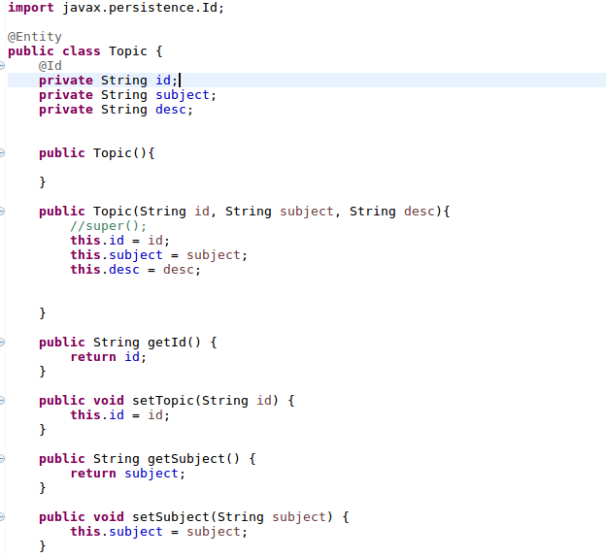

JPA will the topic instance that the table will be created based on the Topic instance and the Id as the primary key.

For teh crud operations:

Create an interface called TopicRepository extending the CrudRepository<Topic, String>

package com.springcourse.service;

import org.springframework.data.repository.CrudRepository;

import com.springcourse.model.Topic;

public interface TopicRepository extends CrudRepository<Topic, String>{

}
----------------------------------------------------------------
The following is the TopicController
----------------------------------------------------------------
package com.springcourse.controller;

import java.util.Arrays;
import java.util.List;

import org.springframework.beans.factory.annotation.Autowired;
import org.springframework.web.bind.annotation.PathVariable;
import org.springframework.web.bind.annotation.RequestBody;
import org.springframework.web.bind.annotation.RequestMapping;
import org.springframework.web.bind.annotation.RequestMethod;
import org.springframework.web.bind.annotation.RestController;

import com.springcourse.model.Topic;
import com.springcourse.service.TopicService;

@RestController
public class TopicController {

@Autowired
private TopicService topicservice;

@RequestMapping("/topics")
public List<Topic> getAllTopics(){

return topicservice.getTopics();

}

@RequestMapping("/topics/{id}")
public Topic getTopic(@PathVariable String id){

return topicservice.getTopic(id);

}

/*@RequestMapping(method=RequestMethod.POST, value="/topics")
public void addTopic(@RequestBody Topic topic){

topicservice.addTopic(topic);

} */

//Post

@RequestMapping(method=RequestMethod.POST, value="/topics")
public void addTopic(@RequestBody Topic topic){

topicservice.addNewTopic(topic);

}

//update

@RequestMapping(method=RequestMethod.PUT, value="/topics/{id}")
public void updateTopic(@RequestBody Topic topic, @PathVariable String id){
topicservice.upateTopic(topic, id);
}

//delete

@RequestMapping(method=RequestMethod.DELETE, value="/topics/{id}")
public void deleteTopic(@RequestBody Topic topic, @PathVariable String id){
//topicservice.upateTopic(topic, id);
topicservice.deleteTopic(topic, id);
}

}

You have to autowire the TopicRepository in the TopicService the following is the example

package com.springcourse.service;

import java.util.ArrayList;
import java.util.Arrays;
import java.util.List;

import org.springframework.beans.factory.annotation.Autowired;
import org.springframework.stereotype.Service;

import com.springcourse.model.Topic;

@Service
public class TopicService {

/*private List<Topic> topics = new ArrayList<>(Arrays.asList(new Topic("Java","Java-Core", "Need to Learn Java-Core first"),
new Topic("C++", "C++ -Pointers","Pointers are the some of the most tough things to learn"),
new Topic("Java-Script","JS-Node and Angular-JS"," Node-Js and Angular Js are some of the good JS scripting languages")
)); */

@Autowired
private TopicRepository topicrepository;

public List<Topic> getTopics() {
//return topics;
List<Topic> topics = new ArrayList<>();
//You are doing an Java 8 lambda expression to add each of the //element that is added from the database and put the same in the list.
topicrepository.findAll().forEach(topics::add);
return topics;
}

public Topic getTopic(String id){

//return topics.stream().filter(t-> t.getId().equals(id)).findFirst().get();
return topicrepository.findOne(id);

}

public void addNewTopic(Topic topic) {
//topics.add(topic);

topicrepository.save(topic);
}

public void upateTopic(Topic topic, String id) {
// TODO Auto-generated method stub
/*for( int i =0; i<topics.size(); i++){
Topic t =topics.get(i);
if(t.getId().equals(id)){
topics.set(i, topic);
return;
}
}*/

topicrepository.save(topic);
}

public void deleteTopic(Topic topic, String id){

/*for( int i =0; i<topics.size(); i++){
Topic t =topics.get(i);

if(t.getId().equals(id)){
topics.remove(i);
}
}*/

topicrepository.delete(id);

}

}

