The followinga re steps for the creation of Spring BOOT and MySQL.

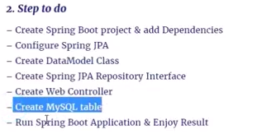

Create Spring Boot Project and add dependencies>

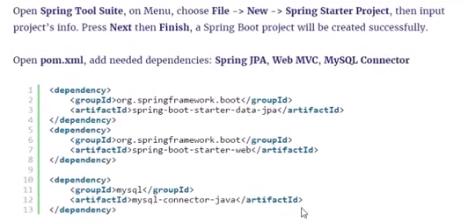

Configure Spring JPA

Open applicaiton.properties and type teh following

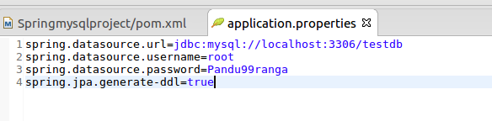

Create a Datamodel class

Create a data model class called “Customer” under the model package.

package com.vilas.mysql.model;

import java.io.Serializable;

import javax.persistence.Column;
import javax.persistence.Entity;
import javax.persistence.GeneratedValue;
import javax.persistence.GenerationType;
import javax.persistence.Id;
import javax.persistence.Table;

@Entity
@Table(name="customer")
public class Customer implements Serializable{

/**
*
*/
private static final long serialVersionUID = 1L;

@Id
@GeneratedValue(strategy=GenerationType.AUTO)
private long id;
@Column(name="firstname")
private String firstName;
@Column(name="lastname")
private String lastName;

public Customer(){

}

public Customer(String firstName, String lastName) {
super();

this.firstName = firstName;
this.lastName = lastName;
}

@Override
public String toString() {
return "Customer [id=" + id + ", firstName=" + firstName + ", lastName=" + lastName + "]";
}

}

The Curd Repository Interface

package com.vilas.mysql.repository;

import java.util.List;

import org.springframework.data.repository.CrudRepository;

import com.vilas.mysql.model.Customer;

public interface CustomerRepository extends CrudRepository<Customer, Long>{

public List<Customer> findByLastName(String lastName);

}
The webcontroller for the project

package com.vilas.mysql.controller;

import java.util.ArrayList;
import java.util.List;

import org.springframework.beans.factory.annotation.Autowired;
import org.springframework.web.bind.annotation.PathVariable;
import org.springframework.web.bind.annotation.RequestMapping;
import org.springframework.web.bind.annotation.RestController;

import com.vilas.mysql.model.Customer;
import com.vilas.mysql.repository.CustomerRepository;

@RestController
public class Webcontroller {

@Autowired
CustomerRepository repository;

@RequestMapping("/save")
public String saveDetailsInDataBase(){

repository.save(new Customer("Jack","Smith"));
repository.save(new Customer("Adam", "Jackson"));
repository.save(new Customer("Peter", "Levlle"));
repository.save(new Customer("Sachin", "tendulkar"));
repository.save(new Customer("Dwayne","Smith"));
repository.save(new Customer("Steve","Smith"));
return "Done";

}

@RequestMapping("/findall")
public String findAll(){

String result="";
List<Customer> addCustomers = new ArrayList<>();

repository.findAll().forEach(addCustomers::add);

System.out.println("The size is "+ addCustomers.size());

for( Customer cust : addCustomers){

result+=cust.toString();

}
System.out.println("/");
return result;

}

@RequestMapping("/findid/{id}")
public String findId(@PathVariable Long id){

return repository.findOne(id).toString();

}

@RequestMapping("findlastname/{lastName}")
public String findCustomersLastName(@PathVariable String lastName){
String resultlastname="";

List<Customer> custLastName = new ArrayList<>();
repository.findByLastName(lastName).forEach(custLastName::add);

for(Customer cust : custLastName){
resultlastname+=cust.toString();
}

//return repository.findByLastName(lastName);;
return resultlastname;
}

}

