Java Servlet

1) Create an Servlet from dynamic web project

Step 1

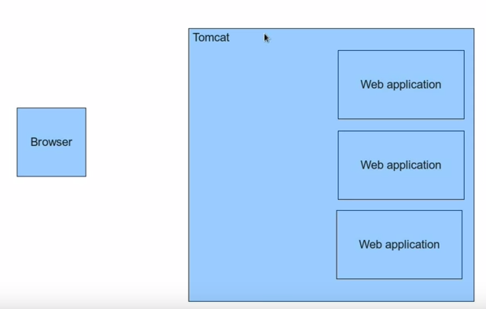

Step 2

Now the browser makes a call with the URL to the tomcat.

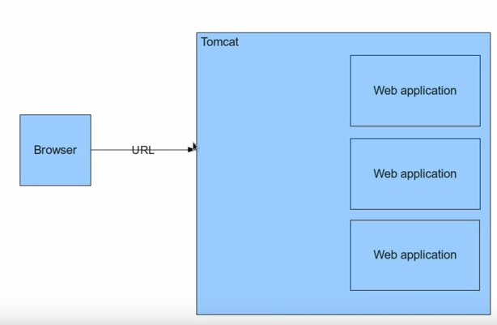

Step 3

After the URL is honoured by TOMCAT it creates 2 objects the request and response

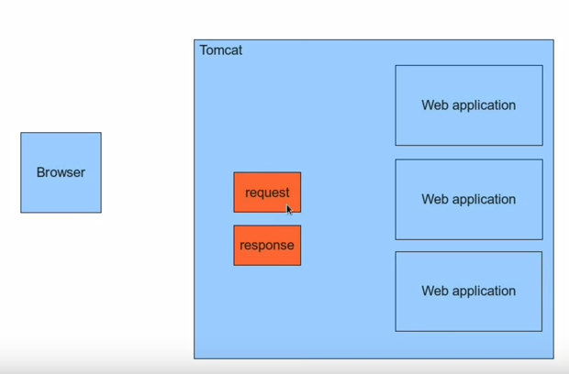
The request onbject contains details that the URL like post query etc.

Step 4:
The tomcat examines the URL and based on that Request

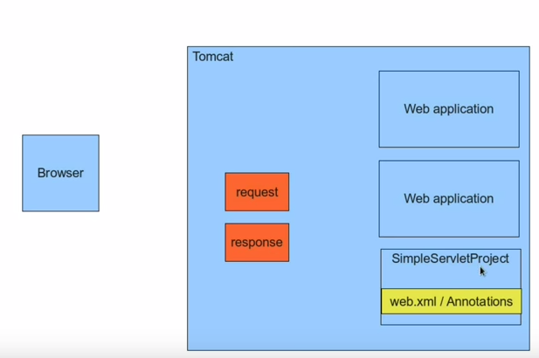

Bsed on the web.xml and Annotations it identifies which Servlet it needs to call. IN this case it calls the SimpleServlet and then passes the request and response methods as parameters to this simple servlet.

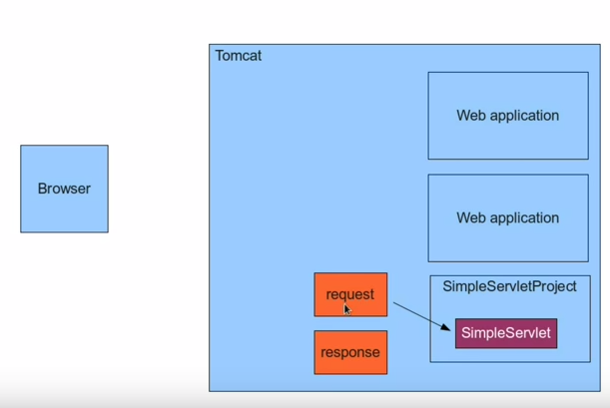

The Simpleservlet picks up the request does the processing and then constucts the response and then passes them to the response object.

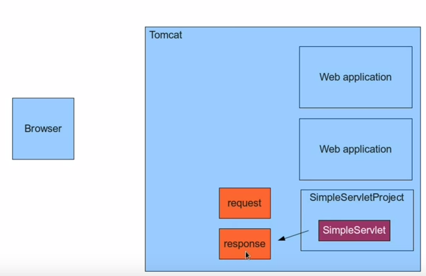

What Tom cat does is takes the response object and renders it as an html to the browser.

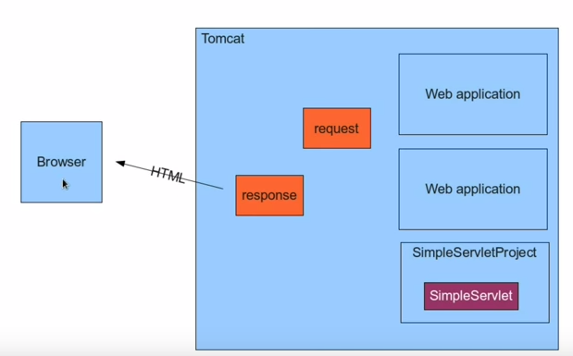

Another way to support servlets is using the XML

We will name the xml as the web.xml in WEB-INF

Servlet XML Configuration

The following is the configuration that we have to execute with the web.xml

In the web-inf of tomcat we need to update the servlet details
The following is the web.xml file

<?xml version="1.0" encoding="UTF-8"?>
<web-app xmlns:xsi="http://www.w3.org/2001/XMLSchema-instance" xmlns="http://xmlns.jcp.org/xml/ns/javaee" xsi:schemaLocation="http://xmlns.jcp.org/xml/ns/javaee http://xmlns.jcp.org/xml/ns/javaee/web-app_3_1.xsd" id="WebApp_ID" version="3.1">
<servlet>
<servlet-name>XmlServlet</servlet-name>
<servlet-class>com.vilas.simpleservlet.XmlServlet</servlet-class>
</servlet>
<servlet-mapping>
<servlet-name>XmlServlet</servlet-name>
<url-pattern>/XmlServlet</url-pattern>
</servlet-mapping>
</web-app>
The following is the process in eclipse

- Create an dynamic web project
- Create an class name say XmlServlet
- Ensure that the XmlServlet extends the HTTPServlet
- We need to override the public void doGet(HttpRequest request, HttpResponse response) method
- We map the servlet in the web.xml file
- We create the <servlet> </servlet> class
- Under the <servlet> class we write the <servlet-name /> and <servlet-class />
- Under <servlet-mapping /> we have the <servlet-name /> and <url-mapping />

The Post Method and Passing of parameters

When we pass the values to the url for ex: user and userid we can print those values in the html format on the page

Say my URL is : http://localhost:8080/SimpleServlet/xmlServlet?userName=Vilas&&userID=313030

we can capture that in the doGet(HttpRequest request , HttpResponse response)
{
String userName = request.getParameter(“ParameterName”);
String userID = request.getParameter(“The second paramterName”);
//get the response and print the respons on the html

PrintWriter out = response.getWriter();
out.Writer(“<h3> The value of the userName is :</h3>” + userName );
out.Writer(“<h3> The value of the userID is :</h3>” + userID );

}

Using the HTML we write an small html for testing.

<HTML>

<BODY>
<form method=”post” action=”XMLServlet”>
<input name =”userName” />
<input type =”submit” />

</form>

</BODY>

</HTML>

Passing More Parameters

<<Working on it>>

Request , Session and Context

We will look into some of the important objects and their scopes

-- Request and Response objects

-- Servlet itself is an object

-- When are these objects created and destroyed and who will create this object and who will destroy this objects.

Object Creation:

Request and response objects are created per access

Servlet object are not created per access

Different requests have different servlet threads, not instances.

Request Object:

HTTP – Stateless protocol -> Http protocol does not except the data to be remembered.

How do we make the servlet remember the session

Session object:

Save data values at the execution of a servlet and return based on the session object.

Session object is of type of HTTPSession

//HttpSession session = request.getSession();

//Need to place the valie of the strin variable into a session.

Session.setAttribute(“savedUserName”, userName);

and the user name is saved into the session

writer.println(“Session parameter has userName as “ + (String)session.getAttribute(“savedUserName”);
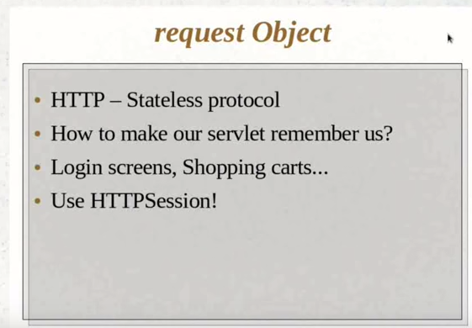

session object
One per user/machine
object are available across requests
prefect for login sessions and shopping cars in the session

every request object has an handle to the session object

More than a session object

Object that can be persisted across different usrs and different browsers.

We need the object be shared across the entire application
shared acorss servlets and suers
Use case is : Initialization code /Common bulletin board.

We use the context object.

Two ways to get the context object.

Second Way is very similar to the session object.

We use the method “getServletContext” on the request object

Eg:

ServletContext servcontext = request.getServletContext();
servcontext.setAttribute(“savedContextName” , userName);

String saveContextName = (String)setvcontext.getAttribute(“savedContextName”);

pout.write(“ The servlet context is “ + saveContextName);

RECAP:

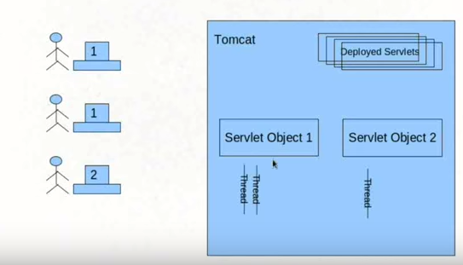

There are many serlets deployed. The servlet objects are then instantiated as Servlet Object 1 and Servlet Object2

When multiple users tries to access servlet object 1 the tomcat will create multiple threads of the servlet object 1 to cater to the needs of the request.

Before Do Get

There are some methods that run before the doGet()or doPost() request of the servlet is executed.

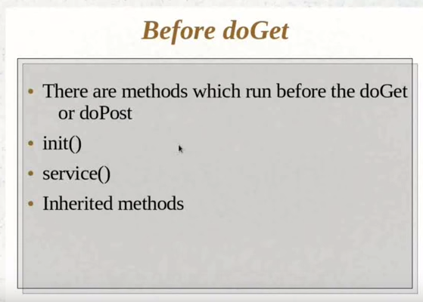

The following is the sequence of the servlet execution flow.

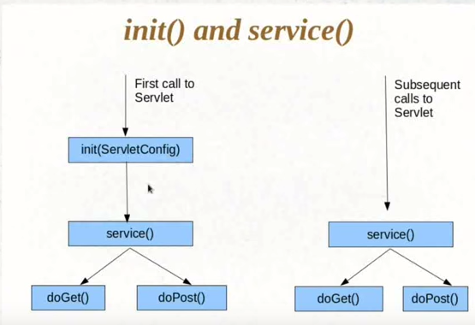

Where do these methods come from:

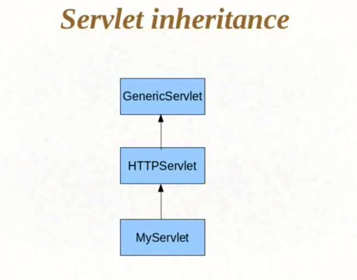

The following methods are now available for the servlet inheritance.

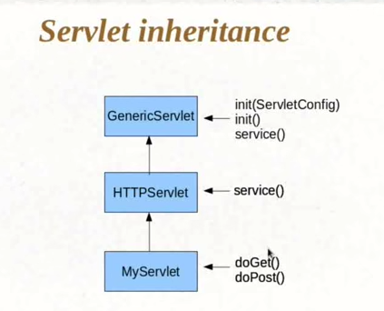

Method Exectuion

