Java Servlet

1) Create an Servlet from dynamic web project

Step 1

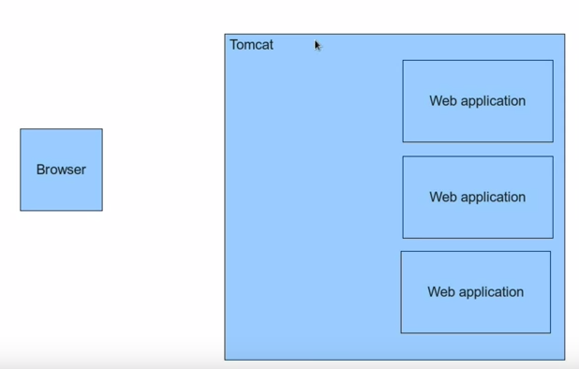

Step 2

Now the browser makes a call with the URL to the tomcat.

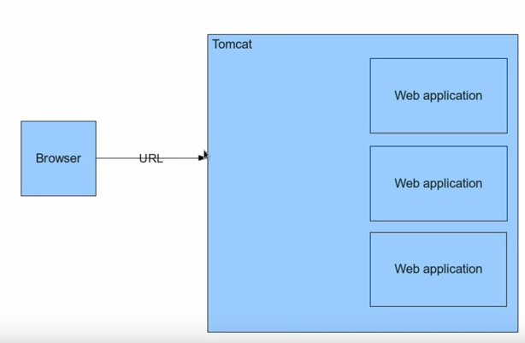

Step 3

After the URL is honoured by TOMCAT it creates 2 objects the request and response

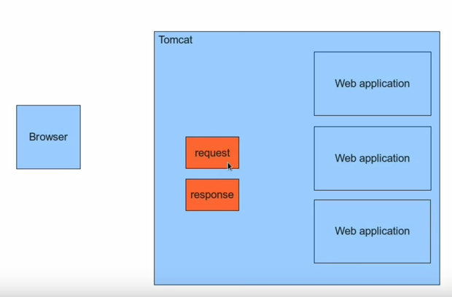
The request onbject contains details that the URL like post query etc.

Step 4:
The tomcat examines the URL and based on that Request

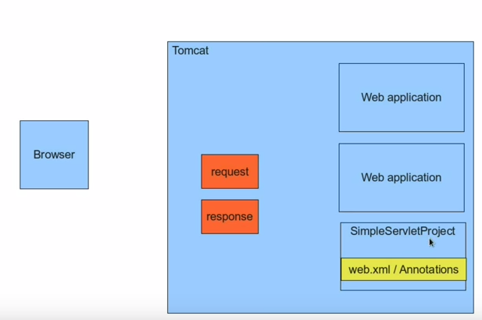

Bsed on the web.xml and Annotations it identifies which Servlet it needs to call. IN this case it calls the SimpleServlet and then passes the request and response methods as parameters to this simple servlet.

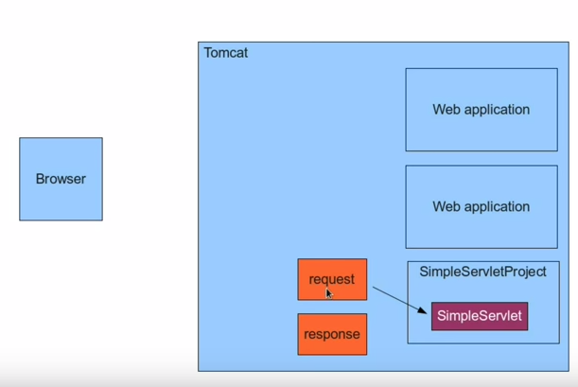

The Simpleservlet picks up the request does the processing and then constucts the response and then passes them to the response object.

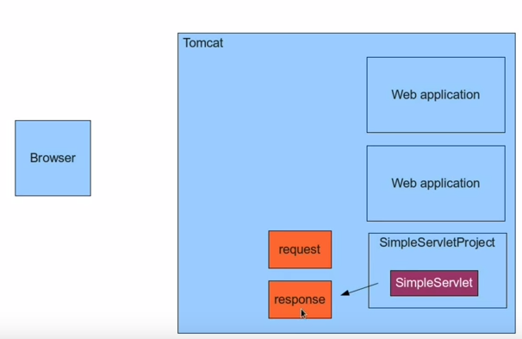

What Tom cat does is takes the response object and renders it as an html to the browser.

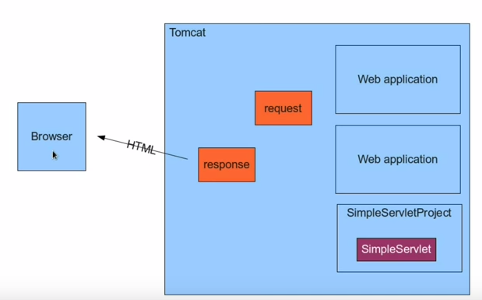

Another way to support servlets is using the XML

We will name the xml as the web.xml in WEB-INF

Servlet XML Configuration

The following is the configuration that we have to execute with the web.xml

In the web-inf of tomcat we need to update the servlet details
The following is the web.xml file

<?xml version="1.0" encoding="UTF-8"?>
<web-app xmlns:xsi="http://www.w3.org/2001/XMLSchema-instance" xmlns="http://xmlns.jcp.org/xml/ns/javaee" xsi:schemaLocation="http://xmlns.jcp.org/xml/ns/javaee http://xmlns.jcp.org/xml/ns/javaee/web-app_3_1.xsd" id="WebApp_ID" version="3.1">
<servlet>
<servlet-name>XmlServlet</servlet-name>
<servlet-class>com.vilas.simpleservlet.XmlServlet</servlet-class>
</servlet>
<servlet-mapping>
<servlet-name>XmlServlet</servlet-name>
<url-pattern>/XmlServlet</url-pattern>
</servlet-mapping>
</web-app>
The following is the process in eclipse

- Create an dynamic web project
- Create an class name say XmlServlet
- Ensure that the XmlServlet extends the HTTPServlet
- We need to override the public void doGet(HttpRequest request, HttpResponse response) method
- We map the servlet in the web.xml file
- We create the <servlet> </servlet> class
- Under the <servlet> class we write the <servlet-name /> and <servlet-class />
- Under <servlet-mapping /> we have the <servlet-name /> and <url-mapping />

The Post Method and Passing of parameters

When we pass the values to the url for ex: user and userid we can print those values in the html format on the page

Say my URL is : http://localhost:8080/SimpleServlet/xmlServlet?userName=Vilas&&userID=313030

we can capture that in the doGet(HttpRequest request , HttpResponse response)
{
String userName = request.getParameter(“ParameterName”);
String userID = request.getParameter(“The second paramterName”);
//get the response and print the respons on the html

PrintWriter out = response.getWriter();
out.Writer(“<h3> The value of the userName is :</h3>” + userName );
out.Writer(“<h3> The value of the userID is :</h3>” + userID );

}

Using the HTML we write an small html for testing.

<HTML>
<BODY>
<form method=”post” action=”XMLServlet”>
<input name =”userName” />
<input type =”submit” />

</form>

</BODY>

</HTML>

Servlet Life Cycle:

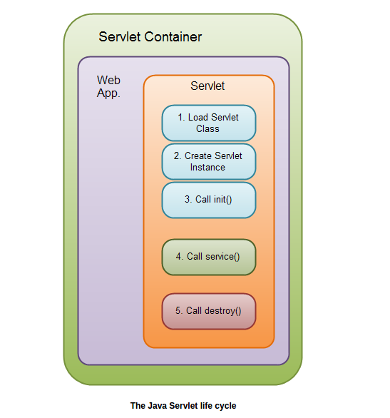

Method Execution
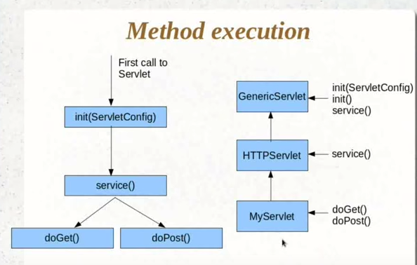

Execution methodology of the Servlet

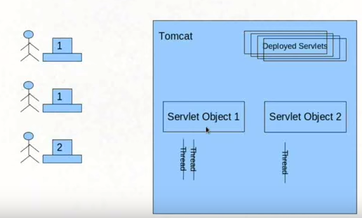

Passing More Parameters

<<Working on it>>

Request , Session and Context

-- Request and Response objects

-- Servlet itself is an object

-- When are these objects created and destroyed and who will create this object and who will destroy this objects.

Object Creation:

Request and response objects are created per access

Servlet object are not created per access

Different requests have different servlet threads, not instances.

Request Object:

HTTP – Stateless protocol -> Http protocol does not except the data to be remembered.

How do we make the servlet remember the session

Session object:

Save data values at the execution of a servlet and return based on the session object.

Session object is of type of HTTPSession

//HttpSession session = request.getSession();

//Need to place the valie of the strin variable into a session.

Session.setAttribute(“savedUserName”, userName);

and the user name is saved into the session

writer.println(“Session parameter has userName as “ + (String)session.getAttribute(“savedUserName”);

Init()
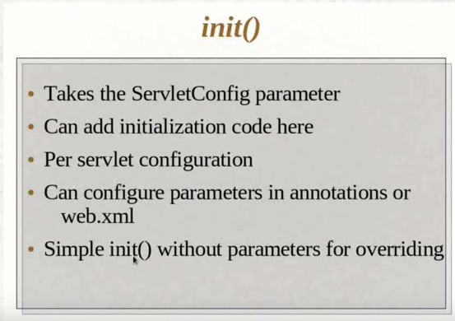

Service()

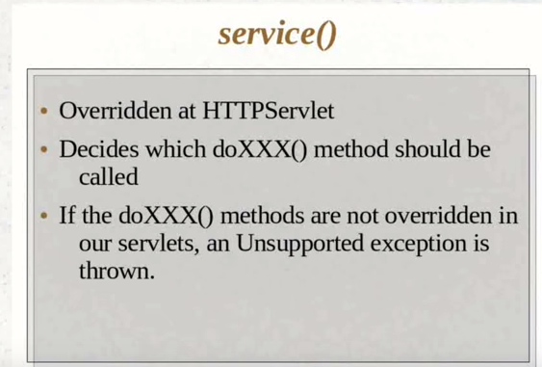

The init() method override is as follows

The annotation at the servlet level:

@WebServlet(urlPatterns={"/Requestservlet"},initParams={@WebInitParam(name = "defaultUser", value = "Suman Gadwal")})
------
public void doGet(HttpServletRequest request, HttpServletResponse response)
{

----
pout.write("\n");
pout.write(" The initParams()" + this.getServletConfig().getInitParameter("defaultUser"));
}

The manual configuration of the init setup

<?xml version="1.0" encoding="UTF-8"?>
<web-app xmlns:xsi="http://www.w3.org/2001/XMLSchema-instance" xmlns="http://xmlns.jcp.org/xml/ns/javaee" xsi:schemaLocation="http://xmlns.jcp.org/xml/ns/javaee http://xmlns.jcp.org/xml/ns/javaee/web-app_3_1.xsd" id="WebApp_ID" version="3.1">
<display-name>Servman</display-name>
<welcome-file-list>
<welcome-file>index.html</welcome-file>

</welcome-file-list>
<servlet>
<display-name>Manual Servlet</display-name>
<servlet-name> Serverman </servlet-name>
<servlet-class>com.vilas.servletman.ServletManual</servlet-class>
<init-param>
<description>Sunga Desc</description>
<param-name>defaultUser</param-name>
<param-value>Default Suman Gadwal</param-value>
</init-param>
</servlet>
<servlet-mapping>
<servlet-name>Serverman</servlet-name>
<url-pattern>/Serverman</url-pattern>
</servlet-mapping>
</web-app>

JSP Page Directives:

Write a JSP code when the user access the system , it displays the current time of the system that he/she has used.

The page re-directives in JSP will be done as per the example below.

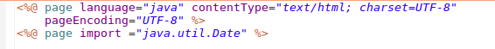

The code is as below:

if you want the contents of another file to be embeded in the current file the we do the following

<%@ page file = “Relative path of the file” %>

Scopes in JSP and page context objectives

- Request /Session and Context.
Tomcat converts JSP’s into a Servlet.

Create an new JSP Page Called this as objects.jsp
- Take the userID and password and print the same in JSP

The following code helps us capture the – UserName/SessionUserName and the ServletContext we execute them in the following manner
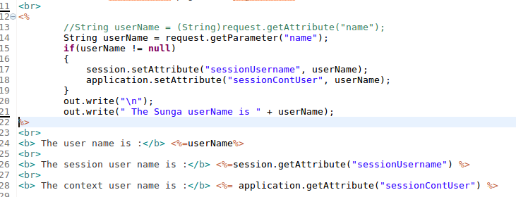
IN addition to the above we have the additonal object it is called as Pagecontexed object.
By using the pagecontext object you can set the attribute on the request scope, set the object on the session scope or set the object on the applciation( servlet context) scope.
-- We can also use the pageContext object and set the application(context)/Session and the request objects.

JSPInit and InitParams

MVC Model:

The controller analyzes the request and passes the request to the Business Service.
Business Service then executes the list of users and passes on the results to the Controller.

The controller will then push the results from the buiness service to the view.

The view then makes it ready for consumption and then presents to the end user.
The enduser will request for the list of users . The list of the users is called the model.

IN the MVC each role is individual.

Servlet is the controller which will get the request from the enduser.
The request is then passed on to the Bean.
The bean will process and send it back to the servlet
The servlet will then passit on to the JSP
JSP will then push it to the HTML dispaly for the end user.

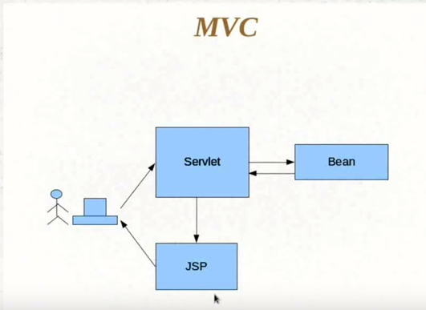

Writing an MVC application:

Simple login application,
Enter the userid and password
Authenticate the credentails
If the creds are successfull greetings page is displayed

MVC Ingredients:

-- Controller
--LoginServlet
-- Business Service
--AuthenticationService
-- Model
-- Implement the model containing the authentication result
-- View
-- Direct the flow to the sucess page
--Login Page and Greetings page

- Create an dynamic web app
--LoginApp

Create the
1) Login.jsp file
2) LoginServlet.java
3) LoginService.java
4)Success.jsp and Failure.jsp files.

Project in Eclipse:

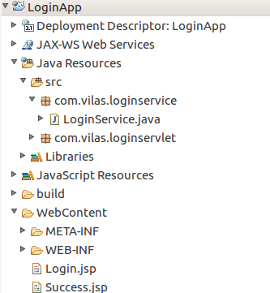

LoginServlet file:

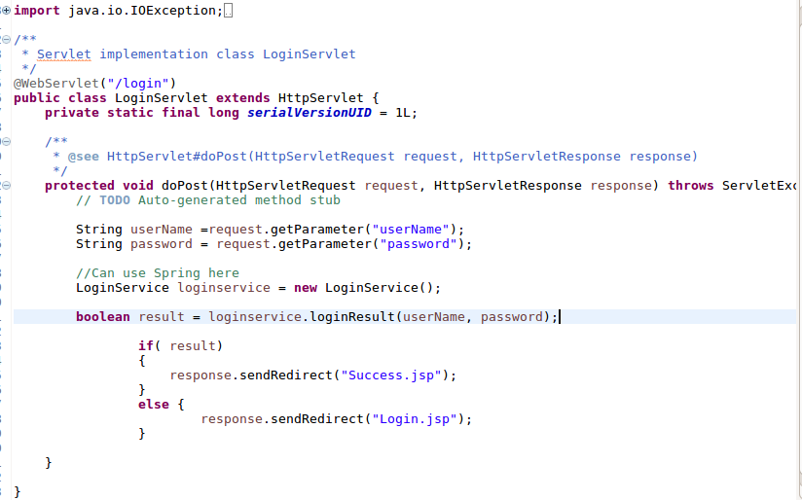

Using Model Object in MVC application:

This can be acived in two ways

1) Sesison object
2) Request dispatcher.

The following is the example of the same:

LoginService.java( The service) in the case the controller(Servlet) will push the request to the service to get the details.

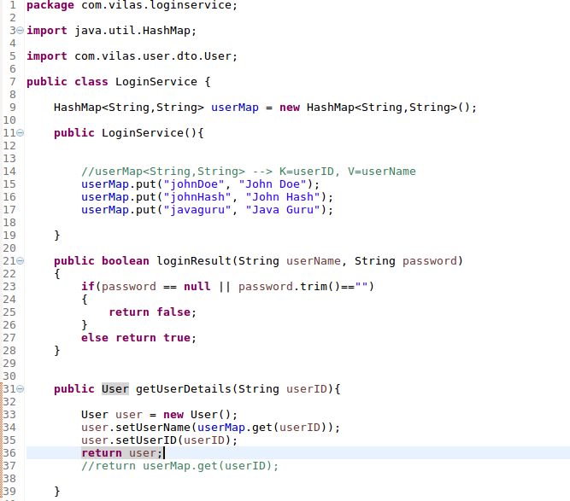

The controller: ( in this case it is Servlet)

LoginServlet.java
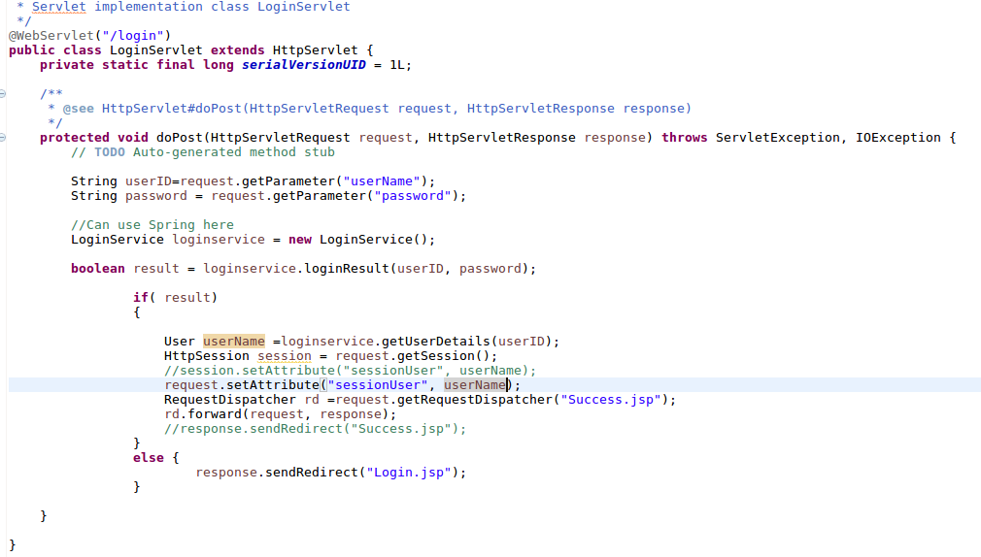

The JSP page that is (View)
Renders the data to be shown in the appropriate manner

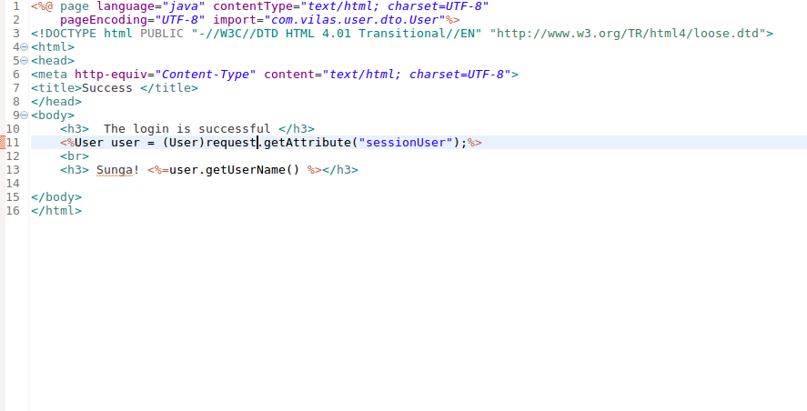

-----The END ------
Need to study the JSP JSTL’s

