Tutorial on Struts

Architecture of Struts2
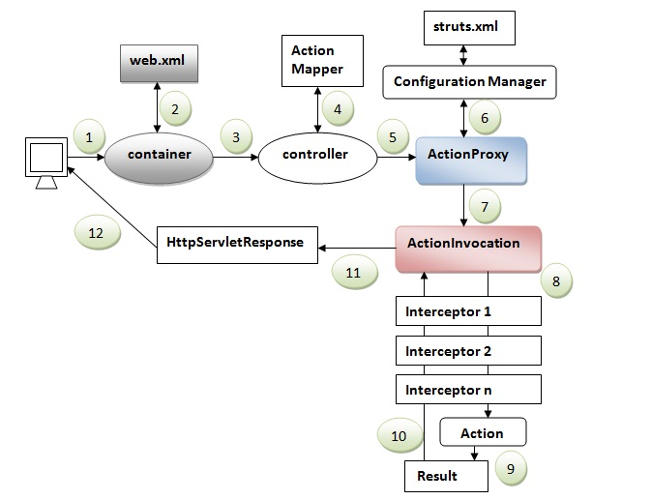

MVC Model:

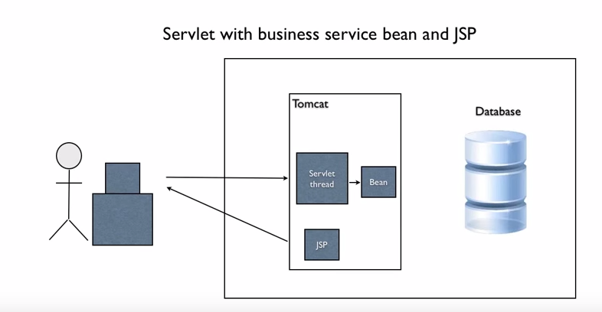

Why MVC:
1) Highly decounpled.
2) Controller is sperated from model
3) View is seperated from model
4) View is seperated from controller.

MVC frameworks:

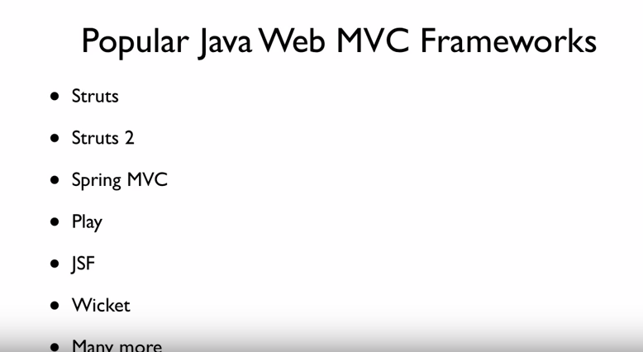

Introduction to Struts 2:

Frameworks Vs Pattern
1) Pattern is the way you can artchitecht your application
2) Framework provides foundation classes and libraries
3) Gets us started quickly
4) Leverages industry best practices.

Struts2 MVC frame work

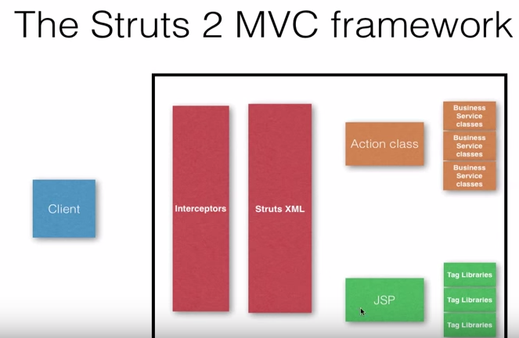

Main components are :

1) Action class
2) JSP
3) Struts 2 XML

We will not work on the interceptors , Business Service Classes and the Tag Libraries. We will work on the following.

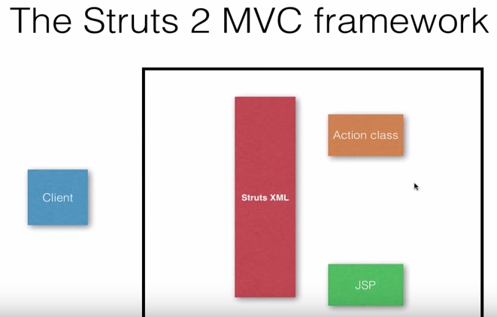

Struts 2 XML
1) Controls the execution flow of the requests
2) Input: URL
3) Needs to map to
a) Action classes
b) Maps the JSP’s

URL to Action Classes:

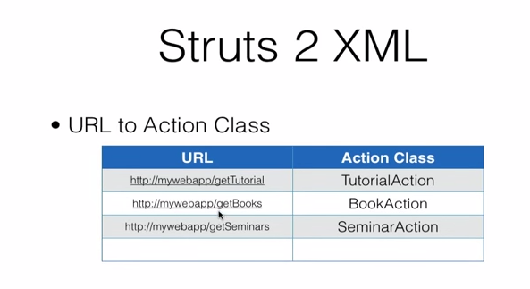

Execution of Struts2 XML

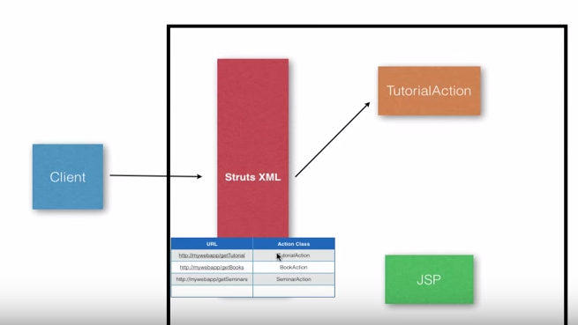

The default method the struts framework calls is the “execute()” method when ever an client call happens to the action method.
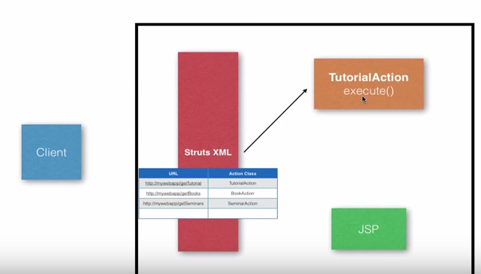

Which JSP?
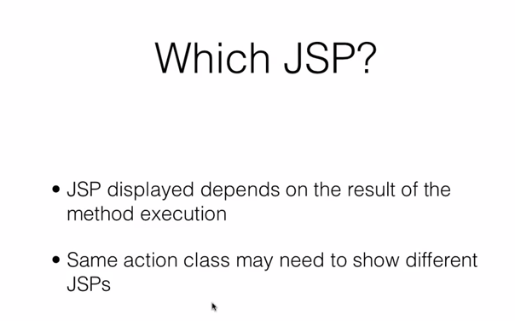

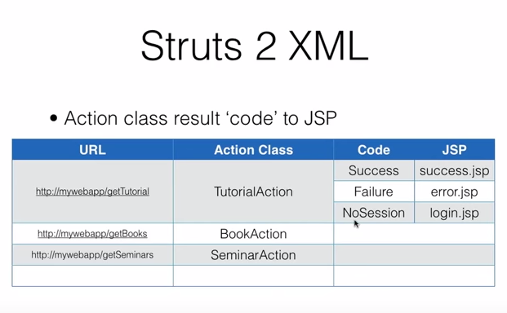

Mapping in the struts.xml

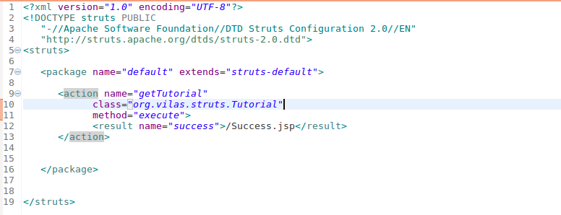

Mapping the web.xml

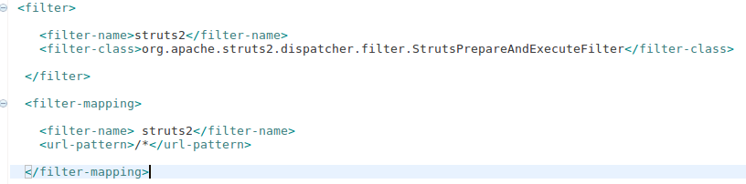

Understanding Namespaces.

Namespace is used to organize the nested URL’s
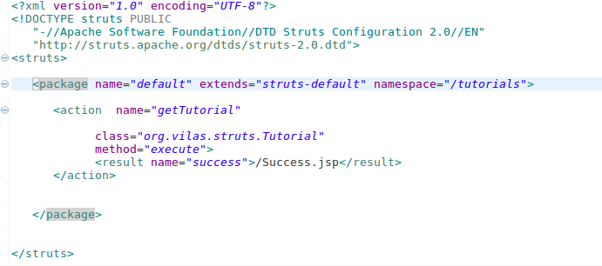

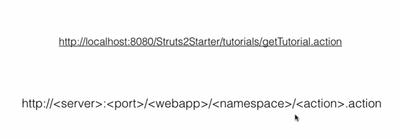

A Tag and A Business Service

First by adding a business service.

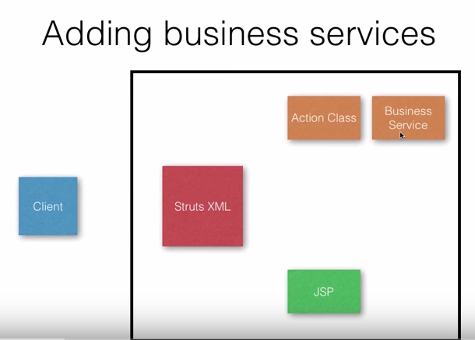

Our curent Struts 2 applicaiton:

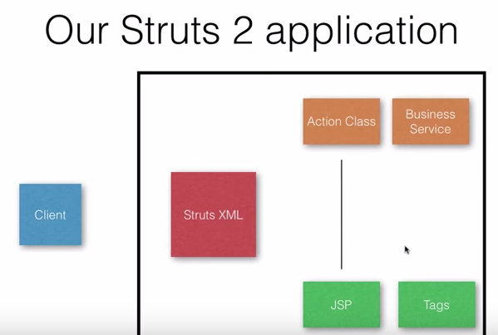

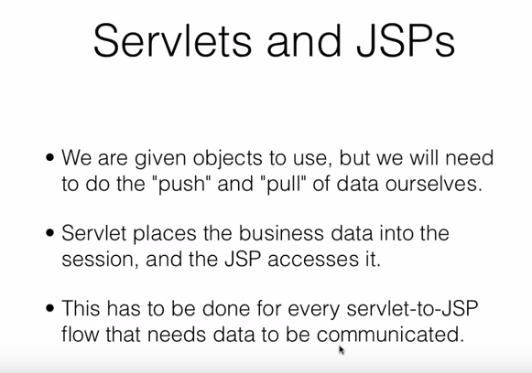
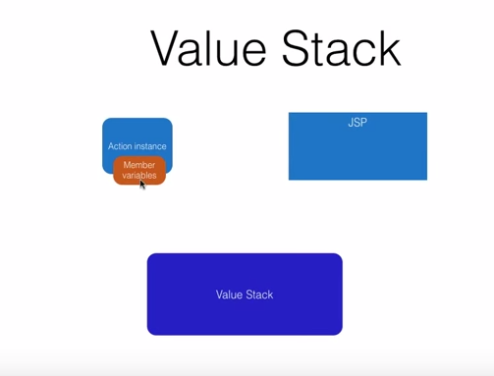
The Action Instance( with the Memeber variables) are stored in the Value Stack and then we use the struts tag from JSP to pull the Value Stack.

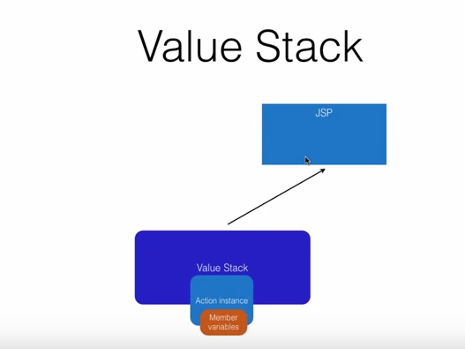

Value stack
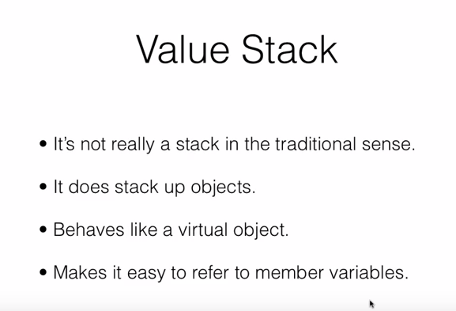

Writing Struts 2 Actions:

- Pojo
- Action Interface
- Extending ActionSupport class

How do the Input Params in Struts2 work.
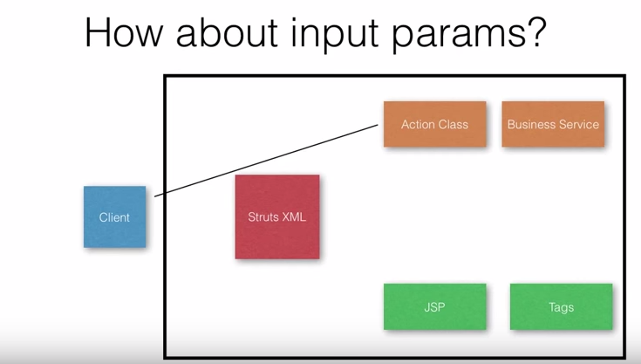

Vlaue Stack for the interceptors:
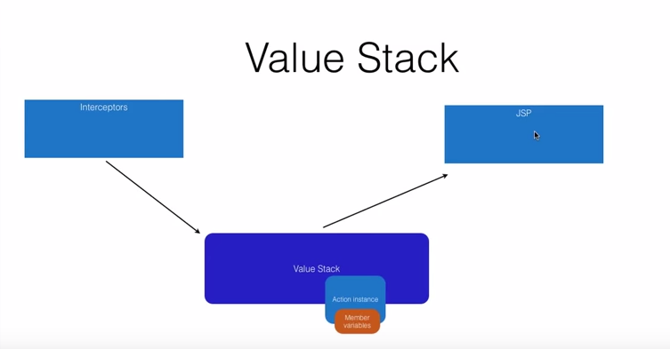

Post Requests to actions:

Writing Struts 2 Action:

- It is an simple pojo with an execute method
- Implementing an Action Interface ( Has an execute method). Will get static string like SUCCESS etc...
- Extending Action Support Class

---> public class LoginAction extends ActionSupport
ActionSupport class implements Action

Override the method called Validate() method.
In out example we are using the userID and password.
In the validate method we see that the userID and password are not empty using the following code

StringUtils.isEmpty(“userID){
addFieldError(“userID”, “userID cannot be empty”);
}

Configuring methods in Action Mappings

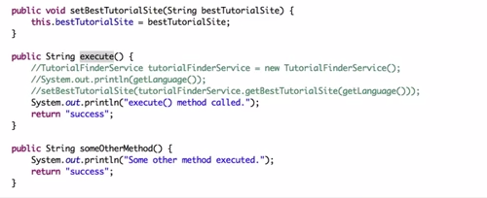
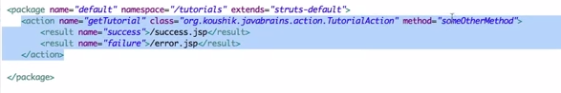

The following methods are called when the addTutorial is called and when the getTutorial is called
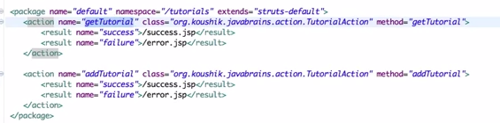

Wild cards can also be added into the method names also.

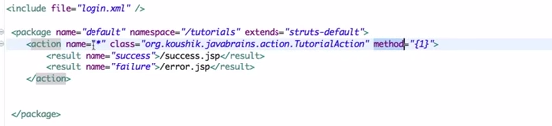

The action name=”*” and method=”{1}” indicates that what ever is the action name the corresponding method name is executed.

For example the action name “getTutorial” is executed , the corresponding method “getTutorial” in the struts.xml is executed.

Similarly if the action name”addTutorial” is executed, the corresponding method “addTutorial” represented in struts.xmls is executed which is “addTutorial”

Using Model Objects:

Hands-on experience across the range of technologies (Java, Web and related technologies, Webservices, popular Java libraries, Unix / Linux and variants, Scripting languages, Databases, Open source tools and technologies) Mandatory Skills
Expertise (5+ years) on some of the following: Core Java, Enterprise Java with web, Web technologies, popular java libraries, XML and related technologies, App servers, relational databases
Experience on one or more of the following: Aspects of SOA, Big data concepts and implementation, Cloud concepts and implementation, Mobile applications, No-SQL
Ability to articulate the understanding of requirements and the reason behind a suggested solution approach
Open to new technologies and standards and technology neutral in suggesting architecture
Self starter and learner of new technologies and is abreast of technological trends
Excellent communication skills Candidates are expected to be thoroughly hands on

Interceptors:
Understanding the interceptors:

Automatic features of Struts2:
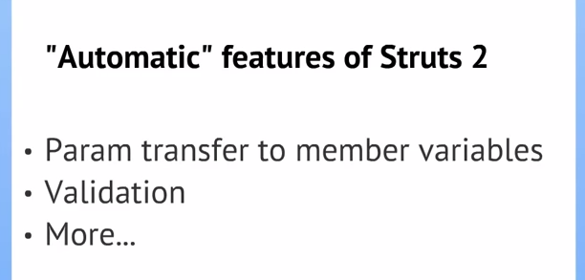

Who/What does all the above work for the enduser?

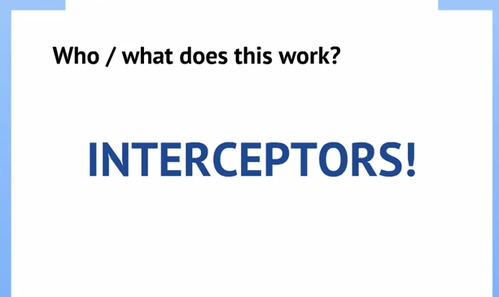

Interceptors come with Struts2 and do all the automatic features
High level pic of struts2 applciation
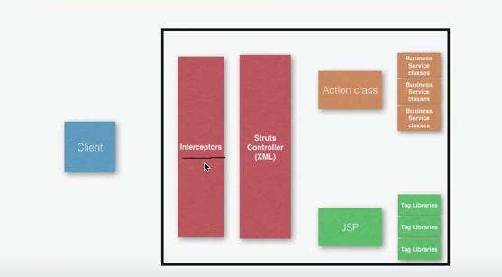

Three concepts that will help us understand the architecture of Struts2.

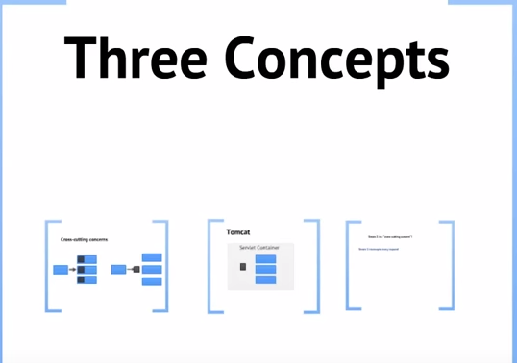

Cross Cutting terminology:
Consumer accessing three diff provider modules.
All the three modules that need to have comming fucntionality before the logic of the module is executed.

This kind of common functionality is the common cross cutting concerns.

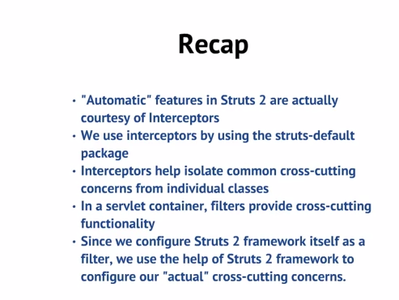
Configuring interceptros:

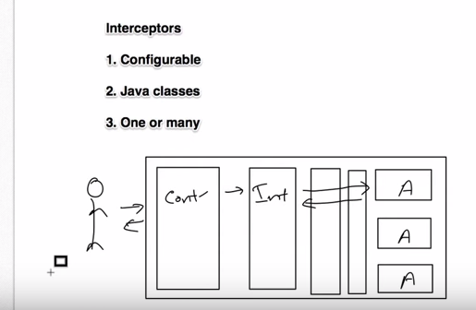

Certain steps to configure the interceptors:
Interceptor Class called MyInt.Java( Does the pre-processing )
Go to the struts.xml and declare the above interceptor
using the element called interceptor <interceptor name = myInt.java class=” class name” >
<action name = >
<ref> -- call the above interceptor.
</action>

Only one interceptor is enough.

3) Interceptor stack
Bundle all the interceptors into what we call as an interceptor stack and refer the common interceptors name together in the right order.

Inner Details of an Interceptor:

For making any standard enterprise applicaitons
like 1) Health care 2) Banking or Ecommerce or sports etc we use MVC 2
Controller:
Capability to read the data from the View and send data out.
- Can use Servlets and JSP/Filters/Tag Support.

View – We need to write the presentation code can be designed by using html/html5/jsp’s and can use custom tags or predefined tags.
Adobe Flex
Client Side validations support we can use Java Scripts
Jquery/Ajax(Async Java Calls)Node JS/Angular JS/Boots Trap
Dynamic event handling and styles ( CSS/CSS3/JQuery)
Model [ Service / Business and DAO]

