**Case study**: **Account Management System** Monolithic Java FSD

1. Customer can have one or more bank accounts (Eg: ICICI,HDFC..).

2. Transfer amount from one account to another account

3. Create CRUD operations for Customer and Accounts

4. Develop customer login , after successful login show accounts summary. Click on account display account information available balance.

5. Transactions Filter/Search operation from date - to date show Transaction summary

Maintain all data in one DB

**Technology stack:** Spring/Spring Boot,Java 1.8,Any DB(H2/PostegreSQL/SQL Server..),Html,Angular Js

Login Page:

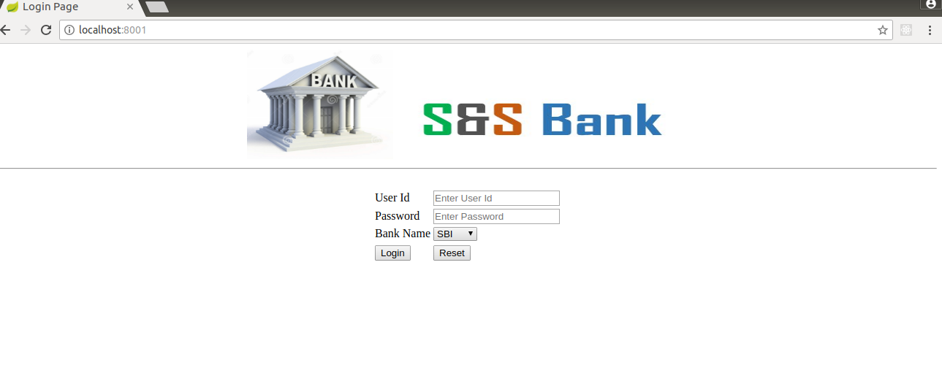

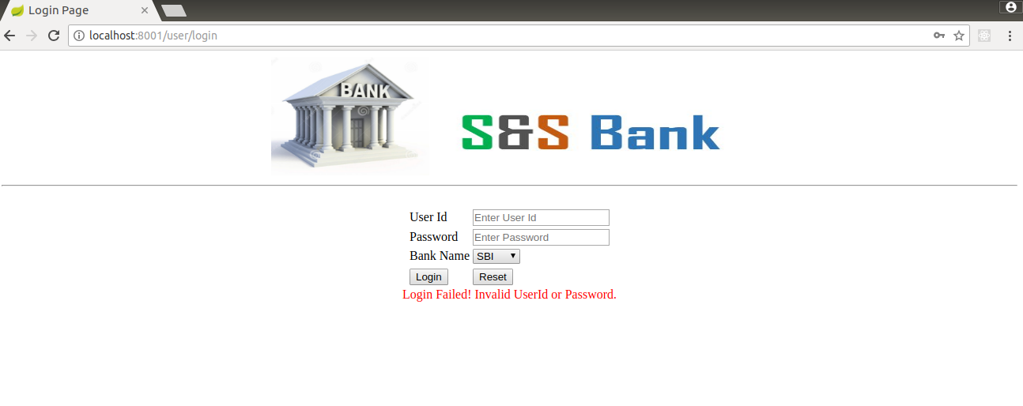

Home Page:

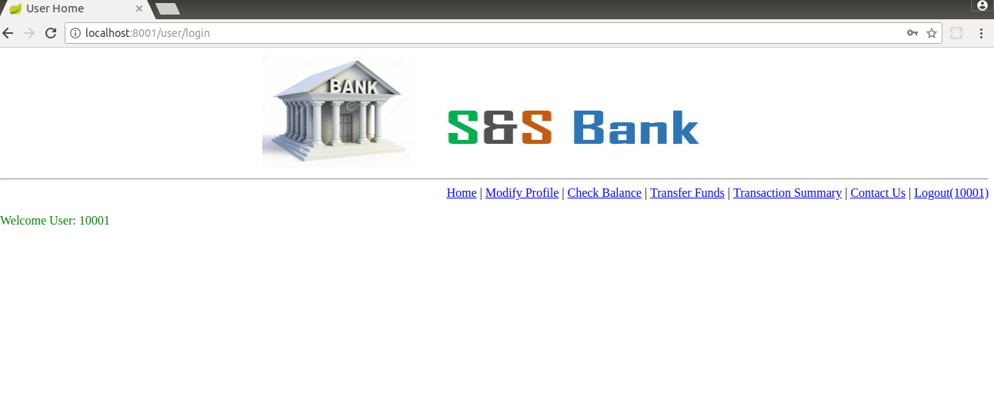

Modify Profile:

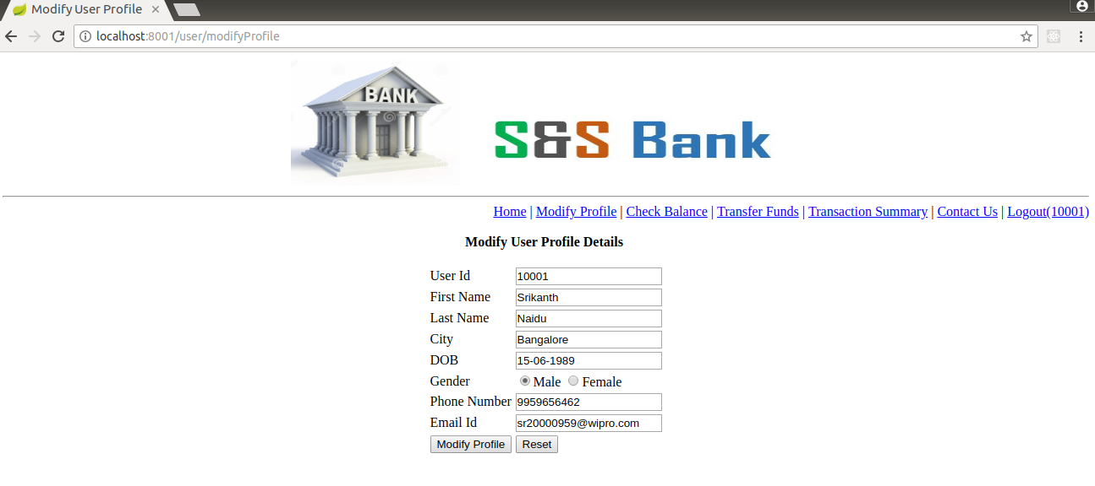

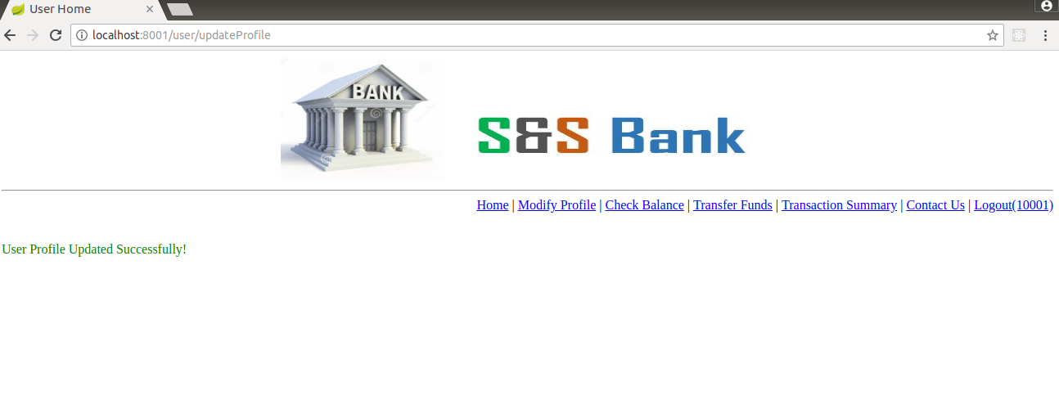

Check Balance:

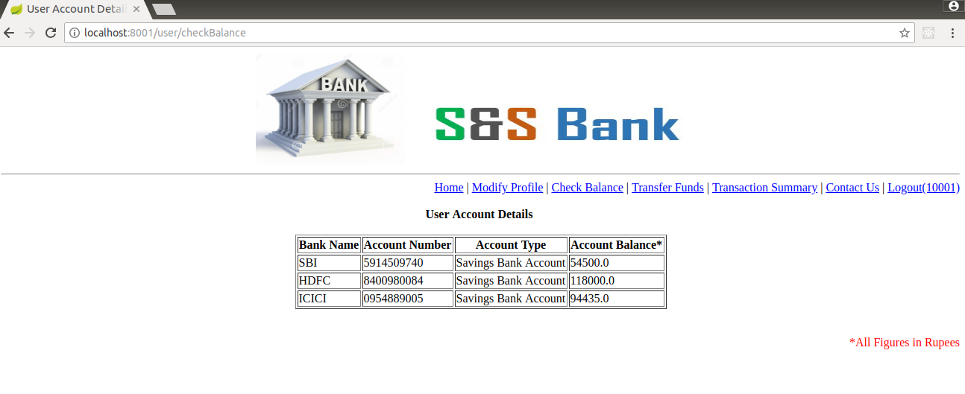

Transfer Funds:

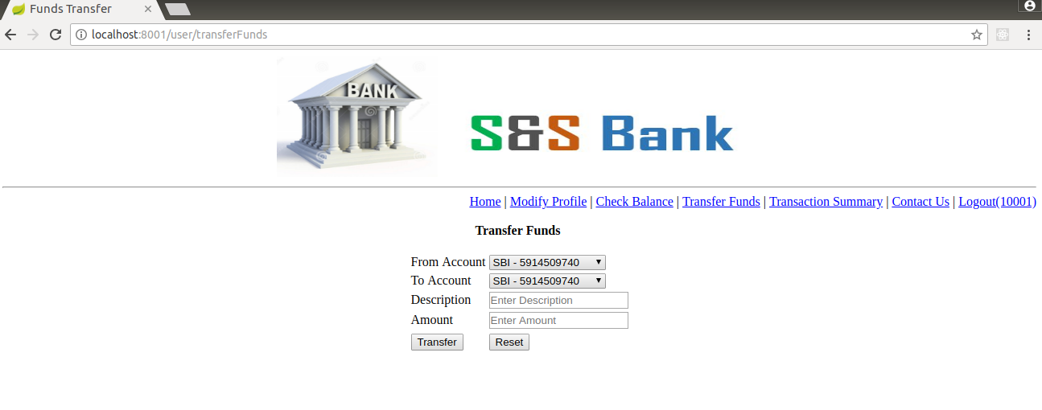

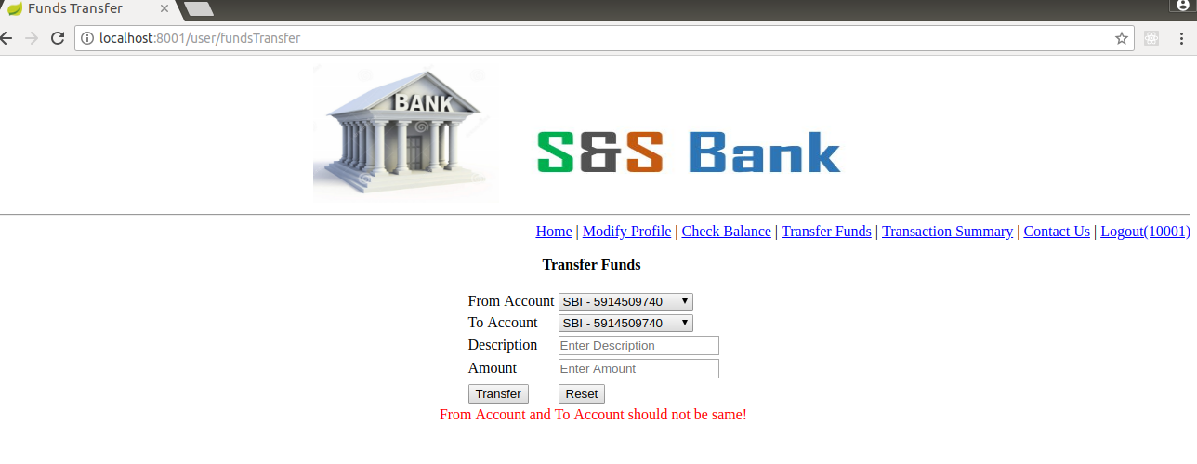

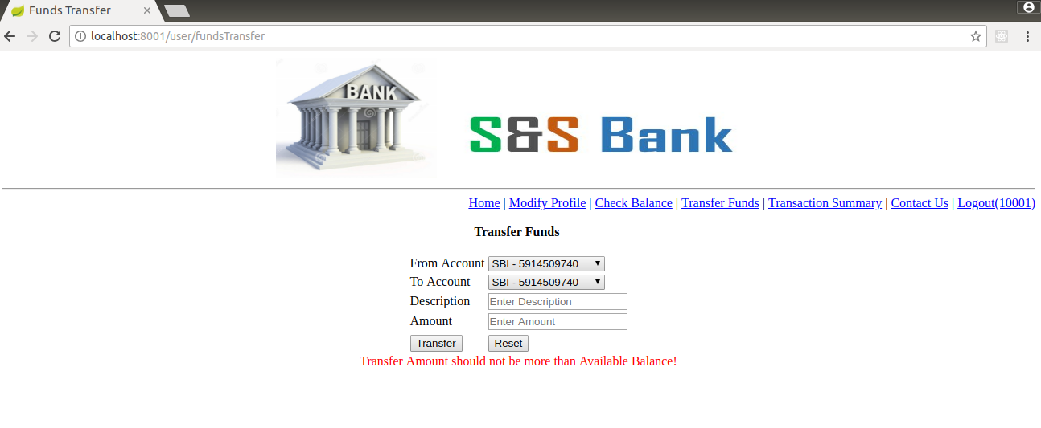

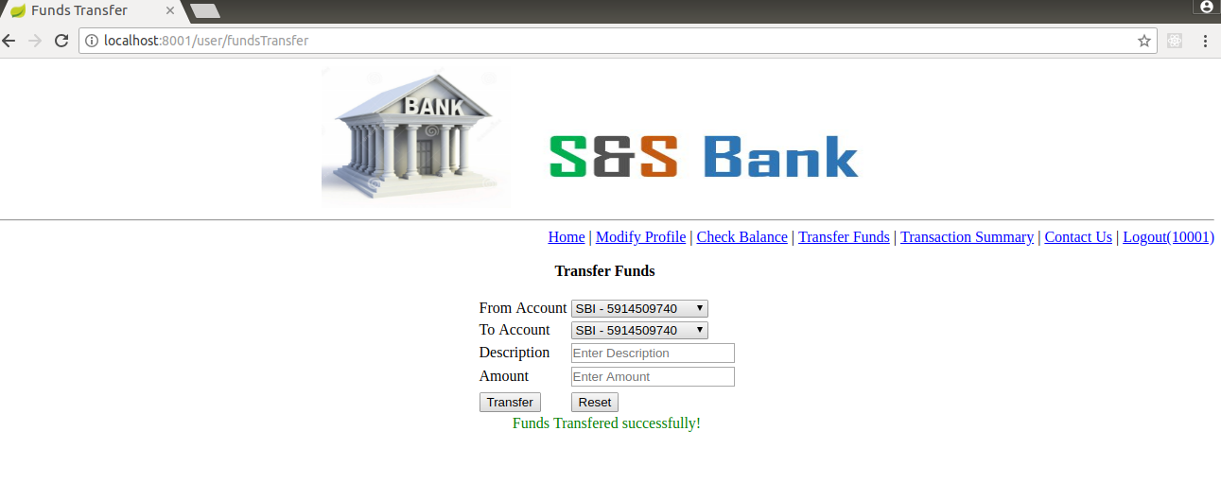

Transaction Summary:

