1. creating project: Open terminal and run the command

mvn archetype:generate -DgroupId=com.srikanth.fullstackjava -DartifactId=assignment2 -DarchetypeArtifactId=maven-archetype-quickstart -DinteractiveMode=false

2. Open eclipe and import existing maven projects and browse the project created in command line.

3. Open pom.xml and add/modify the below dependencies

<dependency>

<groupId>org.apache.commons</groupId>

<artifactId>commons-lang3</artifactId>

<version>${apache.version}</version>

</dependency>

<properties>

<junit.version>3.8.1</junit.version>

<apache.version>3.0</apache.version>

</properties>

4. Cleaning project: Right click on project and Run as --> Maven clean

5. Build and Install project: Right click on project and Run as --> Maven install

6. Run the main class:

Right click on project and Run as --> Run Configurations and create new configuration under Maven Build as shown below

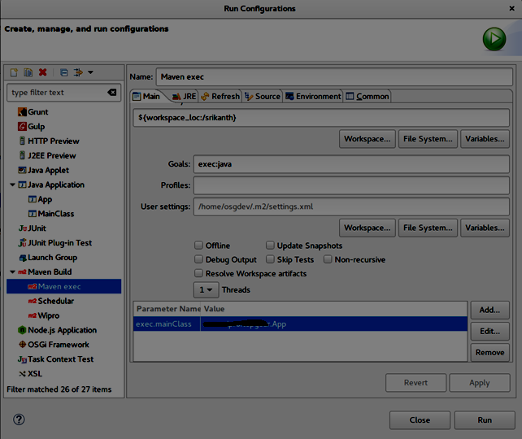

Now click Run.

7. Run the test class:

Follow step 6 to run test class.