1. showAllCDs

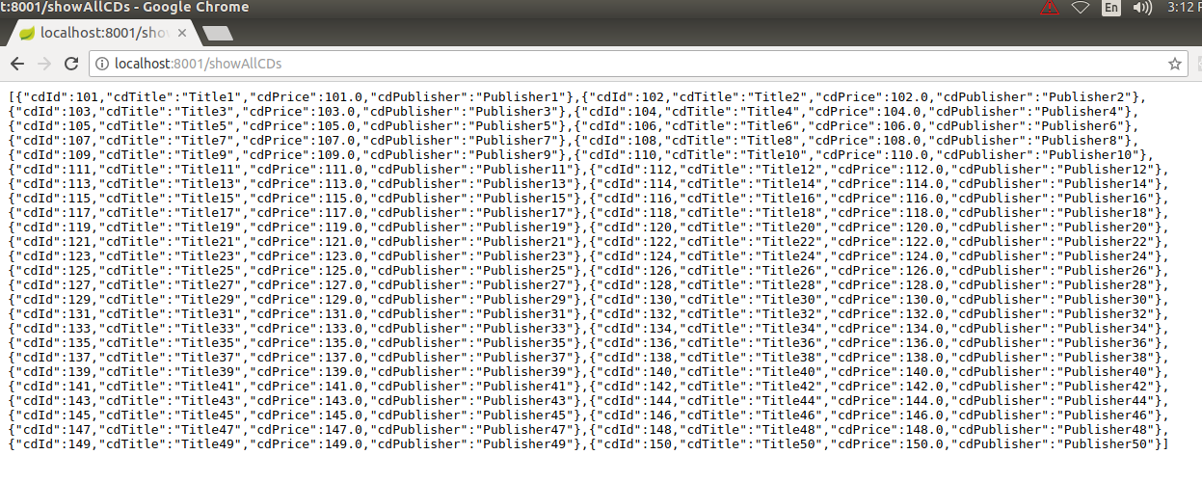

2. showCDsByPublisher

