https://www.youtube.com/watch?v=ANN9rxYo5Hg



Garbage collector

Old framework

Should work across languages

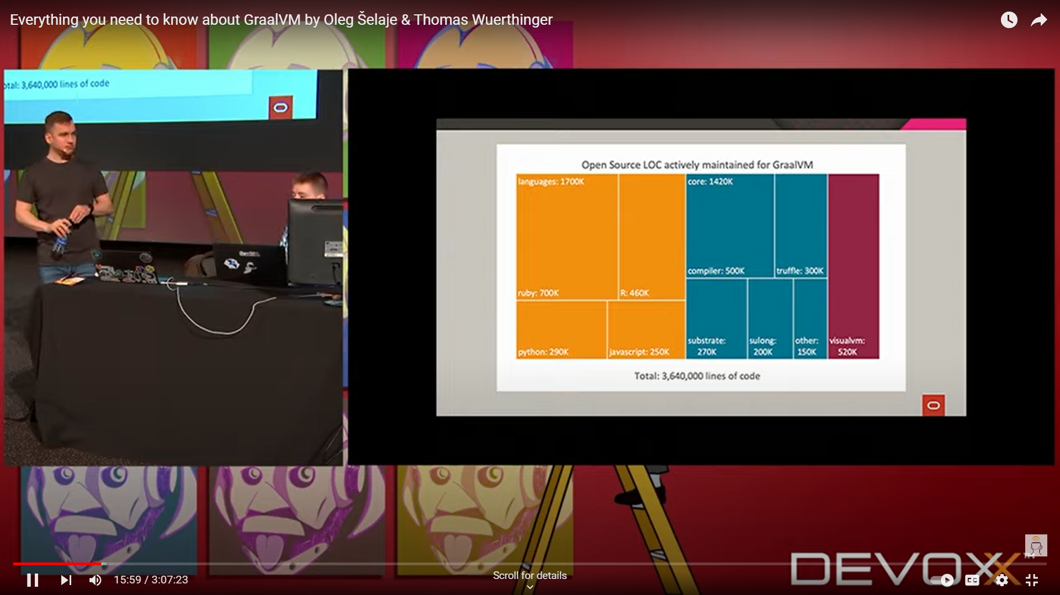

Compiler: JIT compiler

AOT: substrate

JIT Compiler

Written in java

Based on ooops

Graalvm vision: Implement abstractions without performance impact

“Abstractions should be without performance regret!”

Benchmark comparison between different jvm

<https://renaissance.dev/>

Goal

universal vm

run cloud stack

run program more efficiently

less resources

less cpu cycles

make dev. more productive

run multiple languages

**AOT**

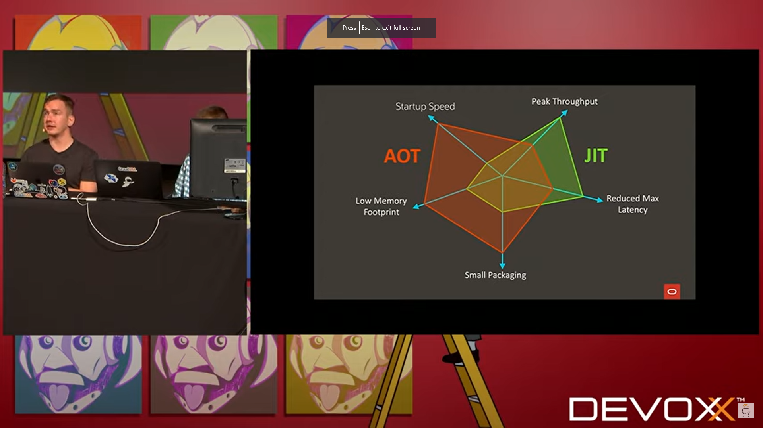

Graal VM as JIT Compiler

JVM based languages more efficient

Replace old JIT compiler with Graalvm compiler

compilation improvement

GraalVM native images

Performance means diff. to diff. people

Startup speed

Peak throughput

Reduced Max Latency

Small packaing

Low memory footprint

Every compiled ahead time

great result startup

nothing to compile JIT