ioNova AI Lab
App User Guide
Address Structuring Lab (App A) and isolation test app (App B) on Microsoft Fabric, using the existing Microsoft Foundry address-structuring agent
Version | 1.0
Date | 2 November 2026
Prepared by | Vilas Menon
Environment | Development (Microsoft Fabric trial, Central India)
Classification | Internal
Version history
Document control
Document | ioNova AI Lab: App User Guide
Current version | 1.0
Status | Released for internal use
Owner | Vilas Menon
Applies to | App A (Address Structuring Lab) and App B (isolation test app), ioNova dev environment, repository main branch as of 2 November 2026
Source repository | github.com/vilasvmenon-ai/azure-fabric-proj (docs/user-guide)
Revision history
Version | Date | Author | Changes
1.0 | 2 November 2026 | Vilas Menon | First release. Step-by-step guide to both apps with screenshots from the dev environment.
Review and approval
Name | Role | Signature | Date
Vilas Menon | Author |  | 2 November 2026
 | Reviewer
 | Approver
Index
About this document 4
Purpose 4
Audience 4
Scope 4
How this guide is organised 4
Conventions 4
Related documents 5
1. The two apps at a glance 6
2. Open and sign in 7
3. Roles 8
4. First-time setup (app admin) 9
5. Structure an address 11
6. Records and record details 14
7. Review a result (reviewer) 16
8. Audit trail (auditor) 17
9. Administration (app admin) 18
10. App B, the isolation test app 19

About this document

Purpose
This guide walks through both ioNova Fabric apps screen by screen, so that anyone who is new to them can sign in, structure an address, review results, check the audit trail and manage access. App A, the Address Structuring Lab, structures postal addresses with the existing Microsoft Foundry agent. App B is a small test app that proves each app stays separate.

Audience
- App users who submit addresses and check their own records.
- Reviewers who approve or correct the agent's results.
- Auditors who read and verify the audit trail.
- App administrators who set up a deployment and grant roles.
- Stakeholders who want to understand what the apps do.

Scope
The guide covers using the two apps in the ioNova development environment. It doesn't cover installing or deploying the apps, which is described in the setup and deployment guides in the repository (see Related documents).

How this guide is organised
Chapters | Read if you want to
1 to 3 | Understand the two apps, sign in, and see which role gives which screens.
4 | Set up a new deployment for the first time (app admin).
5 and 6 | Structure an address and find your saved records (app user).
7 | Review and correct results (reviewer).
8 | Read and verify the audit trail (auditor).
9 | Grant and revoke roles (app admin).
10 | Use App B, the isolation test app.

Conventions
- Bold text is a button, tab, field or label exactly as it appears in the app.
- Italic text is a message the app shows.
- Numbered lists are steps to follow in order.
- Screenshots were taken in the dev environment on 2 November 2026 as vilas@ionova.ai, signed in as app admin and super user. All addresses shown are synthetic test data.

Related documents
Document | Where
ioNova Microsoft Fabric and Foundry React Apps PRD v1.2 | docs/prd/ in the repository
Setting up a new environment | docs/SETUP-NEW-ENVIRONMENT.md
Deploying with Claude Code | docs/CLAUDE-CODE-DEPLOY.md
Support, rollback and restore | docs/SUPPORT.md
Repository | github.com/vilasvmenon-ai/azure-fabric-proj

1. The two apps at a glance
App A turns a free-text postal address into six checked fields using the existing Foundry agent; App B is a small second app that proves apps stay apart.
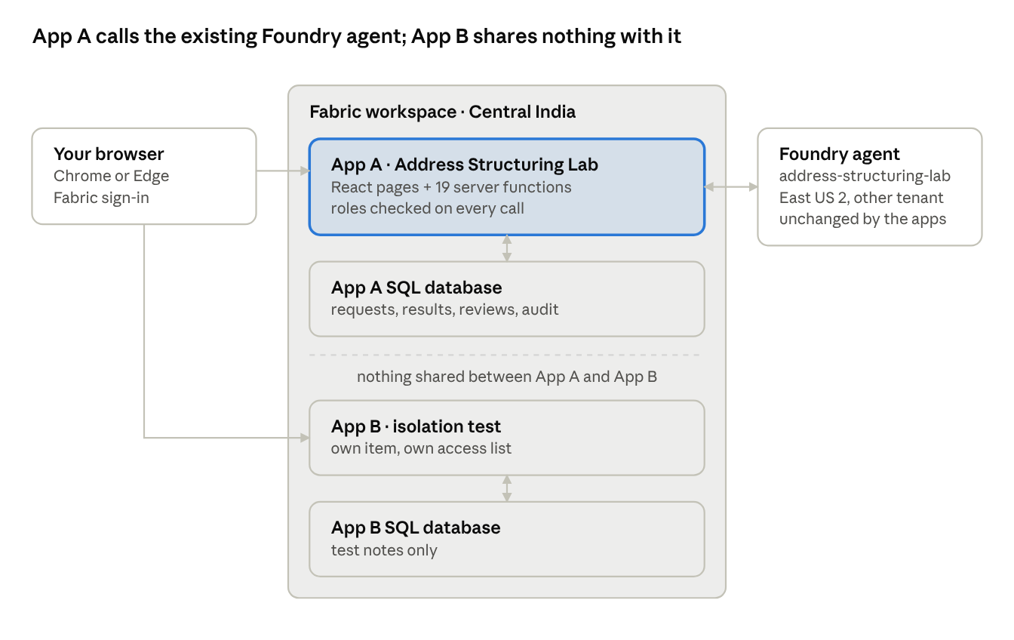
How the two apps fit together · dev environment
Only App A's server functions talk to the agent: they send the address text and save the answer in App A's own database. App B has its own item, database and access list, and nothing links it to App A.

2. Open and sign in
Both apps are private web pages hosted by Microsoft Fabric; you sign in with your ioNova work account.
App | URL (dev)
App A, Address Structuring Lab | hot-shrub-288d05cfbd-centralindia.webapp.fabricapps.net
App B, isolation test | satin-gorge-cc665081ef-centralindia.webapp.fabricapps.net
- Open the app URL in Chrome or Edge.
- Select Sign in. A Microsoft Fabric tab opens.
- Pick your ioNova account (for example vilas@ionova.ai) and finish any MFA prompt. The Fabric tab closes and the app opens.
- Your email and roles appear at the top right. Sign out ends the session.
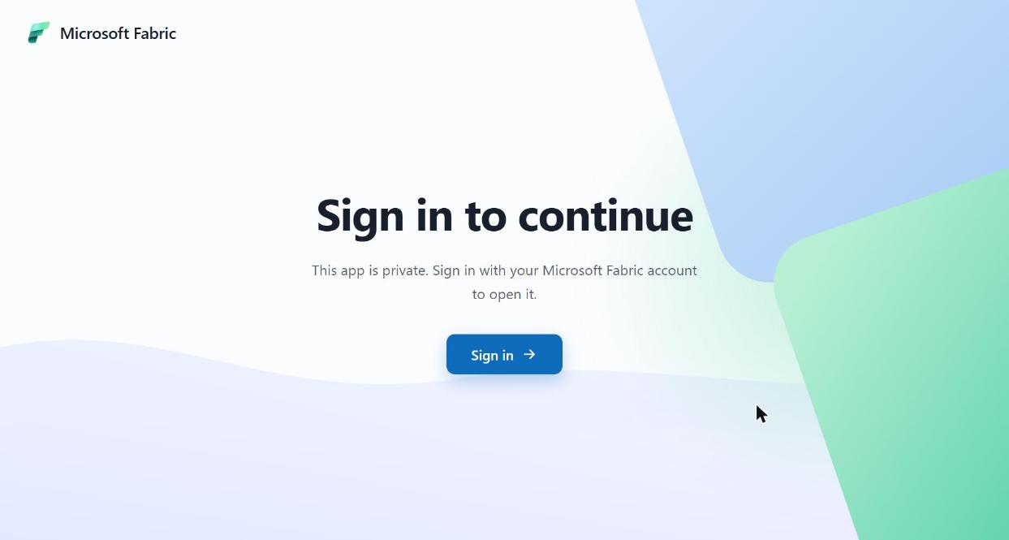
A personal Microsoft account (gmail, outlook) cannot open the apps. You also need the app item shared with you in Fabric (Run and interact) and, for App A, a role granted inside the app.

3. Roles
What you see in App A depends on the roles an app admin granted you; one person can hold several roles, and nobody can change their own roles.
Role | Can do | Tabs you see
app_user | Submit addresses, see and retry own requests | Structure an address, Records
reviewer | See all requests, approve, reject or correct fields | Records (all)
auditor | Read the audit trail and verify its integrity | Audit
audit_exporter | Read and export the audit trail | Audit
app_admin | Grant and revoke roles, run operations checks | Administration
super_user (dev/uat only) | app_user plus app_admin, so one person can check the system alone | Structure an address, Records, Administration
The screenshots in this guide were taken as vilas@ionova.ai with app admin and super user, so the Review and Audit screens are described but not shown. An app admin sees no address data or audit entries unless they also hold those roles.

4. First-time setup (app admin)
A new deployment needs one admin and a few readiness checks before anyone submits addresses; this was done in dev on 26 Oct 2026.
- Sign in as an account listed in the deployment's bootstrap admins. On the No access to this app yet page, select Become the first app administrator.
- Open Administration. Scroll to Operations and readiness.
- Select Seed sample data once. It loads six approved synthetic addresses for the sample picker.
- Select Run diagnostics. It lists the app's settings and a green tick for each database table.
- Select Probe existing Foundry agent. Expect reachable, contract valid; it proves the app can call the agent.
- Optional: Run evaluation (6 live calls) sends the six samples to the agent and compares the answers with the expected fields.
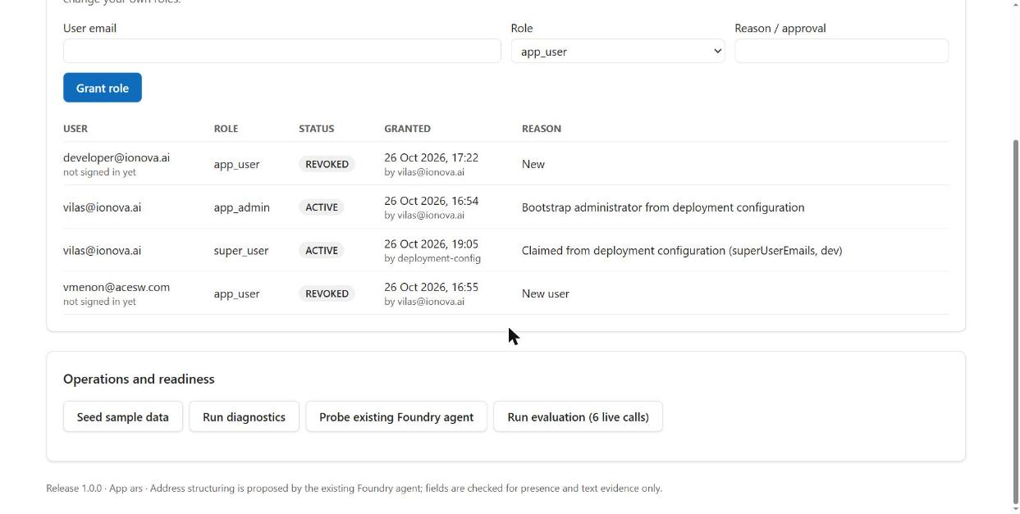
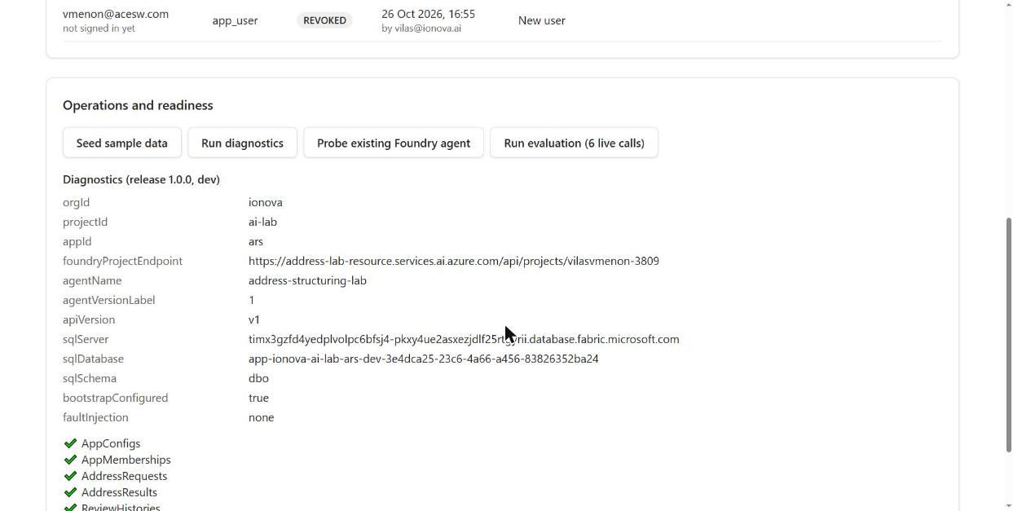
If the probe shows auth (HTTP 403), the Foundry role is missing or still propagating (up to about 15 minutes).

5. Structure an address
You paste one free-text address; the existing Foundry agent splits it into six fields, and the app saves both your input and the result (about 10–15 seconds).
- Open Structure an address (the first tab).
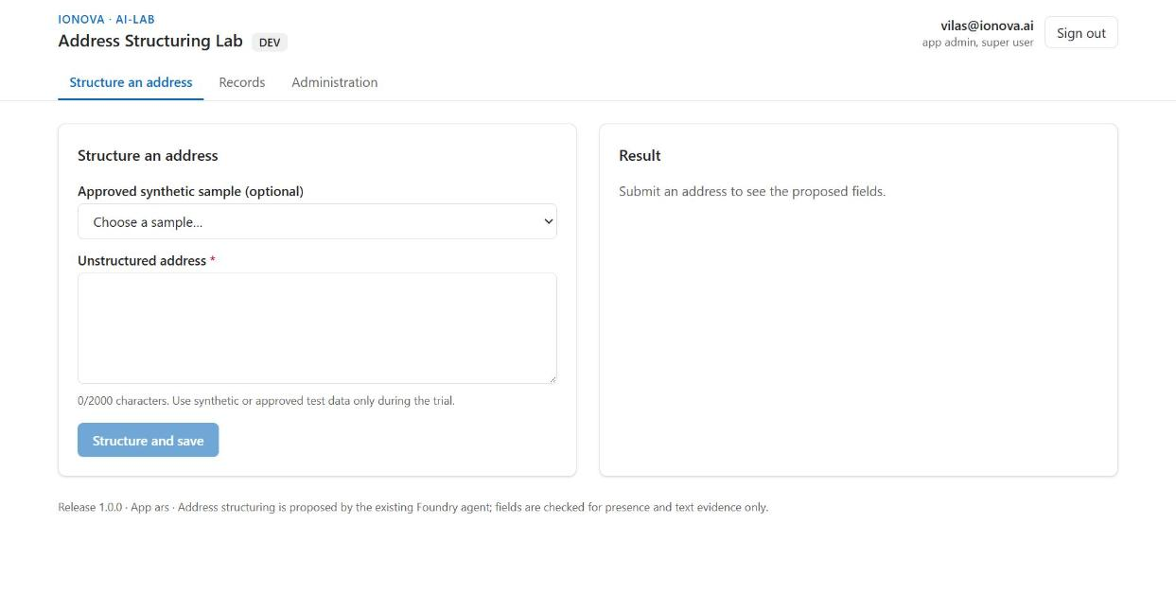
- Either pick an entry from Approved synthetic sample, or type an address into Unstructured address (up to 2,000 characters). During the trial, use synthetic or approved test data only.
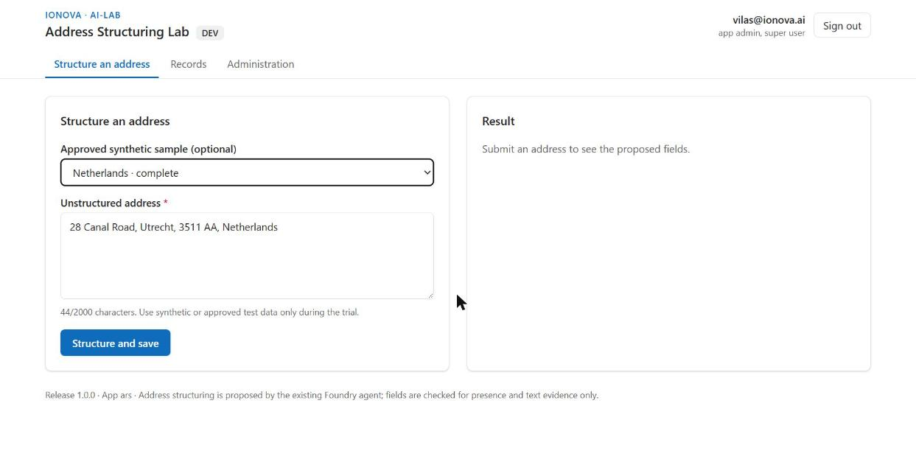
- Select Structure and save. The button shows Structuring… (this can take up to a minute) while the agent works.
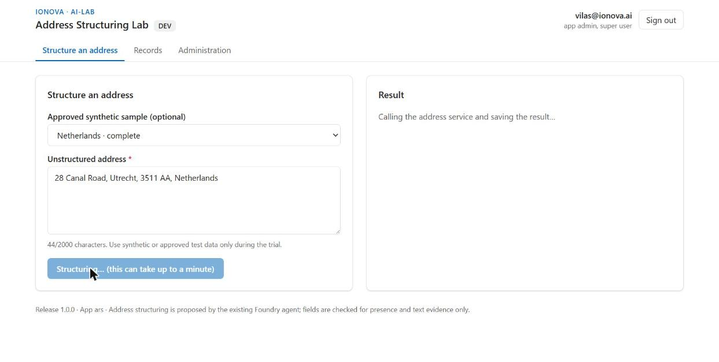
- Read the Result: Building, Street, Town / city, Region, Postcode and Country (ISO), each with the words from your input that support it. A dash means the agent found nothing for that field.
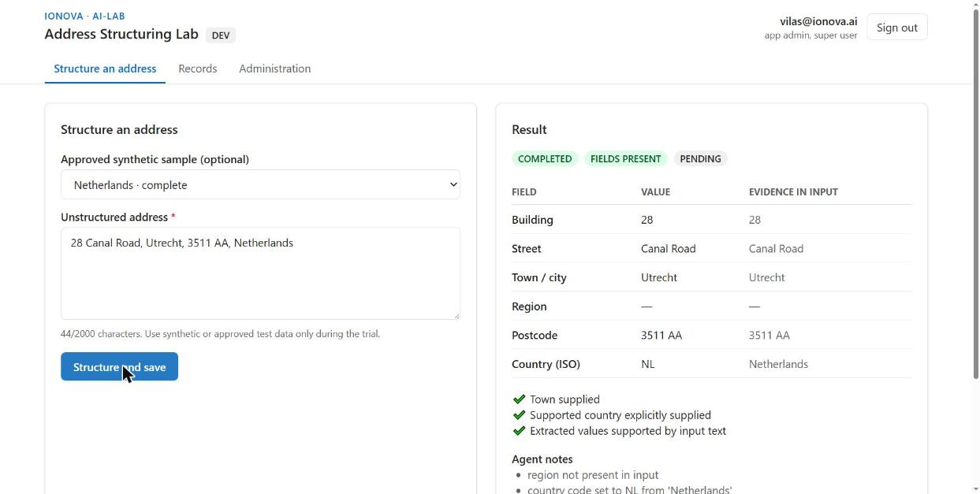
- Check the badges and ticks. COMPLETED means it was saved, FIELDS PRESENT means the result passed the app's checks, and PENDING means no reviewer has looked at it yet. Below them are the agent's notes, the time taken and a Correlation ID for support.
- Select Open record to see the saved record.
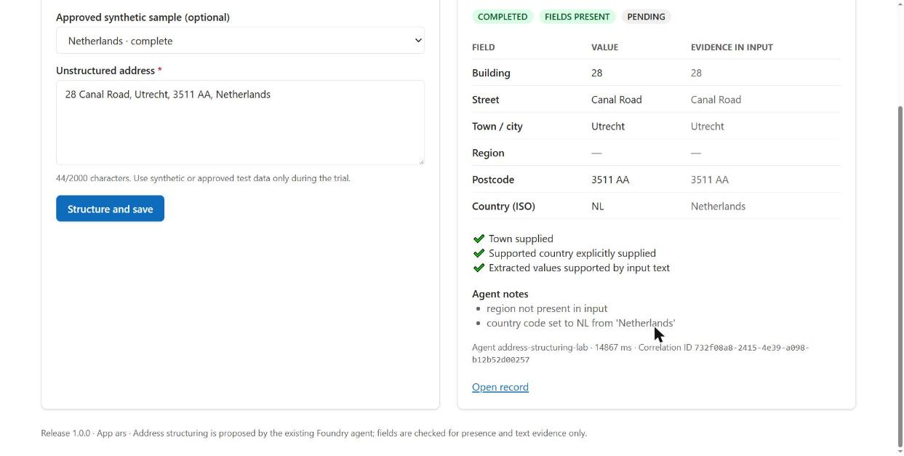

6. Records and record details
Every submission becomes a record that keeps your original input, the agent's untouched output and the current (reviewed) fields side by side.
- Open Records. Filter by Processing (for example COMPLETED or FAILED_AI) and Review (PENDING, APPROVED, REJECTED, NEEDS_CHANGES). App users see their own records; reviewers see everyone's.
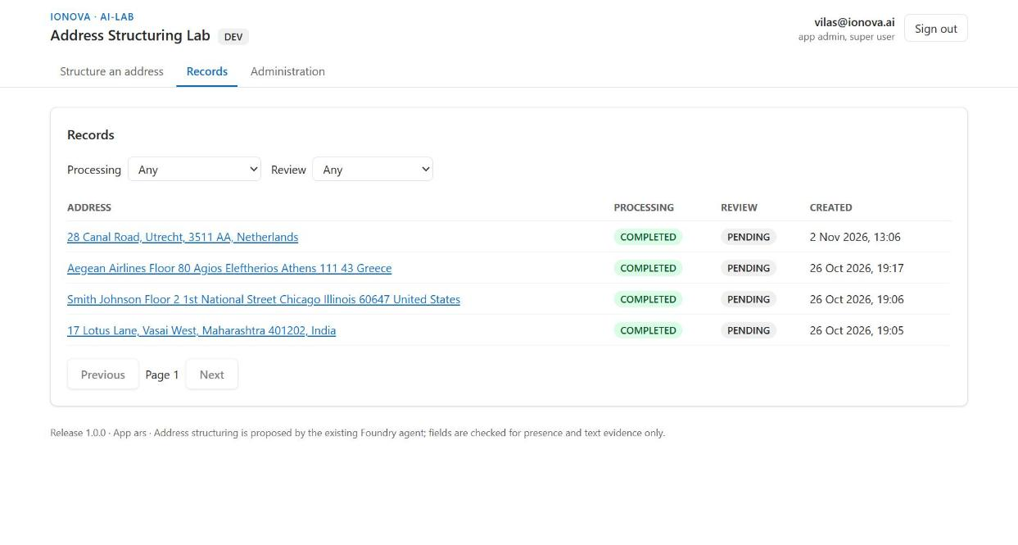
- Open a record (from the list, or Open record after a submission). The top card shows the status badges, version, original input, who submitted it, when, and the correlation ID.
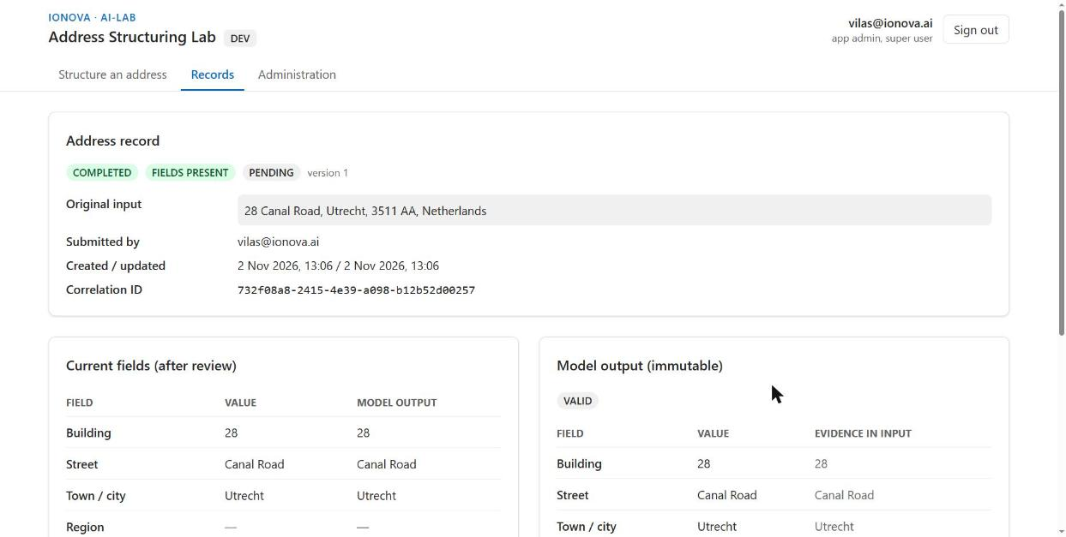
- Compare the two panels. Current fields (after review) is what the business uses; Model output (immutable) is the agent's answer, never edited, with the agent version, contract and response ID. Review history lists every reviewer decision.
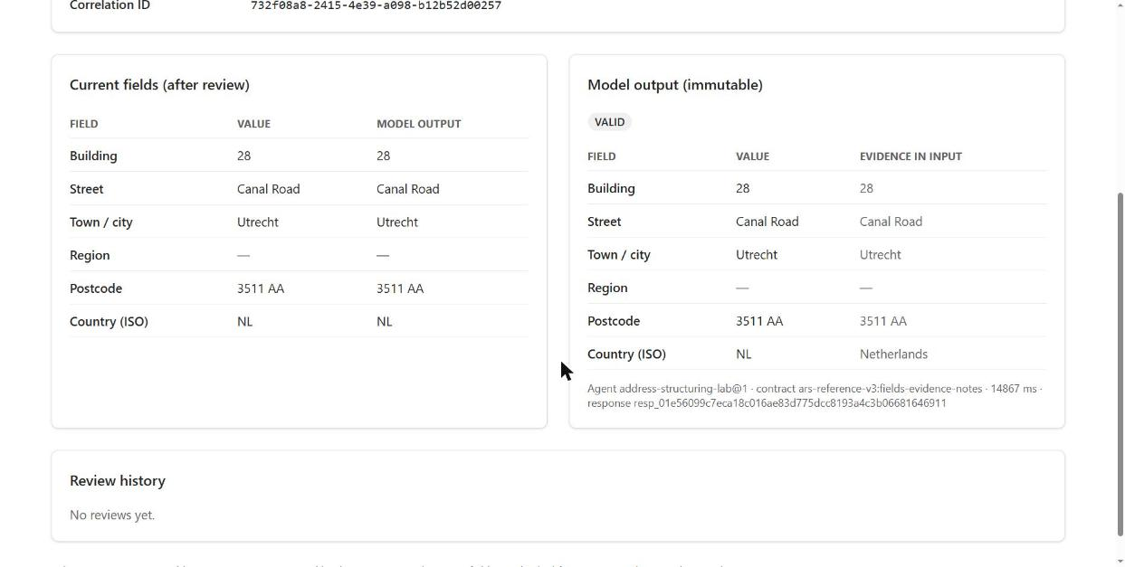

7. Review a result (reviewer)
A reviewer confirms or corrects the agent's fields; the agent's original output is never changed, only the current fields and the review history.
- Open Records and filter Review to PENDING.
- Open a record. Below the panels shown above, a Review card appears for reviewers.
- Under Corrected fields (leave unchanged to keep), edit any of the six fields. Country takes a two-letter ISO code.
- Choose a Decision: Approve, Needs changes, Reject or Comment only. Add Comments if useful.
- Select Save review (version N). The record's review badge and Review history update.
- If someone else saved first, you see a conflict message. Select Reload latest version and review again.
No screenshot: the sample account does not hold the reviewer role.

8. Audit trail (auditor)
Every business action is written to a tamper-evident audit trail: each event carries a hash of the one before it, so any change or gap shows up when you verify it. Audit events never contain address text.
- Open the Audit tab (shown only to auditor and audit_exporter).
- Narrow the list with Actor email, Action (for example address.processed) and Outcome (SUCCESS, DENIED, FAILURE), then select Apply filters.
- Read the table: Time (local), Actor, Action, Object, Outcome and Correlation ID.
- Select Verify integrity. Expect a green Audit chain intact: N events verified. A red Audit chain BROKEN at event N means something was altered; escalate to the project administrator.
- With audit_exporter, Export CSV downloads the filtered events.
No screenshot: the sample account does not hold an audit role. In dev the chain was verified intact on 26 Oct 2026 (28 of 28 events).

9. Administration (app admin)
App admins decide who may use App A and in which role; every grant and revoke is audited with a reason.
- Open Administration. The App membership card lists every grant with its role, status (ACTIVE or REVOKED), who granted it and why.
- To grant a role, enter the person's sign-in User email, choose a Role, write a Reason / approval, then select Grant role. Repeat to give the same person a second role.
- Make sure the person can also open the app: in Fabric, share the App A item with them as Run and interact. A role alone is not enough.
- A new grant shows not signed in yet until the person's first visit, when it binds to their account.
- You cannot change your own roles; another admin must do it.
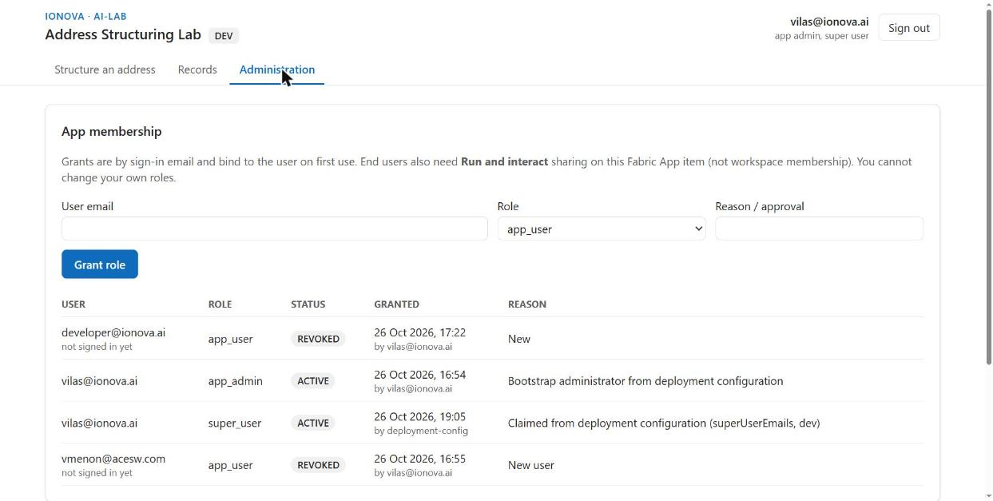
Super user (dev and uat only). An account listed in the deployment's super-user setting can select Claim super user on this tab once. It adds the super_user role (app_user plus app_admin) so one person can test end to end. Production refuses this setting.

10. App B, the isolation test app
App B is a deliberately tiny second app with its own Fabric item, database and access list; it exists to prove that one app cannot see another app's data or users.
- Open the App B URL and sign in (a separate sign-in from App A).
- Type a short note into the box and select Add test note.
- Reload the page: the note is still listed with its date and time, so it was saved in App B's own database.
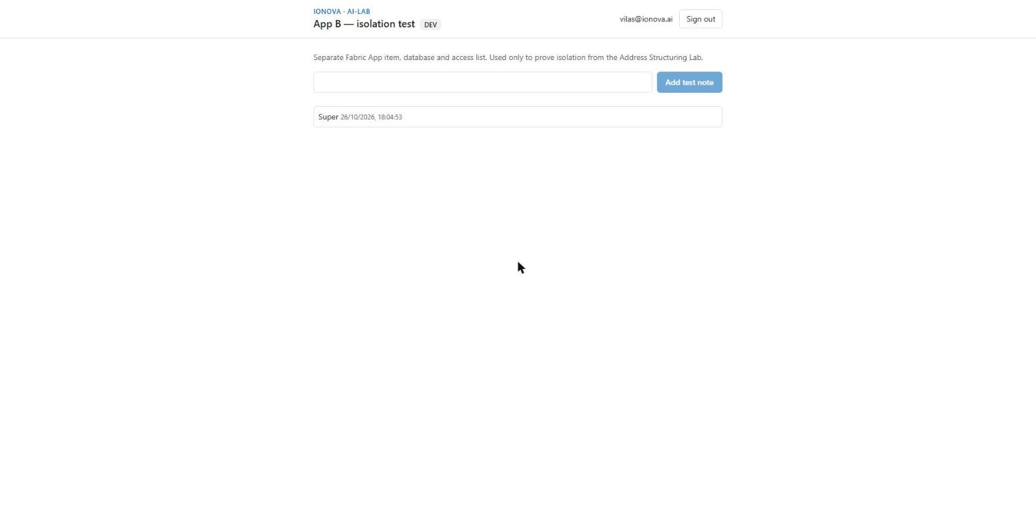
What it proved in dev (26 Oct 2026): App B's database holds only its notes table (1 note, “Super”), and App A's database has no notes table. Access is granted per app item, so a person shared on only one app cannot open the other.

