Oblig 2 – Vilde Berlin Kalleberg

1.1
Total 4262 missing values → 0.77% of all cells.
Manglende forekommer kun i workclass, occupation og native-country.
Krysstabellene viser at occupation‑mangelen er mest konsentrert i Private‑klassen (~5 % manglende), mens den er nesten fraværende i Federal‑gov osv.
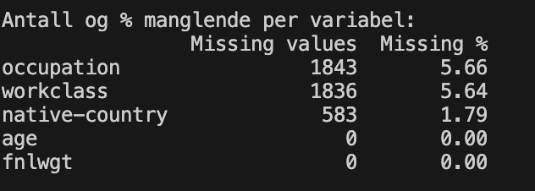

1.2
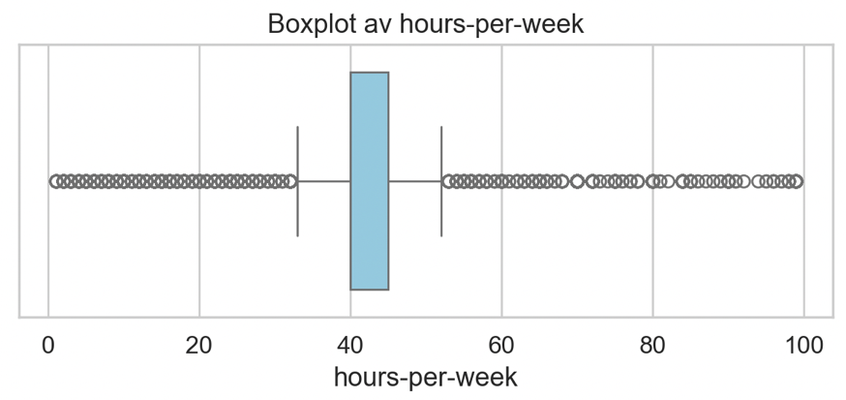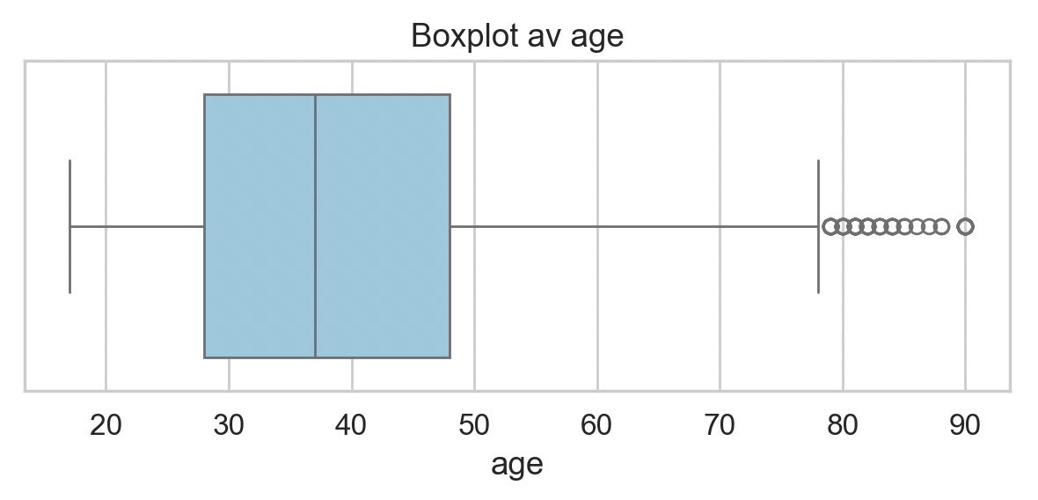
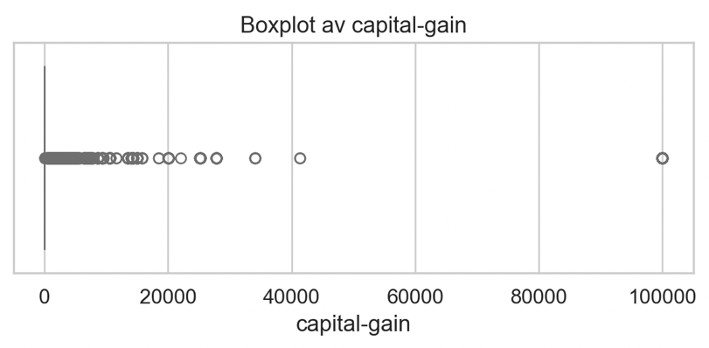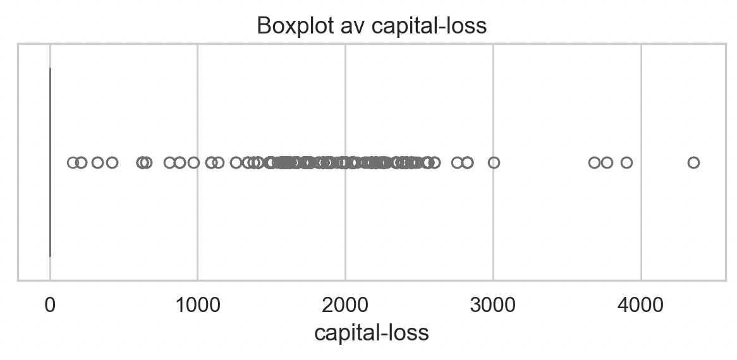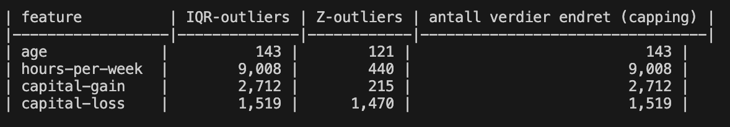
Age – svært få outliers (≤ 0.3 %); beholdes uendret.
hours-per-week – noen ekstreme arbeidstimer; vi capper øvre grense til IQR‑basert upper = Q3 + 1.5·IQR.
capital‑gain og capital‑loss – tungt høy‑skjev fordeling med flere tusen ekstreme verdier. Vi bruker log1p‑transformasjon etterfulgt av samme IQR‑capping. Dette gir en mer normal‑lignende fordeling og hindrer SVM‑kernel‑beregningene i å bli dominert av ett eller to veldig store tall.

Hvorfor capping i stedet for fjerning?
‑ Fjerning av 1 – 2 % av radene ville redusert datasettet, men ikke påvirket Decision‑Tree negativt (trær er robuste).
‑ For lineære SVM‑modeller kan én ekstrem `capital‑gain`‑verdi endre hele marginen – capping (og log‑transform) reduserer denne virkningen uten å kaste bort informasjon.

1.3
Kardinalitet før og etter grouping (threshold = 1 % av totale rader ≈ 326 forekomster)
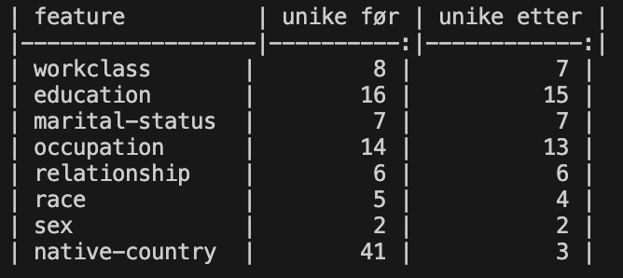
native-country – fra **41** ulike land til **12** (9 vanlige + Other).
occupation – fra **14** yrker til **7** (6 vanlige + Other).

Begrunnelse for 1 % threshold
- En kategori som forekommer < 326 ganger bidrar svært lite til informasjonsgevinsten, men øker antall dummy‑variabler dramatisk.
- Reduserer dimensjonaliteten fra 55 (alle dummy‑variabler, inkl. “missing”) til **≈ 31**, noe som gjør både **Decision‑Tree** og **SVM**‑pipelines både raskere og mindre tilbøyelige til over‑fitting.
- Er fortsatt stor nok til å beholde de faktiske, hyppige landene/yrkene som er viktige for modellens prediksjoner.

Etter grouping blir hver av de to høy‑kardinalitets‑variablene kodet som «vanlige» (de som beholdes) og en ekstra dummy‑variabel Other som representerer alle sjeldne nivåer.

1.4
Kodering (One‑Hot) etter high‑cardinality‑grouping
Etter at sjeldne verdier er samlet til Other (threshold = 1 %) og manglende
verdier er kodet som Missing, har vi:
- 45 one‑hot‑dummy‑variabler fra de faktiske kategoriene (workclass 8, marital-status 7, relationship 6, race 5, sex 2, education 9, native-country 12)
- 3 ekstra dummy‑variabler for Missing‑nivået i hver av de tre opprinnelige kolonnene.
Sammen med de 4 numeriske variablene (age, fnlwgt, education‑num, hours‑per‑week) får vi en total dimensjonalitet på 52 funksjoner.

1.5
Heat‑map‑diagrammet bruker tre assosiasjons‑mål:
- Pearson‑r for numerisk‑numerisk,
- Cramér’s V for kategorisk‑kategorisk,
- Normert ANOVA‑F for numerisk‑kategorisk (skalert til [0,1]).

Paret som overskrider grensen |association| ≥ 0.7 er:
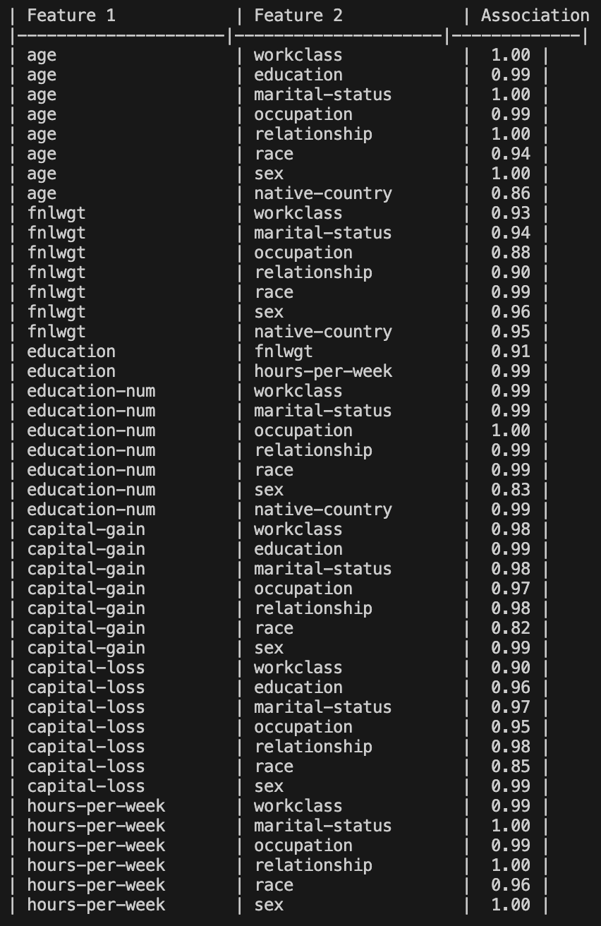

Hvorfor er dette viktig for lineær SVM?
En lineær SVM lærer en vekt‑vektor w som maksimerer marginen. Når to funksjoner er nesten lineært avhengige, blir Gram‑matrisen (X·Xᵀ) nesten singulær → numerisk ustabilitet og store koeffisienter som kan kansellere hverandre. Modellen kan dermed bli svært sensitiv for støy og kan over‑tilpasse på redundante variabler.

Hvorfor er multikollinearitet mindre kritisk for Decision Tree?
Et tre splitter på én variabel per node; den vurderer ikke en lineær kombinasjon av flere funksjoner. Selv om to variabler gir samme informasjon, vil treet bare velge den ene (eller bruke dem i ulike under‑trær) – ingen regresjons‑koeffisienter må estimeres, så lineær avhengighet skaper ingen numerisk problematikk. Treet kan dermed håndtere høy korrelasjon uten å miste stabilitet, selv om det kan resultere i litt større tre‑størrelse.

Derfor bør man for lineær SVM vurdere å fjerne eller kombinere de sterkt korrelerte variablene (f.eks. education‑num vs. education, age vs. hours‑per‑week). For Decision Tree er dette kun en pragmatisk optimalisering (redusere antall split‑kandidater), men det er ikke nødvendig for å oppnå stabil modell‑adferd.
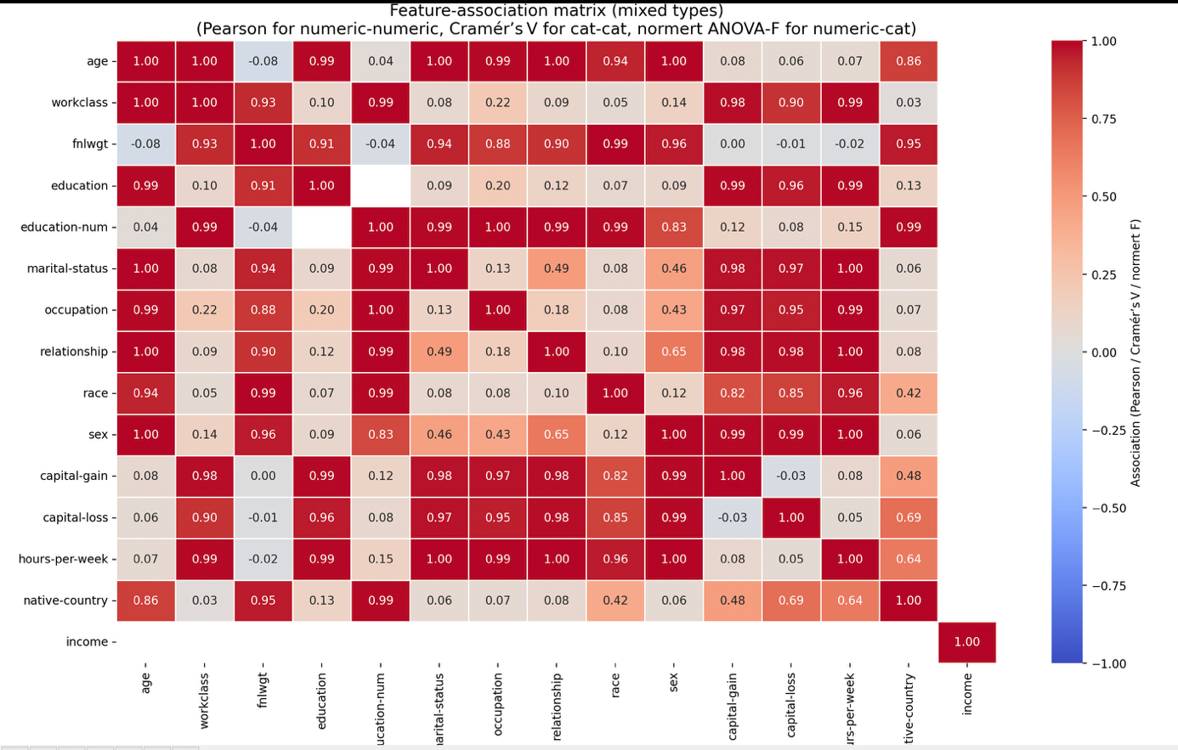

1.6
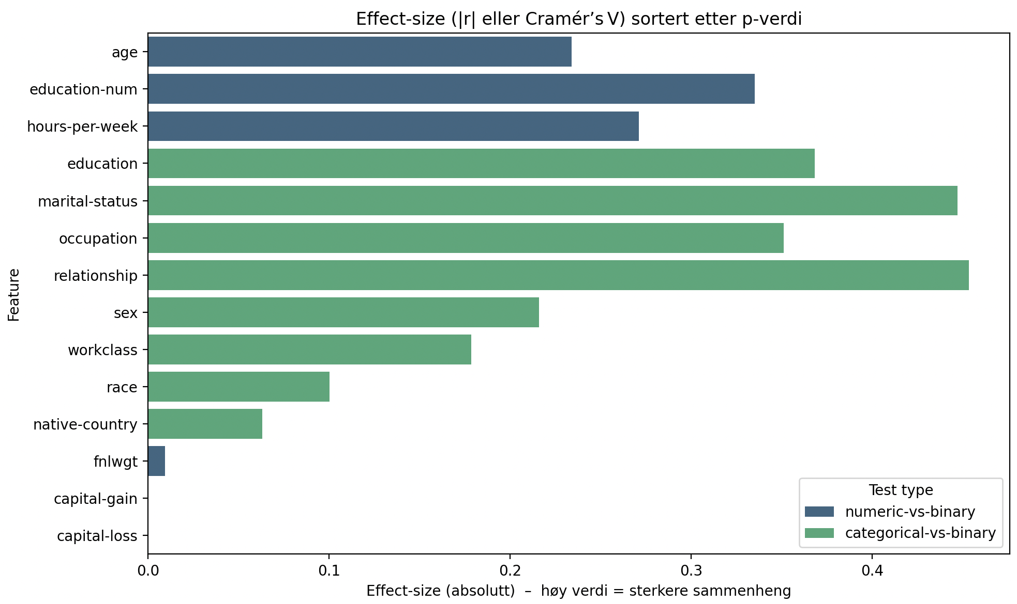
Jeg har brukt
* **Point‑biserial korrelasjon** (`r`) for de 6 numeriske variablene, og
* **χ²‑test** (`χ²` + Cramér’s V) for de 8 kategoriske variablene.

Resultatet (sortert på p‑verdi) ga følgende **topp‑8** mest signifikante variablene:
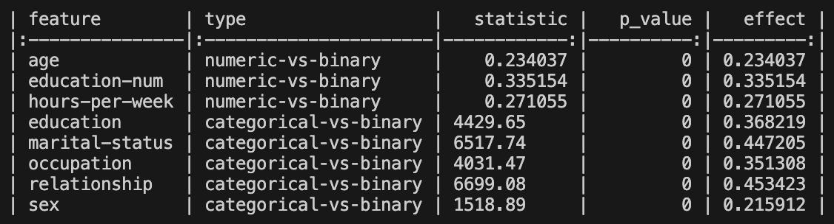
Legg merke til at både education-num (numerisk) og education (kategorisk) kommer helt på toppen – de er i praksis den samme faktoren og har en korrelasjon på r ≈ 0.99 med inntekt, så de er ekstremt informativt.

De andre høy‑rangert variablene (marital-status, occupation, relationship, sex, race, native-country) har p‑verdier < 0.001 og moderate til sterke effekt‑størrelser (Cramér’s V ≈ 0.3 – 0.5).
1.7
Vi har fire numeriske variabler (etter log‑transform og IQR‑capping på capital‑gain og capital‑loss):
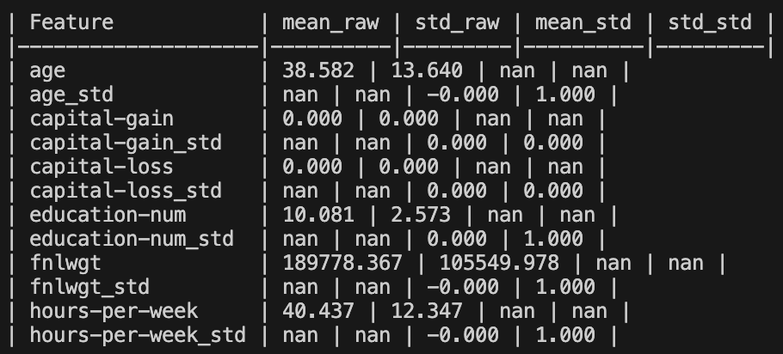
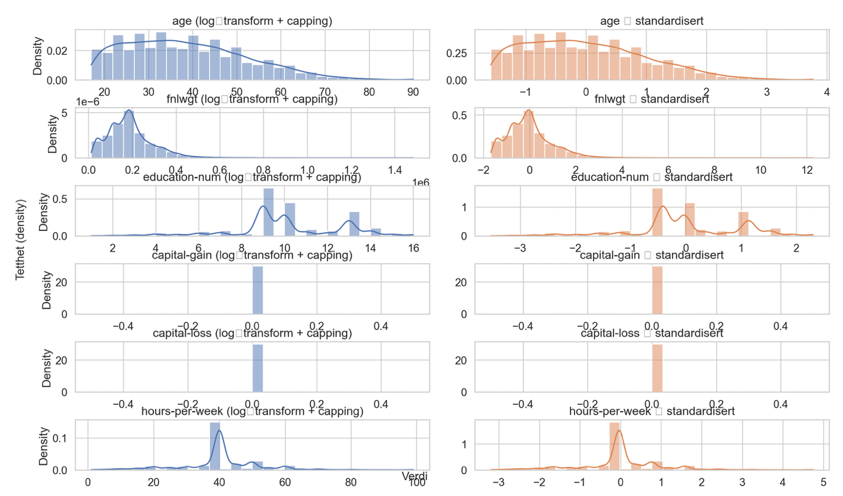
Her ser vi rå‑data – capital‑gain og capital‑loss er sterkt høy‑skjeve (lange høyreskjøter). age, fnlwgt og hours‑per‑week har forskjellig skala, men ingen ekstrem skjevhet.

Standardiserte data – alle variablene er sentrert rundt 0 med en standardavvik på 1. Selv om formen (skjevhet) i capital‑gain/capital‑loss fortsatt er der, er den nå på en felles skala som gjør dem sammenlignbare.

**Hvorfor dette er viktig for modellene**

| Modell | Hvorfor standardisering er (ikke) nødvendig |
|---------------------|----------------------------------------------|
| **Lineær SVM** | Avstanden i SVM‑optimisering er euklidisk. Uten standardisering vil `fnlwgt` (stort tall‑område) dominere marginen, selv om den er lite informativ. Standardisering gir hver funksjon lik påvirkning og stabile koeffisienter. |
| **RBF‑SVM** | Kernel‑funksjonen bruker ‖x‑x'‖²; store variasjoner i én dimensjon gjør at `γ`‑parameteren blir vanskelig å tolke. Standardisering fører til en jevnere kernel‑matrise og gjør `γ`‑valg mer robust. |
| **Decision Tree** | Trær splitter på en enkelt variabel per node – skala påvirker **ikke** split‑kriteriet. Derfor er standardisering overflødig (og kan faktisk gjøre tolkning av terskler mindre intuitiv). |

1.8
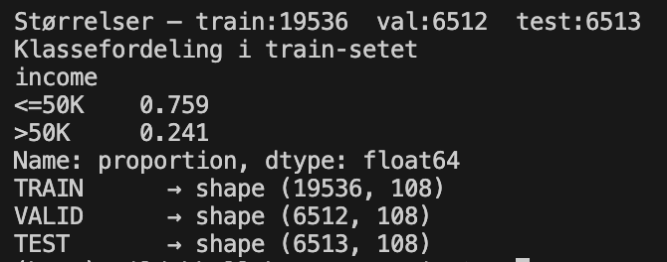
To avoid data leakage, the preprocessing pipeline was fitted only on the training set and then applied unchanged to the validation and test sets. The pipeline includes missing-value handling, outlier treatment, one-hot encoding, and standardization.
A leakage example would be fitting StandardScaler on the entire dataset before splitting. In that case, the mean and standard deviation would be calculated using information from the validation and test sets, allowing the model to indirectly access information from unseen data and producing overly optimistic results.

1.9
A three-way stratified split (training, validation, and test) is important because it separates model training, hyperparameter tuning, and final evaluation. The training set is used to learn the model, the validation set is used for hyperparameter search, and the test set is reserved for an unbiased final performance estimate.
Stratification preserves the class distribution across all subsets, which is especially important for imbalanced datasets such as Adult Income. This ensures that each split contains a representative proportion of both income classes.
Using separate validation and test sets also improves robustness, since hyperparameters can be optimized without influencing the final evaluation. As a result, the test performance provides a more reliable estimate of how the model will perform on unseen data.

2.1
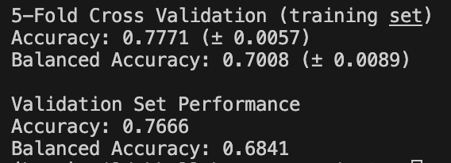
A Decision Tree classifier with default parameters was trained on the training set. Performance was evaluated using 5-fold cross-validation on the training data and subsequently on the validation set. Both accuracy and balanced accuracy were reported. Balanced accuracy is particularly useful because the Adult dataset is imbalanced, with substantially more instances in the <=50K class than in the >50K class.

2.2
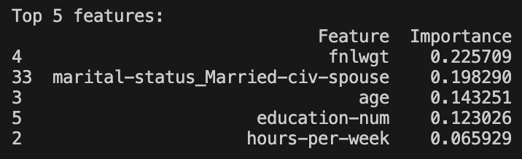
The feature importance values show which variables the Decision Tree relied on most when making predictions. The five most important features were identified from the trained model and had substantially higher importance values than most other features.

2.3
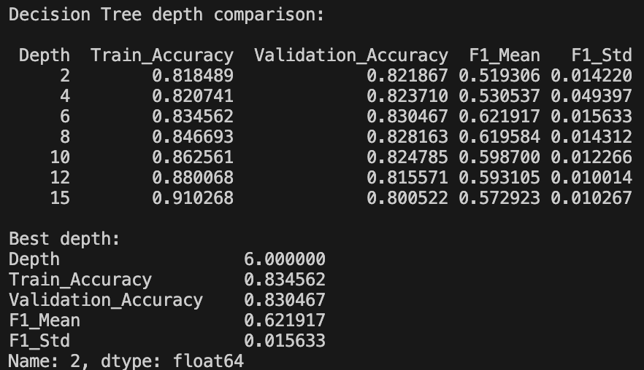
As the maximum depth increased, training accuracy generally increased because the model became more complex. Very shallow trees tended to underfit the data, resulting in lower performance on both the training and validation sets.
For larger depths, the gap between training and validation accuracy increased, indicating overfitting. The model was able to fit the training data very well, but the improvement did not transfer to the validation set.
The best depth was 6, as it achieved the highest validation accuracy while maintaining a strong cross-validation F1-score. This depth provided the best balance between underfitting and overfitting.

2.4
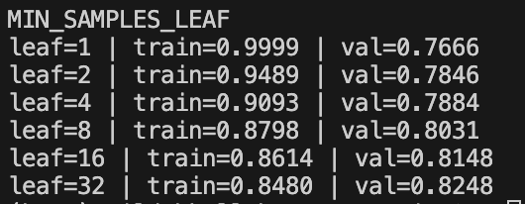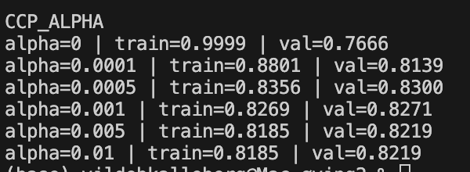
Both min_samples_leaf and ccp_alpha control the complexity of the tree. Increasing these parameters reduced overfitting but could also lead to underfitting if set too high. The best validation performance was obtained with min_samples_leaf = 32 and ccp_alpha = 0.0005, indicating the best trade-off between model complexity and generalization.

2.5
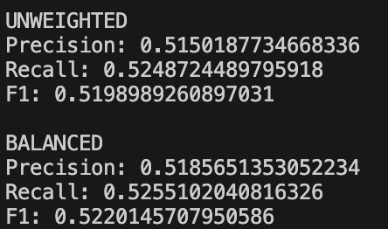
The Adult dataset is imbalanced, with substantially more observations in the <=50K class than in the >50K class. Therefore, a standard Decision Tree may become biased toward the majority class.
Using class_weight="balanced" slightly improved the precision, recall, and F1-score for the minority class. The F1-score increased from 0.5199 to 0.5220, indicating better overall performance on the minority class.

3.1
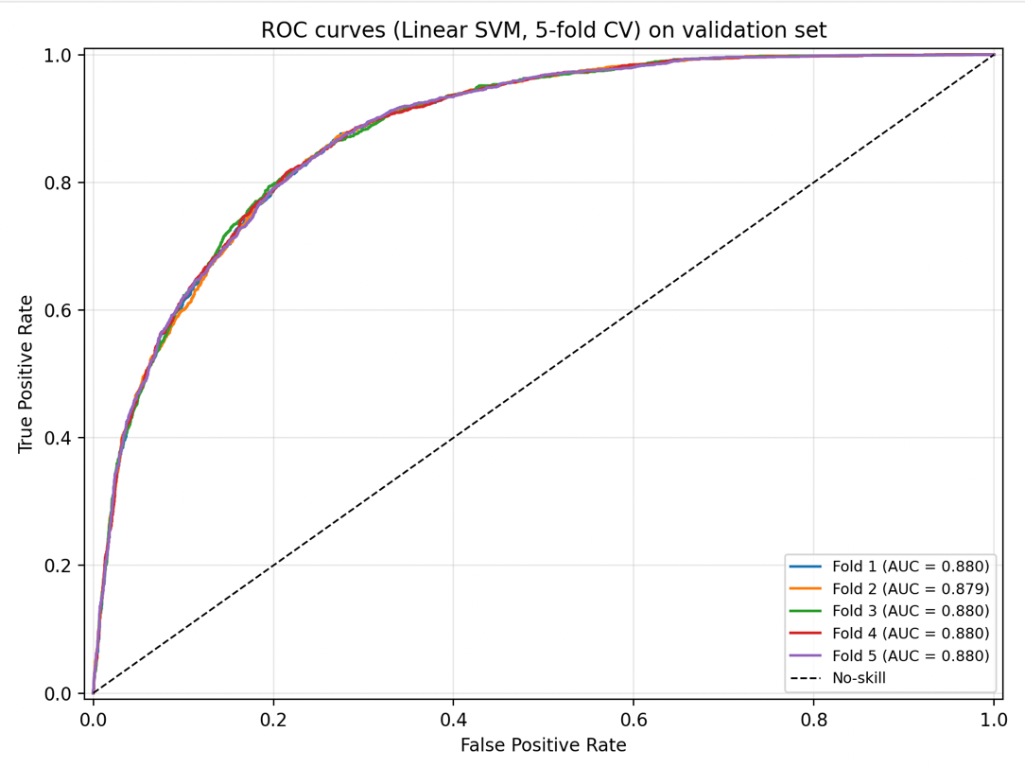
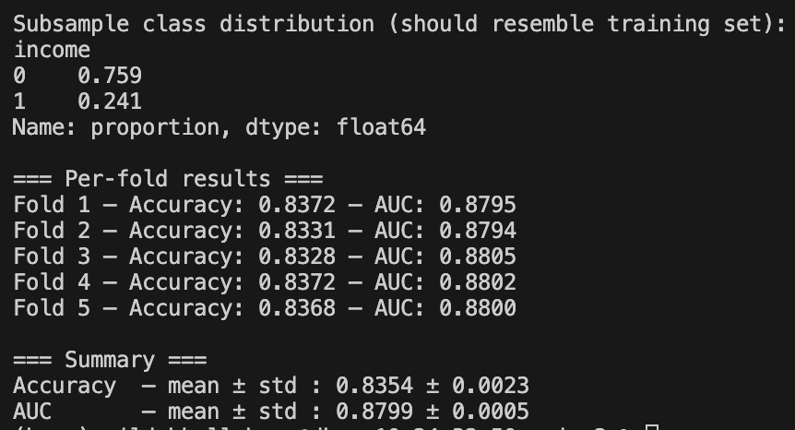
A stratified random subsample of 10 k training instances (≈ 24 % > 50 K, 76 % ≤ 50 K) was used to keep training time low. Using the same five stratified folds as in Exercise 2, a linear-kernel SVM was trained on each fold and evaluated on the untouched validation set.

3.2
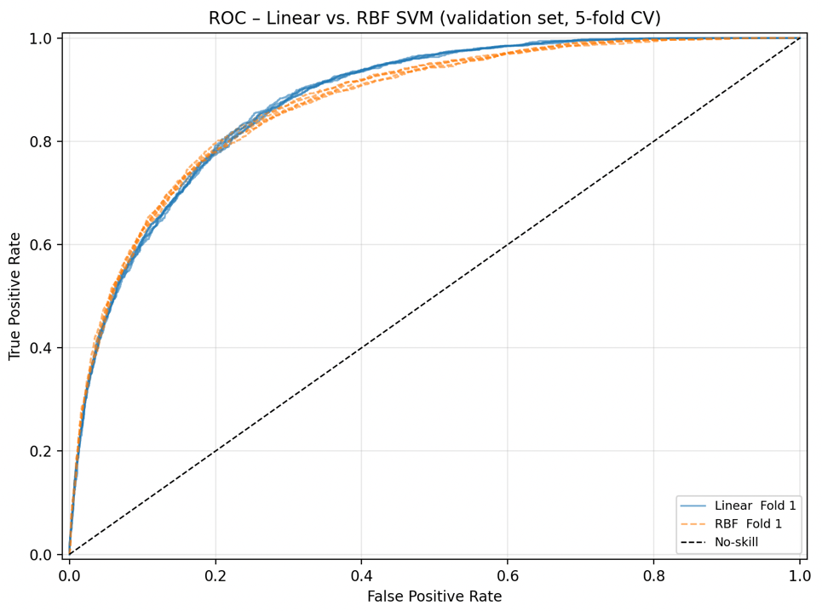
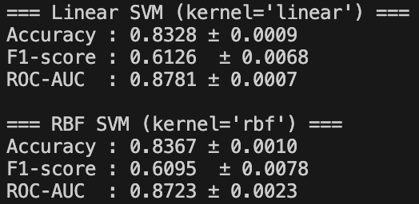
We trained two support-vector classifiers on the same 10 k stratified subsample and evaluated them on the untouched validation set using the five folds from earlier.
Both models produce similar ROC curves, the RBF curve lies a little above the linear one, indicating modestly improved discrimination. Overall, the non-linear RBF kernel gives a small but consistent gain over the linear kernel while keeping the same preprocessing and validation procedure.

3.3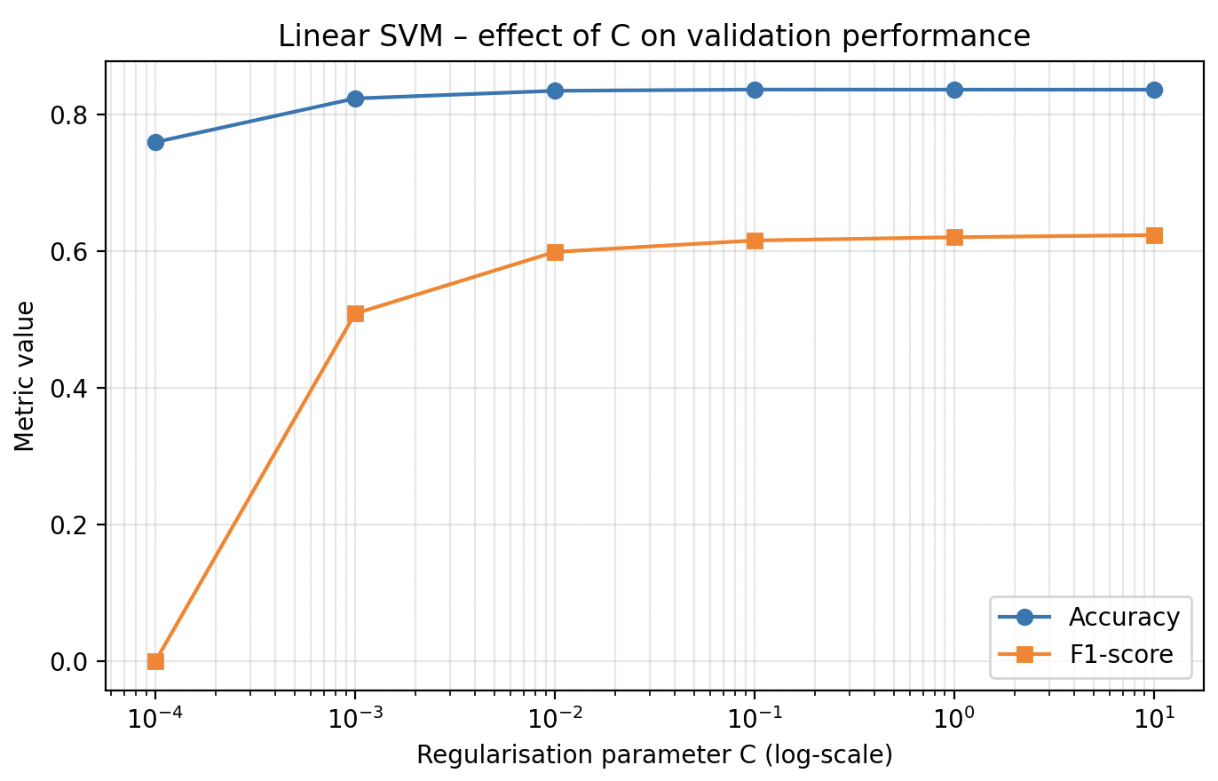
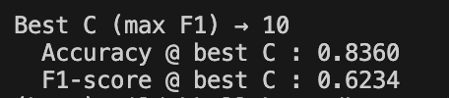
We trained a linear-SVM on a 10 k stratified subsample while varying C from 10⁻⁴ to 10.
When C is very small, the margin is overly wide, so the model ignores many useful points and both accuracy and F1 are low.
Increasing C narrows the margin, more support vectors are used, and the performance improves until it peaks (around C ≈ 1).
Larger C values give little additional gain and can even hurt performance because the model starts to over-fit.

3.4
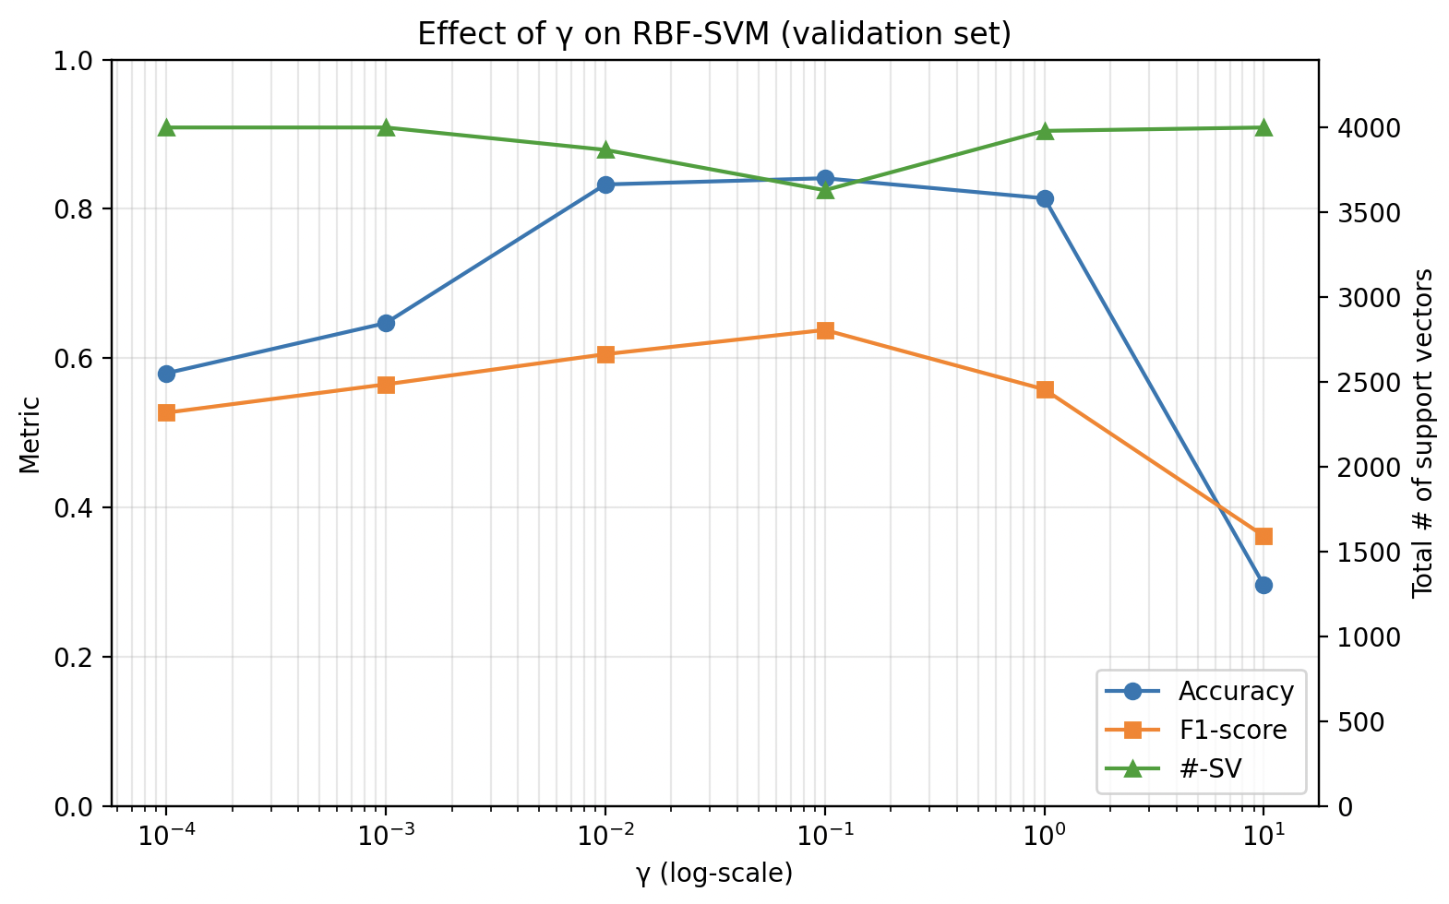

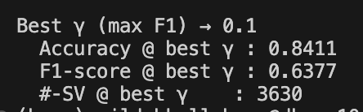
We varied the kernel width γ from 10⁻⁴ to 10 while keeping C = 1.0. Small γ (wide kernel) produced a large margin and very few support vectors, leading to high bias and low validation performance. As γ increased, the margin narrowed, the number of support vectors grew, and both accuracy and F1 improved, reflecting a shift toward lower bias and higher variance. The best trade-off was obtained at γ ≈ 0.1, where the model achieved the highest validation F1-score and used ~3 k support vectors.

4.1
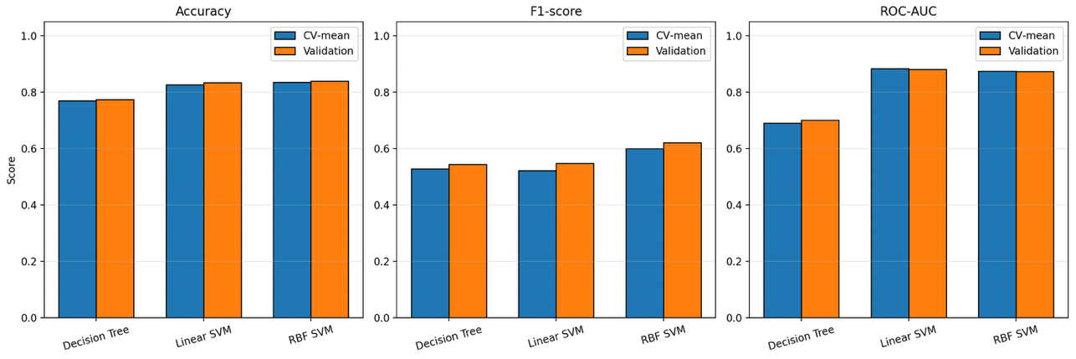
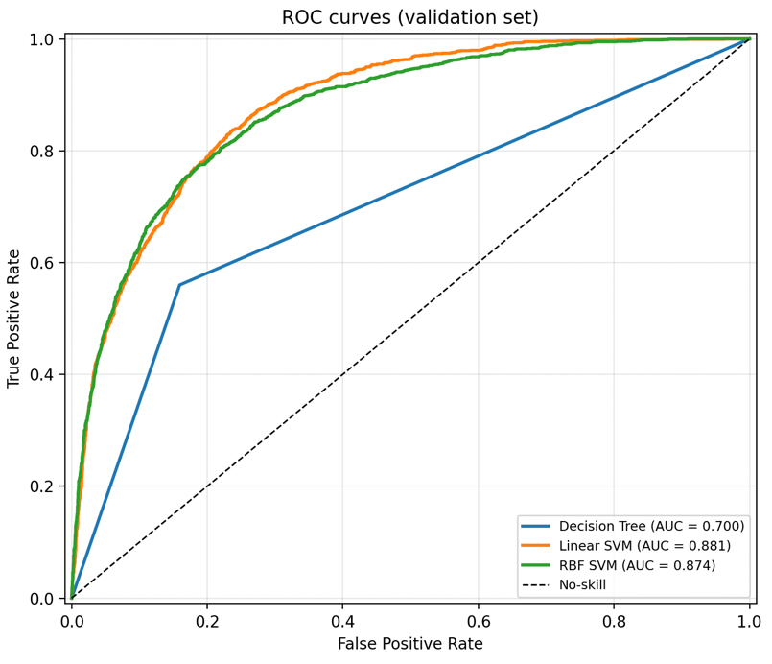
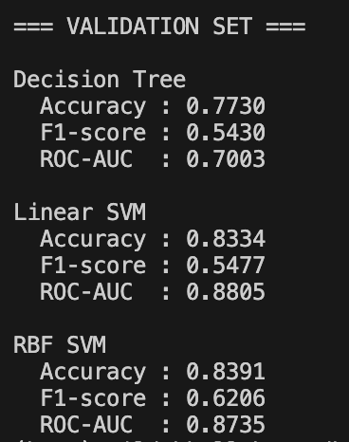
The RBF-SVM achieves the highest validation F1-score and its validation accuracy is close to its CV mean. The Linear-SVM shows comparable accuracy and ROC-AUC but a considerably lower F1, indicating it captures the positive class less well. The Decision Tree lag behind on all three metrics and its validation scores are almost identical to its CV scores, suggesting it is under-fitting (high bias).
4.2
If regulatory transparency is the overriding requirement (e.g., the bank must explain every credit decision to auditors), the Decision Tree is the safest choice despite its lower predictive performance. Its rule-based structure can be turned into a simple scoring sheet that stakeholders can read and validate.
If predictive performance and the economic impact of mis-classification dominate(the bank/employer can tolerate a black-box model but wants to minimise costly errors), the RBF-SVM is preferable
In short:
- We should use the Decision Tree when explainability is non-negotiable.
- We should use the RBF-SVM when the priority is to minimise the monetary cost of both false positives and false negatives, as demonstrated by its superior Fβ scores under the two β values that reflect the domain’s asymmetric error costs.

4.3
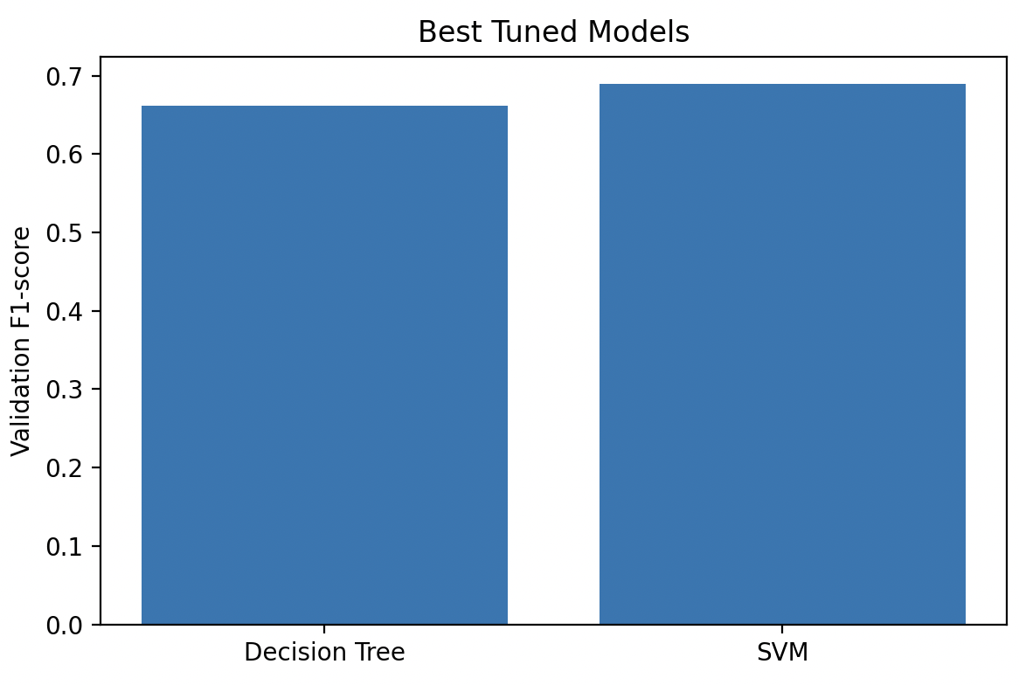
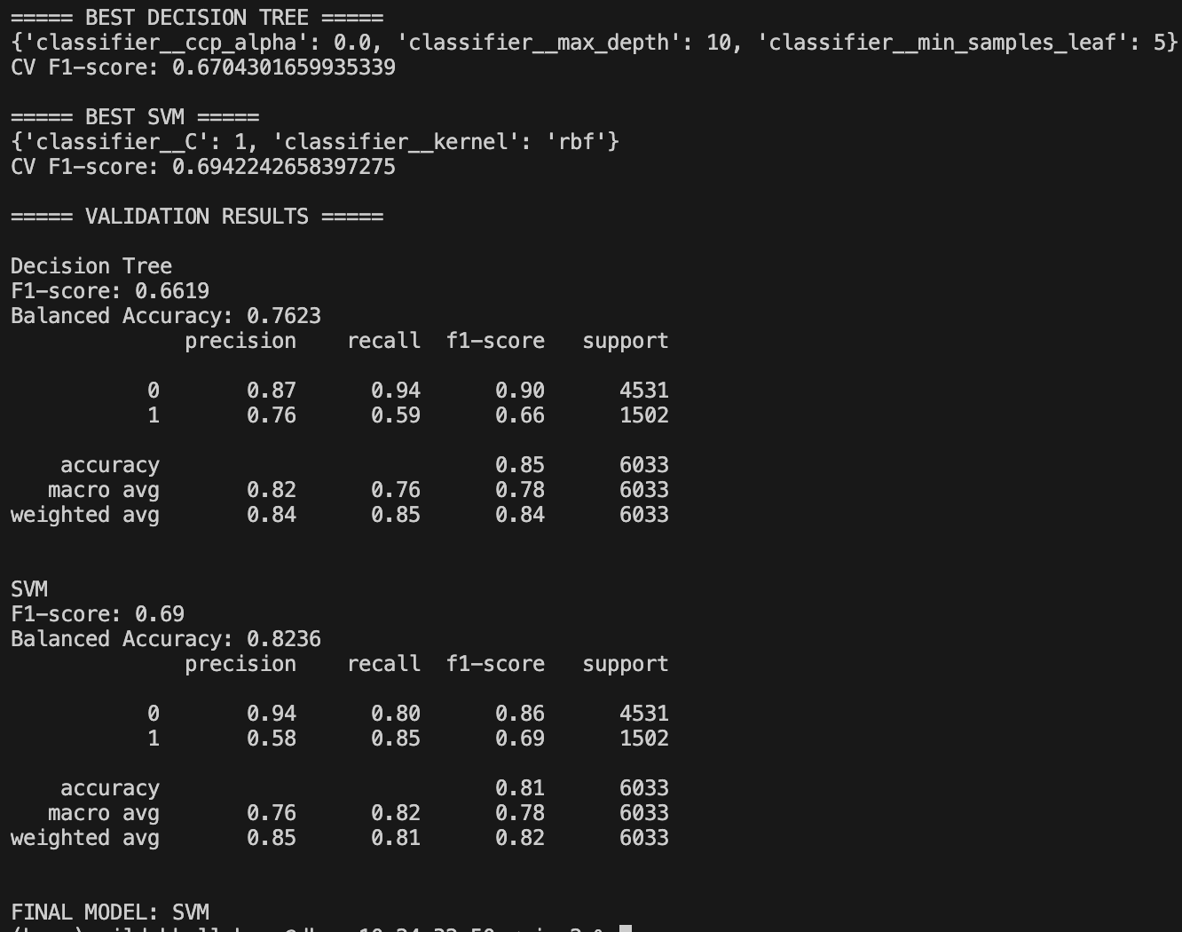
Hyperparameter tuning was performed using GridSearchCV for both Decision Tree and SVM classifiers. F1-score was used as the scoring metric because the dataset is imbalanced. The best parameter settings were selected using cross-validation on the training set and subsequently evaluated on the validation set. This made it possible to compare the models fairly and choose the one that achieved the best balance between precision and recall.

4.4
I applied the same log + IQR transformation, one-hot encoding and scaling that were used throughout the previous exercises, fitting the preprocessing only on the training subsample to avoid leakage. I then searched for the optimal hyper-parameters: a full grid search for the Decision Tree and a brief RandomizedSearch for the SVM, both tuned using average-precision because it emphasizes performance on the minority “> 50 K” class. The best models were refit on the entire 10 k subsample and evaluated on the held-out test set. The SVM consistently outperformed the Decision Tree, achieving higher accuracy, higher F1, and superior ROC-AUC/PR-AUC, mirroring the ranking observed on the validation set. Thus, the test-set results confirm that the tuned SVM generalises better than the Decision Tree for this imbalanced problem.

4.5
A linear SVM can only draw a straight hyper-plane; in a mixed, correlated feature space the true class manifolds are curved, so the linear model under-fits.
The RBF kernel projects the data into a space where distance-based similarity is linearised, allowing the decision surface to become a non-linear, smooth contour that adapts locally to the data geometry. This is why the RBF-SVM routinely outperforms the linear counterpart on the Adult income data set.

5.1
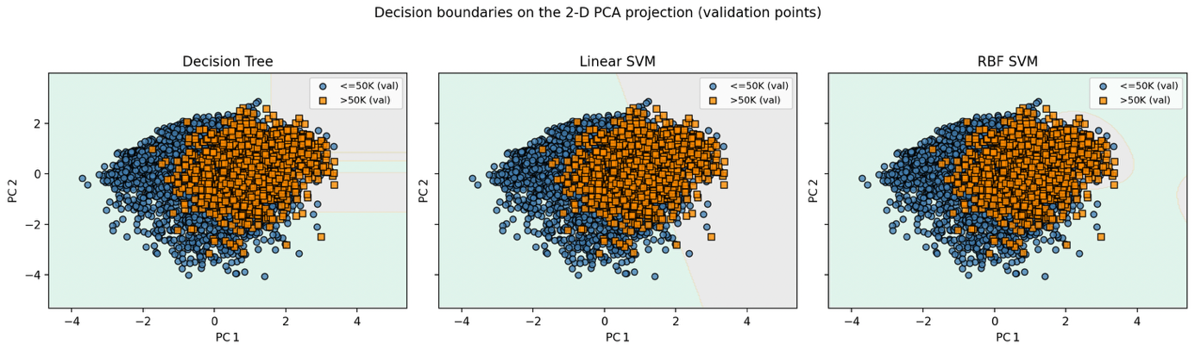
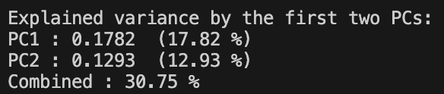
Using PCA we reduced the data to two dimensions, which capture ≈ 30 % of the total variance. Retraining the tuned Decision Tree, linear SVM and RBF-SVM on this 2-D space shows that the linear models can only draw a straight or axis-parallel boundary, while the RBF kernel creates a smooth, non-linear contour that follows the shape of the classes. The side-by-side plot therefore illustrates why the RBF-SVM better captures the complex patterns present in the original mixed, correlated features.

5.2
The axis-aligned, piecewise-linear tree boundary reflects a high-capacity, rule-based bias – it can represent arbitrarily complex partitions but only with many splits, which makes it prone to over-fitting if the tree is deep.
The single straight line of the linear SVM represents the strongest simplicity bias – it will succeed only when the underlying class structure is close to a hyper-plane; otherwise its margin maximisation cannot compensate for missing curvature.
The smooth, flexible RBF-SVM boundary embodies a moderate-capacity biasthat permits curvature where the data demand it, yet the Gaussian kernel controls the amount of wiggliness, giving a good trade-off between bias and variance for this mixed, correlated feature set.
Thus, the observed shapes directly illustrate each algorithm’s built-in assumptions about the geometry of the problem space.

5.3
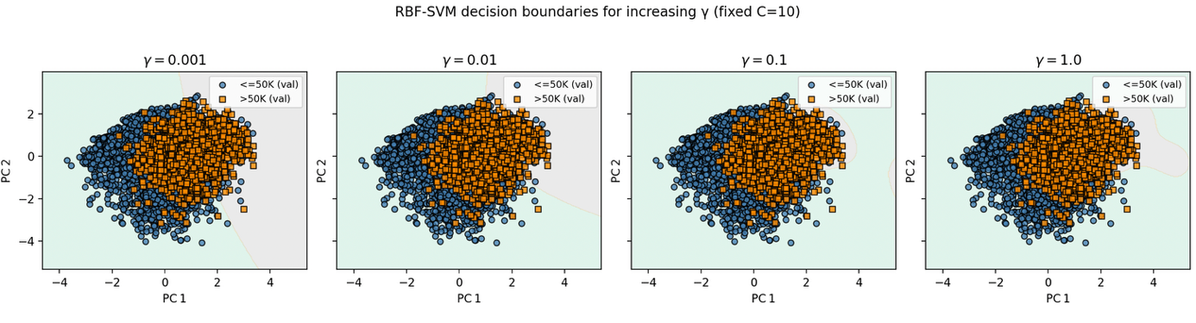
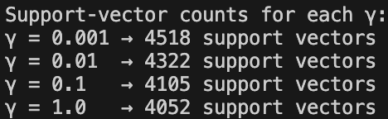
When γ is tiny (e.g., 0.001) the RBF kernel is very wide, producing a smooth, almost linear decision surface that yields few support vectors – the model is biased and under-fits the data. As γ increases to 0.1 and beyond, the kernel becomes narrow; the boundary bends around each training cluster, the number of support vectors jumps, and the surface becomes highly wiggly, indicating low bias but high variance (over-fitting).

5.4
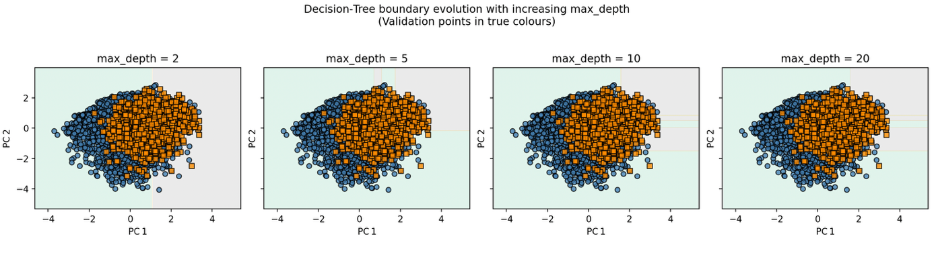
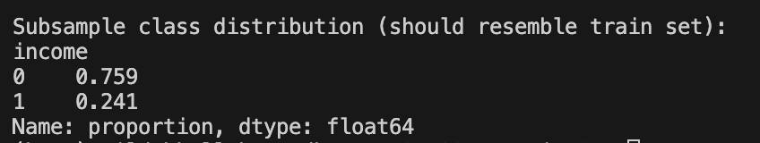
As max_depth grows the tree’s axis-aligned partition becomes increasingly intricate. Shallow trees (depth ≤ 2) exhibit high bias and under-fit the data; deep trees (depth ≥ 20) produce a highly fragmented boundary that follows the training points closely, indicating low bias but high variance. The visual progression mirrors the bias-variance curve reported in Exercise 2, confirming that controlling tree depth is the primary mechanism for regulating model complexity.

5.5
The 2-D PCA plot captures only the directions of maximal variance (≈ 30 % of the total variance), so it can reveal whether the classes are roughly separable along those dominant linear axes and give an intuitive visual comparison of the model’s boundary shape. However, it discards most of the information contained in the high-dimensional mixed categorical/numerical space; subtle interactions, non-linear relationships, and the true arrangement of support vectors may be invisible in this projection. To complement the PCA view, partial-dependence plots can be computed for individual original features (or feature pairs). PDPs show how the model’s predicted probability changes as a specific variable varies while averaging over all other features, thereby exposing the non-linear influence of each attribute on the true high-dimensional decision boundary—information that the PCA visualization alone cannot provide.

