Comparative Genomics 2018
Practical 5: Gene order analysis
Group: 5
Members: Vilde Kaldhusdal, Helen Kiik

Summary: We took the cluster file created in practical 4 and sorted them according to the name of the reference orfs. Using the provided script

Exercise 1
- Used our own clusters from practical 4 named:
all_clustring.txt

Exercise 2
- Sort the clusters according to reference orfs:
sort all_clustring.txt -o sorted_all_clusters.txt
Using the script getGeneOrder.py to orderer of the genomes according to orfs:
python getGeneOrder.py 49.fa.txt.pfa sorted_all_clusters.txt > 49.geneOrder.txt

- Answer following questions:
  - Yes there can be ambiguities where one gene appears in several clusters. This could be due to gene duplication or pseudo genes in the genomes. This script goes through every line of the clustering file. The clustering file contains one cluster per line. Each line is made into a list of orfs, and each element of that list is made into a key in the dictionary called partOfCluster. However only new keys are added. This way duplicates are avoided.

  - This script takes in both forward and reverse orfs, but the output makes no distinction between them. This means the forward and the reverse version of the orfs will get separate positions. To avoid this you could make two separate dictionaries, one for the forward and one for the reverse orfs.

Exercise 3
Synteny is the conservation of gene order during evolution, due to proximity requirements of regulatory elements (source: slides). One way of visualizing Synteny is by dotplotting.

- Modified the script rndseq.py to create dictionary:
python permanent_dict.py 4000 20
4000: number of random sequence
20: length of random sequence

- Assign random sequences to all of the genomes, and write them to a continuous string:
To do this I created a new script called pseudoGene.py script:
python pseudoGeneome.py randomSeq_dict 16.geneOrder.txt 16.pseudGenom.txt
randomSeq_dict: input file with random sequences
16.geneOrder.txt: input file with order of orfs
16.pseudoGenome.txt: output file with continuous pseudo genome

- File containing all three pseudo genomes called: all_pseudoGenomes.txt
ssh to get module to work: ssh -X u2361@stud33.dbb.su.se
Without options:
dotter all_pseudoGenomes.txt all_pseudoGenomes.txt
With different parameters:
By changing the grey map tool I could remove the noise to better visualize the repeats in the the sequence.
The window size was changed to 20 as the random sequences was of size 20. This slightly improved the little peaks.
The full diagonal shows that the two aligned sequences are identical. The smaller lines (peaks) around the diagonal shows repeats in the genomes. After removing the noise, you see that there are mostly reoccurring sequences between genome 10, 44 and 49. There was no significant matches with any of the genomes for genome 16. This seems to fit with the placement of the 16 genome in the belvu tree.

(https://sonnhammer.sbc.su.se/Dotter.html)
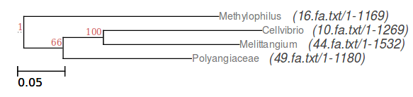
Figure 1. The Belvu bootstrap tree form practical 3.

When zooming in on some of the smaller peaks you can see the identical alignment in the alignment tool. In the case depicted in figure 2. you can see there are exactly 60 identical aa aligned. This means that the genes corresponding to these three random sequences have syntheny between genome 44 and genome 49.

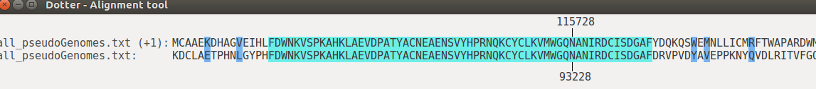

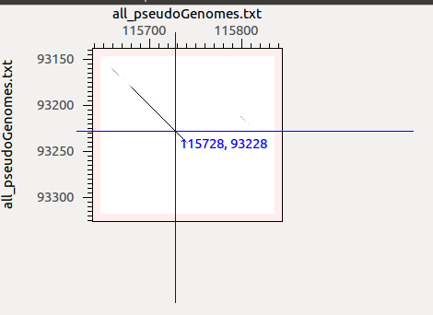
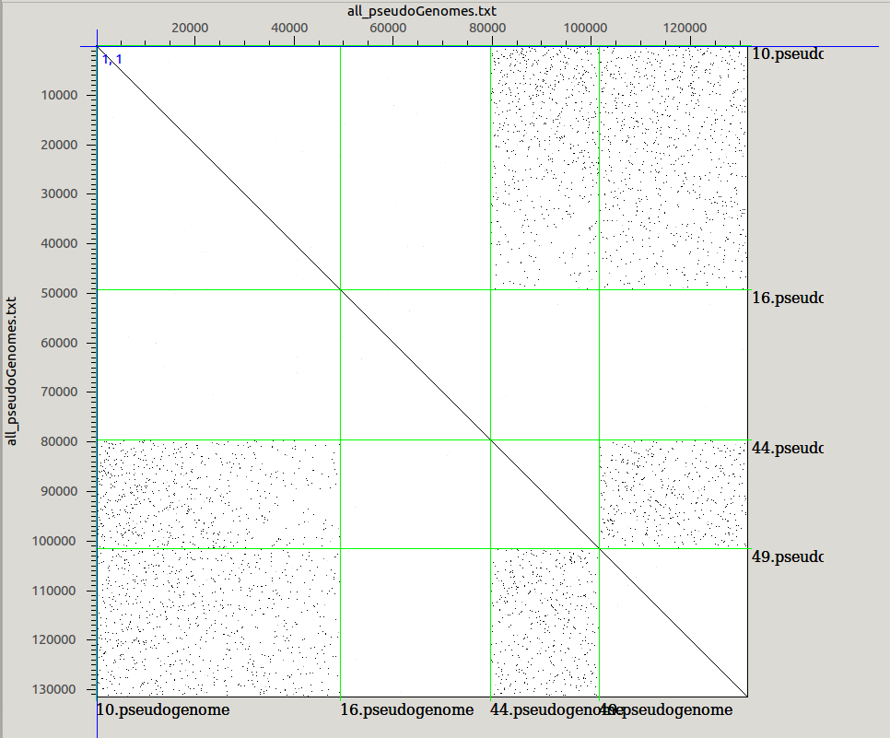

Figure 2. The dotter dotplot.

Exercise 4
- Create correct Grimm input:
Wrote script called grimm_order.py that converts the geneOrder.txt files to be on a single line:
python3 grimm_order.py 10.geneOrder.txt 10.grimm_order.txt

Modified the script to include the “>” in the heading of the genome, as this is required for grimm input:
python getGeneOrderGrimm.py 4000 10.grimm_order.txt 16.grimm_order.txt 44.grimm_order.txt 49.grimm_order.txt

- Calculate the distance matrix between the genomes:
to run grimm you have to use the given path:
path: /afs/pdc.kth.se/misc/pdc/volumes/sbc/prj.sbc.dmessina.5/Comparative_Genomics/programs/
grimm -f grimm_genomes.txt -o distance.txt -C -m

- Reconstruct the species tree in Belvu:
To
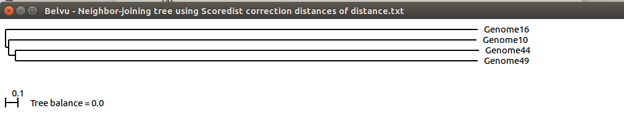

Figure 3.

