**Radar Object Detection Project - Colab Notebook Running Instruction**

**Note**: This is based on official Tensorflow tool called TFLite Model Maker (<https://www.tensorflow.org/lite/models/modify/model_maker>), but it will not work in its current state due to verison conflict (it is normal due to fast changing libraries). So, I forked and modify it to make it work. That is why you see it is pulling the tool from my Github. Please fork it too (create Github account first) so that you can work with it in the future.

1. Make sure you have Colab account and subscribe Colab Pro to utilize GPU unless the training will be very long.

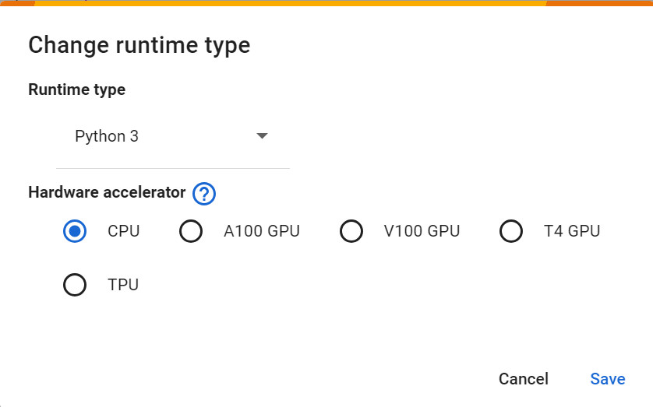

1. This part is mounting your Google Drive.

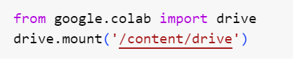

After it is mounted, you can see in the folder tree (on the left side) that drive is mounted as MyDrive (refresh it first).

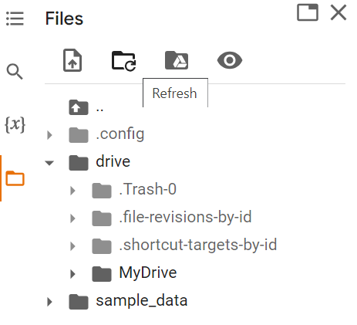

1. Pull the tool and install. After installing, there are message to ‘Restart the Runtime’. Perform accordingly unless the tflite_model_maker will fail to import.

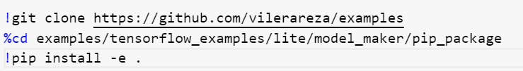

1. The following part specify the path to your dataset.

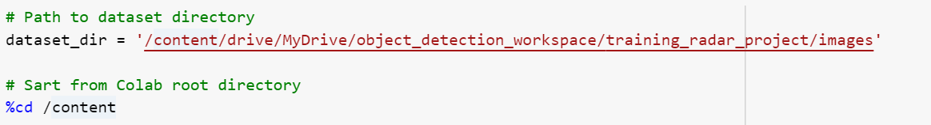

In my case, the the dataset is in the folder **object_detection_workspace/training_radar_project/images** and is organized as follows (as you do when you shared with me).

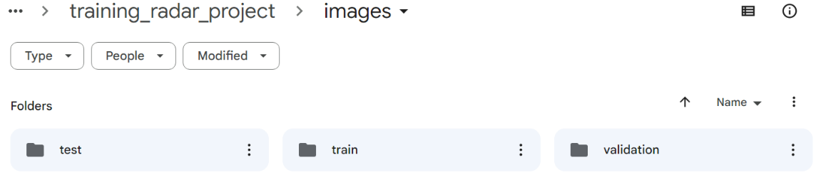

1. The following part specifies the model. The supported models for object detection in TFLite model maker are: 'efficientdet_lite0', 'efficientdet_lite1', 'efficientdet_lite2', 'efficientdet_lite3', 'efficientdet_lite4'.

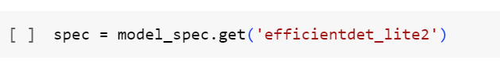

1. Continue running the scripts to complete the training

Change the batch_size and epochs as desired in the following line.

model = object_detector.create(train_data, model_spec=spec, batch_size=8, epochs=50, train_whole_model=True, validation_data=val_data)

1. The following part export the TFLite and save it. You can either save it directly to your Google Drive by specifying the path in tflite_filename or save it in current Colab Runtime, refresh the folder tree and you can see the file then download it to your local.

