**Setup with Raspi OS Lite Setup (Bullseye) – 64 bit**

1. Prepare Raspberry Pi Imager to create OS Image in SD card.

* Download link: <https://www.raspberrypi.com/software/>

1. Download OS image.

* Go to <https://www.raspberrypi.com/software/>. On ‘Manually install OS image’ select ‘see all download options’
* On Raspberry Pi OS (64 bit), download the **Raspberry Pi OS Lite**

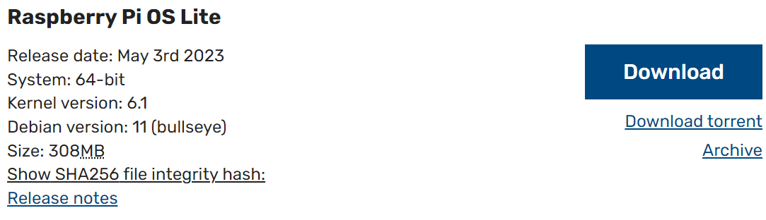

1. Create image on SD card using Pi Imager. In imager software:

* Erase the SD Card.
* Select the downloaded OS.
* Operating System: Select ‘Custom’ and select downloaded OS file (in zip format):
* Storage: Select appropriate SD Card.
* Press the setting icon.

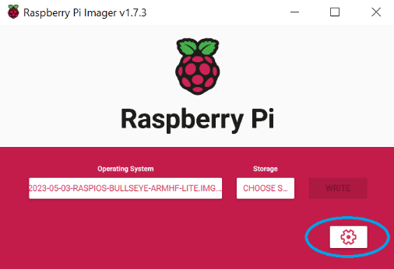

* + - Set hostname (leave default or make a note of your custom hostname).
    - Enable ssh.
    - Check password authentication.
    - Set username and password for the existing Wifi (for automatic connect) after first boot.
    - Complete the rest (local setting, etc).
* Press ‘Write’ to write the OS image to SD card.

1. Install SD Card in RPi.

**Note: The next steps can be done directly on RPi using external monitor (connect HDMI) and keyboard or via terminal from host computer using SSH.**

1. Power-on the RPi.
2. If using SSH from host computer (skip this if using external monitor and keyboard)

* Open the terminal and type: ssh pi@raspberrypi
* Enter the pasword.

1. Enter config, type sudo raspi-config. Enter Interface Options >

* Interface Options > Legacy Camera > Enable camera and SSH
* Interface Options > SSH > Enable SSH
* Interface Options > I2C > Enable
* Reboot the Raspi and connect to RPi again using SSH as in Step 6.

1. Update and upgrade. Type:

sudo apt update (wait until complete) then sudo apt full-upgrade (wait until complete).

1. Install Git. Type:

sudo apt install git

1. Clone the Git repository in user root directory. Type:

git clone <https://github.com/vilerareza/sleep_awaker_pi.git>

1. Install PIP. Type:

sudo apt install python3-pip

1. Install Numpy. Type:

sudo apt-get install libatlas-base-dev

pip install numpy

1. Install OpenCV. Type:

pip install opencv-python-headless==4.6.0.66

sudo apt-get install libopenjp2-7

sudo apt-get install ffmpeg

sudo apt-get install libgtk-3-dev

1. Install Dlib. Type:

wget <https://github.com/prepkg/dlib-raspberrypi/releases/latest/download/dlib_64.deb>

sudo apt install -y ./dlib_64.deb

sudo rm dlib_64.deb

1. Install scipy. Type:

sudo apt-get install python3-scipy

1. Reboot the RPi. After sometime, enter the RPi using SSH again.

sudo reboot now

1. Transfer the face detector weight file to RPi

* Download the shape_predictor_68_face_landmarks.dat to your computer from

<https://drive.google.com/drive/folders/1A1MD7km-gClkIR8z_8pUJcV8gRpX-cZv?usp=sharing>

* Transfer the downloaded file from your computer to your RPi using SCP. Open new cmd terminal at your computer. Depending on the location of the downloaded file at your computer, type the following and enter the password when prompted:

scp "<path to the weight file at your computer>" pi@raspberrypi:/home/pi/

**for example:**

scp "E:/vscode/eye_blink_detection/shape_predictor_68_face_landmarks.dat" pi@raspberrypi:/home/pi/

**Checking available camera:** vcgencmd get_camera

/boot/config.txt

dtoverlay=imx708

camera_auto_detect=0

**Checking available camera:** vcgencmd get_camera

**supported=1 detected=1, libcamera interfaces=0**