# assesment

# Created on May 21 2020

# Table of Contents

1.0. index

2.0. about us

3.0. menu

3.0. contact

3.0. event

# Index

# 0 Imagen

# 2.0. about us

# 0 Imagen

# 3.0. menu

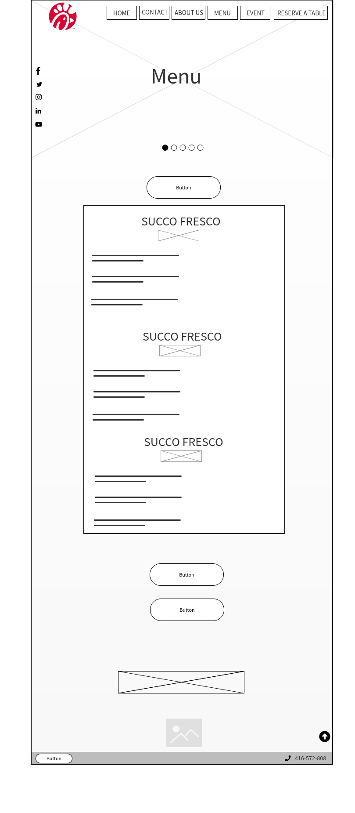

# 4.0. contact

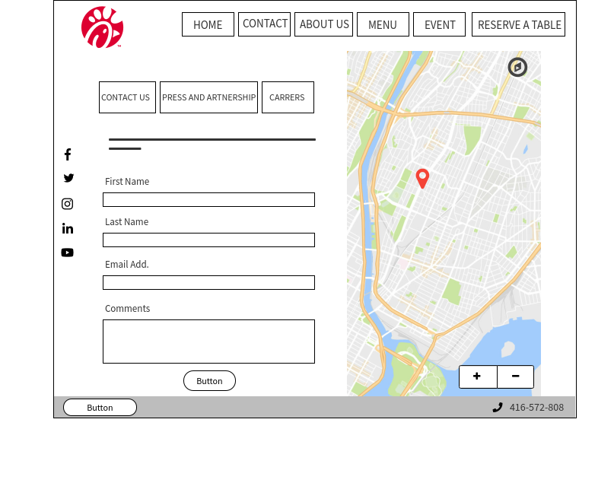

# 5.0. event

