**EXP2: Design a dual LED chaser**

**Circuit diagram:**

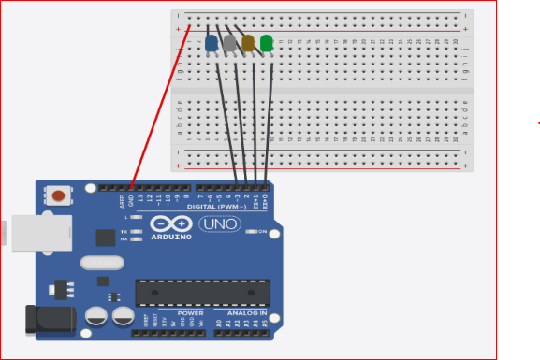

**Theory:**

**Concept Used:**

Two consequent LEDs flash at a time and then both turn off. Then the second one of the previous combination flashes with the next LED and so on. It appears as if the LEDs are chasing each other.

**Learning and observations:**

Following observations were recorded during the experiment:

* The LEDs blink in the pattern set in the sketch of a particular experiment.
* The program uploaded into the ARDUINO UNO starts executing as soon as the power is supplied and goes on executing in a loop till the power is supplied.
* LED’s can be connected in a circuit using a minimal number of wires if connected correctly.
* Problems and Troubleshooting:
* The problem faced while performing the experiment was the error in uploading which was the programmer not responding error.
* The error was troubleshooted by changing the USB cable connecting the PC and the ARDUINO UNO.

**Precautions:**

The following precautions need to be considered while performing this experiment:

* The connections of the USB in both the PC and the ARDUINO UNO board should be snug.
* The USB ports of the PC and the ARDUINO UNO should be in a working condition.
* The sketch should be logically and syntactically correct and germane to the experiment that needs to be performed.
* The correct serial port should be selected that is the one through which the ARDUINO UNO has been connected.
* Look for errors during compilation and upload of the executable to the ARDUINO UNO.
* Disconnect the digital 1 and 0 pins while uploading the program to the board.
* Do not open more than one instance of the ARDUINO IDE at a time.

**Learning outcomes:**

The various learnings as the outcome of performing the above-mentioned experiment are:

* There are multiple approaches to solve a single problem.
* Use of loops can decrease the manual work put into programming.