**Exp.3: Button controlled LED**

**Circuit Diagram:**

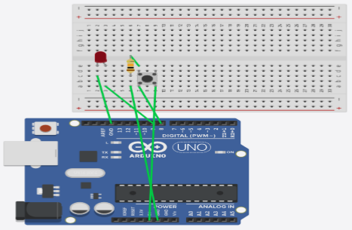

**Theory:**

**Concept Used:**

The LED turns on when the button is pushed and turns off when the button is released.

**Learning and Observations:**

Following observations were recorded during the experiment: ➢

* The LED turns on when the input from the button is HIGH and turns of when it is LOW.
* The button needs to be connected to the ground to give LOW input when the button is not pressed.

**Problems and Troubleshooting:**

The problem faced while performing the experiment was that the program compiled and uploaded to the board successfully but the LED didn’t glow. The problem was troubleshooted by replacing a connecting wire.

**Precautions:**

The following precautions need to be considered while performing this experiment: ➢

* The connections of the USB in both the PC and the ARDUINO UNO board should be snug.
* The USB ports of the PC and the ARDUINO UNO should be in a working condition.
* The sketch should be logically and syntactically correct and germane to the experiment that needs to be performed.
* The correct serial port should be selected that is the one through which the ARDUINO UNO has been connected.
* Look for errors during compilation and upload of the executable to the ARDUINO UNO.
* Disconnect the digital 1 and 0 pins while uploading the program to the board.
* Do not open more than one instance of the ARDUINO IDE at a time.

**Learning outcomes:**

The various learnings as the outcome of performing the above-mentioned experiment are:

* Use of the digitalRead() function.
* Connecting a push button to take input and send it to ARDUINO.