**Exp.4: Smart Phone LED control**

**Circuit diagram:**

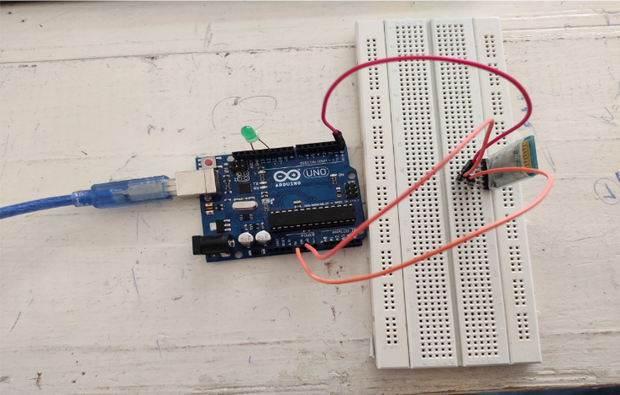

**THEORY:**

**Concept Used:**

The flashing of LED is controlled by an app in smartphone via wireless signal over Bluetooth.

**Learning and Observations:**

Following observations were recorded during the experiment:

* The bluetooth module used in the experiment has 6 pins namely VCC(power supply), GND(Ground pin), TXD(Transmitter pin), RXD(Receiver pin), EN and STATE pin.
* The TX of the Bluetooth module is connected to the RX pin of the ARDUINO UNO so that the ARDUINO UNO can receive the input from the bluetooth module.
* The bluetooth module requires 3.6 to 6V for its operation.

**Problems and Troubleshooting:**

The experiment was performed successfully without any problem.

**Precautions:**

The following precautions need to be considered while performing this experiment:

* The connections of the USB in both the PC and the ARDUINO UNO board should be snug.
* The USB ports of the PC and the ARDUINO UNO should be in a working condition.
* The sketch should be logically and syntactically correct and germane to the experiment that needs to be performed.
* The correct serial port should be selected that is the one through which the ARDUINO UNO has been connected.
* Look for errors during compilation and upload of the executable to the ARDUINO UNO.
* Disconnect the digital 1(TX) and 0(RX) pins while uploading the program to the board.
* Do not open more than one instance of the ARDUINO IDE at a time.
* The bluetooth module needs to be handled with care and proper voltage should be supplied to it.

**Learning outcomes:**

The various learnings as the outcome of performing the above-mentioned experiment are: ➢

* Ability to identify and connect the Bluetooth module with the ARDUINO through proper connections using a breadboard.