**Evaluation**

**CIRcuit diagram:**

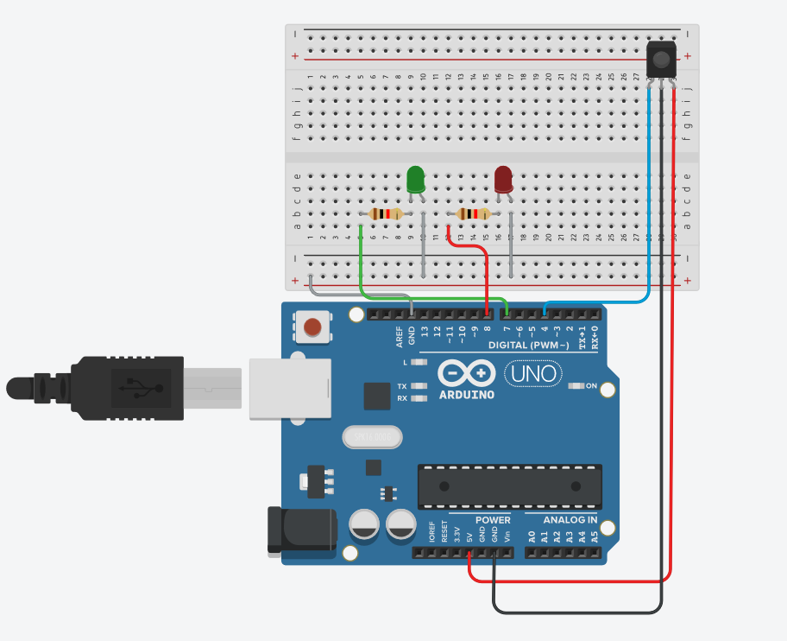

**Theory:**

**Concept used:**

* This experiment involves the flashing of two LEDs, red and green, using ARDUINO UNO.
* For this experiment, we used an IR sensor to read the signal coming from the remote and the value was used accordingly to lit the LEDs accordingly

**Learning and observation:**

* We require remote button value for this task.
* We also have to include the IR remote library for the IR sensor to work.
* This task simply works on if and case loop,
* The green LED and red LED glows for 20 and 40 ms repectively.
* The program uploaded into the ARDUINO UNO starts executing as soon as the power is supplied and goes on executing in a loop till the power is supplied.

**Problems and troubleshooting:**

* The LEDs didn’t glow.

**Precautions:**

The following precautions need to be considered while performing this experiment:

* The USB ports of the PC and the ARDUINO UNO should be in a working condition.
* The correct serial port should be selected that is the one through which the ARDUINO UNO has been connected.
* The connections of the USB in both the PC and the ARDUINO UNO board should be snug.
* The sketch should be logically and syntactically correct to the experiment that needs to be performed.
* Do not open more than one instance of the ARDUINO IDE at a time.

**Learning outcomes:**

The various learning as the outcome of performing the above-mentioned experiment are :

* The arduino can also work with IR sensors to suffice the need.
* IR sensing requires inclusion of a library.