GIS4107 GitHub and exercise folder setup

**Intro**

This document contains the instructions for setting up a GitHub repository and cloning it to a lab exercise folder for GIS4107. This example uses gis4107-day02. You will replace this with the appropriate day (e.g. gis4107-day03, etc.)

Contents

Create a new repository in GitHub 2

Add Collaborators 3

Clone the GitHub repository to a local repository 4

# Create a new repository in GitHub

Login to GitHub

Select “New repository”:

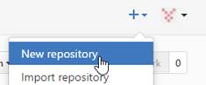

1. For Repository name, use the pattern “course-dayN” (e.g. gis4107-day03)
2. Set it to be a Private repository
3. Check Initialize this repository with a README. This will allow you to clone this GitHub repository to a local repository.

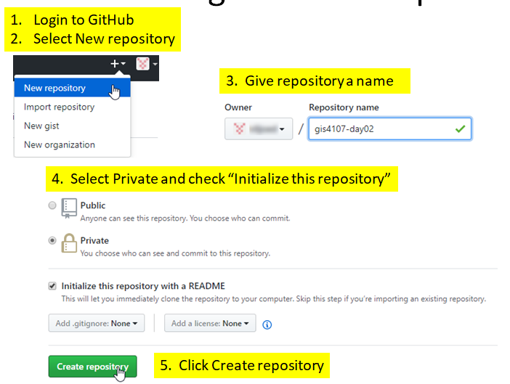

This creates the new repository shown below.

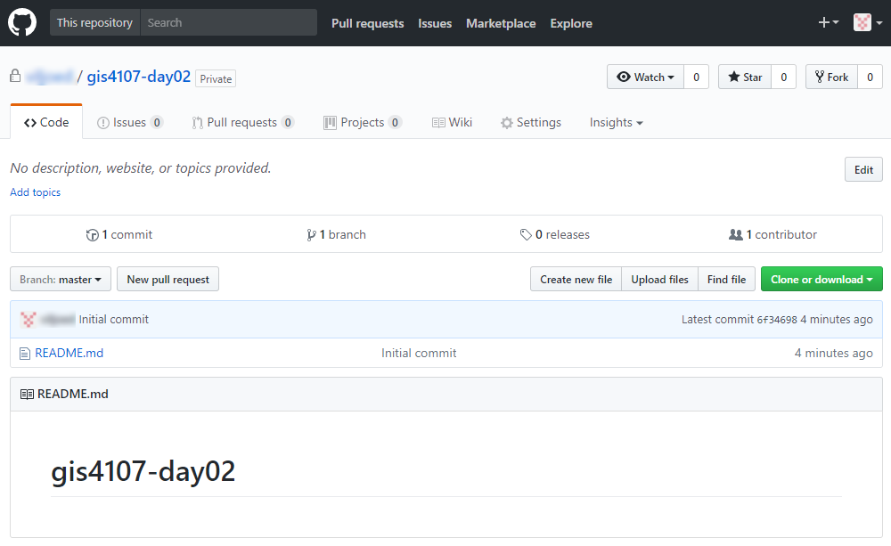

# Add Collaborators

You have now successfully created a Private repository and it will be the active repository.  Add viljoed and your partner as collaborators as follows:

Select the Settings tab for the repository …

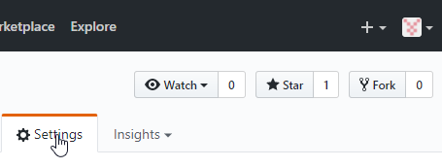

Select Collaborators from left menu …

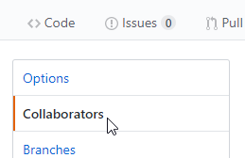

Search / select /add collaborator …

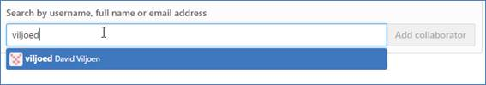

Search / select / add other collaborators (e.g. your partner)

# Clone the GitHub repository to a local repository

A local repository will be created as a .git hidden folder in a folder of your choosing. In this example, E:\acgis\gis4107_Intro2Prog\day02\lab.

In GitHub, copy the URL for the repository you created above

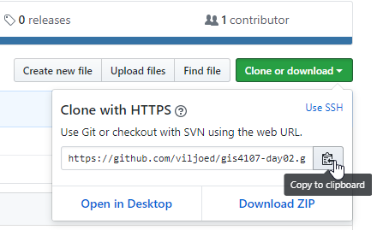

In SourceTree, click the Clone button

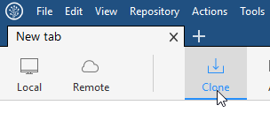

Fill out the Clone dialog and click Clone

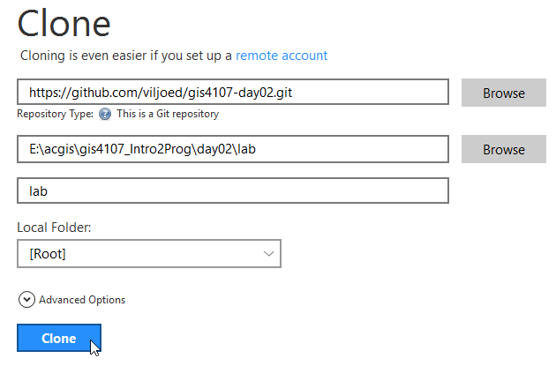

Lab 2

The Git repository is now cloned in E:\acgis\gis4107_Intro2Prog\day02\lab

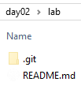

Create a folder in this working directory (tree) for you and your partner, e.g.

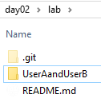

Where UserAandUserB will be replaced with the first and last initial of you and your partner. This folder will need a file before you stage, commit, and push to GitHub.