GIS4207 Git Setup for C#

Intro

This document outlines the steps for creating a Git Repository, cloning it to your local computer, and setting up a blank Visual Studio solution.

Contents

Create a new repository in GitHub 1

Add Collaborators 2

Clone the GitHub repository to a local repository 3

Create a src folder and blank Visual Studio solution 5

# Create a new repository in GitHub

Login to GitHub

Select “New repository”:

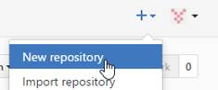

1. For Repository name, use the pattern “gis4x07-dayN” (e.g. gis4107-day03, gis4207-day08, etc.)  
   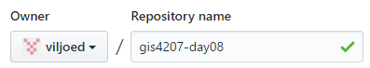
2. Set it to be a Private repository  
   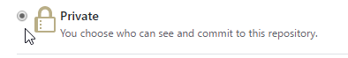
3. Check Initialize this repository with a README. This will allow you to clone this GitHub repository to a local repository.  
   
4. Select the “Add .gitignore” drop down list  
   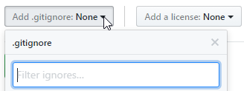
5. Begin to type Visual Studio in the “Filter ignores” text box …  
   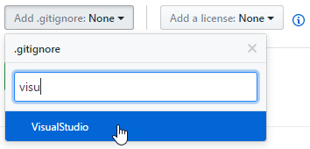
6. Click Create repository ..  
   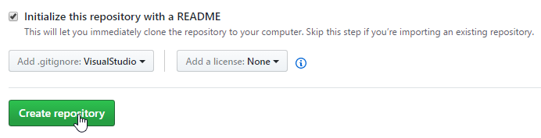
7. You will now find two files in your repository:  
   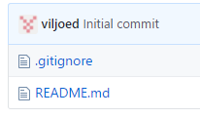
8. The .gitignore file contains “filters” to ignore files from a Visual Studio solution that should not be under version control. For example, bin and obj folders will not be included with git commands such as add, commit, push.

# Add Collaborators

You have now successfully created a Private repository and it will be the active repository.  Add viljoed and your partner as collaborators as follows:

Select New collaborator …

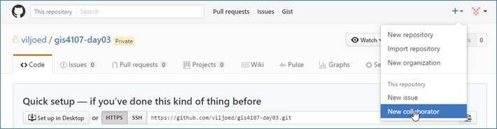

Search / select /add collaborator …

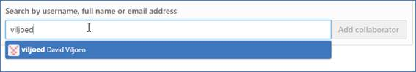

Search / select / add other collaborators

# Clone the GitHub repository to a local repository

A local repository will be created as a .git hidden folder in a folder of your choosing. In this example, the folder is E:\acgis\gis4207\day08\lab. Right-click on its parent folder (e.g. E:\acgis\gis4107\day08) and select Git Bash …

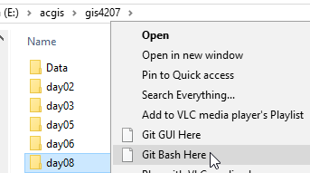

This will open the Git Bash shell. It should have, for example, day08 as the last part of the path:

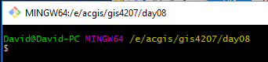

In GitHub, copy the GitHub URL by clicking Clone or Download and then clicking Copy to clipboard.

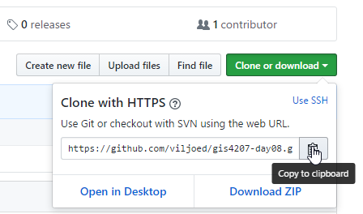

In the Git Bash shell, enter git clone in the Git Bash shell and then right-click and select Paste

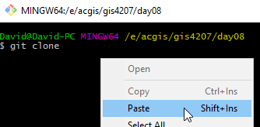

Then enter “lab” as the target folder. You git command should look something like the following:

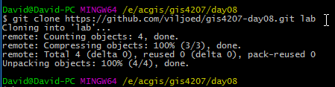

Press Enter



Use the cd command to change to the lab folder and then enter “git status” to confirm the repository was cloned properly and everything is up to date.

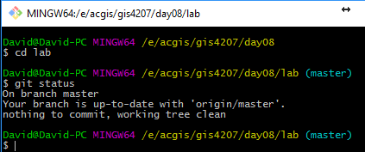

Before the local repository is ready to pull/push updates from/to the GitHub repository, you need to add some other folders/files to the local repository: a folder for the source code (src) and the Visual Studio solution file.

# Create a src folder and blank Visual Studio solution

For coding projects, it is common to have a src folder to contain your source code. A docs folder to contain documentation about the project. Perhaps a data folder for miscellaneous files containing data required by the application. To start, create a src folder. This can be done in the bash shell or in Explorer.

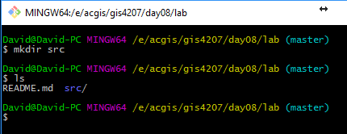

Launch Visual Studio and select File > New > Project or press Ctrl, Shift, and N

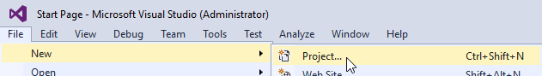

In the New Project dialog, select Other Project Types > Visual Studio Solutions > Blank Solution

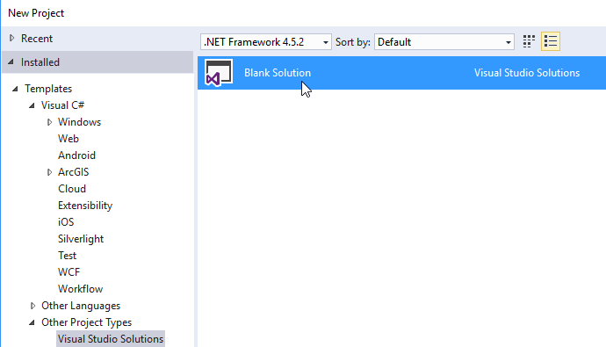

Click the Browse button …



Browse to your src folder

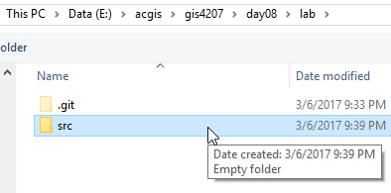

Click the Select folder button.

Enter the name of the solution (e.g. LearnCSharp) and click OK

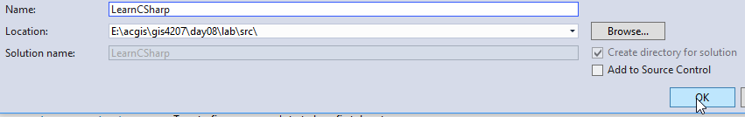

Exit Visual Studio.

Browse to the Solution folder

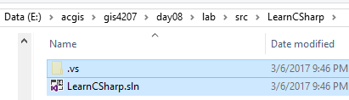

Select the folder and .sln file and cut to the clipboard (i.e. Ctrl-A, Ctrl-X).

Browse to the parent folder (Backspace key) and paste the contents there

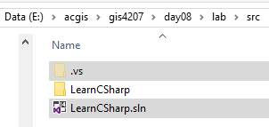

Delete the LearnCSharp folder. The src folder should look something like:

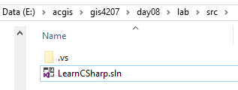

This is a good time to add/commit/push.

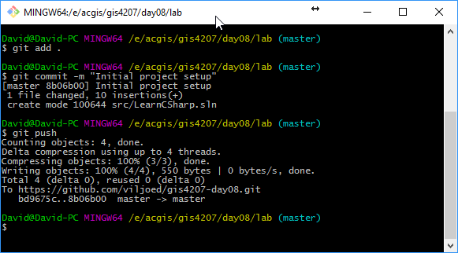

You are now ready to start coding.