Visual Studio Solution setup

This document assumes that you have followed the instructions in <https://github.com/viljoed/gis4x07/raw/master/GIS4x07_ExerciseSetup.docx>. It will provide step-by-step instructions for setting up a blank Visual Studio solution.

## Create blank solution

For coding projects, it is common to have a src folder to contain your source code. A docs folder to contain documentation about the project. Perhaps a data folder for miscellaneous files containing data required by the application. To start, create a src folder in your exercise folder   
(e.g. BobMandDougM\src).

Launch Visual Studio and select File > New > Project or press Ctrl, Shift, and N

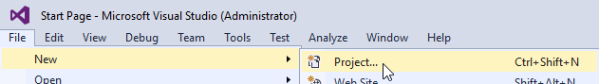

In the New Project dialog, select Other Project Types > Visual Studio Solutions > Blank Solution

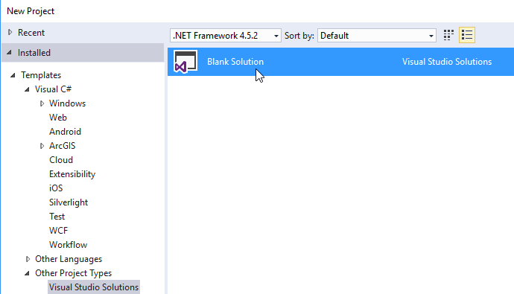

Click the Browse button …



Browse to your src folder: e.g. E:\acgis\gis4207_Customization_I\day08\lab\BobMandDougM\src

Click the Select folder button.

Enter the name of the solution (e.g. ExerciseSolutionName) and click OK

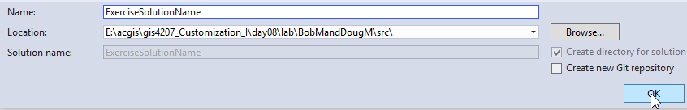

Exit Visual Studio.

## Move blank solution folder/files to exercise folder

Browse to the Solution folder

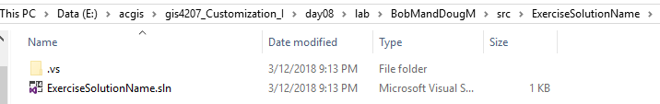

Select the folder and .sln file and cut to the clipboard (i.e. Ctrl-A, Ctrl-X).

Browse to the parent folder (Backspace key) and paste the contents there

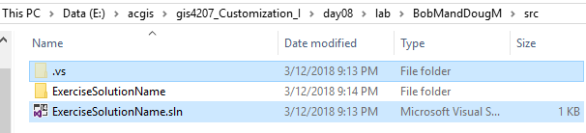

Delete the ExerciseSolutionName folder. The src folder should look something like:

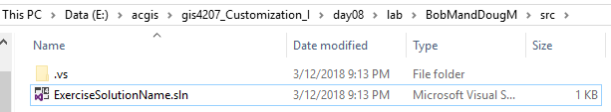

This is a good time to stage/commit/push.

You are now ready to start coding.