Messenger
project specifications

author: Nastya Vilkova
anastaciyavilkova@gmail.com
call: 093-699-6662

Table of Contents

Description 2
Technologies 2
Deployment & Execution 2
Behavior 3
main page 3
addMessage.html page 4
searchMessages.html 4

Description
The Messenger project is developed to provide ability in:
- adding and storing messages in centralized database including:
  - user name
  - message body
- search messages in database via following filters:
  - user name
  - from and to date range which are based on message creation timestamp

Technologies
- Back-end
  - Spring Core
  - Spring MVC
  - JBoss
  - MySQL
  - Maven
  - Slf4J
- Front-end
  - JavaScript, Html, Css, jQuery, AJAX
- Testing
  - jUnit, Mockito

Deployment & Execution
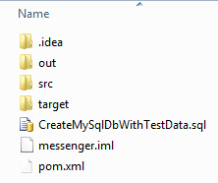
- Create MySQL database using sql query stored in CreateMySqlDbWithTestData.sql file
- Build project via: mvn clean install
- Run JBoss server
- Start application http://localhost:8080/message/ (host and port are examples)

Behavior

main page
Once application is requested in the browser - index.html page is loaded, displaying following pages in frames
- addMessage.html
- searchMessages.html

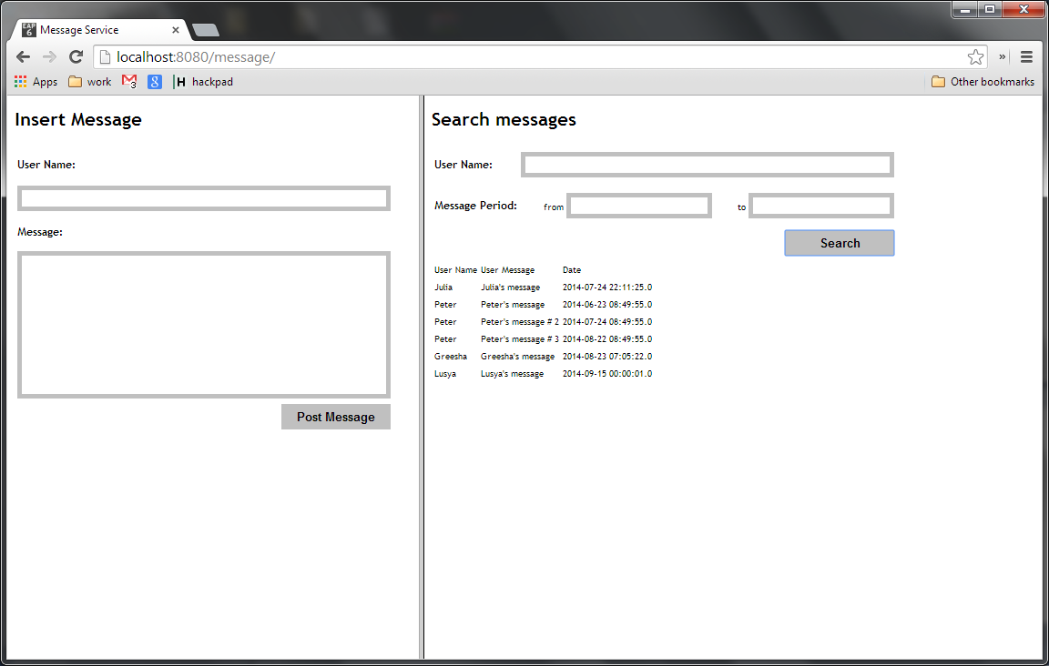

addMessage.html page
On this page, user types his name and message and hits the [Post Message] button to submit message into database.

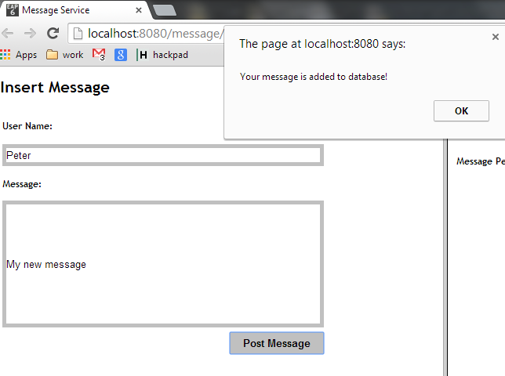

searchMessages.html
Here user has an opportunity to search messages by name and period of time in format "yyyy-MM-dd HH:mm:ss". Or simply press the [Search] button to display all messages
