Sentiment analysis on book reviews: a comparative study of VADER, BERT, and Generative AI

[Alessandra Virginia Villa]
Linguistic Computing alessandra.villa05 – 5405075
Abstract
Sentiment analysis is a powerful NLP tool that has been proven reliable for many applications but has been extensively tested mostly on social media posts such as former Twitter. The aim of this study is to extend the analysis to more nuanced textual data such as book reviews. The scope is to test different sentiment analysis models on user generated content more linguistically rich than traditional social media posts and to gauge which model could more accurately replicate human ratings of books. Three different sentiment analysis models were tested: a lexicon-based model: VADER, a supervised machine learning model: BERT and an AI system: Flan-T5 testing two different prompting techniques: zero shot and few shot prompting. The test was carried out in two steps. A first step was to feed the models with textual reviews of books hiding their scores. The second step was to assess how accurately the models could predict the score. Supervised machine learning and AI models, which could better analyse the reviews’ context, showed greater capability in replicating readers’ ratings.
Keywords
Sentiment analysis; book reviews; Natural Language Processing
1 Introduction
Sentiment analysis is the field of study that analyses people’s sentiments and emotions towards many different topics and aspects of daily life [1]. It’s a powerful tool that can be used for tracking people’s perceptions on different events and services. In their study, Kiersh and Losacker (2026) for example used a pretrained Natural Language Inference (NLI) zero shot classifier and identified dominant themes using a manually compiled corpus of news articles on heat pumps. Their results showed that on average such articles were framed more positively than broader news landscape, but that sentiment varies consistently based on topic [2]. Sentiment analysis has also been employed by private and public companies to better satisfy costumers’ needs, by analysing clients’ feedback on services and products. A study by Grljevik and Bosnjak (2018) investigates how the spread of social media platforms has changed customer behaviour and demonstrated how firms relying on automated systems for sentiment analysis and opinion mining have a significant advantage over their competitors.[3] In the literary field several studies have been conducted that span various research topics. Heuser et al. (2016) employed NRC and sentiment analysis to paragraph of novels set in London to link emotions to specific landmarks and visualised them through maps.[4] Pianzola et al. (2020) conducted an analysis mixing qualitative and quantitative approaches based on scalable reading to investigate which are the preferred themes and the emotional engagement of readers on the online platform Wattpad. Their results showed how teen fiction seems to engage more affective interaction than other genres. They also extracted comments from both literary texts and readers’ comments and compared them graphically, looking for points of convergence and macro differences between the story arcs and readers’ perceptions to understand which are people’s favourite elements in the selected texts.[5]
Book reviews on platforms such as Amazon, Goodreads or Reddit are a specific type of social media data. Unlike tweets for example, they are longer, more nuanced, and convey a complex spectrum of users’ emotions. Since readers often manifest conflicting opinions towards books they have read, such data represent a challenge for this task, especially for more traditional lexicon-based systems. These data are often self contradictory and make use of obscure linguistic constructions such as metaphors, irony and non textual elements (emojis).
The aim of this study is to find which computational strategy predicts best a book rating based on its users’ textual review, and how modern prompt engineering strategies compare to more traditional models in such tasks. Having an overall perception of readers’ opinions can help not only authors but also publishing houses in selecting future paths to follow to satisfy costumers’ desires. Understanding the true sentiment towards literary works, going beyond ratings that can be biased by fans or sponsored creators, by looking at general trends among a large number of readers can help in understanding people’s true sentiments towards the publishing field in the current time.
Figure 1: Example of non standard grammar
Figure 2: Example of non standard grammar
2 Data
The dataset used to conduct this analysis was taken form Kaggle, an online community platform owned by Google for data scientists and machine learning engineers. (https://www.kaggle.com/datasets/meetnagadia/amazon-kindle-book-review-for-sentiment-analysis). The dataset is composed by 12.000 real users’ book reviews from Amazon Kindle store for a total of 1310842 tokens. The data covers a time span of 18 years, going from May 1996 to July 2014. Each of the reviewers has published at least 5 reviews and each book has at least 5 reviews in the dataset. In the original Kaggle repository two versions of this dataset were made available: the first is unprocessed and the other one has been preprocessed specifically for sentiment analysis tasks. This second dataset has been used to conduct the following analysis. The original file contains 11 columns, among them we find the textual reviews, original users’ scores and the date of the review. To conduct the analysis the fields: “reviewText” and “rating” were the ones used to test the three models in replicating real users’ star ratings.
The dataset has been modified to make the comparison between the three models fair and balanced, the 5 star rating system used by users has been converted as follows into standardized categorical sentiment labels:

- Negative = 1 - 2 stars
- Neutral = 3 stars
- Positive = 4 - 5 stars

The data have been selected in a discretely balanced way, containing 6000 positive reviews, 4000 negative and 2000 neutral ones. Under the linguistic point of view, the reviews show a tone that lies in between in the spectrum of written and spoken language. Some users employ non-standard grammar for self censorship, due to platform’s constraints. As linguistic clues of non standard grammar we may find capitalization and a non standard use of punctuation reported as examples in figures 1 and 2.

3 Workflow
Reviews and social media posts are difficult to analyse for sentiment analysis tools, because they present many linguistic aspects that lean more towards spoken language: the usage of non standard grammar, emojis, sarcasm and irony. To conduct research on the emotions expressed on user generated content, three main approaches have been developed over time [6]:

1. Lexicon-based approach:

This methodology relies on the usage of dictionaries of selected “sentiment words” and the calculation of their frequency[6]. There are two categories of lexicons: polarity-based ones, in which words are categorized into binary classes, for example positive and negative, and valence-based lexicons, that associate words with intensity scores to determine not just the generic direction of the sentiment, but also the strength of it.[7] VADER (Valence Aware Dictionary and Sentiment Reasoner) is fully open source under the MIT license. It is a popular lexicon and rule-based system analysis tool that has been designed to analyse specifically social media posts, in particular to handle specific characteristics of such textual data, as highlighted above: the usage of punctuation in a non standard way, capitalization, emojis and slang. Researchers aggregated words from already existing lexicons with features typical of user generated content like emoticons with the scope of making VADER a tool tailored for the analysis of social media data.
The correlation coefficient r shows that VADER performs as well as human raters at matching ground truth and that VADER’s classification accuracy even outperforms individual human raters.[7] This model makes use of both a gold standard sentiment lexicon and five human-validated heuristic rules regarding: punctuation; capitalization; degree modifiers; contrastive conjunction; negation.
Each word in VADER lexicon has a “valence score” ranging from -4 (extremely negative) to +4 (extremely positive) with 0 being neutral. Once the models assignes the scores, then it applies the heuristic rules listed above to modify the total intensity. At the end the raw scores are normalised in a range between -1 and +1.

2. Supervised Machine learning:

In the third edition of the book by Farzindar and Ipken on the study of deep learning and transformer based learning, the authors focused on BERT (Bidirectional encoder representation from Transformers), a bidirectional transformer encoder. Unlike static embeddings like the ones of Word2vec, BERT is built on a transformer architecture, and in contrast to traditional models is able to capture context both on the left and on the right of a target word. [8] For this experiment the model bert-base-multilingual-uncased-sentiment was used. It is a BERT-based-multilingual-uncased model finetuned for sentiment analysis on product reviews in six languages, among them English. It predicts the sentiment of the review as a number of stars (between 1 and 5).[9] For this research an already pre-trained model has been used and applied to the dataset without further training.

3. Generative AI:

A third option relies on the adoption of generative AI, in the case of this work the general version of Flan-T5, a LLM developed by Google. This model is able to process an input context and predict the most logical next step or generate relevant content based on that specific information. It utilizes an encoder to process the input context and a decoder to generate the output sequence.[10]
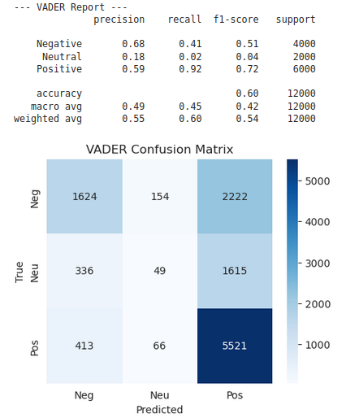Figure 3: VADER's results
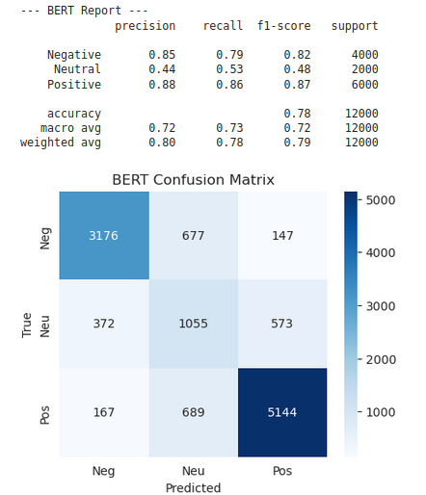Figure 4: Bert's results

For this experiment, to make the comparison between the three models balanced, the 5-star rating system adopted by the reviewers has been converted into standardized categorical sentiment labels as follows:

- Negative = 1 - 2 stars
- Neutral = 3 stars
- Positive = 4 - 5 stars

The three models have been used with the standard configuration. For the 3 class classification of this paper (positive, neutral and negative) the threshold of VADER has been set at -0.05 and +0.05 as suggested by Hutto and Gilbert (2014) [7]. To conduct the analysis with BERT, a tokenizer has been employed, the maximum limit of tokens for this model to analyse has been set at 512 tokens.
It must be pointed out that if a review in one of the rows is missing, the model has been instructed to label such row as Neutral. VADER, BERT and Google Flan T5 were fed with textual reviews, keeping the ratings given by users hidden, in order to use it as a gold standard. In fact, each model was used to predict such scores based on the 12.000 textual reviews and consequently three CSV files containing the textual reviews, the original scores and the models’ predicted scores were produced, to later calculate precision, accuracy and F1-score for each of the three models. For what concerns the test of the generative AI system, two prompting techniques were tested, to see whether giving examples to the system could improve its performance. For zero shot prompting the model was asked directly to “Classify the sentiment of this review as Positive, Neutral or Negative” without providing it any type of example. For the few-shot startegy instead, the model was fed with three examples, one for each sentiment class defined above, to better guide the model’s reasoning. By using pandas and seaborn Python libraries, confusion matrices were generated to better visualize misclassifications for each approach, especially since the data were imbalanced to see how this impacted on the results.

4 Results and Discussion

The three models performed a classification task: in this case the classes are the categorical labels designed for sentiment analysis defined in the first step of the workflow: positive, neutral and negative. For each model precision, recall and F1-score were calculated using Python code. Precision measures how precise is the result by class. To count how many false negatives were misclassified by the models, recall was used. The higher the number of false negatives, the lower the recall. F1-score is the armonic mean of precision and recall, it gives an overview on how much the systems is able to perform a specific task.
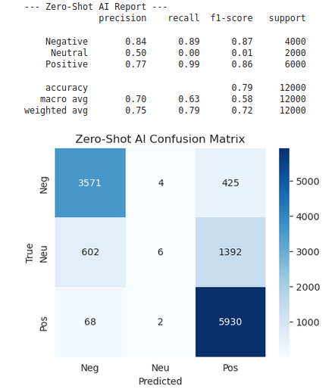Figure 5: zero shot results (Flan-T5)
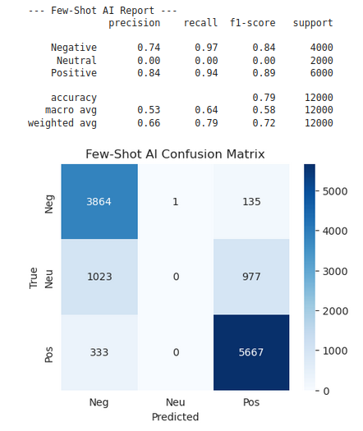Figure 6: few shot results (Flan T5)

As expected, the three models predicted best the positive class, the most frequent label in the dataset. All three systems classified the negative class slightly worse, but better than the neutral one, the least present among the reviews. The lexicon based approach performed worse than the other two, with a weighted average score of F1-score only equal to 0.54 while on Tweets it reaches an accuracy of 0.96.[11] The best system proved to be BERT, with a weighted average F1-score of 0.79, which for english has an accuracy of 0.95 for product reviews.[9] There isn’t much difference about few shot and zero shot prompting, it reached a F1 of 0.72, which for general tasks achieves a F1 Score of 0.81, but there is lack of data on research on applications to sentiment analysis tasks.[12] Overall, for such task relying on this dataset BERT proved to be the best approach. By looking at the linguistic characteristics of misclassifed reviews, we can see that the majority of them are longer comments of people starting with a good review to later change their opinion througth the text: “When I read the description for this book, I couldn’t wait to read it. Once I downloaded it to my Kindle, I found extremely hard to keep reading it” or “I bought this book because I loved the cover and I try to read any Civil War romace I come across. Unfortunately, I wanted more story.” Capitalization seemed to help the tools to understand peoples’ sentiments towards a book, especially when used to communicate strong positive or negative emotions.

5 Conclusions

The results show how supervised machine learning models such BERT represent a robust solution for this type of task. Lexicon based systems such as VADER are less demanding under the computational point of view, but are not sufficient to conduct analysis on nuanced and more emotionally complex texts such as book reviews. Generative AI offers a flexible choice, without a strong difference between the two prompting approaches used for this experiment. Its results for this case though don’t seem to be much better then transformer based models, but still performed better than traditional systems as VADER. Future work should be conducted on a larger and more recent dataset, investigating reviews from other social media platforms, such as Goodreads and Reddit. Furthermore, Generative AI could be fine tuned and not just prompted, to test whether a chain of thought approach could improve the results even more.
Bibliography
1: Bing Liu, Sentiment analysis and opinion mining, 2012
2: Lucas Kriesch, Sebastian Losacker, Tracking the public perception of heat pumps: A sentiment analysis of German news articles, 2026
3: Olivera Grljevic, Zita Bosnjak, Sentiment analysis of customer data, 2018
4: Ryan Heuser, Zephyr Frank, Franco Moretti, The emotions of London, 2016
5: Federico Pianzola, Simone Rebora, Gerhard Lauer, Wattpad as a resource for literary studies. Quantitative and qualitative examples of the importance of digital social reading and readers’ comments in the margins, 2020
6: Anna Atefeh Farzindar, Diana Inkpen , Natural Language Processing for Social Media, Third Edition, 2020
7: C.J. Hutto, Eric Gilbert, VADER: A Parsimonious Rule-based Model forSentiment Analysis of Social Media Text, 2014
8: Dorca Manuel-Ilie, Antoniu Pitic, Radu George Cretulescu, Sentiment Analysis Using Bert Model, 2023
9: , https://huggingface.co/nlptown/bert-base-multilingual-uncased-sentiment, ,
10: Jay Oza, Hrishikesh Yadav, Enhancing Question Prediction with Flan T5 -A Context-Aware Language Model Approach, 2023
11: , https://querio.ai/blogs/vader-sentiment-analysis#conclusion-and-next-steps, ,
12: , https://huggingface.co/sudhanshusinghaiml/flan-t5-base-airline-sentiment-analysis,

