Data Science Career Track

Capstone 2 -

Final Report

by Edward Franke

06/11/2019

Detect Pneumonia is chest x-rays Project – Final Report

EXECUTIVE SUMMARY:

The purpose for this project is to find a correlation connected to chest x-rays containing pneumonia that can separate them in real time compared to normal healthy chest x-rays. The dataset is a cleaned dataset from Kaggle.com. Tensorflow and Keras has discovered connections and methods to determine which x-rays have pneumonia with varying success.

IDEA: A model to detect pneumonia is chest x-rays. (problem to solve)

CLIENT: Medical Industry

REASON: Pneumonia is a very serious condition that has the potential for death. I have personal knowledge of how serious it can be. The sooner it can be detected, the better the chance for survival and less damage to the lungs.

DATA: From Kaggle, 2 cleaned datasets with 5863 images and over 112,000 images.

SOLUTION: Create a model or analysis to discover what makes an x-ray image of the chest to have pneumonia and to capture this automatically.

DETAILS: See below.

DELIVERABLES: Code and a presentation outlining the discoveries.

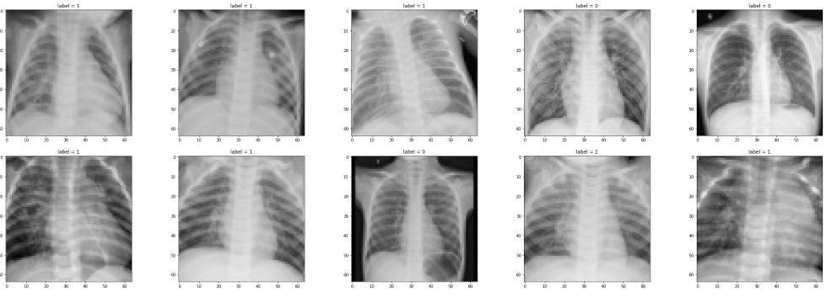

**Pneumonia Dataset**

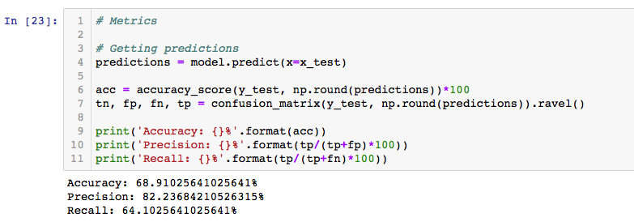

Tensorflow and Keras has discovered some connections.

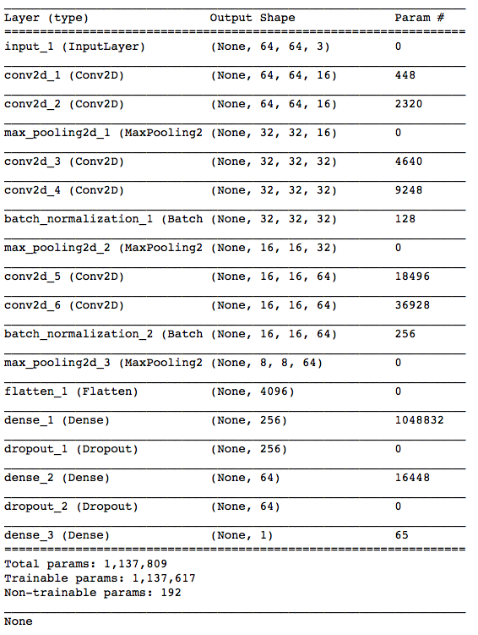

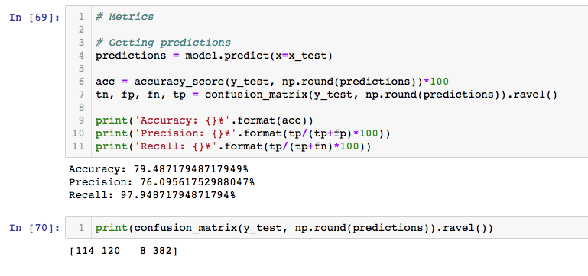

**NIH Dataset**

The NIH dataset contains 112,000 x-rays with varying ailments or no ailments. The code used for the Pneumonia dataset is ineffective on this dataset.

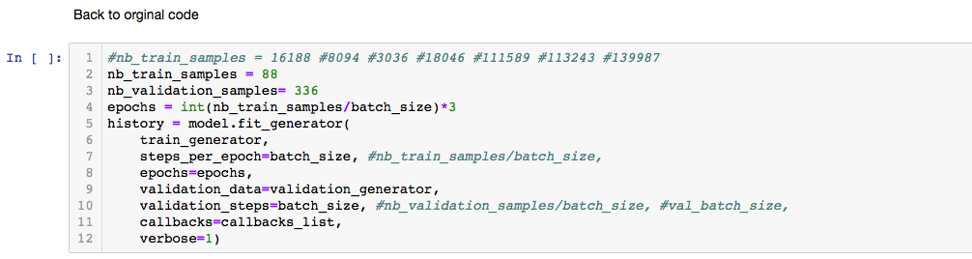

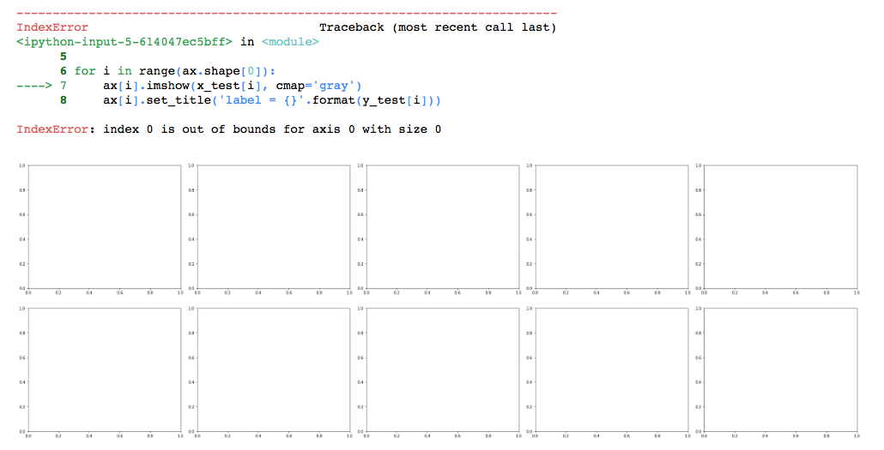

Code written specifically for this dataset gathers labels from a csv file and is also able to analyze the images to determine the ailment being searched for. This code was originally set to discover Fibromyalgia but was modified to detect Pneumonia.

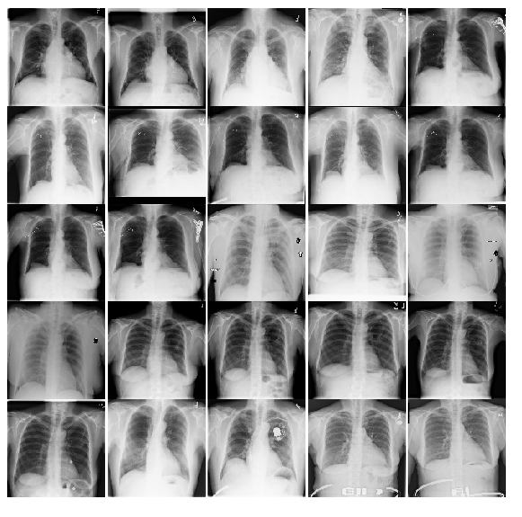

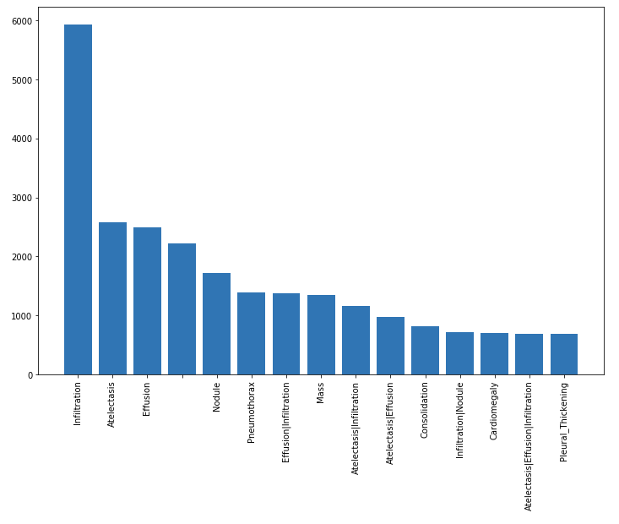

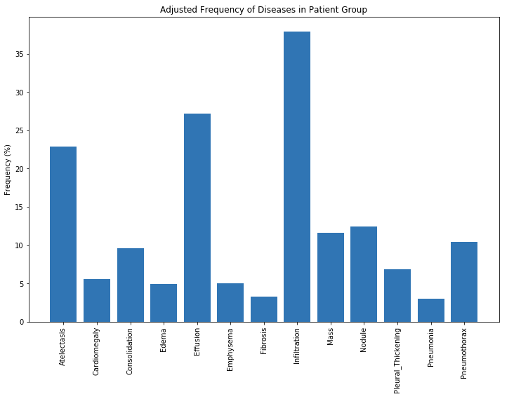 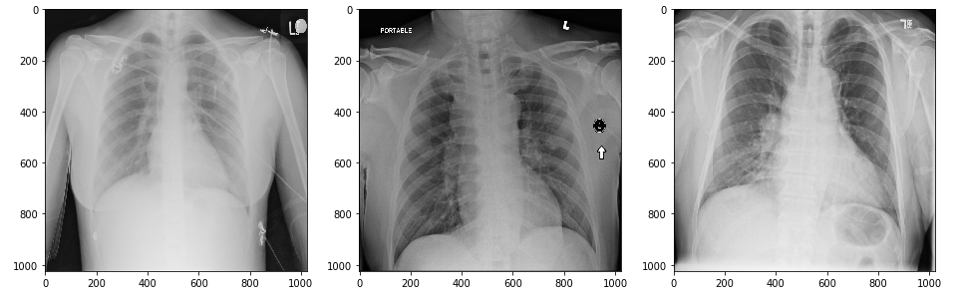

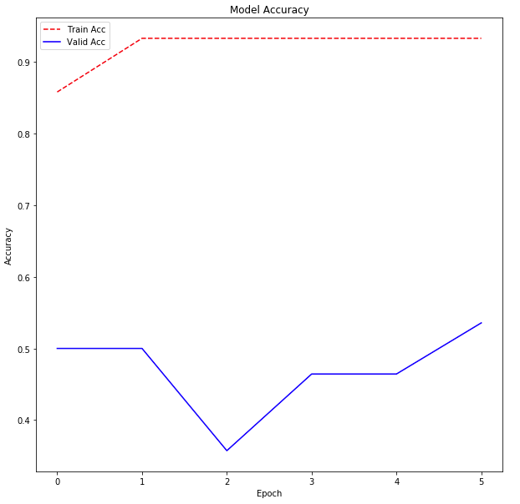

Tensorflow and Keras has discovered some connections. With the number of Epochs increased, the accuracy will also increased but this will also require decent computer processing power due to the number of images being processed.

