Data Science Career Track

TAKE HOME CHALLENGE -

Relax Report

by Edward Franke

05/25/2019

adoption .

We suggest spending 12

hours on this, but you're welcome to spend more or less.

Please send us a brief writeup of your findings (the more concise, the better no

more

than one page), along with any summary tables, graphs, code, or queries that can help

us understand your approach. Please note any factors you considered or investigation

you did, even if they did not pan out. Feel free to identify any further research or data

you think would be valuable.

FINDINGS

12000 observations

5583 (46.5% missing an invited by user id)

3177 (26.5% missing a last session so they never logged in)

1656 (13.8% considered as an “adopted user”)

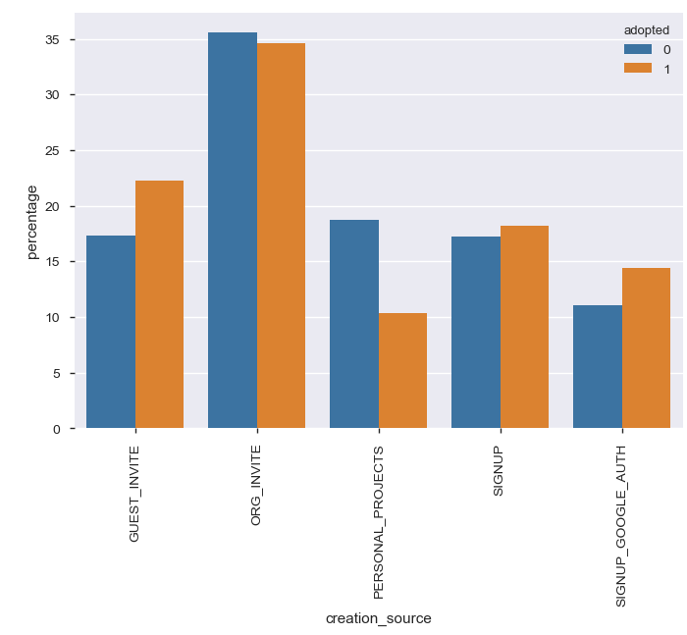

The analysis shows some correlations.

When a guest invites a person, they’re more likely to adopt.

Signup with Google authorization also lead more likely to adopt.

Special projects is more likely not to adopt than adopt (by percentage)

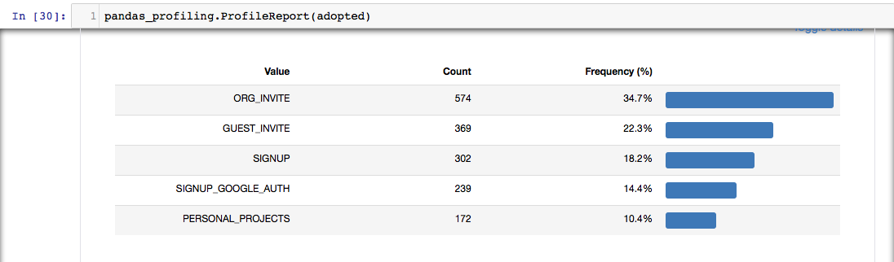

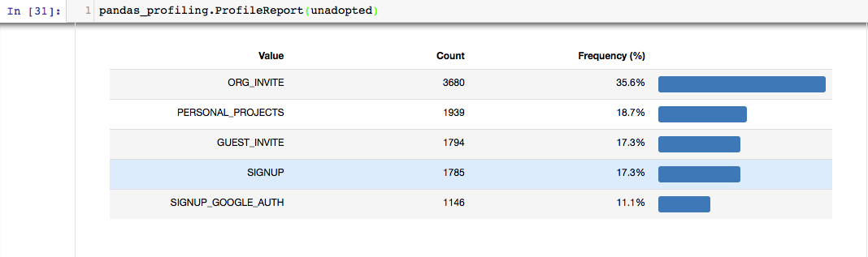

Percentages are great, but companies are looking for numbers as each number represents income and success for the company. Take personal projects, 172 adopted while 1939 did not adopt. It is the worst performing creation type. Running regressions or machine learning will not yield beneficial data in this instance.

Ultimately, further investigation is required to determine where the company should concentrate focusing for greater success. With such a low adoption rate, it’s highly likely the user is not finding what they were looking for and this area needs review.