Data Science Project

Technology Addiction Twitter Study

by Edward Franke

**EXECUTIVE SUMMARY:**

The purpose for this project is to determine and track addiction to technology and how it changes over time. The data came from twitter feeds using twitter’s api and code to determine the type of tweet related to addiction (if any being tracked). This code has been run twice (April of 2018 and July of 2019) with a net increase of technology addiction tweets of 1%. This needs to be tracked further better analyze the trend. Also, other sources of data should be examined.

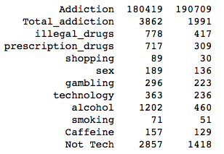

**IDEA:** Code to capture tweets and classify them into nine categories of addiction.

**CLIENT:** Persons interested in monitoring addiction to technology (or other addictions).

**REASON:** Addiction to technology devices and solutions is a growing concern.

**DATA:** From Twitter feeds using Twitter’s API to collect the data.

**SOLUTION:** Create code to analyze Twitter feeds for user’s comments (tweets) about addiction topics.

**DETAILS:** See below.

**DELIVERABLES:** Code and a report outlining the discoveries.

**BACKGROUND**

A growing number of activists and technology professionals are concerned about people becoming addicted to technology and the negative impact on society it brings. This study was initially requested to determine whether 50%+ of the mentioned addictions are technology related. And if not, what percentage or ratio is technology related addictions compared to other non-technology addictions. It then has been updated to look at the trends of addiction, especially related to technology.

**DATASETS and PROCESSING**

Twitter’s API was used on two occasions with the same search criteria and processing to determine technology addictions compared to other addictions and to determine the trend of technology addiction.

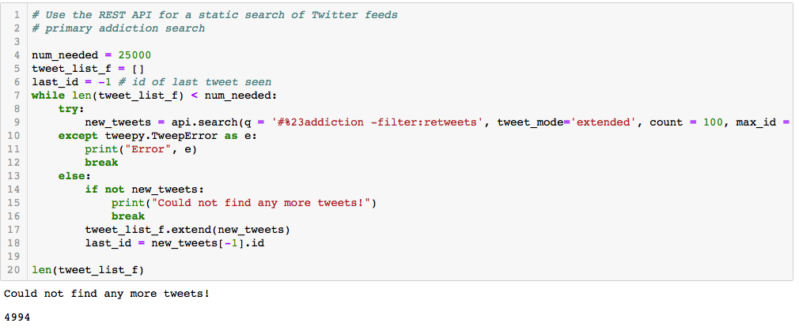

Tweets were captured using search criteria of addiction and then 2 additional for phone down and texting driving which are considered symptoms of technology addiction. The data was extracted into the following categories from the following symptoms:

illegal_drugs = ["cocaine", "meth", "marijuana", "heroin", "drugs"]

perscription_drugs = ["pills", "opioid", "oxycontin", "painkiller", "painkillers"]

shopping = ["shop", "shopping", "buy", "buying"]

sex = ["sex", "porn", "pornography"]

gambling = ["gambling", "gamble", "bet", "betting", "casino", "horse", "horses"]

alcohol = ["alcohol", "alcoholism", "drink", "drinking", "party"]

smoking = ["smoking", "smoke", "cigarettes", "ecigarettes"]

technology = ["phone", "iphone", "digital", "technology", "facebook", "smartphone", "texting", "driving", "gaming", "internet", "video"]

caffeine = ["caffeine", "coffee", "tea", "red bull", "energy”]

**DISCLAIMER**

It is known that counting tweet information for a source of information is not the best method to gain information. Some outlets of addiction are excluded, and others could be mis-identified. For example, weed or pot can be used instead of marijuana, but this hasn’t been accounted for. It is known that some areas of the country consider marijuana not to be an illegal drug but for the purpose of this analysis, it is considered as illegal. Only English words are used so foreign languages are not included.

**RESULTS**

When the code was first run in April of 2018, about 10% of the addiction was indicated as technology related. When it was run a second time in July of 2019, about 11% of the addiction was indicated as technology related. This is an increase of 1% over about 18 months timeframe.

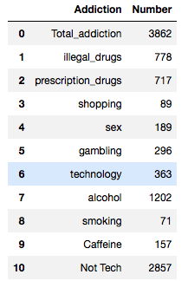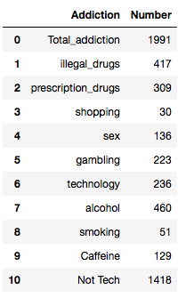

April 2018 results July 2019 results



Combined results

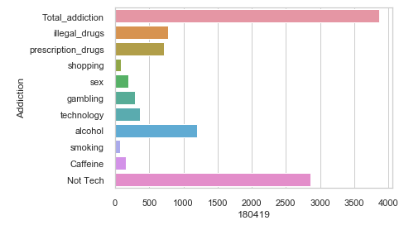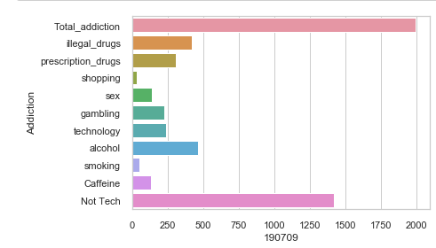

Barcharts showing the distribution of addiction types per time run.

The total number of tweets related to addiction dropped from 3862 to 1991 between the two dates the code was run. What factors contributed to this are unknown.

**CONCLUSION**

Further analysis is needed at different times to determine trends beyond just two datapoints. Also, other more credible sources of addiction data should be investigated.