CST 370 – Spring 2022

Homework 6

Due: 03/11/2022 (Friday) (11:55 PM)

How to turn in: Develop two programs in either C++ or Java on replit.com and then submit the source programs on Canvas before the due.
- You can submit your programs multiple times before the due. However, the last submission will be used for grading.
- Due time is 11:55(PM). Since there could be a long delay between your computer and Canvas, you should submit it early.

1. Write a C++ program (or Java program) for hw6_1 that reads the number of input values from a user. Then, read the input values from the user. After that, your program should display them in the ascending order. When you display the numbers, you have to use a short representation if there are consecutive numbers. For example, if there are three numbers such as 51, 52, and 53 in the input values, you have to display them 51–53 to save space. For the assignment, you can assume that the input values are positive integers and unique (= No duplications in the input numbers).

Input format: This is a sample input from a user.
6
51
27
53
77
52
75

The first number (= 6 in the example) indicates that there will be 6 values in the input. Then, the following lines are the actual values.

Sample Run 0: Assume that a user typed the following lines

6
51
27
53
77
52
75

This is the correct output.

27 51-53 75 77

Sample Run 1: Assume that a user typed the following lines

7
26
51
27
53
77
52
75

This is the correct output.

26-27 51-53 75 77

Sample Run 2: Assume that a user typed the following lines

10
4
5
6
1
2
3
7
9
10
11

This is the correct output.
1-7 9-11

2. Write a C++ (or Java) program for hw6_2 that implements the Depth-First Search (DFS) algorithm as you learned in the class.

Input format: This is a sample input from a user.
3
2
0 1
1 2

The first line (= 3 in the example) indicates that there are three vertices in the graph. For the homework, you can assume that the first vertex starts from the number 0. The second line (= 2 in the example) represents the number of edges, and following two lines are the edge information. This is the graph with the input information.

0

1

2

Sample Run 0: Assume that the user typed the following lines

3
2
0 1
1 2

This is the correct output. Your program should display the mark array of DFS. For the problem, you can assume that the starting vertex is always 0. However, you should assume that the graph could be disconnected.

Mark[0]:1
Mark[1]:2
Mark[2]:3

Sample Run 1: Assume that the user typed the following lines

5
6
0 1
0 2
0 3
1 3
2 3
3 4

This is the correct output.

Mark[0]:1
Mark[1]:2
Mark[2]:5
Mark[3]:3
Mark[4]:4

Sample Run 2: Assume that the user typed the following lines

6
5
0 2
0 1
3 4
4 5
2 1

This is the correct output.

Mark[0]:1
Mark[1]:2
Mark[2]:3
Mark[3]:4
Mark[4]:5
Mark[5]:6

This is the graph with the input information. Note that the graph is disconnected.
3
0

2

1
4
5

Sample Run 3: Assume that the user typed the following lines

5
6
0 1
0 2
0 3
1 4
2 3
3 4

This is the correct output.

Mark[0]:1
Mark[1]:2
Mark[2]:4
Mark[3]:5
Mark[4]:3

[Hint] In the lecture, we used a stack for the operation of DFS algorithm. So, you can use an explicit stack to implement it. However, you can use a function that uses an implicit run-time stack. The following is the pseudocode with a recursive function named “dfs()” and it may make your implementation easier.

// This is the main function named DFS().
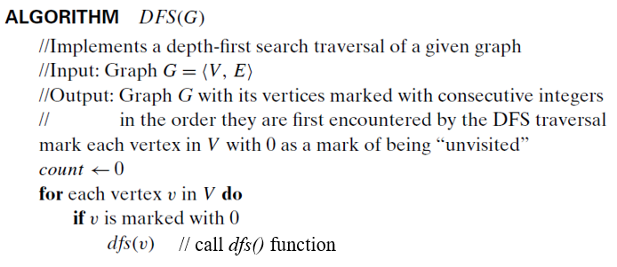

// This is the recursive function named dfs().
// Don’t be confused with the main function DFS().
