**INTRODUCTION TO EMERGING TECHNOLOGIES**

Submitted by:

**Gabriel Lambert C. Pampanga**

**Kyle Sandrei Q. Villamor**

**Kent Clark Gian C. Ortiz**

Course/Section:

**Bachelor of Science in Computer Engineering – Fourth Year**

Submitted to:

**Engr. Venis M. Docdoc**

CPE 19 – Emerging Technologies

**SY 2023 – 2024**

**First Semester**

**Chapter I: Introduction to Emerging Technologies**

In this chapter, we talk about how technology has changed over time. We explore how data is important for new technologies, how devices and networks are designed to work with these technologies (devices that can be programmed), how people interact with machines (like computers), and what we might expect to see in the future of technology.

Emerging technology is a phrase often used to talk about a new technology, but it can also describe the ongoing improvements of existing technology. Its meaning can vary depending on the context, like in media, business, science, or education. Usually, it refers to technologies that are in the process of developing or are likely to be around in the next five to ten years. This term is usually used for technologies that are causing or are expected to cause big changes in society or the economy. Technological evolution is a theory about how society can drastically change due to technological progress.

**What is the root word of technology and evolution?**

* **Technology:** In the 1610s, it meant "discussion or writing about an art or arts." It comes from the Greek word "tekhnologia," which initially referred to the organized understanding of an art, skill, or method, often related to grammar. The sense of "Science concerning mechanical and industrial skills" was first documented in 1859.
* **Evolution:** The term evolution signifies the progression of growth through step-by-step alterations. This word originates from the Latin term "evolution," which means "unfolding or opening up," formed by combining the prefix e-, meaning "out," and volvere, meaning "to roll."

**Evolution of Technologies**

**Introduction to Industrial Revolution (IR)**

The Industrial Revolution was a significant time of big changes and new inventions that happened in the late 1700s and early 1800s. It's when societies shifted from using simple tools to make things to using new forms of energy, like coal, to power machines in big factories. This all started in England, where people came up with ideas to make work faster and better. During this time, making things changed from being done in small workshops and homes to being done in large factories. This change also caused people to move from the countryside to cities to find work.

In the United States, the Second Industrial Revolution, also called the American Industrial Revolution, began between 1820 and 1870. It had a big impact on many industries like making cloth, mining, making glass, and farming. Before this time, clothes were mostly made from wool and spun by hand.

From the first Industrial Revolution, which used steam and water power, to the second one that used electricity and assembly lines, the fourth Industrial Revolution will build on what the third started by using computers and automation. This new revolution will make things even smarter and more automatic using data and machines that learn. Overall, these industrial revolutions have transformed the world into the modern society we know today. Some important parts of these changes include the invention of the steam engine, the growth of science and making things in large quantities, the rise of digital technology, and the development of smart systems that work on their own using data and machine learning.\

**The Most Important Inventions of the Industrial Revolution**

* **Transportation:** The Steam Engine, The Railroad, The Diesel Engine, The Airplane.
* **Communication:** The Telegraph, The Transatlantic Cable. The Phonograph. The Telephone.
* **Industry:** The Cotton Gin, The Sewing Machine, Electric Lights.

**Historical Background (IR1, IR2, IR3.0)**

The Industrial Revolution started in the late 1770s in Great Britain and later spread to other parts of Europe. Following England, Belgium, France, and the German states were the first European countries to experience industrialization. The Agricultural Revolution played a crucial role in eventually causing the Industrial Revolution. As mentioned earlier, the initial spark of the Industrial Revolution in 18th century Britain was linked to greater food production, a significant result of the changes brought about by the Agricultural Revolution.

The four types of industries are:

* **The primary industry** – involves getting raw materials e.g., mining, farming, and fishing.
* **The secondary industry** – involves manufacturing e.g., making cars and steel.
* **Tertiary industries** – provide a service e.g., teaching and nursing.
* **The quaternary industry** – involves research and development industries e.g., IT.

**Industrial Revolution (IR1.0)**

The Industrial Revolution (IR) is characterized as a shift to fresh methods of manufacturing. The term IR was initially introduced in the 1760s, precisely when this transformation commenced. The changes in the inaugural IR encompassed a shift from manual production techniques to machinery, the growing adoption of steam power, the creation of machine tools, and the emergence of the factory system.

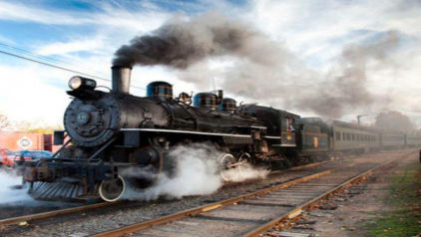

**Industrial Revolution (IR2)**

The Second Industrial Revolution, which is also referred to as the Technological Revolution, commenced around the 1870s. The progress in this second phase of industrialization encompassed the creation of techniques for producing parts that could be swapped easily, along with the widespread integration of existing technologies like telegraph and railroad networks. This integration facilitated the extensive movement of people and concepts, thus improving communication. Furthermore, novel technological systems were introduced during this period, such as electric power and telephones.

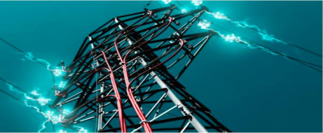

**Industrial Revolution (IR3.0)**

The Third Industrial Revolution (IR 3.0) emerged. IR 3.0 marked the shift from mechanical and analog electronic technology to digital electronics, commencing in the late 1950s. Because of this transition to digital processes, IR 3.0 earned the moniker "Digital Revolution." The central aspect of this revolution lies in the widespread production and utilization of digital logic circuits and their related technologies like computers, mobile phones, and the Internet. These technological breakthroughs have arguably revolutionized conventional methods of production and business, facilitating remote communication between people without requiring physical presence. Some practices initiated during IR 3.0 continue to be relevant today, such as the extensive use of digital computers and digital records.

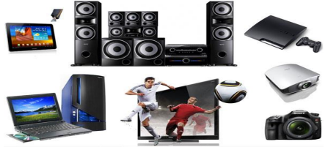

**Industrial Revolution (IR4.0)**

In the present time, with progressions in diverse technologies like robotics, the Internet of Things, additive manufacturing, and self-driving vehicles, the term "Fourth Industrial Revolution" or IR 4.0 was introduced by Klaus Schwab, the founder and executive chairman of the World Economic Forum, in 2016. The aforementioned technologies fall under the category of cyber-physical systems. A cyber-physical system refers to a mechanism that's governed or observed by computer-based algorithms, closely integrated with the Internet and its users.

A prime illustration that finds extensive application in industries nowadays is the utilization of Computer Numerical Control (CNC) machines. These machines operate through computer-provided instructions. Another pivotal innovation linked with IR 4.0 involves the incorporation of Artificial Intelligence (AI), which we observe in its implementation in smartphones. AI also plays a pivotal role in enabling the functioning of Autonomous Vehicles and Automated Robots.

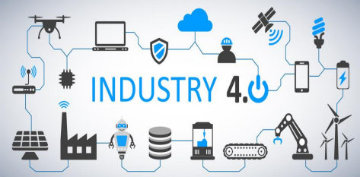

**Role of Data for Emerging Technologies**

In the age of big data, information is considered as valuable as oil, shaping our world's future in science, technology, and the economy. While data holds immense potential, it also poses challenges that drive innovation and economic growth. This transformative shift isn't solely due to data itself, but how it can create, transform, and impact various aspects. This trend has sparked discussions about data-driven scientific advancement in the context of the "fourth industrial revolution." Undeniably, data science and analytics are increasingly recognized for their role in driving theories, economies, and professional growth across disciplines like computing, informatics, statistics, business, social sciences, and health/medicine.

**Enabling devices and networks for Emerging technologies (programmable devices)**

In the realm of digital electronic systems, there exist four fundamental types of devices: memory, microprocessors, logic, and networks. Memory devices are used to store various information like spreadsheet or database contents. Microprocessors carry out software instructions for diverse tasks, like running word processing software or video games. Logic devices fulfill specific roles, such as interfacing between devices, data communication, signal processing, data display, timing and control functions, and nearly every other operation required by a system. Networks encompass a collection of interconnected computers, servers, mainframes, peripherals, and more, enabling data sharing. The Internet is a prime example of a network, linking millions of people worldwide.

Programmable devices generally refer to chips incorporating field-programmable logic devices (FPGAs), complex programmable logic devices (CPLD), and programmable logic devices (PLD). Analog equivalents of these devices are also present, known as field-programmable analog arrays.

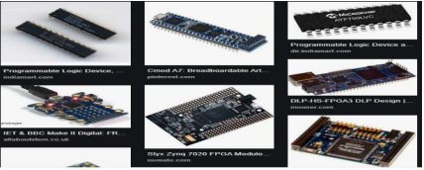

**Why is a computer referred to as a programmable device?**

Because what makes a computer a computer is that it follows a set of instructions. Many electronic devices are computers that perform only one operation, but they are still following instructions that reside permanently in the unit.

**List of some Programmable devices**

* Achronix Speedster SPD60
* Actel’s
* Altera Stratix IV GT and Arria II GX
* Atmel’s AT91CAP7L
* Cypress Semiconductor’s programmable system-on-chip (PSoC) family
* Lattice Semiconductor’s ECP3
* Lime Microsystems’ LMS6002
* Silicon Blue Technologies
* Xilinx Virtex 6 and Spartan 6
* Xmos Semiconductor L series

A full range of network-related equipment referred to as Service Enabling Devices (SEDs), which can include:

* Traditional channel service unit (CSU) and data service unit (DSU)
* Modems
* Routers
* Switches
* Conferencing equipment
* Network appliances (NIDs and SIDs)
* Hosting equipment and servers

**Human to Machine Interaction**

Human-machine interaction (HMI) refers to the communication and interaction between a human and a machine via a user interface. Nowadays, natural user interfaces such as gestures have gained increasing attention as they allow humans to control machines through natural and intuitive behaviors.

**What is interaction in human-computer interaction?**

HCI (human-computer interaction) is the study of how people interact with computers and to what extent computers are or are not developed for successful interaction with human beings. As its name implies, HCI consists of three parts: the user, the computer itself, and the ways they work together.

**How do users interact with computers?**

The user interacts directly with hardware for the human input and output such as displays, e.g., through a graphical user interface. The user interacts with the computer over this software interface using the given input and output (I/O) hardware.

**How important is human-computer interaction?**

The goal of HCI is to improve the interaction between users and computers by making computers more user-friendly and receptive to the user’s needs. The main advantages of HCI are simplicity, ease of deployment & operations and cost savings for smaller set-ups. They also reduce solution design time and integration complexity.

**Disciplines Contributing to Human-Computer Interaction (HCI)**

* Cognitive psychology: Limitations, information processing, performance prediction, cooperative working, and capabilities.
* Computer science: Including graphics, technology, prototyping tools, user interface management systems.
* Linguistics
* Engineering and design
* Artificial intelligence
* Human factors

**Future trends in emerging technologies**

**Emerging technology trends in 2019**

* 5G Networks
* Artificial Intelligence (AI)
* Autonomous Devices
* Blockchain
* Augmented Analytics
* Digital Twins
* Enhanced Edge Computing and
* Immersive Experiences in Smart Spaces

**Some emerging technologies that will shape the future of you and your business**

The future is now or so they say. So-called emerging technologies are taking over our minds more and more each day. These are very high-level emerging technologies though. They sound like tools that will only affect the top tier of technology companies who employ the world’s top 1% of geniuses. This is totally wrong. Chatbots, virtual/augmented reality, blockchain, Ephemeral Apps and Artificial Intelligence are already shaping your life whether you like it or not. At the end of the day, you can either adapt or die.