**Group Information**

Create a table listing all group members and their assigned roles or responsibilities.

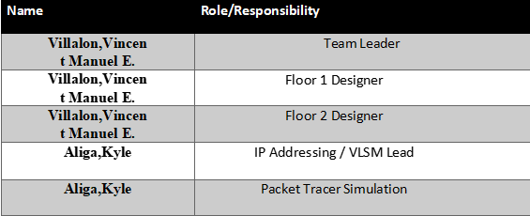

**Project Overview**

Modernization and Enhancement of the Computer Laboratory Facilities at the CIT Building

II. **Building and Floor Design**

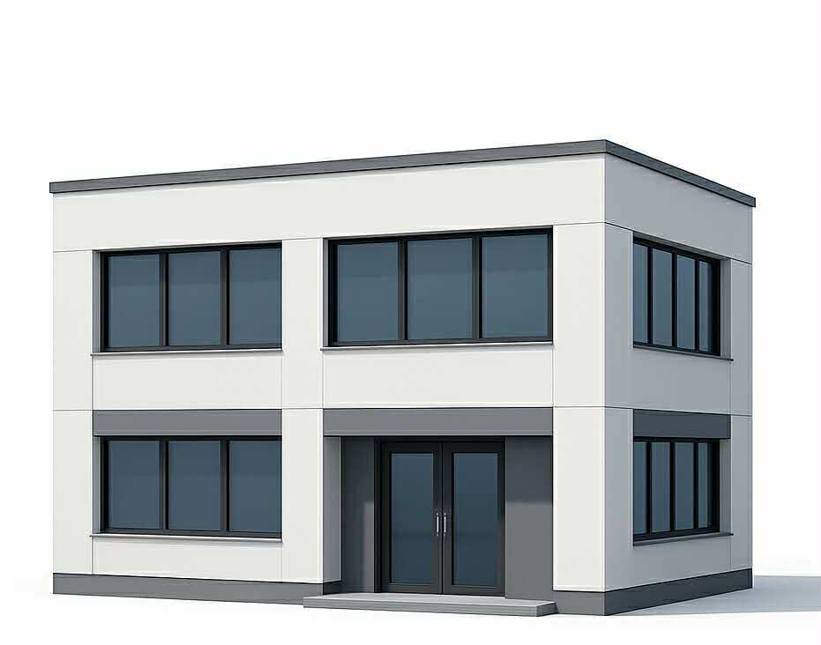**2.1 Building Layout**

**2.2 Floor Plan**

Provide the building’s floor plan. You may add furniture and other details to make it more realistic.

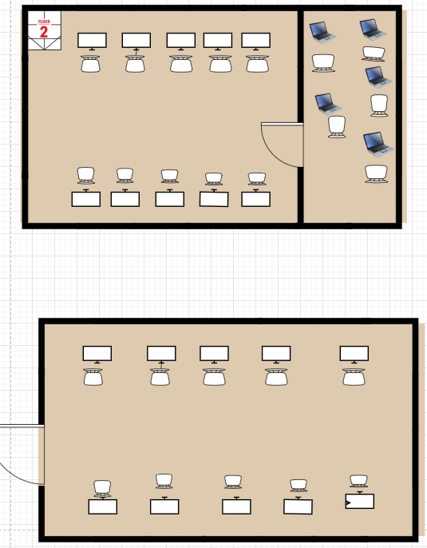

## 2.3 Floor Plan with network devices

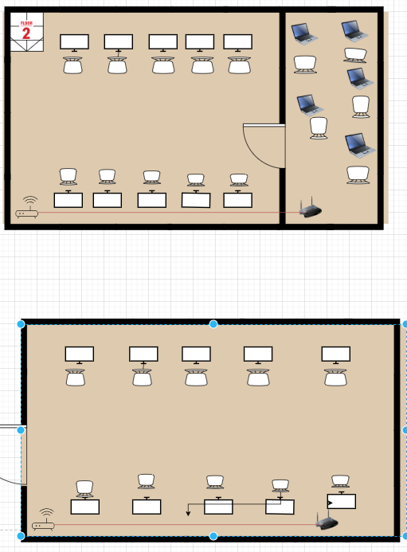

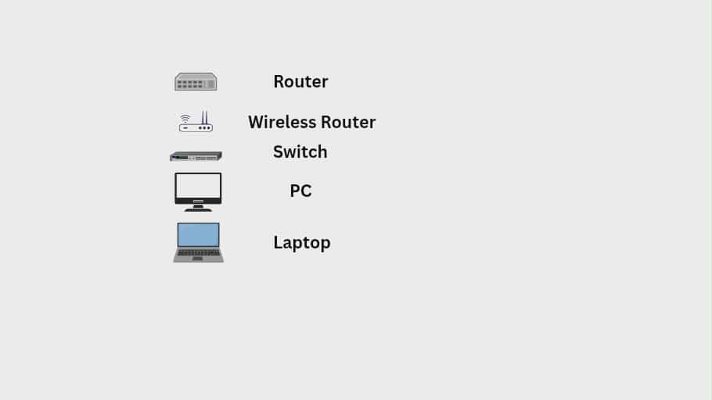

## 2.3 Cables

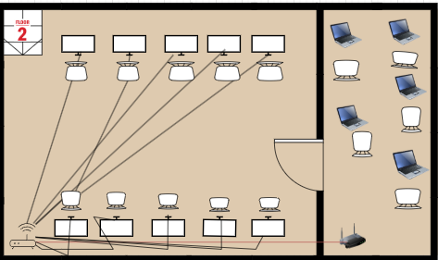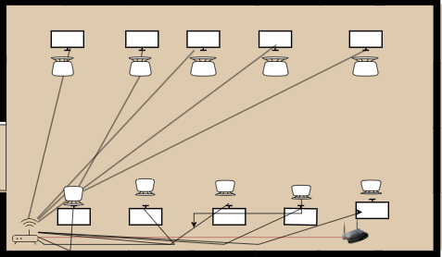

# III. Network Design (Cisco Packet Tracer)

Using Cisco Packet Tracer, design and connect the network devices, including at least 20 computers and 5 wireless end devices.

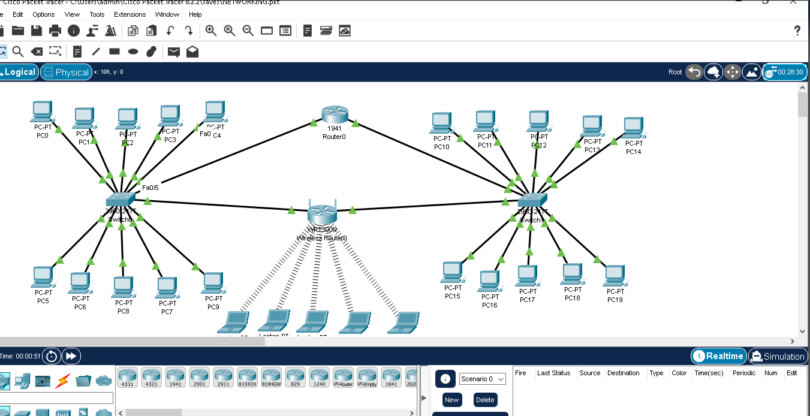

This network setup illustrates the CIT Office Building, composed of two floors linked through a central router.

**First Floor:** Houses 10 desktop computers connected to **Switch0**.

**Second Floor:** Contains another 10 desktop computers connected to **Switch1**.

Both switches are connected to the **main router**, which functions as the central gateway for all devices. A **WRT300N wireless router** is also connected to Switch1, providing Wi-Fi access for 10 laptops on the second floor.

All wired connections use **straight-through cables**, while laptops connect wirelessly to the WRT300N. The router handles communication between the two switches and the wireless network, enabling all wired and wireless devices to exchange data efficiently.

This configuration effectively demonstrates the proper application of **subnetting, network topology, and inter-device connectivity** within a small office environment.



# IV. IP Addressing using VLSM/FLSM

## 4.1 Subnet Requirements

|  |  |  |  |  |  |
| --- | --- | --- | --- | --- | --- |
| **Floor** | **Number of Device** | **Network Needed** | **Assigned Network** | **IP Range** | **Broadcast Address** |
| **Floor 1** | 10 PCs + 2 devices (Switch & Router) | 12 | 192.168.10.0/28 | |  | | --- | | 192.168.10.1 – 192.168.10.14 | | 192.168.10.15 |
| **Floor 2** | 10 PCs + 2 devices (Switch & WAP) | 12 | 192.168.10.16/28 | 192.168.10.17  –192.168.10.30 | 192.168.10.31 |
| **Wireless (Wi-Fi)** | |  | | --- | |  |  |  | | --- | | 5 Laptops + 1 WAP | | 6 | |  | | --- | |  |  |  | | --- | | 192.168.10.32/29 | | 192.168.10.33 – 192.168.10.38 | 192.168.10.39 |

## 4.2 IP Assignment Table

List down the IP addresses assigned to each device in your network. Include the interface, IP address, subnet mask, and default gat

|  |  |  |  |  |
| --- | --- | --- | --- | --- |
| **Device Name** | **Interface** | **Assigned IP Address** | **Subnet Mask** | **Gateway** |
| **PC0-Floor1** | FastEthernet0 | 192.168.10.2 | 255.255.255.0 | 192.168.22.1 |
| **Router** | G0/0 | 192.168.10.1 | 255.255.255.0 | — |
| **Switch_Floor1** | VLAN1 | 192.168.10.12 | 255.255.255.0 | 192.168.10.1 |
| **Switch_Floor2** | VLAN1 | 192.168.10.17 | 255.255.255.0 | 192.168.10.1 |
| **PC0** | FastEthernet0 | 192.168.10.2 | 255.255.255.0 | 192.168.10.1 |
| **PC1** | FastEthernet0 | 192.168.10.3 | 255.255.255.0 | 192.168.10.1 |
| **PC2** | FastEthernet0 | 192.168.10.4 | 255.255.255.0 | 192.168.10.1 |

## 4.3 Wired and Wireless Connections

Table that shows all devices and how they are connected to the network. Include the type of connection (wired or wireless), the device connected to, and the type of cable or medium used.

|  |  |  |  |
| --- | --- | --- | --- |
| **Device Name** | **Connection Type** | **Connected To** | **Cable/Medium Used** |
| **PC0-Floor1** | Wired | Switch_Floor1 | Straight-through |
| **PC1-Floor1** | Wired | Switch_Floor1 | Straight-through |
| **PC2-Floor1** | Wired | Switch_Floor1 | Straight-through |
| **PC3-Floor1** | Wired | Switch_Floor1 | Straight-through |
| **PC4-Floor1** | Wired | Switch_Floor1 | Straight-through |
| **PC5-Floor1** | Wired | Switch_Floor1 | Straight-through |
| **PC6-Floor1** | Wired | Switch_Floor1 | Straight-through |
| **PC7-Floor1** | Wired | Switch_Floor1 | Straight-through |
| **PC8-Floor1** | Wired | Switch_Floor1 | Straight-through |
| **PC9-Floor1** | Wired | Switch_Floor1 | Straight-through |
| **Router** | Wired | Switch_Floor1 | Straight-through |
| **Switch-Floor1** | Wired | Swich_Floor2 | Straight-through |
| **Switch-Floor2** | Wired | WRT300N (Internet Port) | Straight-through |
| **PC10-Floor2** | Wired | Swich_Floor2 | Straight-through |
| **PC11-Floor2** | Wired | Swich_Floor2 | Straight-through |
| **PC12-Floor2** | Wired | Swich_Floor2 | Straight-through |
| **PC13-Floor2** | Wired | Swich_Floor2 | Straight-through |

|  |  |  |  |
| --- | --- | --- | --- |
| **PC14-Floor2** | Wired | Swich_Floor2 | Straight-through |
| **PC15-Floor2** | Wired | Swich_Floor2 | Straight-through |
| **PC16-Floor2** | Wired | Swich_Floor2 | Straight-through |
| **PC17-Floor2** | Wired | Swich_Floor2 | Straight-through |
| **PC18-Floor2** | Wired | Swich_Floor2 | Straight-through |
| **PC19-Floor2** | Wired | Swich_Floor2 | Straight-through |
| |  | | --- | | **Laptop0-Floor2** | | |  | | --- | | **Laptop1–Floor2** | | |  | | --- | | WRT300N (CIT_WIFI SSID) | | Wi-Fi |
| |  | | --- | | **Laptop1-Floor2** | | Wireless | WRT300N (CIT_WIFI SSID) | Wi-Fi |
| |  | | --- | | **Laptop2-Floor2** | | Wireless | WRT300N (CIT_WIFI SSID) | Wi-Fi |
| |  | | --- | | **Laptop9-Floor2** | | Wireless | WRT300N (CIT_WIFI SSID) | Wi-Fi |
| |  | | --- | | **Laptop10-Floor2** | | Wireless | WRT300N (CIT_WIFI SSID) | Wi-Fi |

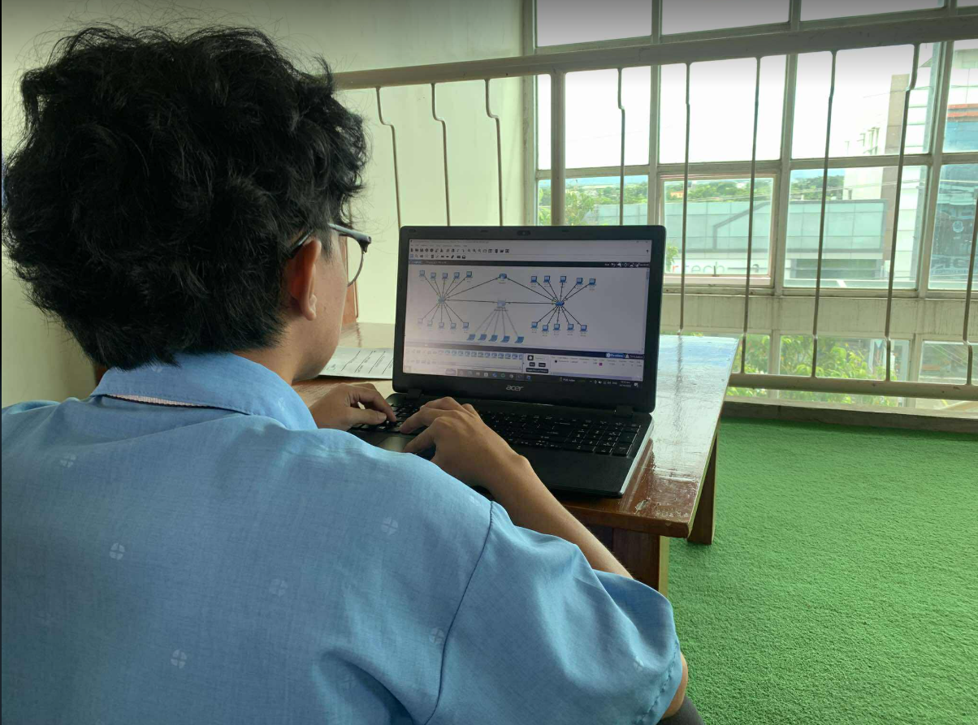

**VI. QR Code of Project File**

**Generate a QR code that links to a Google Drive folder. Save both the soft copy of your documentation and your Cisco Packet Tracer file inside that folder.**

**VII.**  
Working on this networking project was both difficult and rewarding. In the beginning, I struggled to understand subnetting and how to properly connect devices in Cisco Packet Tracer. I made several mistakes and had to experiment multiple times while assigning IP addresses, setting up wireless connections, and fixing network problems.

Through these challenges, I gained a deeper understanding of how networks are structured and how crucial proper planning and configuration are for successful communication. This project also improved my patience and attention to detail.

I’m grateful for the guidance and for the opportunity to experience real-world networking tasks, even though the process was quite challenging.