

Mapua University

School of Electrical, Electronics and Computer Engineering

**Cisco Borrowing System**

by

**Fernando, Rachel Abbie**

**Milan, Erwin Christopher**

**Villanueva, Shannen Mae**

**COE125/C1**

**Engr. Dionis Padilla**

Professor

This program is created to manage the inventory of the laboratory equipment by creating logs of borrowed equipment and allow the user to view and borrow available equipment in the inventory. For this project we will use the CISCO Laboratory equipment as sample database.

**User Requirements:**

1. User or Students must be able to log-in.
2. The user must be able to enter the basic information regarding the borrowing the equipment such as name, student number, course, room and professor.
3. The system must have a database for information on the equipment and user accounts.
4. Let the user click on the item to borrow from a list of materials.
5. The user must be able to view which equipment are available or not.
6. The system must display the number of available equipment.
7. The user must be able to enter the quantity of each equipment that is desired to be borrowed.
8. Let the user click “done” and a message will be displayed to inform the success of borrowing equipment.
9. Automatically update the equipment inventory database
10. There should be a back button if ever the user made a mistake.
11. The user will enter its student number in returning equipment.
12. The system will display the information of the returnee and confirm the process of returning the equipment.
13. The proceeding to the next window, the previous window will be hidden.

**Getting Started:**

These instructions will get you a copy of the project up and running on your local machine for development and testing purposes. See deployment for notes on how to deploy the project on a live system.

**Prerequisites:**

What things you need to install the software and how to install them

- Spyder

- Python

- Anaconda Prompt

- DB Browser

- PyQt5 Designer

**Installing:**

1. Open the Anaconda Prompt

2. Go to the directory of the file you downloaded using cd instruction

3. Type 'python Link.py'

----> cd Documents/TRIO_COE125_C1_PROJECT-master/SOURCE/BLL/python Link.py

**Running the Test:**

1. Choose between 'Borrow' and 'Return' of equipment

2. When borrowing equipment, enter the required student information then click 'OK'

3. Select on the equipment you want to borrow and enter the quantity of each equipment.

4. When returning equipment, enter the student number then click 'OK'.

|  |
| --- |
| Return |
| setupUi(self,BackForm)  retranslateUi(self, BackForm)  search(self)  clear(self)  checkLineEdit(self)  checkStudent(self)  remove(self)  disableButton(self) |
|  |

**Class Diagram:**

|  |
| --- |
| Main |
| setupUi(self, MainForm)  retranslate(self, MainForm) |
| borrowbtn  centralwidget  statusbar  returnbtn |

|  |
| --- |
| Student1 |
| __init__(self, Name, StudNum, Course, Room, Professor)  addStudInfo(self)  removeStudInfo(StudNum) |
| StudNum  Professor  Course  Room  Name |

|  |
| --- |
| Inventory |
| __init__(self,, StudNum, Rack, Switch, Console, LAN, Power)  borrowItems(self)  returnItems(StudNum) |
| StudNum  Rack  Switch  Console  LAN  Router  Power |

|  |
| --- |
| Borrow |
| setupUi(self, BorrowForm)  retranslateUi(self, BorrowForm)  checkIfExit(self)  addStud(self)  clear(self) |
|  |

**Flowchart**



**Entity Relationship Diagram (ERD)**

|  |
| --- |
| Student |
| First: TEXT  Last: TEXT  Student Number: INTEGER  Course: TEXT  Room: TEXT  Professor: TEXT |

|  |
| --- |
| Equipment |
| Materials: TEXT  Quantity: INTEGER  Available: TEXT  Borrowed: TEXT |

**Testing: Unit Test**

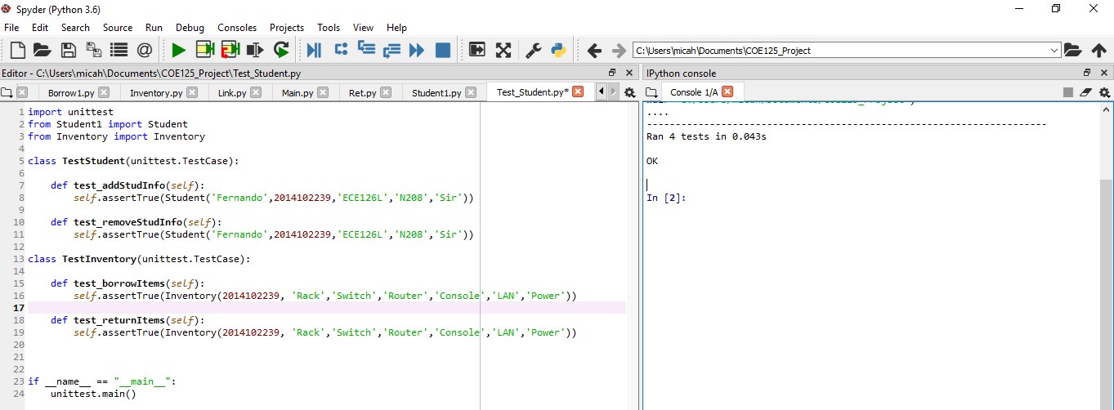

**GUI**

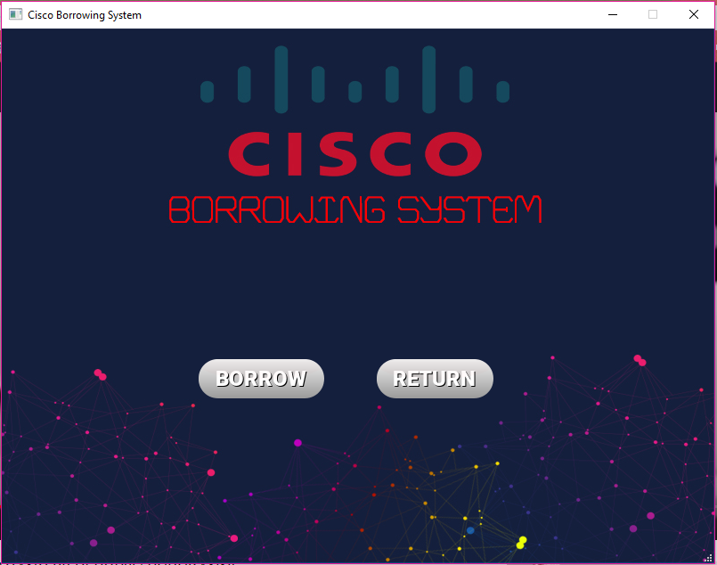

Running the program, this is the main page where the user can select between borrowing an equipment or returning an equipment.

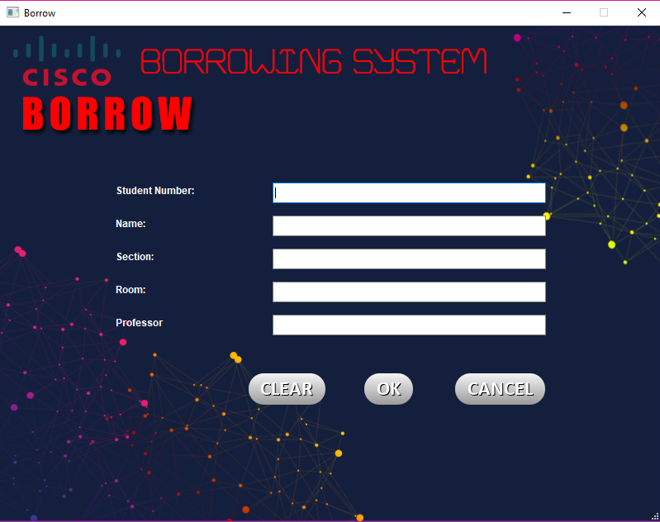**.**

This is the page for borrowing an equipment. The user will enter its information such as student number, name, section, room and professor. After which the user can confirm to continue to the next page or clear the entered information. If the user wants to return to the main page, simply click on the ‘Cancel’ button.

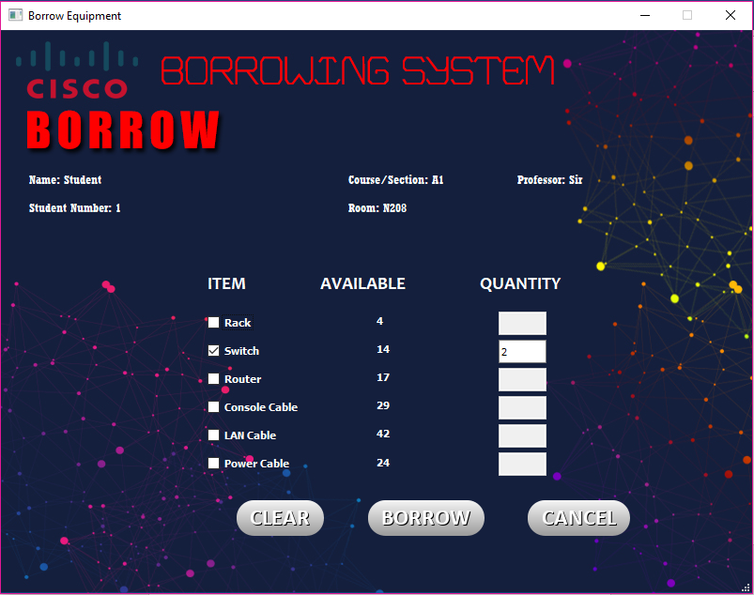

This is the page for choosing on the desired equipment and the quantity the user can borrow. The page also displays the information of the user and includes the number of available items per equipment.

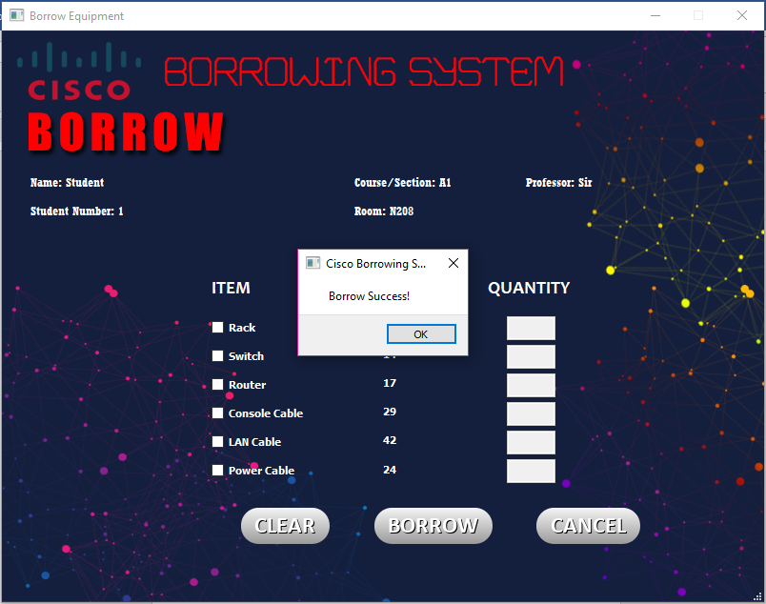

A message box will be displayed after a successful borrowing of equipment.

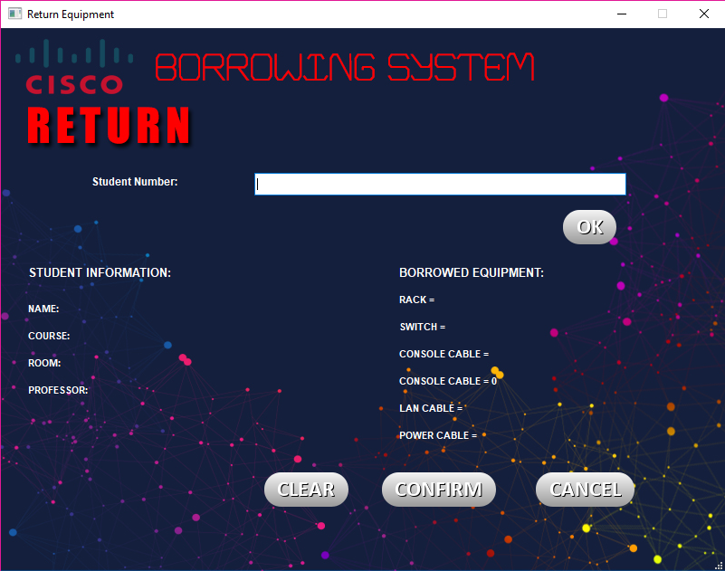

This is the page for returning an equipment where the user will enter its student number and the system will display the information of the user to confirm its identity.

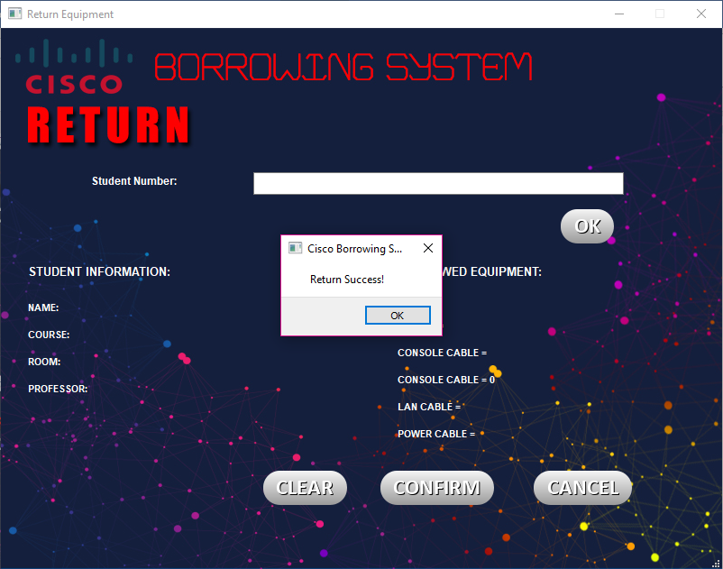

The user can choose between the three buttons below, ‘Clear’ button to delete the text entered, ‘Cancel’ to return to the stop the process and return to the previous window and ‘Confirm’ button in which a message box will declaring a successful return of equipment.