CEBU TECHNOLOGICAL UNIVERSITY
Cebu City
AP3
Midterm Project
Agriculture Information Systems
Database: Supabase PostgreSQL
Application: Web-Based Information System
Project Goal: Design and develop a working Agriculture Information System that demonstrates proper database normalization, relational database design, secure data management, CRUD operations, reporting, and dashboard visualization using Supabase PostgreSQL
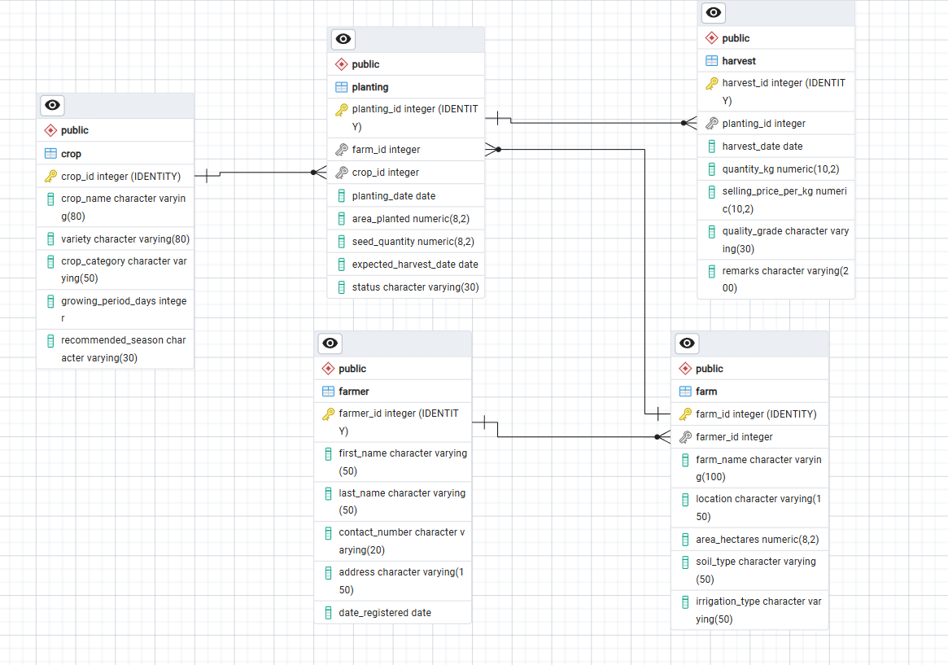
Table: Crop
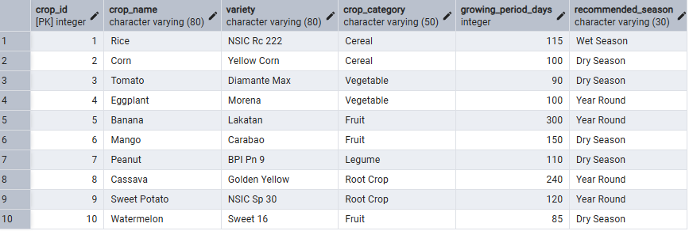

Table: Farmer
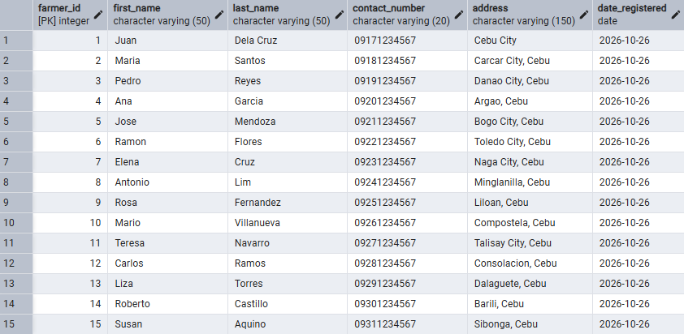
Table: Farm
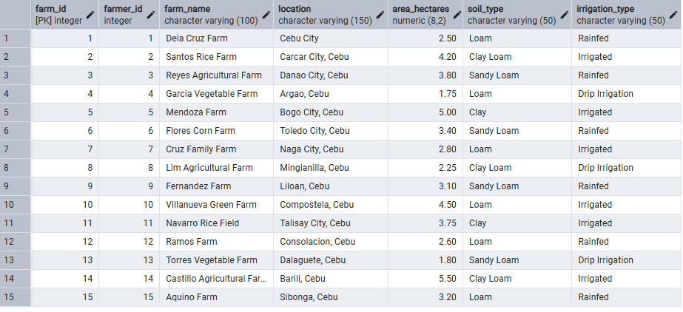
Table: Planting
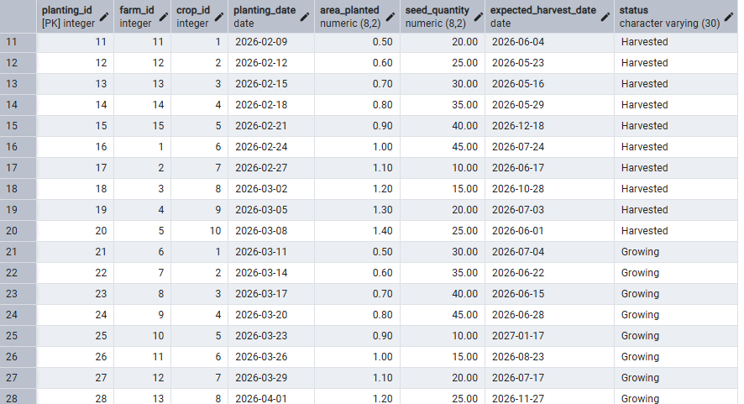

Table: Harvest
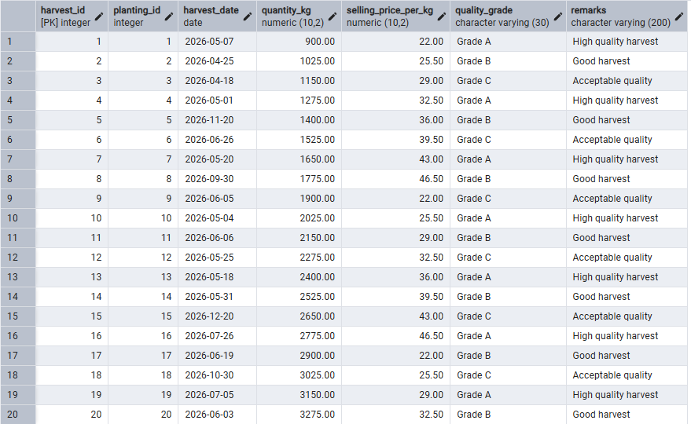

Core Database Modules
Table / Module | Purpose | Main Relationship
FARMER | Stores farmer information | FARMER 1:M FARM
FARM | Stores farm information | FARM 1:M PLANTING
CROP | Stores crop master data | CROP 1:M PLANTING
PLANTING | Stores crop planting transactions | PLANTING 1:M HARVEST
HARVEST | Stores harvest transactions | Related to PLANTING

- Database Normalization
- The database must be properly normalized from First Normal Form (1NF) up to Third Normal Form (3NF).
- Remove repeating groups and ensure that every field contains an atomic value.
- Resolve multivalued attributes by creating appropriate related tables when necessary.
- Remove partial dependencies and transitive dependencies.
- Identify the correct primary keys, foreign keys, and relationships between tables.
- Submit the unnormalized form, 1NF, 2NF, and 3NF structures as part of the documentation.
- Use Supabase as the Database
- Use Supabase PostgreSQL as the database platform for the project.
- Create all required tables, keys, constraints, and relationships in Supabase.
- The application must read from and write to the Supabase database.
- Database credentials and connection information must be stored securely and must not be exposed in public source code.
- Use Controlled Dropdown Values for Selected Fields
- Fields with predefined values must use a dropdown list instead of allowing users to type arbitrary text.
- The dropdown must display a descriptive label to the user while the database stores the corresponding numeric ID or code.
- The descriptive values must be stored in a separate reference or lookup table and connected using a foreign key.
- Example for Harvest Remarks:
- 1 = Good Harvest
- 2 = Acceptable Quality
- 3 = Low Yield
- 4 = Poor Quality
- 5 = Damaged Harvest
- If the user selects “Good Harvest,” the interface displays the text Good Harvest, but the value stored in the HARVEST record is the corresponding numeric value, such as 1.
Example: Lookup Table for Harvest Remarks
remark_id | remark_description
1 | Good Harvest
2 | Acceptable Quality
3 | Low Yield
4 | Poor Quality
5 | Damaged Harvest

- Develop a Working Agriculture Information System
- Create a fully functional web-based Agriculture Information System using the normalized Supabase database.
- The system must support Create, Read, Update, and Delete (CRUD) operations.
- The system must manage the following major modules:
- Farmers
- Farms
- Crops
- Planting Records
- Harvest Records
- The relationships between tables must be correctly implemented using primary keys and foreign keys.
- Related information must be displayed using appropriate JOIN operations. For example, planting records should display the corresponding farm and crop information.
- All major features must be functional and connected to the actual Supabase PostgreSQL database.
- Create a Dashboard
- The system must include a dashboard as the main page after a user enters the system.
- At minimum, the dashboard must display summary cards for:
- Total number of farmers
- Total number of farms
- Total number of crops
- Total number of planting records
- Total number of harvest records
- The dashboard should also display useful agricultural information such as:
- Recent planting records
- Recent harvest records
- Number of plantings by status
- Total harvested quantity
- Use appropriate charts, summary cards, or tables when they improve understanding.
- All dashboard values must be retrieved dynamically from the database and must not be hard-coded.
- Provide navigation from the dashboard to all major modules.
- User Authentication and Access Control
- The system must include a login page.
- Only authorized users may access protected pages and system functions.
- Use at least two user roles, such as Administrator and Staff.
- Restrict selected functions according to user role when appropriate.
- Passwords must not be stored as plain text.
- Input Validation
- Validate all form inputs before saving data to the database.
- Required fields must not accept empty values.
- Numeric fields must accept only valid numeric values and must follow applicable minimum or maximum constraints.
- Date fields must contain valid dates and logical date relationships must be checked.
- Foreign key values must correspond to existing related records.
- Apply validation both in the application and, where appropriate, through database constraints.
- Search, Filter, and Sorting
- Each major module must provide a search function.
- Provide filtering based on relevant fields.
- Examples include filtering farmers by address, farms by irrigation type, crops by category, planting records by status, and harvest records by quality grade.
- Provide sorting for appropriate table columns when useful.
- Reports
- The system must generate useful agricultural reports.
- At minimum, provide reports for:
- Farmers and their farms
- Crops planted per farm
- Planting records by status
- Harvest records
- Total harvested quantity
- Estimated harvest value based on quantity and selling price
- Reports should allow filtering by date range or other relevant criteria.
- Report results must come from database queries and must not be hard-coded.
- Data Tables and Pagination
- Display record lists using organized data tables with clear column headings.
- Large record lists must use pagination.
- Provide appropriate View, Edit, and Delete actions for records.
- Tables should remain readable and usable on common screen sizes.
- Confirmation Before Deletion
- Display a confirmation dialog or message before permanently deleting a record.
- Handle records referenced by other tables according to the defined foreign-key relationships.
- Prevent or properly manage deletion when it would violate referential integrity.
- Responsive and Organized User Interface
- Create a clean, consistent, and easy-to-navigate user interface.
- The system must be usable on desktop, tablet, and mobile devices.
- A CSS framework such as Bootstrap may be used.
- Use consistent navigation, form design, buttons, labels, spacing, and table presentation throughout the system.
- Error and Success Messages
- Display clear success messages after successful Create, Update, and Delete operations.
- Display understandable validation or error messages when an operation cannot be completed.
- Do not display sensitive database credentials, full connection strings, or unnecessary technical error details to end users.
- Audit Information
- Important tables should include created_at and updated_at fields where appropriate.
- The system should record when data was created and when it was last modified.
- If user accounts are implemented, recording the responsible user for important changes is encouraged.
- Database Constraints and Data Integrity
- Use appropriate PRIMARY KEY and FOREIGN KEY constraints.
- Use NOT NULL for required database fields.
- Use UNIQUE constraints for values that must not be duplicated.
- Use CHECK constraints for valid numeric ranges or other business rules where appropriate.
- Ensure referential integrity across FARMER, FARM, CROP, PLANTING, HARVEST, and lookup/reference tables.
- System Documentation
- The project documentation must include:
- Project title and description
- Project objectives
- Functional requirements
- Entity-Relationship Diagram (ERD)
- Normalization process from unnormalized form through 3NF
- Data dictionary
- Table relationships and constraints
- Screenshots of the working system
- Testing results
- User guide or basic operating instructions
- System Testing
- Test all major modules and functions before submission.
- CRUD operations, searches, filters, dropdowns, joins, authentication, dashboard, and reports must work correctly.
- Test invalid input and error conditions, not only successful operations.
- The submitted system must not contain broken links, missing pages, or non-functional buttons.
- Deployment and Final System Readiness
- The final database must be hosted in Supabase.
- The final application must successfully connect to the Supabase PostgreSQL database.
- Use environment variables or another secure configuration approach for database credentials when deployed.
- The submitted project must be complete enough to demonstrate all required features using actual database records.
- The final system must be ready for demonstration and evaluation.

Required Project Deliverables
- Working Agriculture Information System source code
- Supabase PostgreSQL database with complete tables, constraints, relationships, and lookup data
- ERD and normalized database design (UNF/1NF/2NF/3NF as applicable)
- Project documentation
- Screenshots or evidence of all major working modules
- Test results showing that required functions operate correctly
- Final deployed or demonstrable version of the system

