# Relational Databases with MySQL Week 6 Coding Assignment

**Points possible:** 70

|  |  |  |
| --- | --- | --- |
| **Category** | **Criteria** | **% of Grade** |
| **Functionality** | Does the code work? | 25 |
| **Organization** | Is the code clean and organized? Proper use of white space, syntax, and consistency are utilized. Names and comments are concise and clear. | 25 |
| **Creativity** | Student solved the problems presented in the assignment using creativity and out of the box thinking. | 25 |
| **Completeness** | All requirements of the assignment are complete. | 25 |

**Instructions:** In Eclipse, or an IDE of your choice, write the code that accomplishes the objectives listed below. Ensure that the code compiles and runs as directed. Take screenshots of the code and of the running program (make sure to get screenshots of all required functionality) and paste them in this document where instructed below. Create a new repository on GitHub for this week’s assignments and push this document to the repository. Additionally, push an .sql file with all your queries and your Java project code to the same repository. Add the URL for this week’s repository to this document where instructed and submit this document to your instructor when complete.

**Coding Steps:**

This week you will be working together as a **team** to create a full CRUD application.

Your console CRUD application will need to use a database to store all the application data.

As a team, decide what you want your project to do. Get instructor approval early in the week before beginning development.

You need to have at least 3 entities.

Users should be able to interact via the console (i.e. Scanner(System.in)))

Everyone must individually submit their own assignment documents and the full code for the entire project. Inside the code, use comments to make it clear which code you specifically wrote.

Although git provides collaboration functionality, you are not required to use it to collaborate back and forth with your teammates. You can use any method you decide on as a team.

Everyone will be graded on their individual contributions.

**Project Name:**

MySQL-week-6

**Project Team Members:**

Alicia Brandt @ allobrandt

**My Contribution to the Project:**

I worked on the Dao methods and menu application, We both troubleshooted the database connections. Alicia was instrumental in creating the database with the foreign keys and other constraints which made the project.

**Screenshots of Code:**

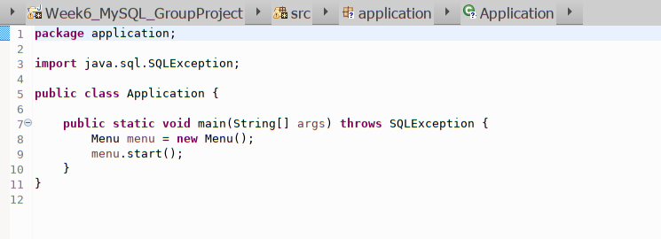

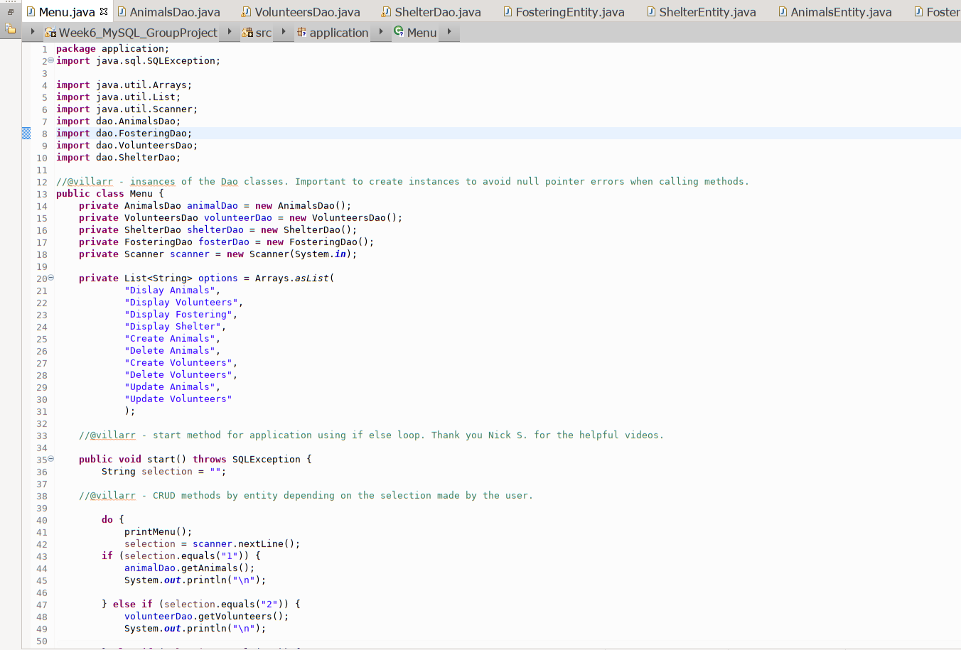

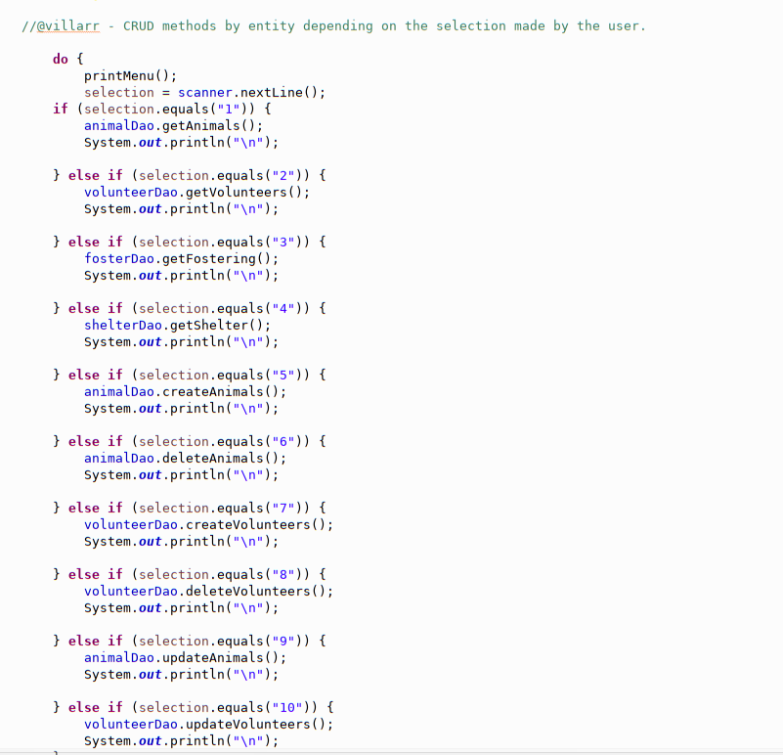

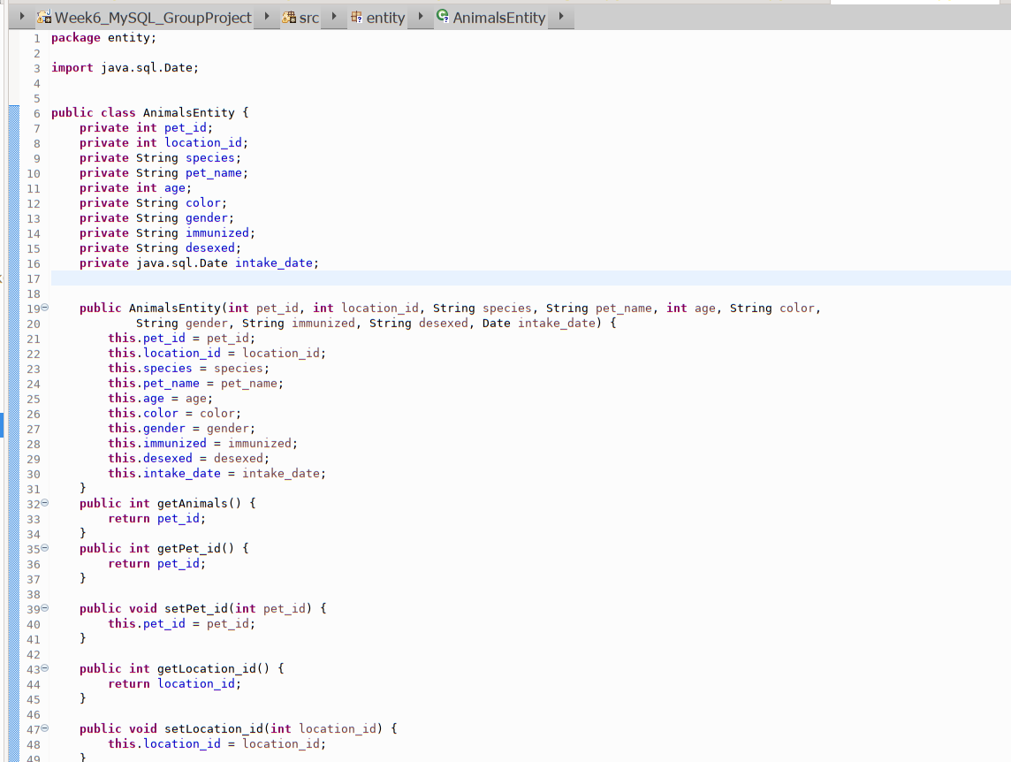

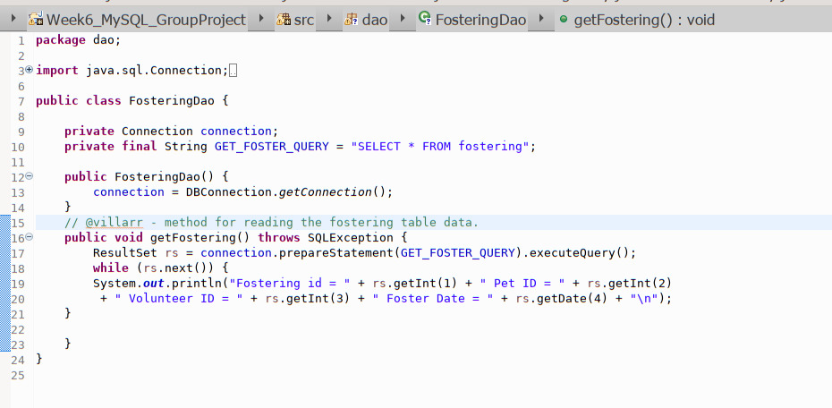

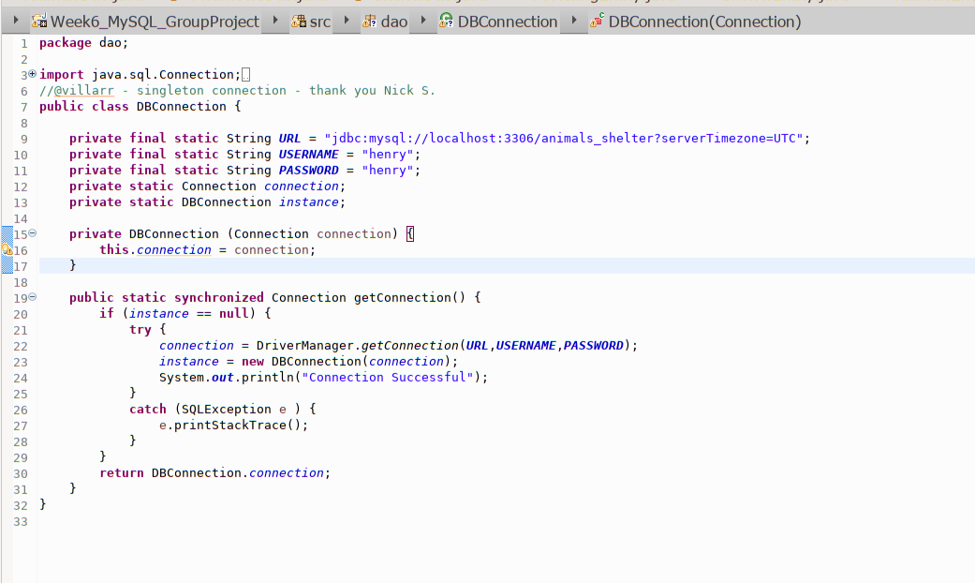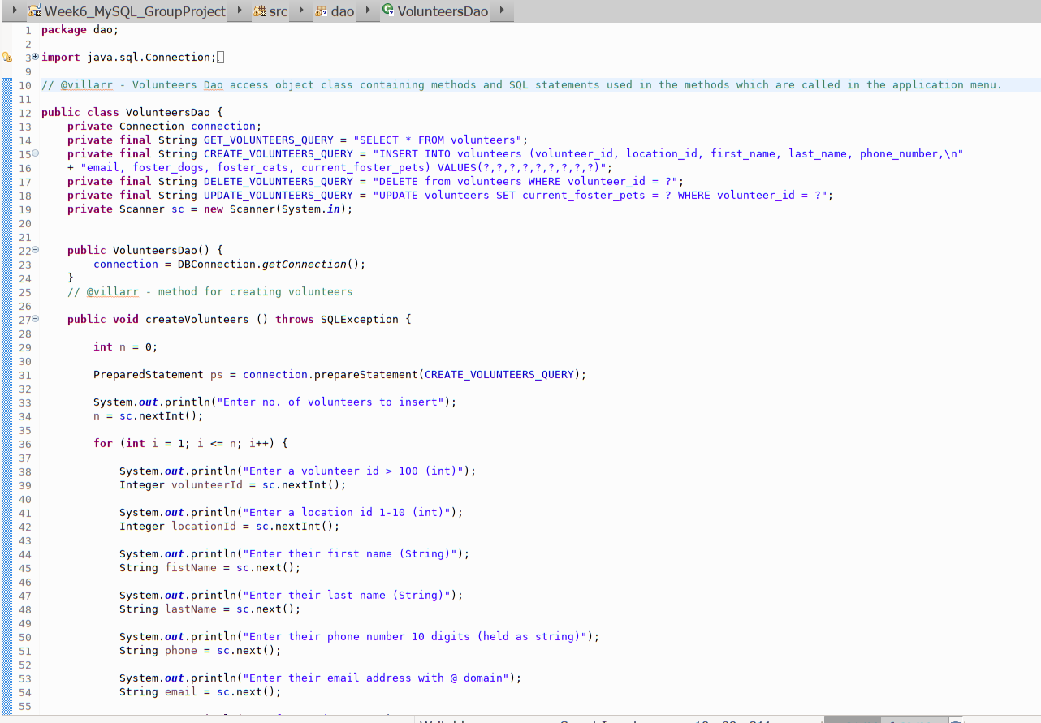

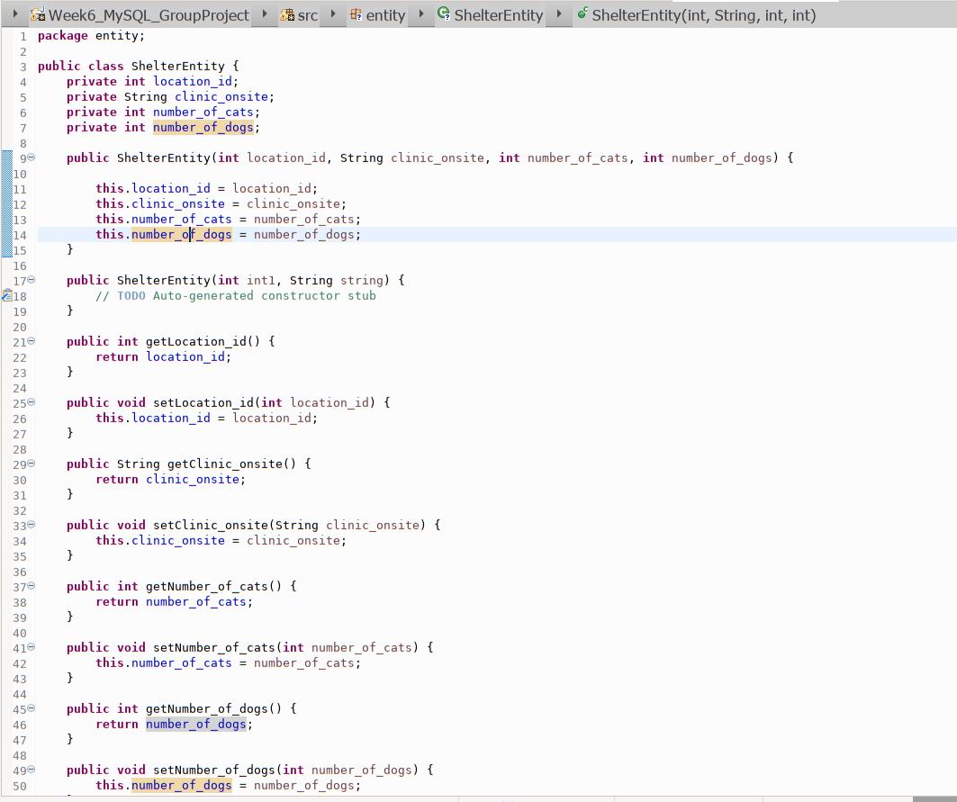

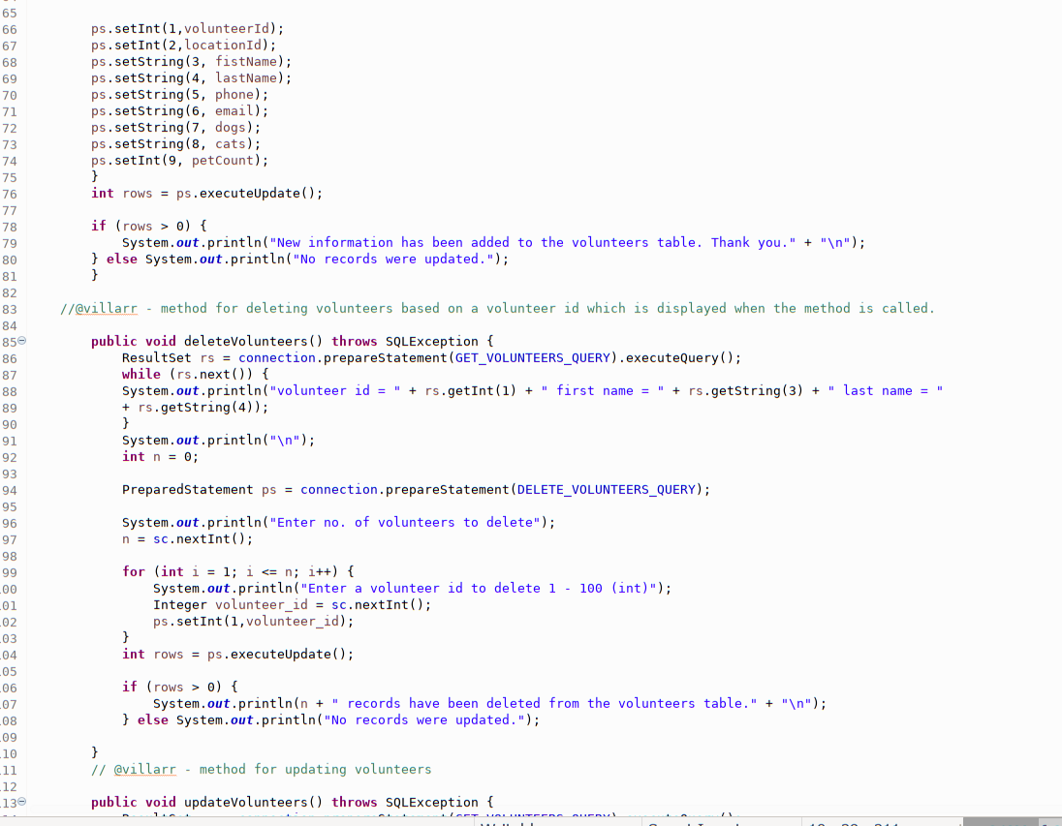

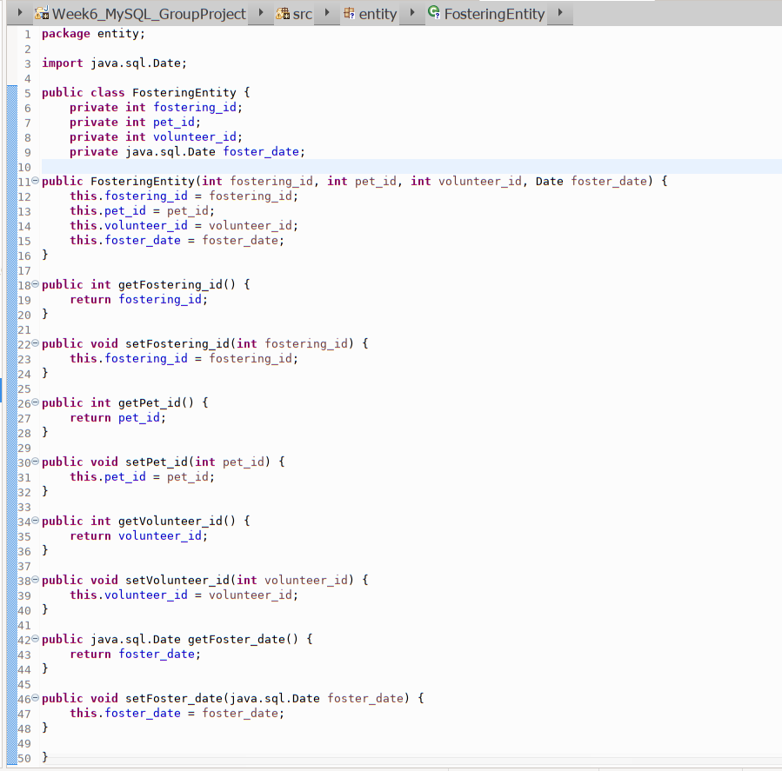

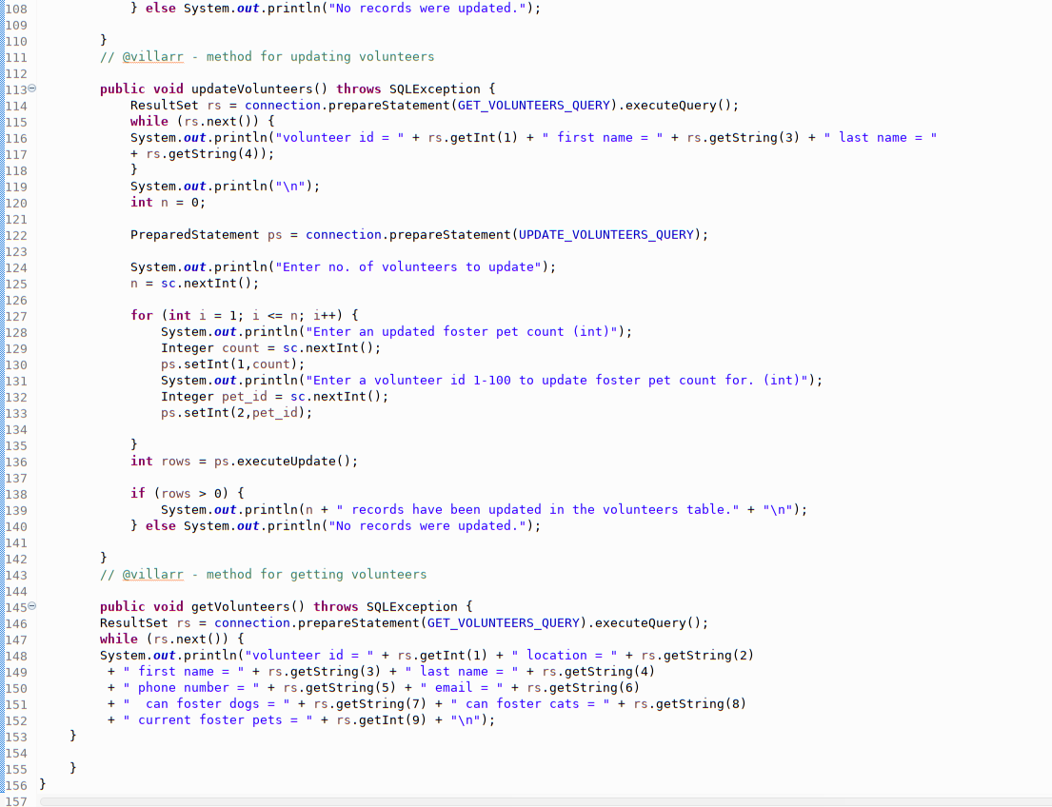

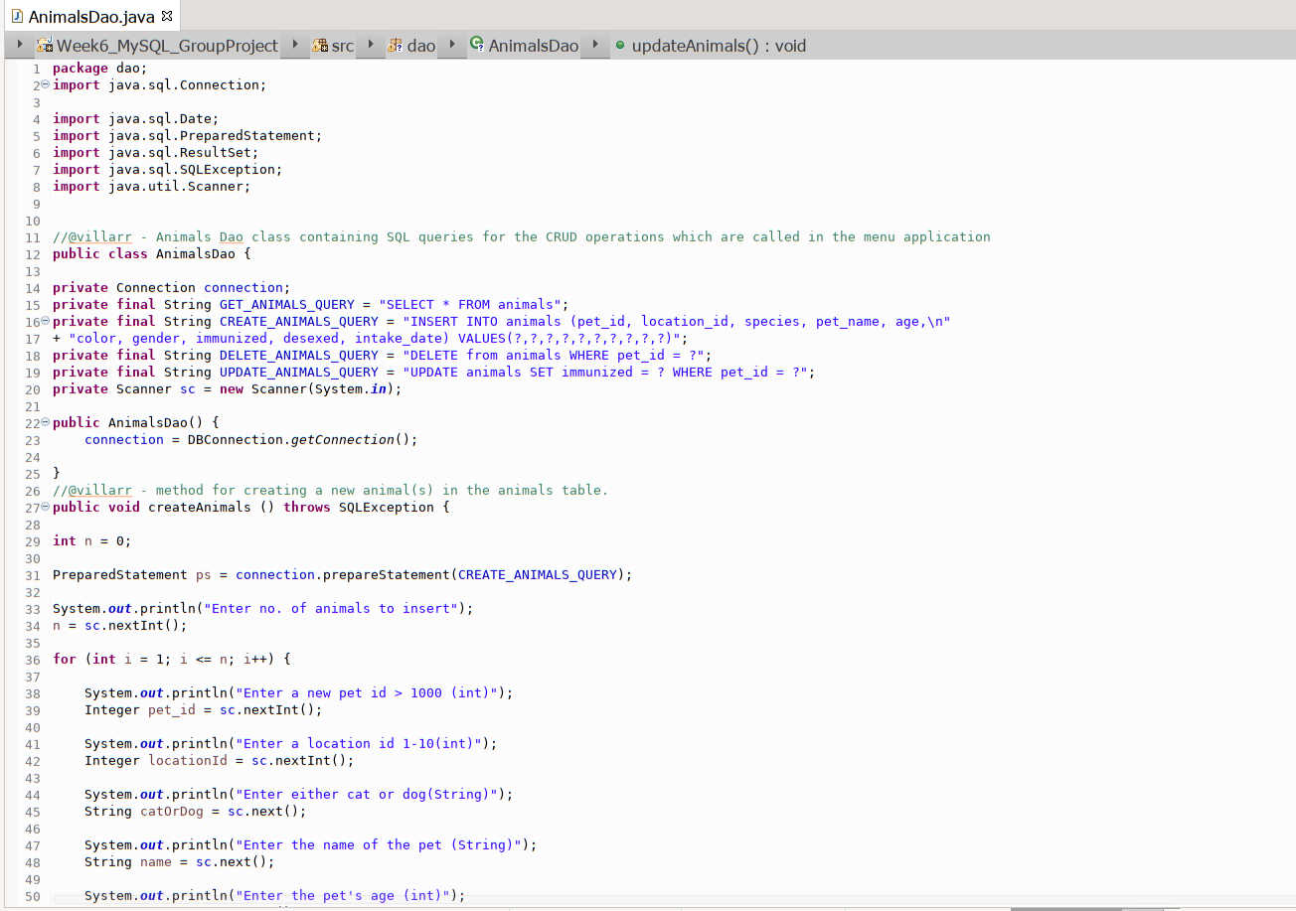

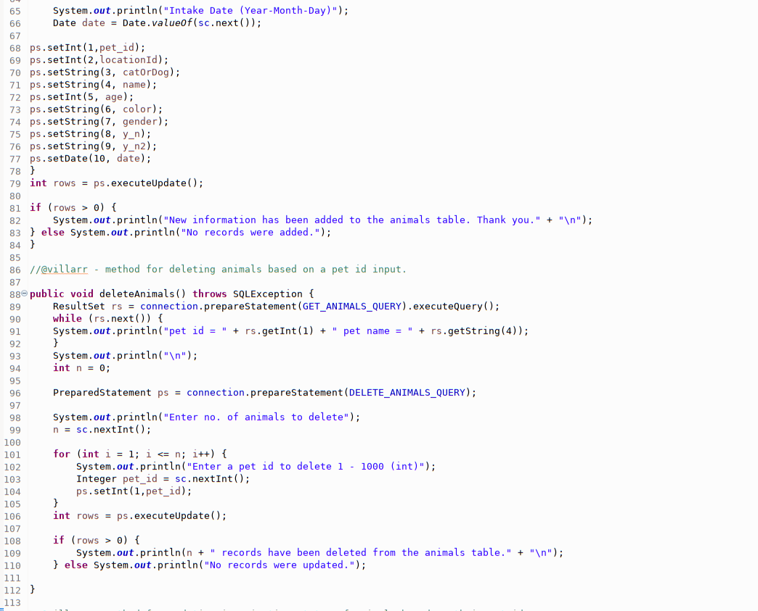

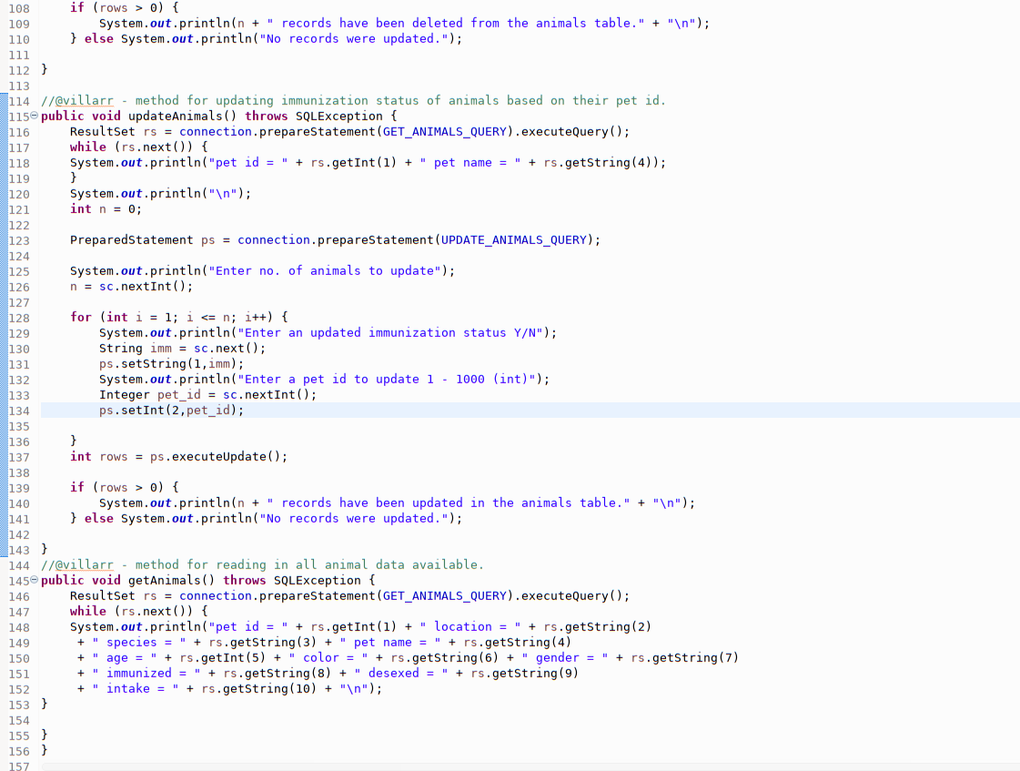

**Screenshots of Running Application:**

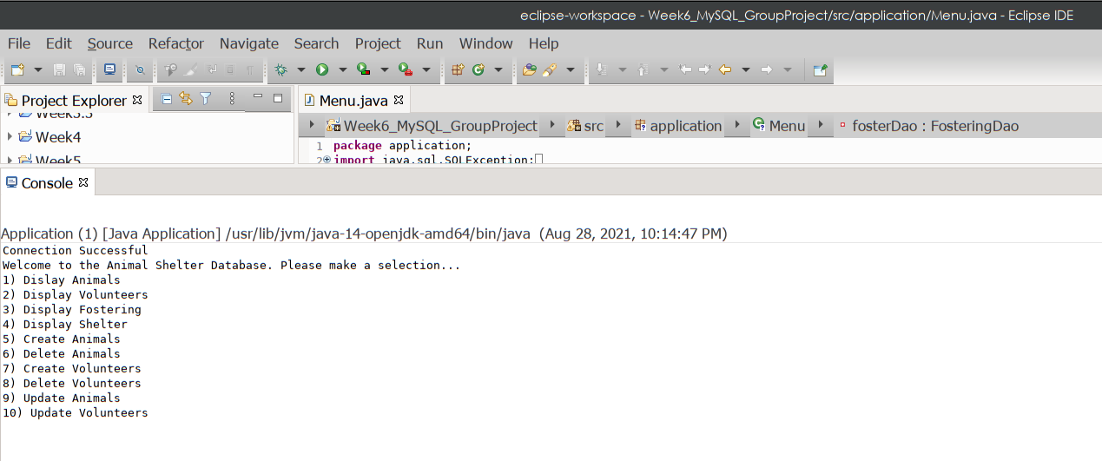

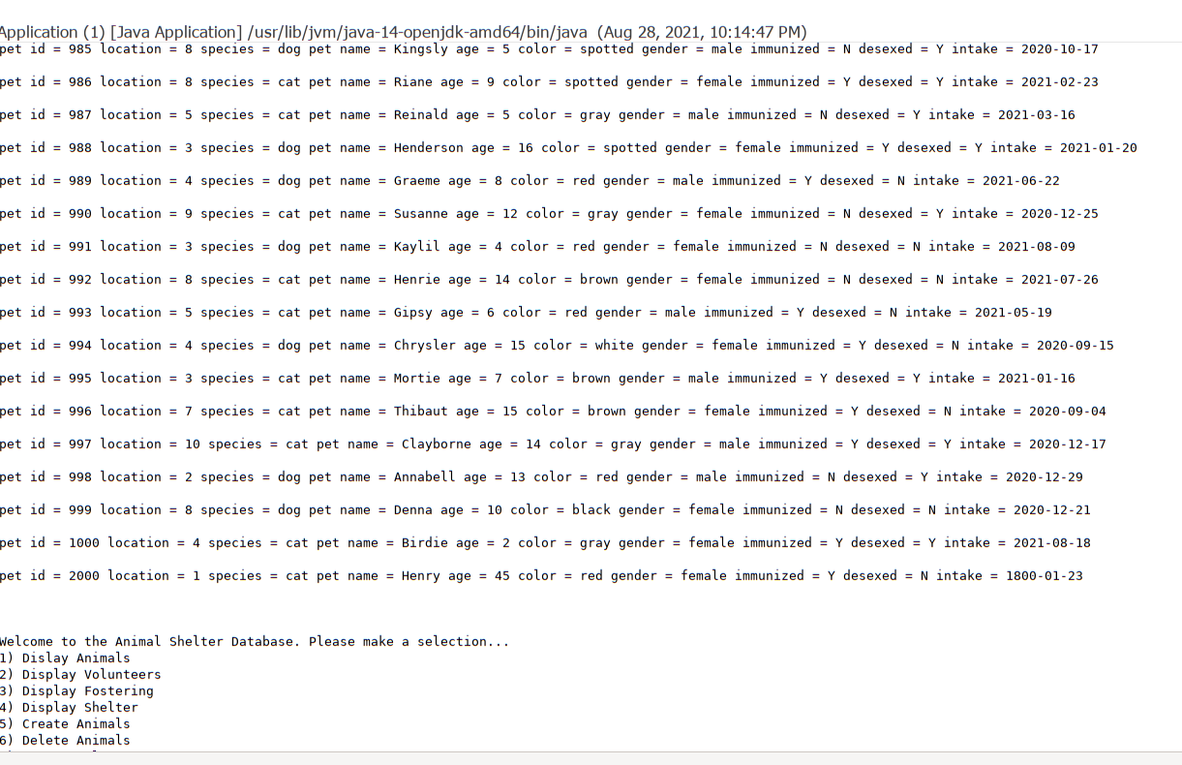

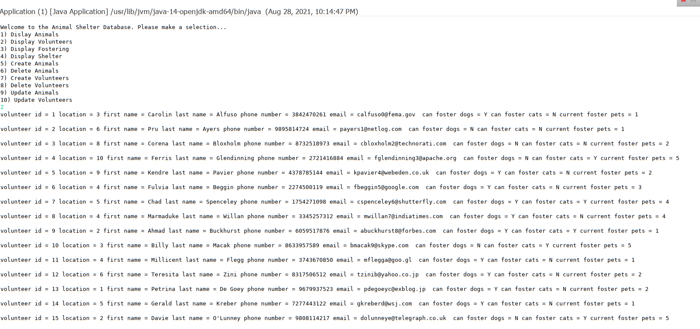

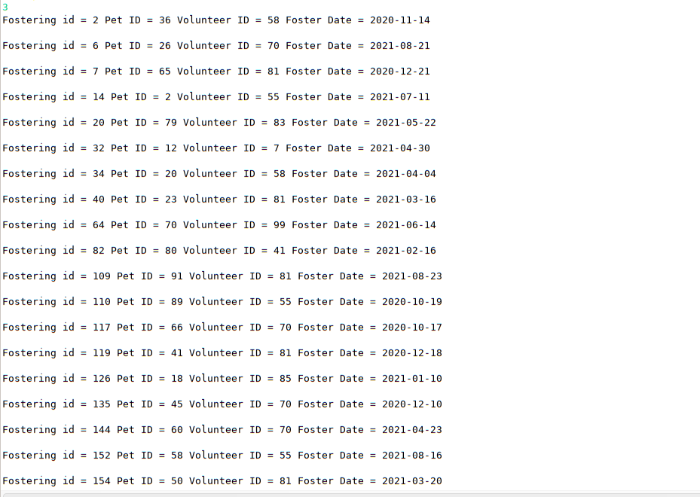

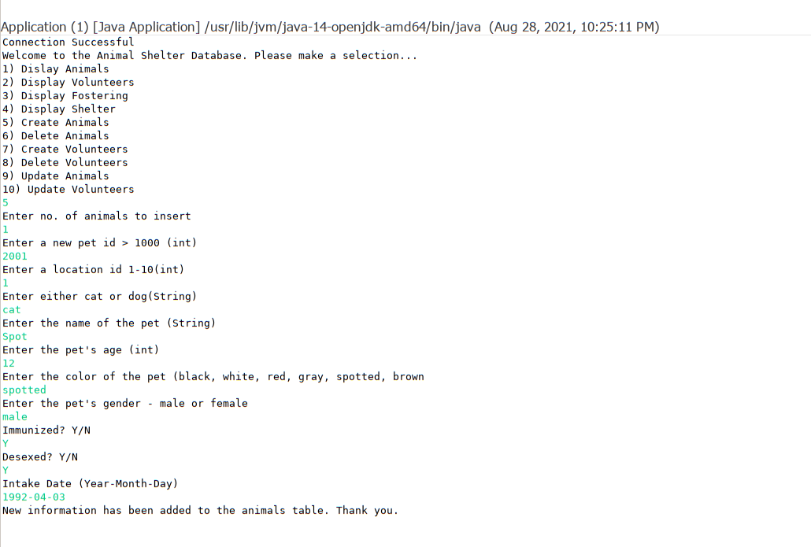

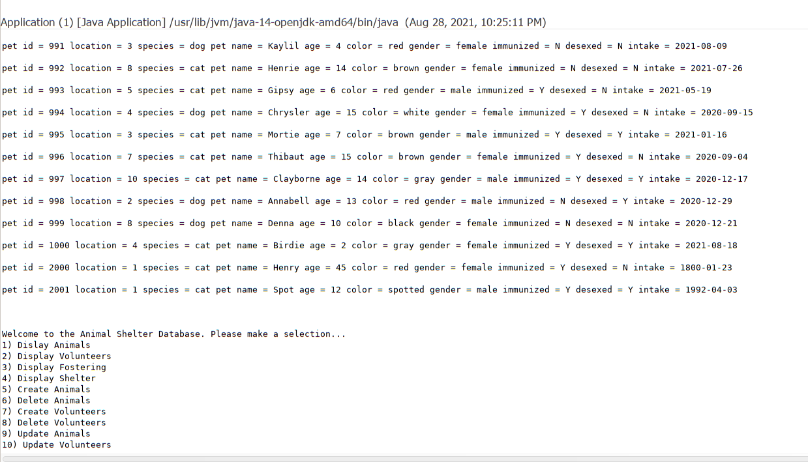

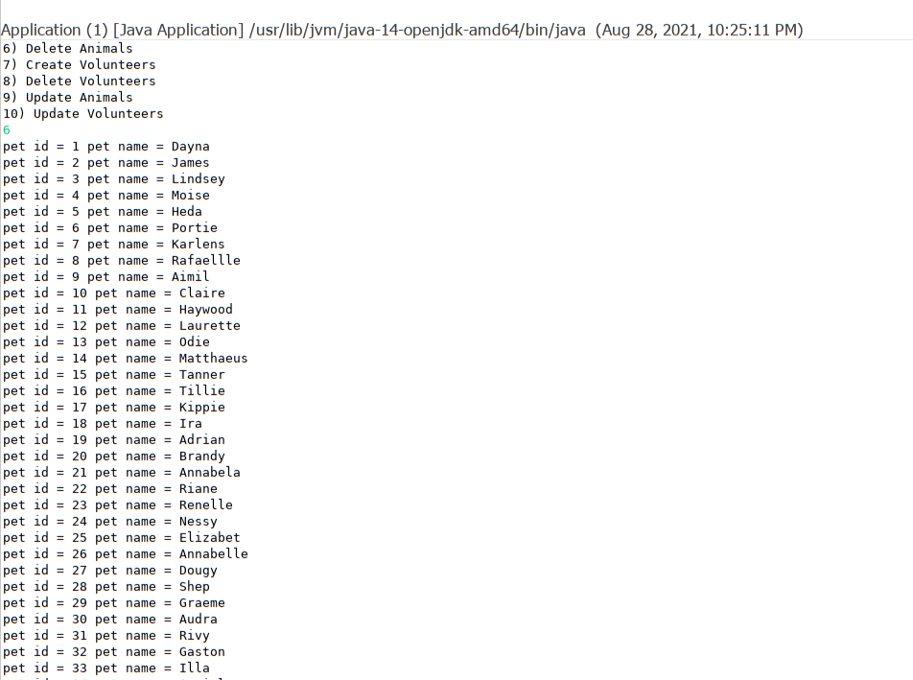

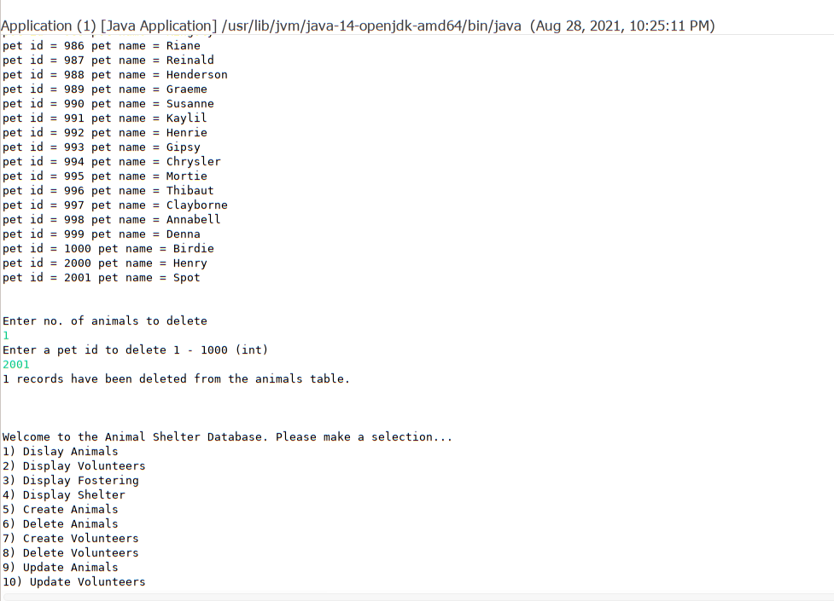

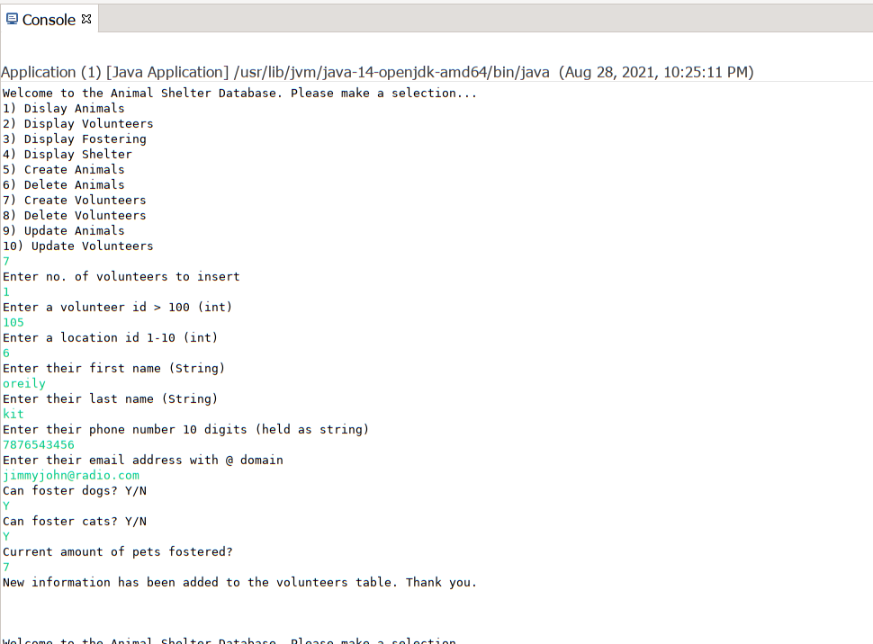

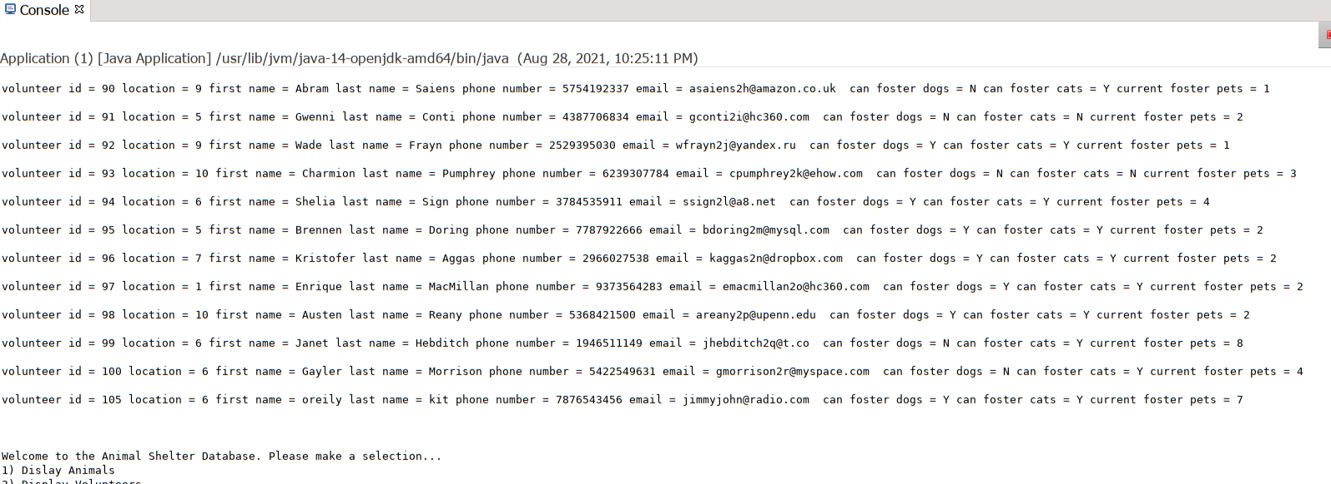

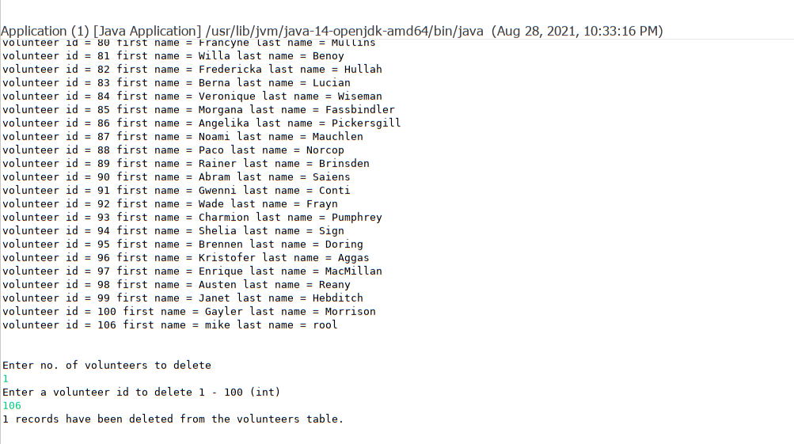

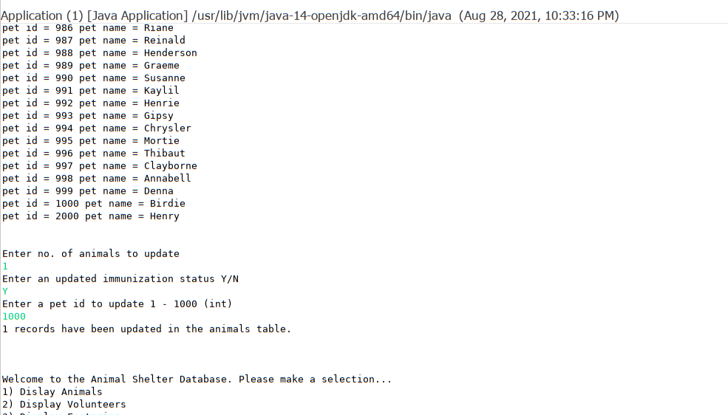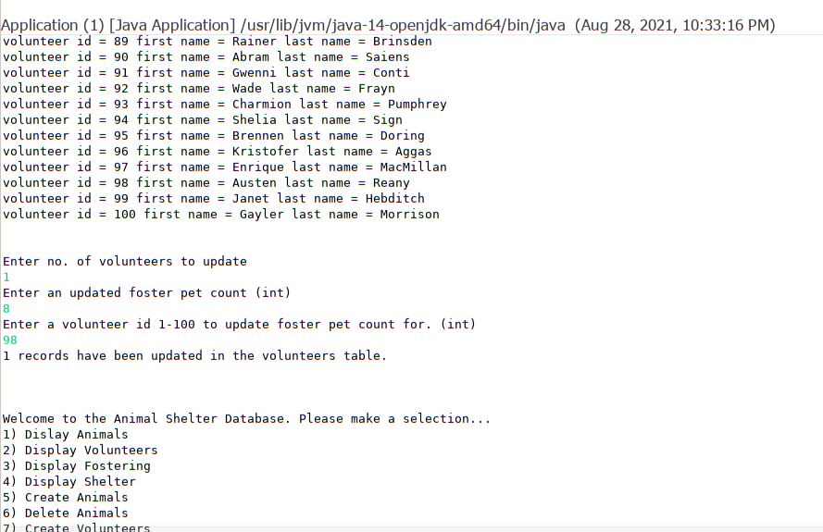

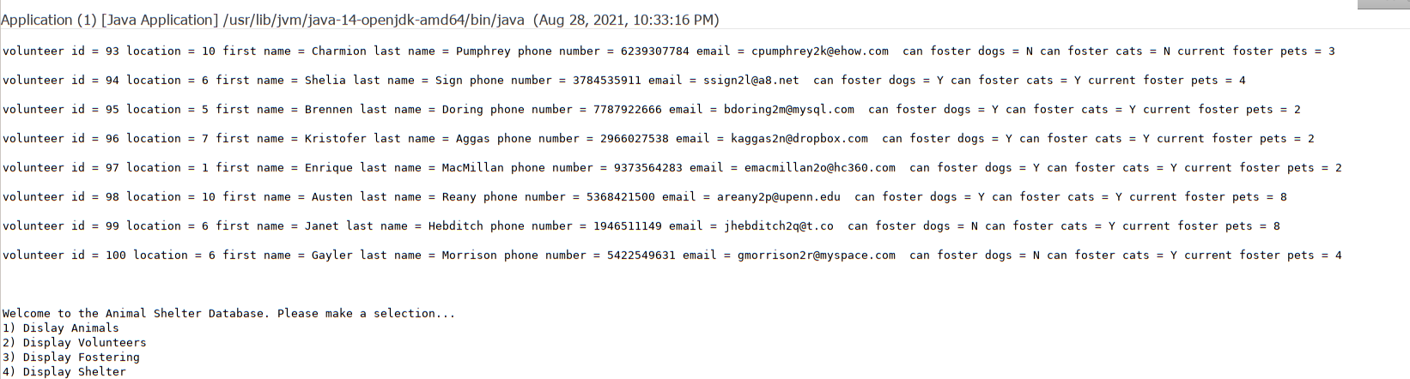

**URL to GitHub Repository:**

<https://github.com/villarr/MySQL-week-6> – my repository with code layers. I forked the repo from Alicia with the database files and merged some pull requests to the shared project initially.

https://github.com/allobrandt/MySQL-week-6