Martin Villasenor

CC1350 TI-RTOS/RF LAB1

**11/13/2018**

**------------------------------------------------------------------------------------**

Modifications highlighted in Yellow

**Task 01:**

**Modified Code:**

/*

* ======== hello.c ========

*/

/* TI-RTOS Header files */

**#include** <xdc/std.h>

**#include** <ti/sysbios/BIOS.h>

**#include** <ti/sysbios/knl/Task.h>

**#include** <ti/drivers/GPIO.h>

**#include** <ti/sysbios/knl/Clock.h>

/* Example/Board Header files */

**#include** "Board.h"

**void** **myDelay**(**int** count);

/* Could be anything, like computing primes */

**#define** FakeBlockingSlowWork() myDelay(12000000)

**#define** FakeBlockingFastWork() myDelay(2000000)

Task_Struct workTask;

Task_Struct urgentWorkTask;

/* Make sure we have nice 8-byte alignment on the stack to avoid wasting memory */

**#pragma** DATA_ALIGN(workTaskStack, 8)

**#define** STACKSIZE 1024

**static** uint8_t workTaskStack[STACKSIZE];

**static** uint8_t urgentWorkTaskStack[STACKSIZE];

**void** **doUrgentWork**(**void**)

{

**GPIO_write**(Board_GPIO_LED1, Board_GPIO_LED_OFF);

FakeBlockingFastWork(); /* Pretend to do something useful but time-consuming */

**GPIO_write**(Board_GPIO_LED1, Board_GPIO_LED_ON);

}

**void** **doWork**(**void**)

{

**GPIO_write**(Board_GPIO_LED0, Board_GPIO_LED_OFF);

FakeBlockingSlowWork(); /* Pretend to do something useful but time-consuming */

**GPIO_write**(Board_GPIO_LED0, Board_GPIO_LED_ON);

}

Void **workTaskFunc**(UArg arg0, UArg arg1)

{

**while** (1) {

/* Do work */

doWork();

/* Wait a while, because doWork should be a periodic thing, not continuous.*/

//myDelay(24000000);

Task_sleep(500 * (1000 / Clock_tickPeriod));

}

}

Void **urgentWorkTaskFunc**(UArg arg0, UArg arg1)

{

**while** (1) {

/* Do work */

doUrgentWork();

/* Wait a while, because doWork should be a periodic thing, not continuous.*/

//myDelay(24000000);

Task_sleep(50 * (1000 / Clock_tickPeriod));

}

}

/*

* ======== main ========

*

*/

**int** **main**(**void**)

{

Board_initGeneral();

**GPIO_init**();

/* Set up the led task */

Task_Params workTaskParams;

Task_Params_init(&workTaskParams);

workTaskParams.stackSize = STACKSIZE;

workTaskParams.priority = 2;

workTaskParams.stack = &workTaskStack;

Task_construct(&workTask, workTaskFunc, &workTaskParams, NULL);

Task_Params urgentWorkTaskParams;

Task_Params_init(&urgentWorkTaskParams);

urgentWorkTaskParams.stackSize = STACKSIZE;

urgentWorkTaskParams.priority = 3;

urgentWorkTaskParams.stack = &urgentWorkTaskStack;

Task_construct(&urgentWorkTask, urgentWorkTaskFunc, &urgentWorkTaskParams, NULL);

/* Start kernel. */

BIOS_start();

**return** (0);

}

/*

* ======== myDelay ========

* Assembly function to delay. Decrements the count until it is zero

* The exact duration depends on the processor speed.

*/

**__asm**(" .sect \".text:myDelay\"\n"

" .clink\n"

" .thumbfunc myDelay\n"

" .thumb\n"

" .global myDelay\n"

"myDelay:\n"

" subs r0, #1\n"

" bne.n myDelay\n"

" bx lr\n");

**Runtime Object View**

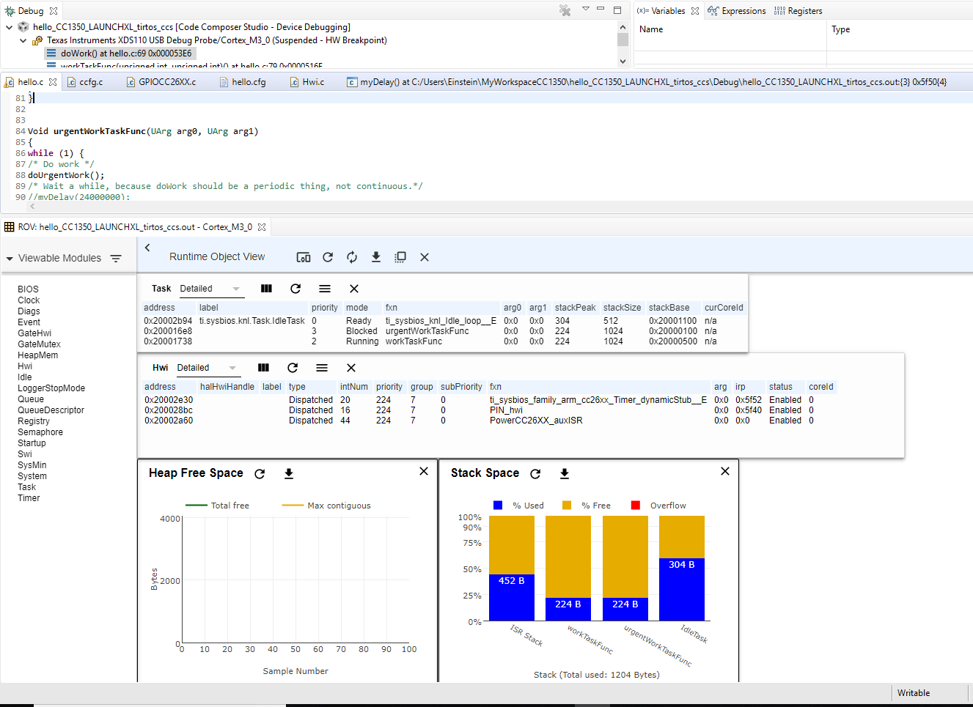

**TASKS**

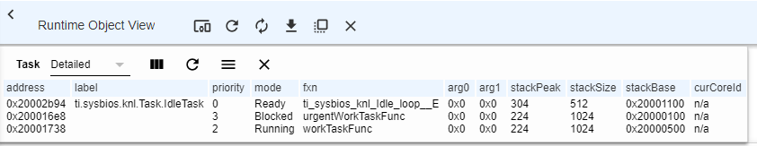

Enabling logging.

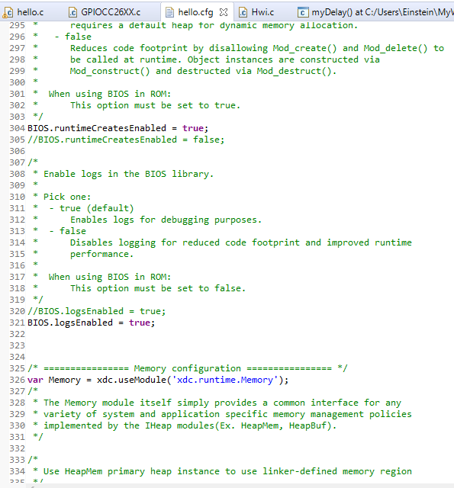

Removing use of Bios in ROM. Will be running in Flash instead to enable kernel log events.

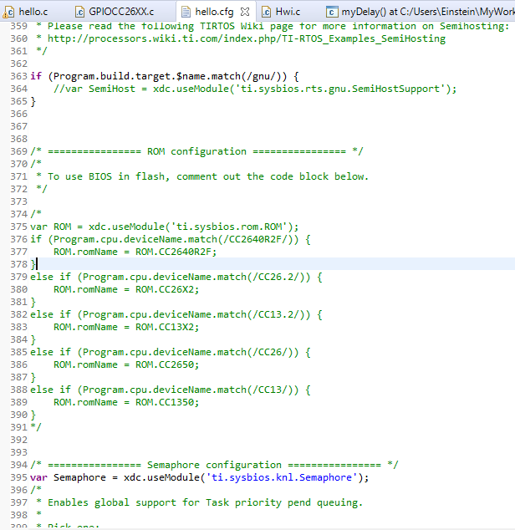

Configuring kernel to keep buffers on target.

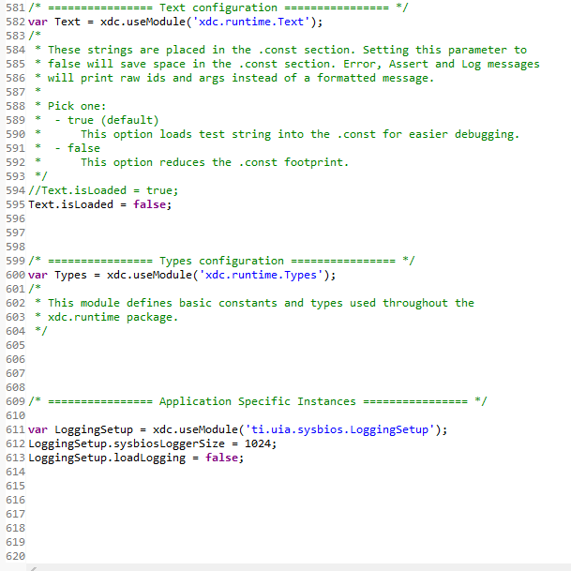

Execution Analysis configuration for Execution graph

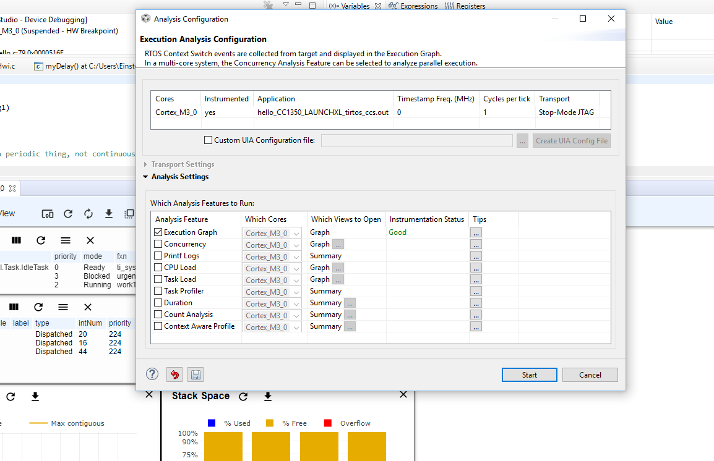

Execution Graph

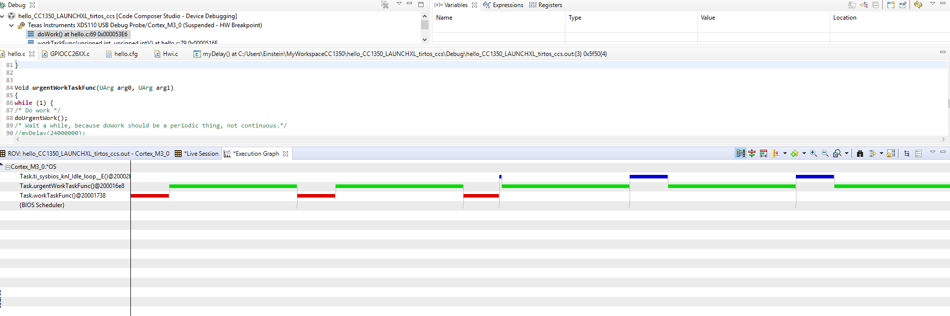

Tasks executing

