Martin Villasenor

CC1350 TI-RTOS/RF LAB2

**11/16/2018**

**------------------------------------------------------------------------------------**

Youtube Link: <https://youtu.be/2mnE_Pd4j98>

**Modified Code:**

/*

* ======== empty.c ========

*/

/* For usleep() */

**#include** <unistd.h>

**#include** <stdint.h>

**#include** <stddef.h>

/* Driver Header files */

**#include** <ti/drivers/GPIO.h>

**#include** <ti/drivers/ADC.h>

**#include** <ti/display/Display.h>

// #include <ti/drivers/I2C.h>

// #include <ti/drivers/SDSPI.h>

// #include <ti/drivers/SPI.h>

// #include <ti/drivers/UART.h>

// #include <ti/drivers/Watchdog.h>

/* Board Header file */

**#include** "Board.h"

// Global variables for GUI COMPOSER

uint16_t adcValue = 0;

uint16_t threshold = 100;

uint16_t trigger = 0;

/*

* ======== gpioButtonFxn0 ========

* Callback function for the GPIO interrupt on Board_GPIO_BUTTON0.

*/

**void** **gpioButtonFxn0**(uint_least8_t index)

{

/* Clear the GPIO interrupt and decrement threshold */

**if**(threshold < 250){ // Ensure threshold doesn't go below zero

threshold = 0;

} **else** {

threshold -= 250; // decrement by 250

}

}

/*

* ======== gpioButtonFxn1 ========

* Callback function for the GPIO interrupt on Board_GPIO_BUTTON1.

* This may not be used for all boards.

*/

**void** **gpioButtonFxn1**(uint_least8_t index)

{

/* Clear the GPIO interrupt and increment threshold */

**if**(threshold > 16133){ // Ensure threshold doesn't go above max ADC range

threshold = 16383;

} **else** {

threshold += 250; // increment by 250

}

}

/*

* ======== mainThread ========

*/

**void** \***mainThread**(**void** *arg0)

{

/* 1 second delay

uint32_t time = 1;

*/

// ~10 loops/second

uint32_t time = 100000;

/* Call driver init functions */

**GPIO_init**();

**ADC_init**();

// I2C_init();

// SDSPI_init();

// SPI_init();

// UART_init();

// Watchdog_init();

//Open Display Driver

Display_Handle displayHandle;

Display_Params displayParams;

Display_Params_init(&displayParams);

displayHandle = Display_open(Display_Type_UART, NULL);

// Open ADC Driver

ADC_Handle adc;

ADC_Params params;

**ADC_Params_init**(&params);

adc = **ADC_open**(Board_ADC0, &params);

**if**(adc == NULL){

// Error initializing ADC Channel 0

**while** (1);

}

/* install Button callback */

**GPIO_setCallback**(Board_GPIO_BUTTON0, gpioButtonFxn0);

**GPIO_setCallback**(Board_GPIO_BUTTON1, gpioButtonFxn1);

/* Enable interrupts */

**GPIO_enableInt**(Board_GPIO_BUTTON0);

**GPIO_enableInt**(Board_GPIO_BUTTON1);

**while**(1){

int_fast16_t res;

res = **ADC_convert**(adc, &adcValue);

**if** (res == ADC_STATUS_SUCCESS) {

Display_printf(displayHandle, 1,0, "ADC Reading %d", adcValue);

**if** (adcValue >= threshold){

**GPIO_write**(Board_GPIO_LED0, Board_GPIO_LED_ON);

trigger = 1;

} **else**{

**GPIO_write**(Board_GPIO_LED0, Board_GPIO_LED_OFF);

trigger = 0;

}

}

**usleep**(time);

}

}

**Code was modified to add global variables for the adc value, threshold and LED reading.**

**After creating project, via XDS110 interface flashed the empty_CC1350_LAUNCHXL_tirtos_ccs.out CC1350 board. Once connected**

**An application was created on http://dev.ti.com/gc**

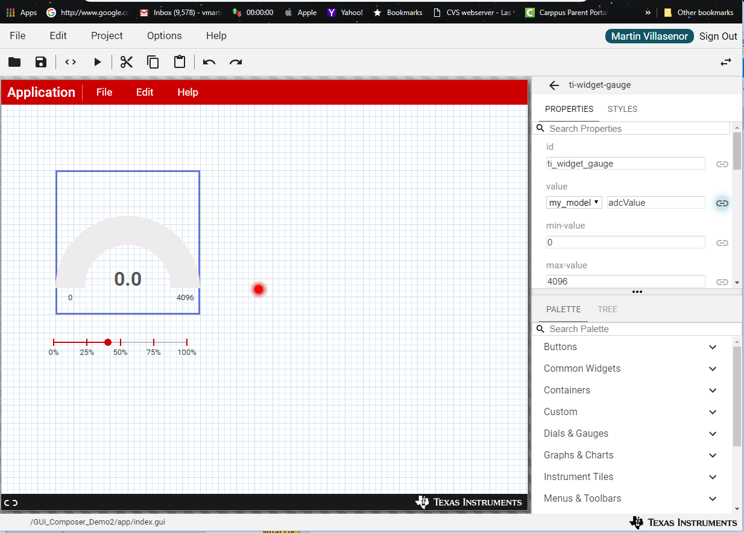

Gauge properties

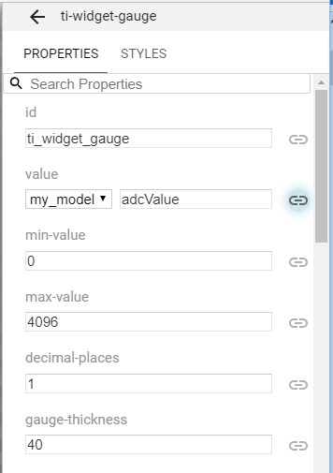

**Slider properties**

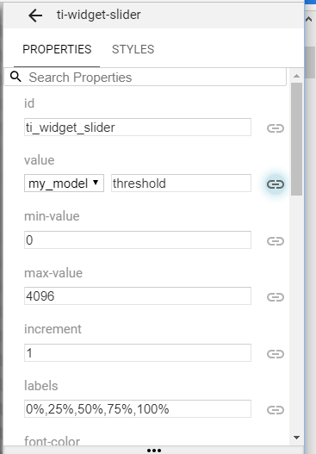

**LED properties**

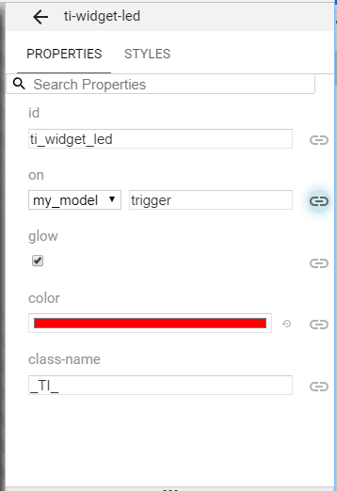

**Application running on separate page. Showing gauge, slider and LED indicators.**

