Martin Villasenor

CC1350 TI-RTOS/RF LAB3

**11/17/2018**

**------------------------------------------------------------------------------------**

Youtube Link: Task1- https://youtu.be/RbxMfvd1hjI

**Modified Code:**

**TASK0:**

When connecting both device and running SmartRF Studio, both devices recognized and named L40007FZ(Transmitter*) and L40007NG(Receiver*). Recognized which IDs belong to my boards and labeled them respectively. *The labels were selected by me to distinguish boards.

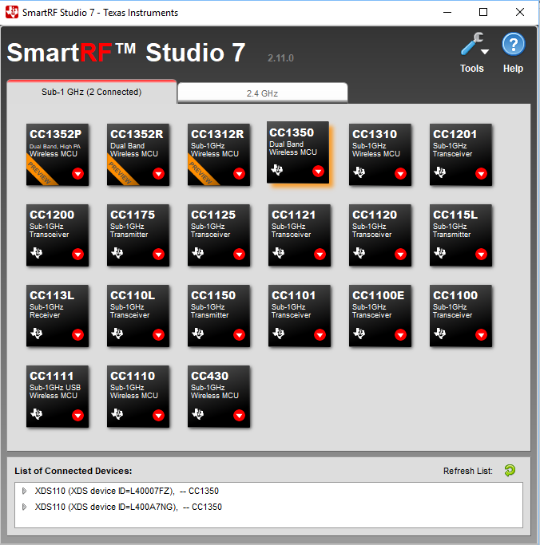

**TASK1:**

Opened two instances of Device Control Panel, one for each board. Left TX board running default frequency of 868 MHz since no other group were around to conflict with my wireless communication. Started running RX followed by TX. Observed packets being sent and received on window. These are shown as

TX Device Control Panel

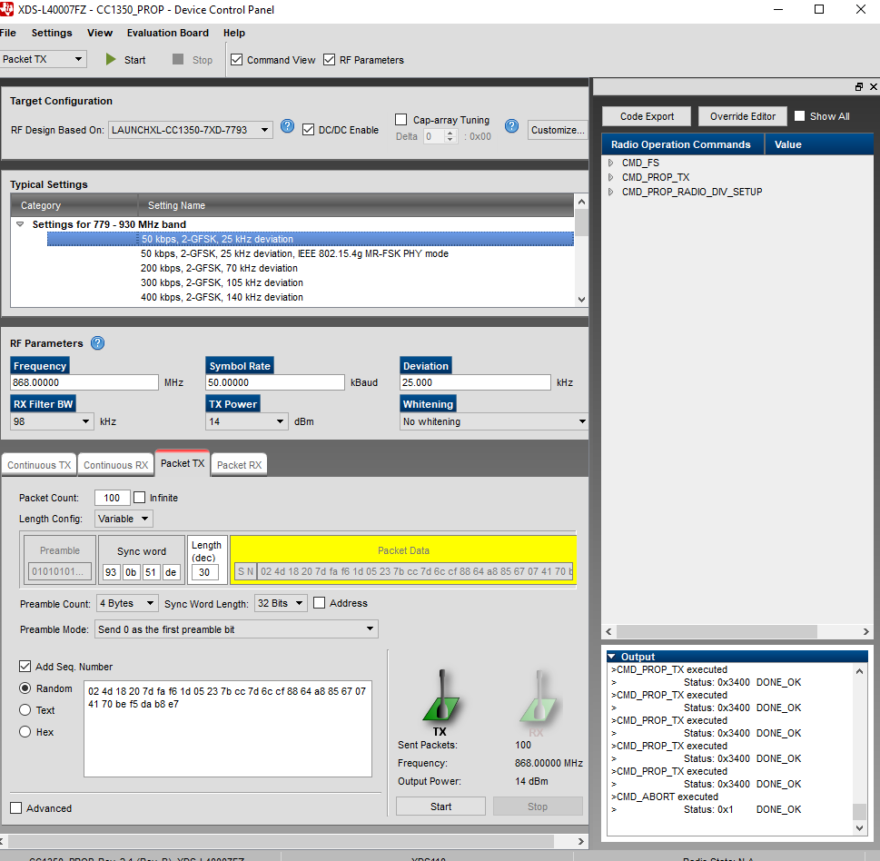

RX Device Control Panel

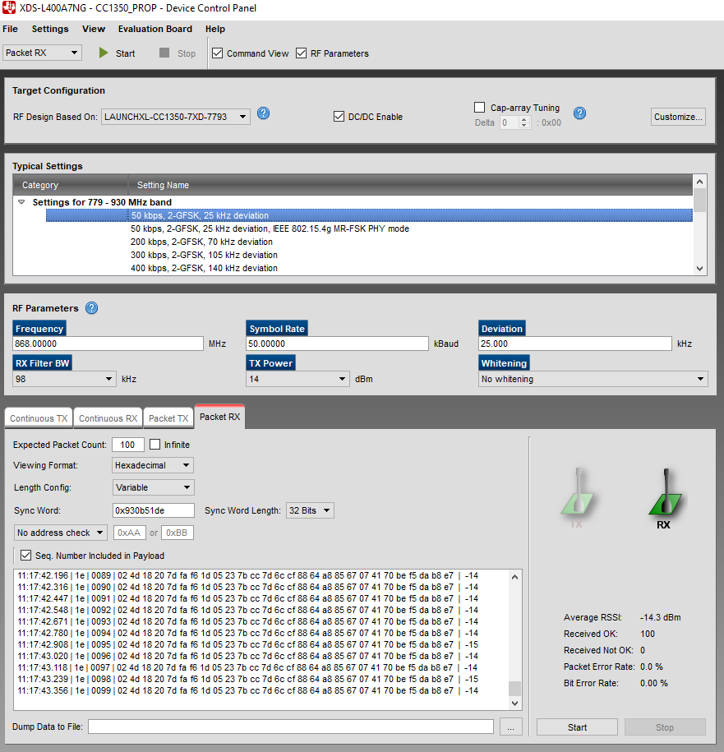

**TASK2:**

Imported the rfPacketTx_CC1350_LAUNCHXL_tirtos_ccs project.

From Project Explorer

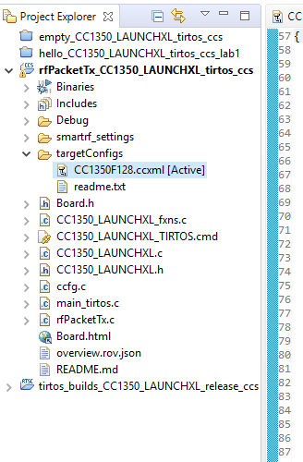

Fixed build problems and built. Since two target board will be using build environment, modified CC1350F128.ccxml file in targetConfigs folder to add serial number of board.

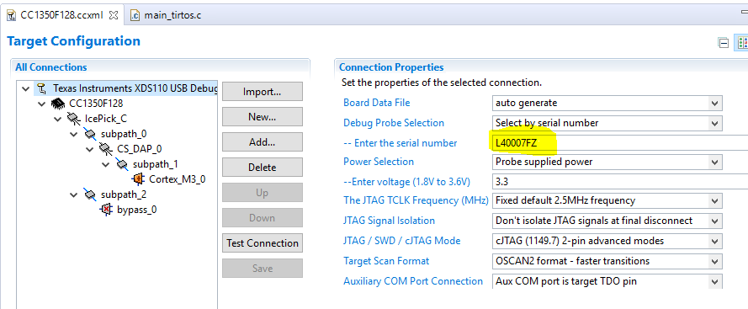

Built and debugged project to flash new image. Running with LED flashing.

**TASK3:**

Exporting RF setting form SmartRF Studio

Changing settings in RF parameters

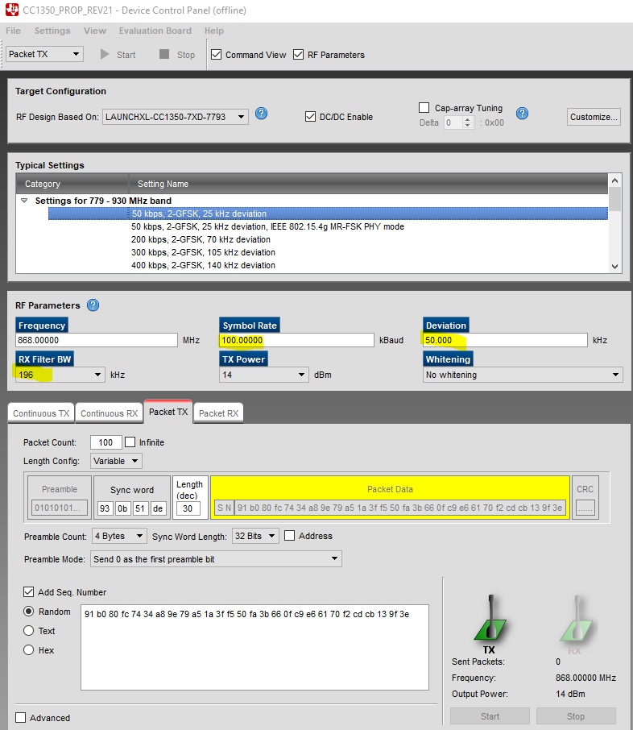

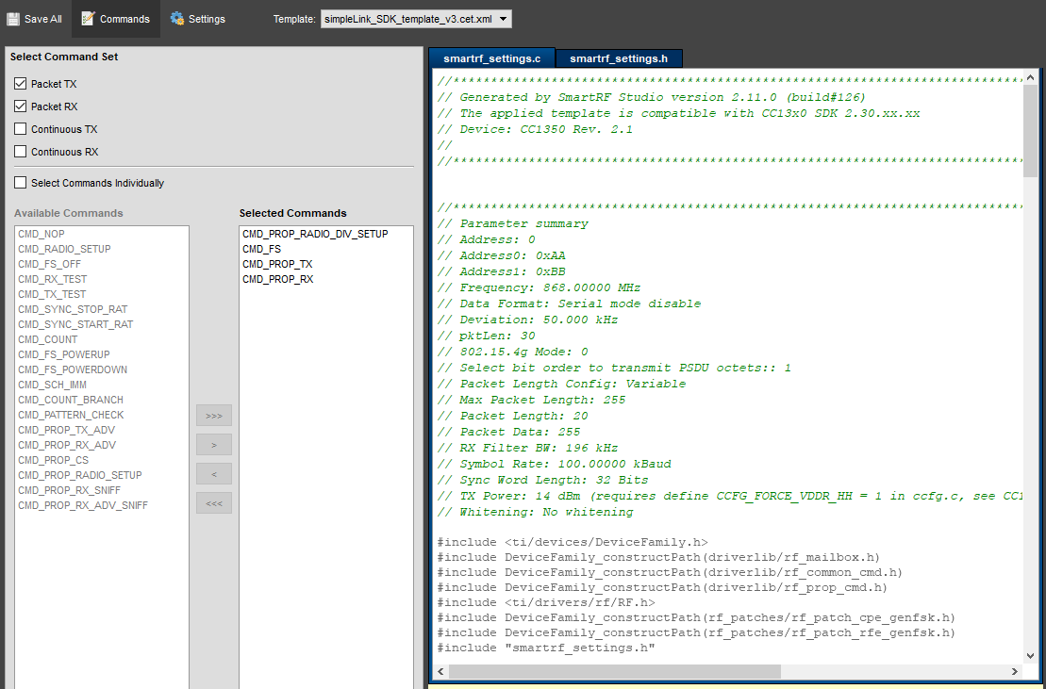

Saving smartf_settings.c and Saving smartf_settings.h in project. Running and debugging. LED blinking.

**TASK4:**

Entering parameters for RX board and changing Packet RX settings. When starting Device control panel the board starts receiving packets from Transmitter board.

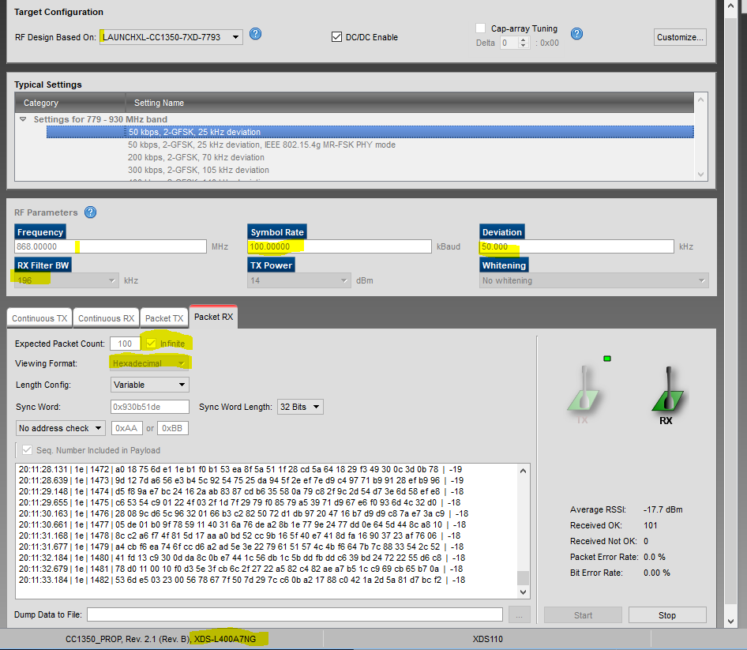

**TASK5:**

Importing rfPacketRx_CC1350_LAUNCHXL_tirtos_ccs. Built successfully.

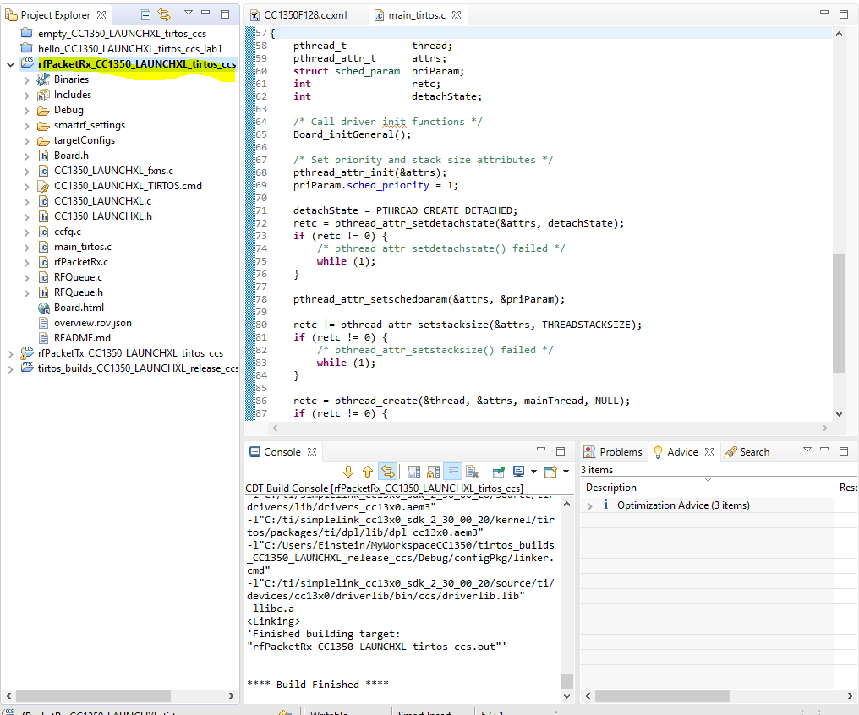

**TASK6:**

Youtube Link: Task1- **https://youtu.be/yNLhMpx9AfY**

Using firmware from both CC1350 Lauchpads communicating to each other. Youtube link shows how these are working.