Martin Villasenor

CC1350 TI-RTOS/RF LAB4

**11/21/2018**

**------------------------------------------------------------------------------------**

Youtube Task3 Link: <https://youtu.be/XvPzqgXX-No>

Task5 Link: https://youtu.be/jpSgUnMZgLA

**Modified Code:**

**Modifications are highlighted**

**#include** "ex_include_tirtos.h"

**#include** "scif.h"

**#include** <ti/devices/DeviceFamily.h>

**#include** DeviceFamily_constructPath(driverlib/aux_adc.h)

**#define** BV(n) (1 << (n))

// Display error message if the SCIF driver has been generated with incorrect operating system setting

**#if** !(defined(SCIF_OSAL_TIRTOS_H) || defined(SCIF_OSAL_TIDPL_H))

**#error** "SCIF driver has incorrect operating system configuration for this example. Please change to 'TI-RTOS' or 'TI Driver Porting Layer' in the Sensor Controller Studio project panel and re-generate the driver."

**#endif**

// Display error message if the SCIF driver has been generated with incorrect target chip package

**#ifndef** SCIF_TARGET_CHIP_PACKAGE_QFN48_7X7_RGZ

**#error** "SCIF driver has incorrect target chip package configuration for this example. Please change to 'QFN48 7x7 RGZ' in the Sensor Controller Studio project panel and re-generate the driver."

**#endif**

// Task data

Task_Struct myTask;

Char myTaskStack[1024];

// Semaphore used to wait for Sensor Controller task ALERT event

**static** Semaphore_Struct semScTaskAlert;

**void** **scCtrlReadyCallback**(**void**) {

} // scCtrlReadyCallback

**void** **scTaskAlertCallback**(**void**) {

// Wake up the OS task

Semaphore_post(Semaphore_handle(&semScTaskAlert));

} // scTaskAlertCallback

PIN_Config pLedPinTable[] = {

Board_GLED | PIN_GPIO_OUTPUT_EN | PIN_GPIO_LOW | PIN_PUSHPULL | PIN_DRVSTR_MAX,

Board_RLED | PIN_GPIO_OUTPUT_EN | PIN_GPIO_LOW | PIN_PUSHPULL | PIN_DRVSTR_MAX,

PIN_TERMINATE

};

PIN_State ledPinState;

**void** **taskFxn**(UArg a0, UArg a1) {

int32_t adcOffset = AUXADCGetAdjustmentOffset(AUXADC_REF_FIXED);

int32_t adcGainError = AUXADCGetAdjustmentGain(AUXADC_REF_FIXED);

int32_t adcValue, adcCorrectedValue, adcValueMicroVolt;

/* Set threshold based on microVolt */

int32_t adcThresholdLowMicro = 400000; // 0.4 Volt

int32_t adcThresholdHighMicro = 800000; // 0.8 Volt

int32_t adcThresholdLow = AUXADCMicrovoltsToValue(AUXADC_FIXED_REF_VOLTAGE_NORMAL, adcThresholdLowMicro);

int32_t adcThresholdHigh = AUXADCMicrovoltsToValue(AUXADC_FIXED_REF_VOLTAGE_NORMAL, adcThresholdHighMicro);

int32_t adcThresholdLowRaw = AUXADCUnadjustValueForGainAndOffset(adcThresholdLow, adcGainError, adcOffset);

int32_t adcThresholdHighRaw = AUXADCUnadjustValueForGainAndOffset(adcThresholdHigh, adcGainError, adcOffset);

PIN_Handle hLedPins;

// Enable LED pins

hLedPins = **PIN_open**(&ledPinState, pLedPinTable);

// Initialize the Sensor Controller

scifOsalInit();

scifOsalRegisterCtrlReadyCallback(scCtrlReadyCallback);

scifOsalRegisterTaskAlertCallback(scTaskAlertCallback);

scifInit(&scifDriverSetup);

scifStartRtcTicksNow(0x00010000 / 8);

// Configure and start the Sensor Controller's ADC window monitor task (not to be confused with OS tasks)

// scifTaskData.adcWindowMonitor.cfg.adcWindowHigh = 800;

// scifTaskData.adcWindowMonitor.cfg.adcWindowLow = 400;

// scifStartTasksNbl(BV(SCIF_ADC_WINDOW_MONITOR_TASK_ID));

// Configure and start the Sensor Controller's ADC window monitor task (not to be confused with OS tasks)

scifTaskData.adcWindowMonitor.cfg.adcWindowHigh = adcThresholdHighRaw;

scifTaskData.adcWindowMonitor.cfg.adcWindowLow = adcThresholdLowRaw;

scifStartTasksNbl(BV(SCIF_ADC_WINDOW_MONITOR_TASK_ID));

// Main loop

**while** (1) {

// Wait for an ALERT callback

Semaphore_pend(Semaphore_handle(&semScTaskAlert), BIOS_WAIT_FOREVER);

// Clear the ALERT interrupt source

scifClearAlertIntSource();

// Read ADC value

adcValue = scifTaskData.adcWindowMonitor.output.adcValue;

// Correct ADC raw value

adcCorrectedValue = AUXADCAdjustValueForGainAndOffset((int32_t) adcValue, adcGainError, adcOffset);

// Convert ADC value to Microvolts.

adcValueMicroVolt = AUXADCValueToMicrovolts(AUXADC_FIXED_REF_VOLTAGE_NORMAL,adcCorrectedValue);

// int32_t adcValue = (int32_t) scifTaskData.adcWindowMonitor.output.adcValue;

// Indicate on LEDs whether the current ADC value is high and/or low

**if** (scifTaskData.adcWindowMonitor.output.bvWindowState & SCIF_ADC_WINDOW_MONITOR_BV_ADC_WINDOW_LOW) {

**PIN_setOutputValue**(hLedPins, Board_GLED, 1);

} **else** {

**PIN_setOutputValue**(hLedPins, Board_GLED, 0);

}

**if** (scifTaskData.adcWindowMonitor.output.bvWindowState & SCIF_ADC_WINDOW_MONITOR_BV_ADC_WINDOW_HIGH) {

**PIN_setOutputValue**(hLedPins, Board_RLED, 1);

} **else** {

**PIN_setOutputValue**(hLedPins, Board_RLED, 0);

}

// Acknowledge the alert event

scifAckAlertEvents();

}

} // taskFxn

**int** **main**(**void**) {

Task_Params taskParams;

// Initialize the board

Board_initGeneral();

**#ifdef** Board_shutDownExtFlash

Board_shutDownExtFlash();

**#endif**

// Configure the OS task

Task_Params_init(&taskParams);

taskParams.stack = myTaskStack;

taskParams.stackSize = **sizeof**(myTaskStack);

taskParams.priority = 3;

Task_construct(&myTask, taskFxn, &taskParams, NULL);

// Create the semaphore used to wait for Sensor Controller ALERT events

Semaphore_Params semParams;

Semaphore_Params_init(&semParams);

semParams.mode = Semaphore_Mode_BINARY;

Semaphore_construct(&semScTaskAlert, 0, &semParams);

// Start TI-RTOS

BIOS_start();

**return** 0;

} // main

**TASK1:**

Configuration for Sensor Controller

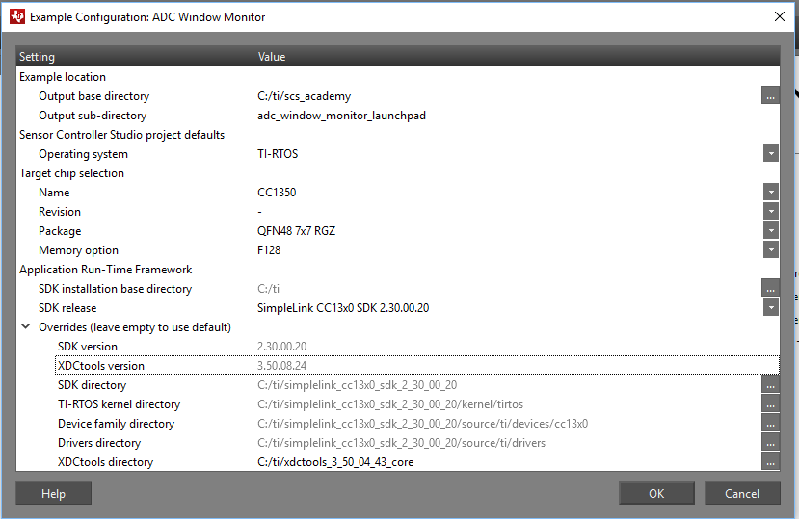

Generating source code. Output shown on Event screen.

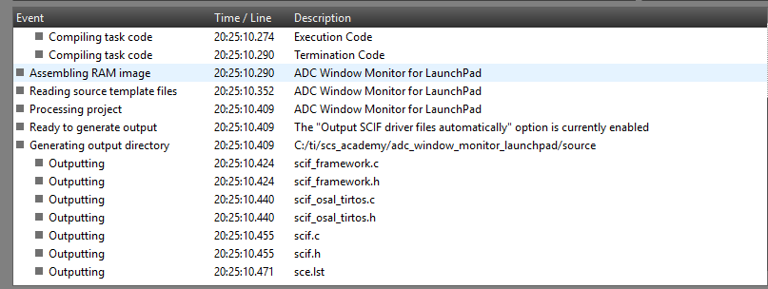

Imported scs project to ccs. Built correctly

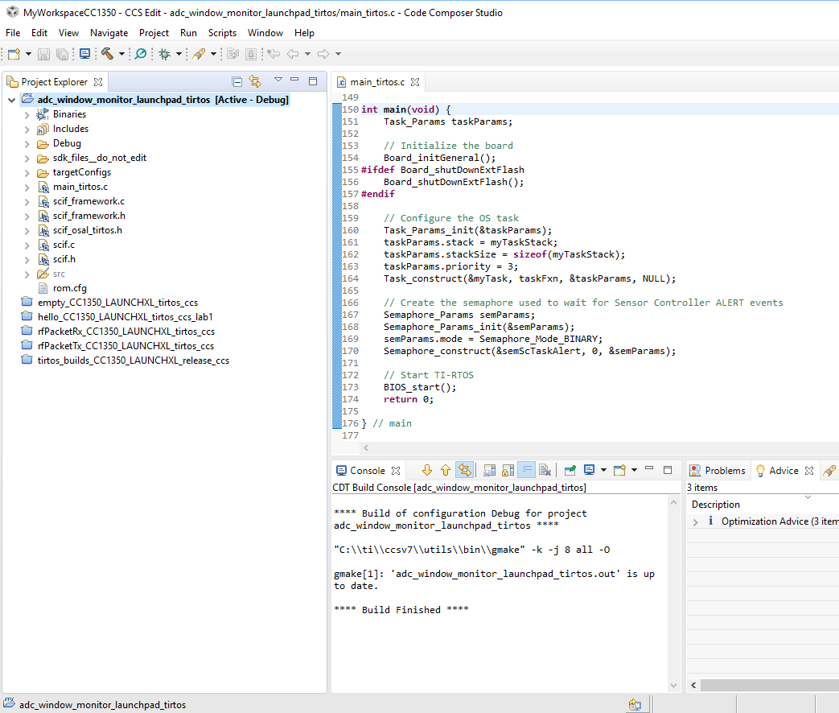

**TASK2:**

Running and debugging project.

**TASK3:**

Debugging directly from Sensor Controller Studio.

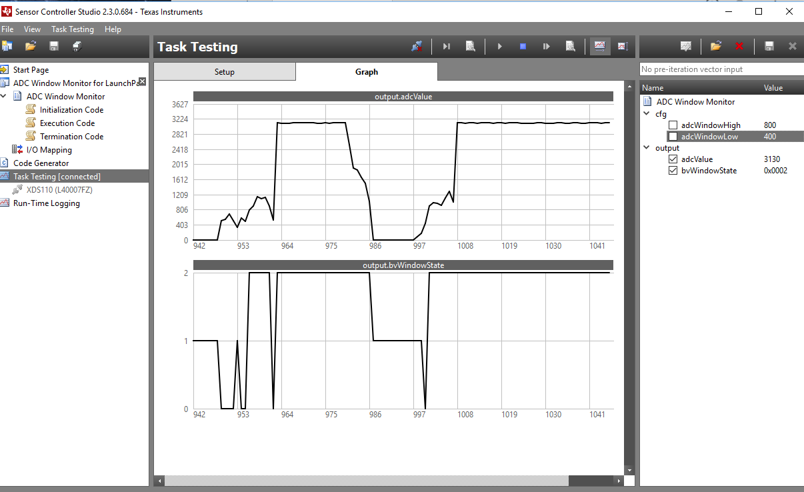

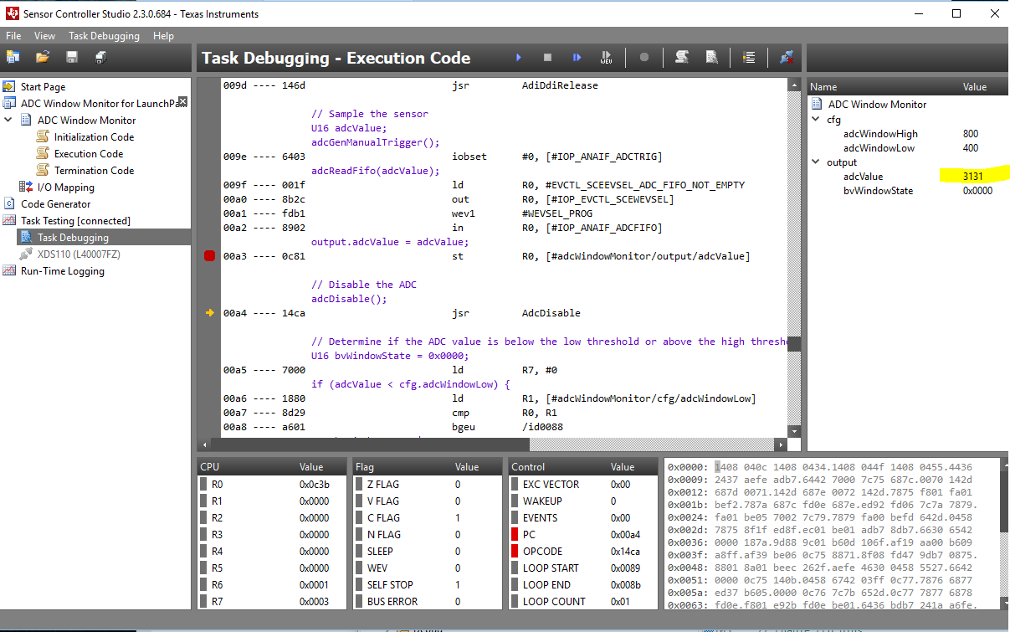

**TASK5: Bonus Task**

Reading raw value connecting ADC to 3.3 volt pin.

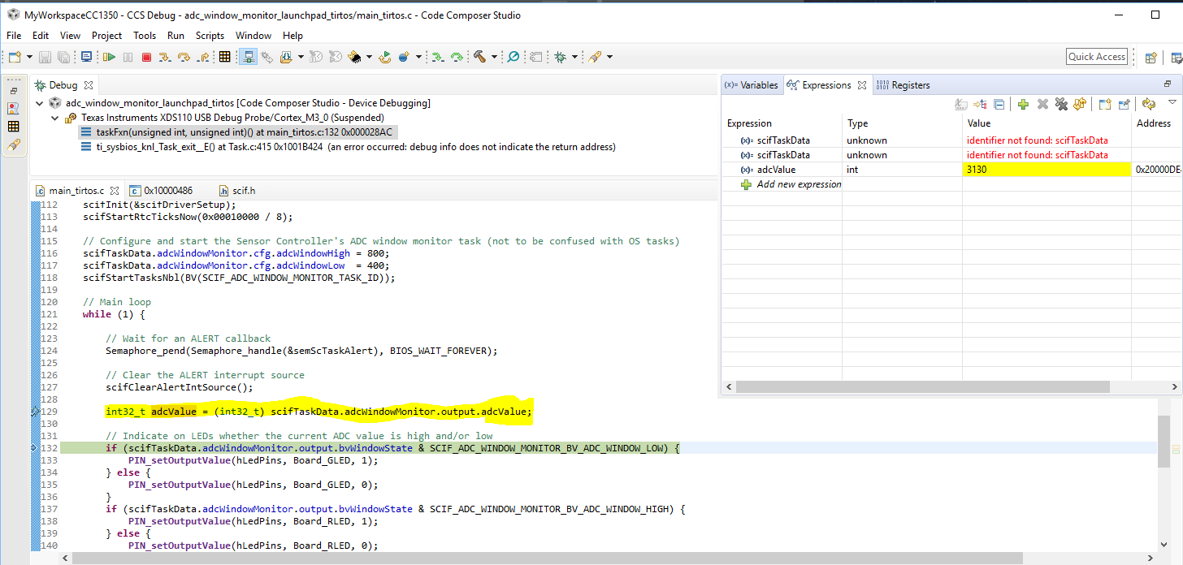

Changing ADC input voltage to 0 (Ground pin) after reading

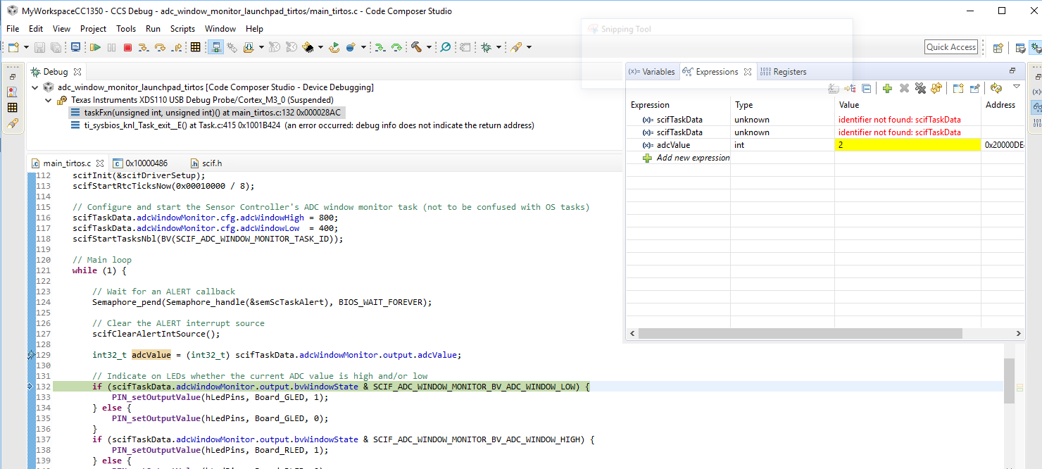

Correcting raw ADC value and converting to microvolts.

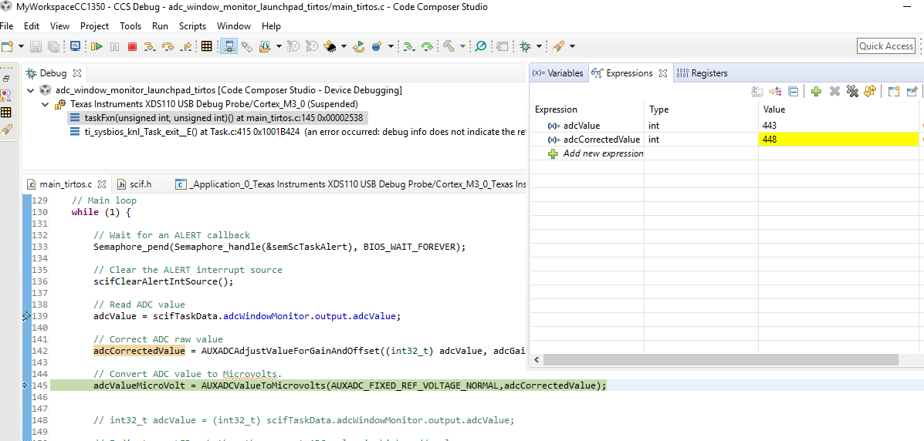

After building and debugging modified code including new variables and aux_adc apis, observing difference between raw adc value (443) and corrected acd value(448) is 5.

Configuring Microvolt threshold. Modified code shown above.